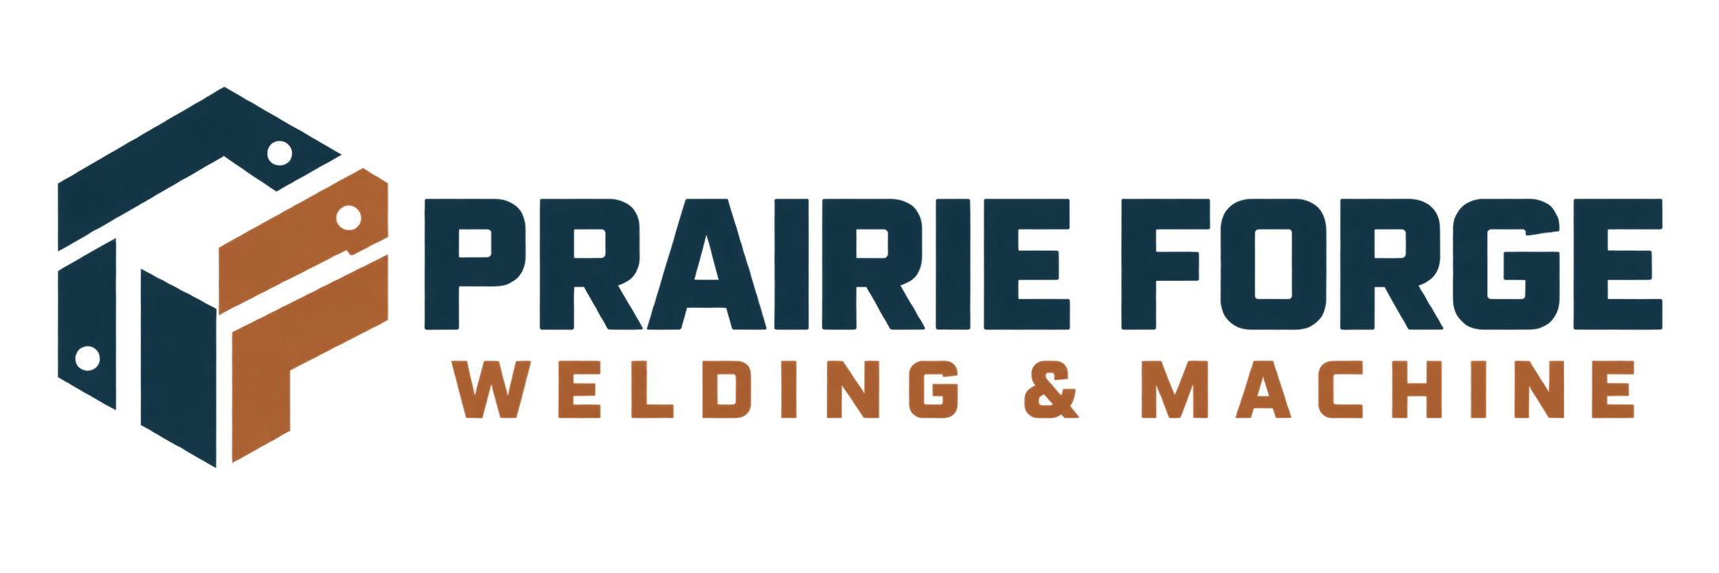

Project scope & quote-request worksheet
Prepare a clear first conversation without turning a public form into a technical drawing vault.
WORKSHOP NOTE
Prairie Forge Welding & Machine is a fictional learning example. Replace every sample detail with verified business information before use. Keep drawings, payment data and private customer records in approved systems.

Customer / organisation and best contact route

Project purpose and intended use

Material, approximate size and quantity

Preferred timing and delivery or pickup needs

CONFIRM BEFORE ESTIMATING

Shop follow-up and scope check
Use this page during the first conversation. Attach drawings only through the shop’s approved private process.
☐ Confirm whether this is fabrication, machining, repair or an inspection request.
☐ Confirm material grade, finish, tolerances and site conditions where they affect scope.
☐ Identify drawings, measurements, photographs or samples still required.
☐ Record assumptions and exclusions in plain language.
☐ Confirm who can approve the estimate and changes.

Questions or missing information

Next action, owner and follow-up date

