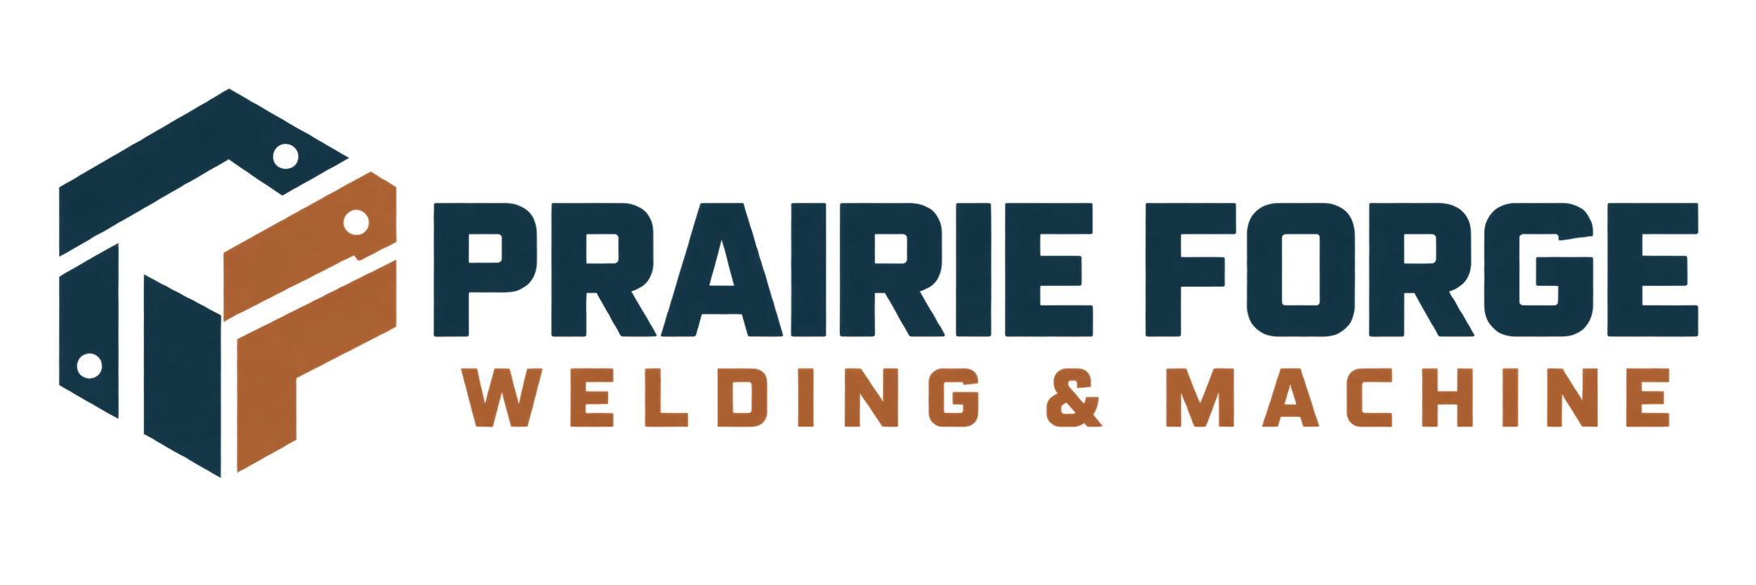

Job traveller & handover checklist
Keep the work order, checks and customer handover together from intake to completion.
WORKSHOP NOTE
Prairie Forge Welding & Machine is a fictional learning example. Replace every sample detail with verified business information before use. Keep drawings, payment data and private customer records in approved systems.

Job number, customer and project

Approved scope, drawing revision and material

Process sequence, assigned people and checkpoints

COMPLETE THE HANDOVER

Quality, release and customer record
Mark only checks that your shop actually performs and retain controlled records according to your policy.
☐ Approved scope and latest drawing revision are available.
☐ Material and consumables match the job requirements.
☐ Required dimensional, visual or process checks are recorded.
☐ Non-conformances and approved changes are resolved or clearly noted.
☐ Customer pickup, delivery, installation or next-step instructions are confirmed.
☐ Final photos and documents are stored in the approved job folder.

Completion notes and remaining limitations

Completed by / reviewed by / date

