

Water Well Drilling & Water Treatment
Website workbook
A practical workshop for a 6-page website. Study the example, plan the content and draft your own version in Word or on paper.
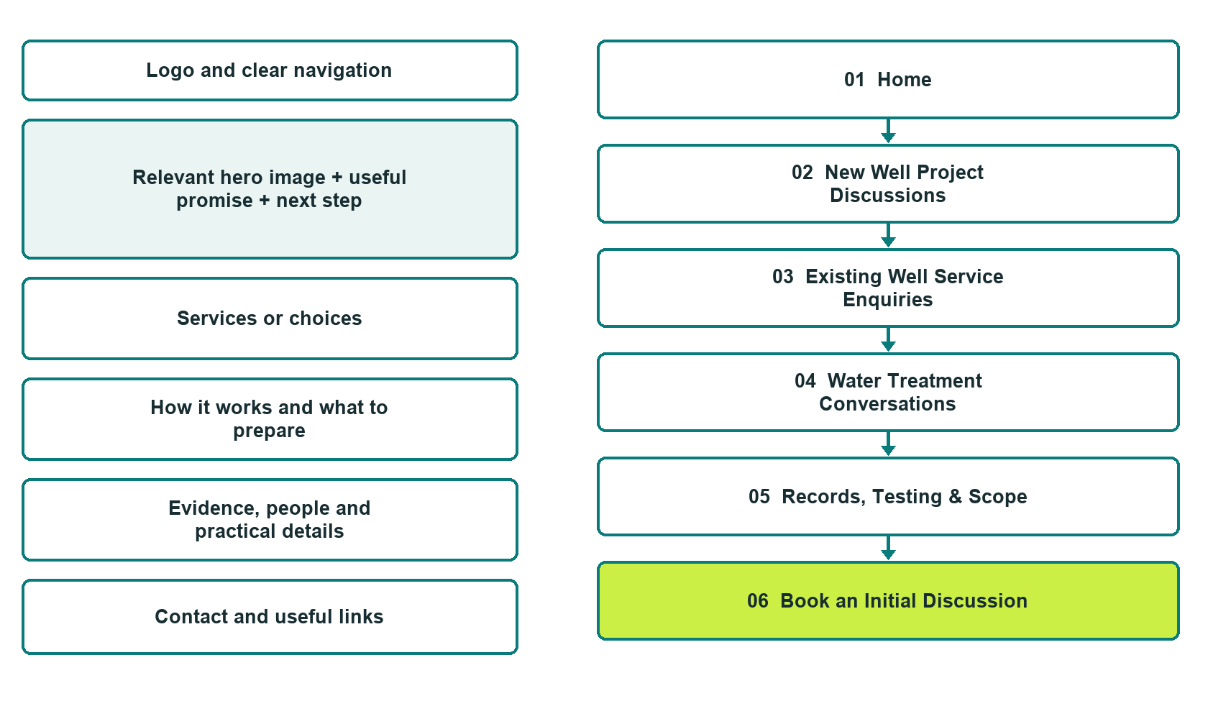

Plan → Draft → Build → Test
Finished-demo edition: authentic desktop captures of the unpublished Prairie Source Well & Water demo. The front-page wireframe remains a planning illustration.
Explore Website Builder and compare plans

Before you build
Your business supplies the facts. Prairie Source Well & Water is a fictional teaching example, not a live service.
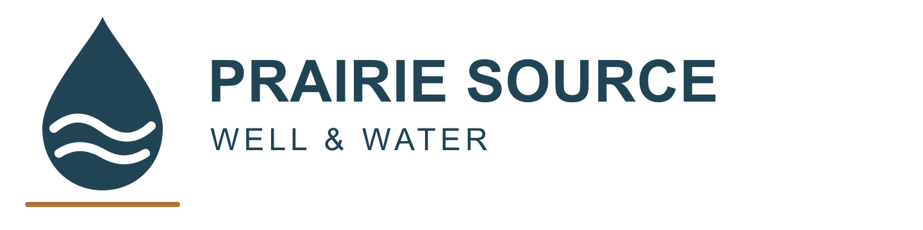
□ Discuss your property and water enquiry
□ Verified business identity, services and current contact information
□ A clear enquiry, review and confirmation process
□ Choose original photographs and confirm permission to use them.
□ Keep private customer records out of public website forms.

Your audience and the action you want them to take

Facts to verify and people who must approve them
Create your SaaSTech account

01 Home
Give this page one clear job in the customer journey.
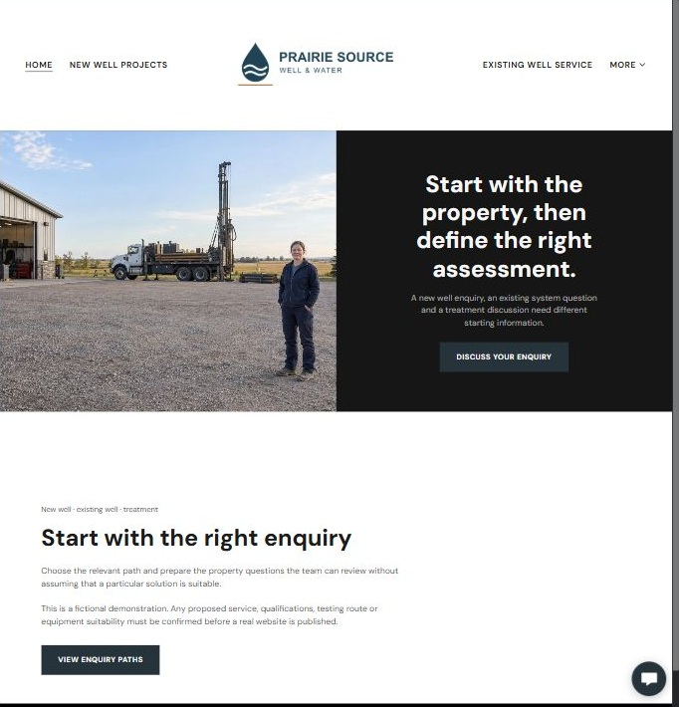
Actual Website Builder desktop capture • unpublished fictional demo

Sample wording — adapt and verify
Start with the property, then define the right assessment.
A new well enquiry, an existing system question and a treatment discussion need different starting information.
Choose the relevant path and prepare the property questions the team can review without assuming that a particular solution is suitable.
Suggested button: Discuss your property and water enquiry

Website advice
Separate new-well, existing-well and water-treatment enquiries, with qualified assessment and operator-confirmed service boundaries.

Your draft: Home
Write in the voice of your own business. Use facts you can verify, not promises copied from the example.

Headline and short introduction

Main content and details visitors need

Button wording and destination

Photo choice, permission and facts still to confirm
Partner check: can someone unfamiliar with the business find a useful next step?

02 New Well Project Discussions
Give this page one clear job in the customer journey.
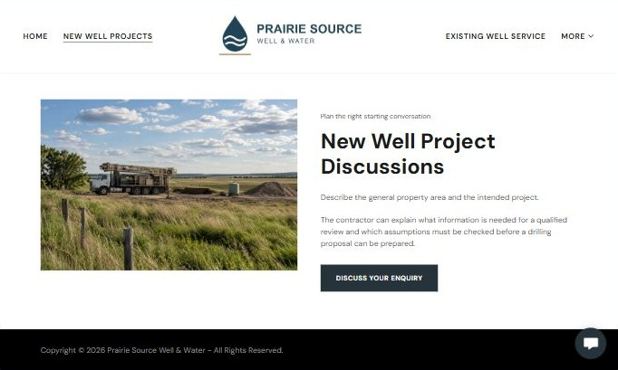
Actual Website Builder desktop capture • unpublished fictional demo

Sample wording — adapt and verify
New Well Project Discussions
Describe the general property area and the intended project.
The contractor can explain what information is needed for a qualified review and which assumptions must be checked before a drilling proposal can be prepared.
Suggested button: Discuss your property and water enquiry

Website advice
Explain early property and project conversations without predicting yield, depth, location or approval requirements.

Your draft: New Well Project Discussions
Write in the voice of your own business. Use facts you can verify, not promises copied from the example.

Headline and short introduction

Main content and details visitors need

Button wording and destination

Photo choice, permission and facts still to confirm
Partner check: can someone unfamiliar with the business find a useful next step?

03 Existing Well Service Enquiries
Give this page one clear job in the customer journey.
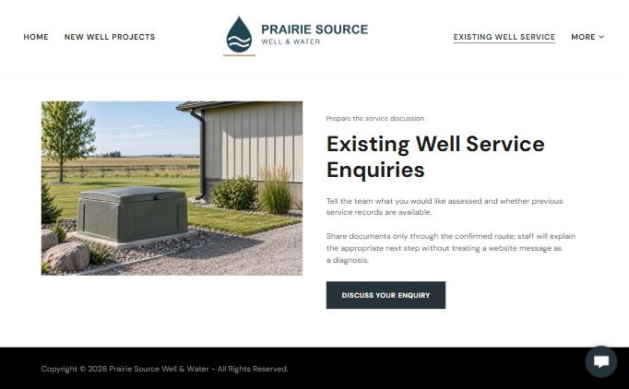
Actual Website Builder desktop capture • unpublished fictional demo

Sample wording — adapt and verify
Existing Well Service Enquiries
Tell the team what you would like assessed and whether previous service records are available.
Share documents only through the confirmed route; staff will explain the appropriate next step without treating a website message as a diagnosis.
Suggested button: Discuss your property and water enquiry

Website advice
Provide a separate route for existing systems without remote diagnosis or asking customers to inspect equipment.

Your draft: Existing Well Service Enquiries
Write in the voice of your own business. Use facts you can verify, not promises copied from the example.

Headline and short introduction

Main content and details visitors need

Button wording and destination

Photo choice, permission and facts still to confirm
Partner check: can someone unfamiliar with the business find a useful next step?

04 Water Treatment Conversations
Give this page one clear job in the customer journey.
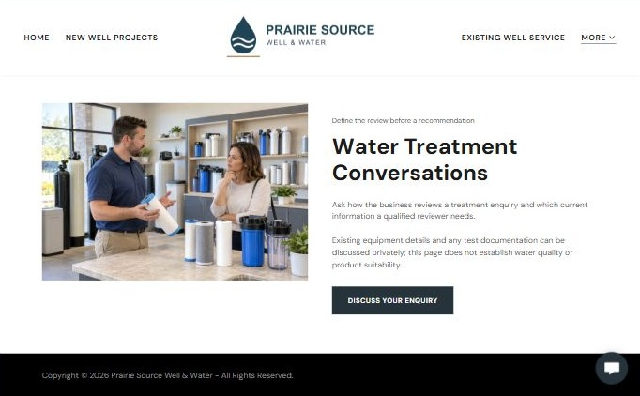
Actual Website Builder desktop capture • unpublished fictional demo

Sample wording — adapt and verify
Water Treatment Conversations
Ask how the business reviews a treatment enquiry and which current information a qualified reviewer needs.
Existing equipment details and any test documentation can be discussed privately; this page does not establish water quality or product suitability.
Suggested button: Discuss your property and water enquiry

Website advice
Explain assessment and product-review questions without recommending treatment or interpreting a water result.

Your draft: Water Treatment Conversations
Write in the voice of your own business. Use facts you can verify, not promises copied from the example.

Headline and short introduction

Main content and details visitors need

Button wording and destination

Photo choice, permission and facts still to confirm
Partner check: can someone unfamiliar with the business find a useful next step?

05 Records, Testing & Scope
Give this page one clear job in the customer journey.
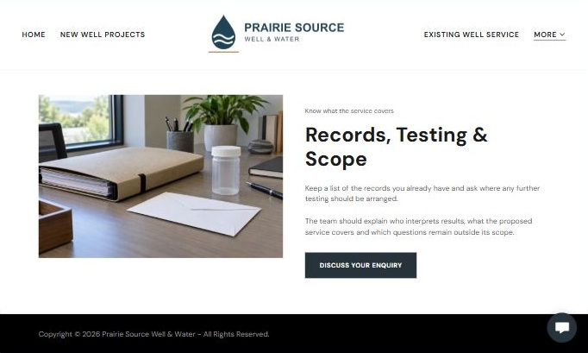
Actual Website Builder desktop capture • unpublished fictional demo

Sample wording — adapt and verify
Records, Testing & Scope
Keep a list of the records you already have and ask where any further testing should be arranged.
The team should explain who interprets results, what the proposed service covers and which questions remain outside its scope.
Suggested button: Discuss your property and water enquiry

Website advice
Distinguish record collection, qualified interpretation and a written service proposal.

Your draft: Records, Testing & Scope
Write in the voice of your own business. Use facts you can verify, not promises copied from the example.

Headline and short introduction

Main content and details visitors need

Button wording and destination

Photo choice, permission and facts still to confirm
Partner check: can someone unfamiliar with the business find a useful next step?

06 Book an Initial Discussion
Give this page one clear job in the customer journey.
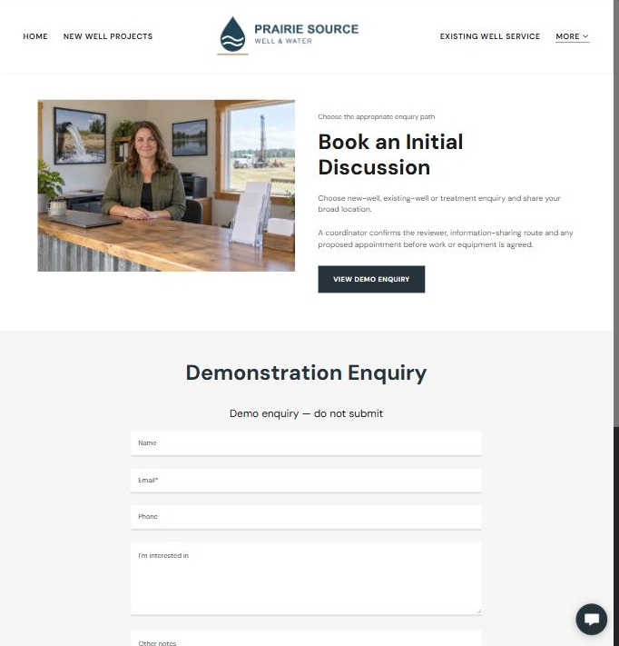
Actual Website Builder desktop capture • unpublished fictional demo

Sample wording — adapt and verify
Book an Initial Discussion
Choose new-well, existing-well or treatment enquiry and share your broad location.
A coordinator confirms the reviewer, information-sharing route and any proposed appointment before work or equipment is agreed.
Suggested button: Discuss your property and water enquiry

Website advice
Use general contact information and property context without making a booking, water-quality or performance promise.

Your draft: Book an Initial Discussion
Write in the voice of your own business. Use facts you can verify, not promises copied from the example.

Headline and short introduction

Main content and details visitors need

Button wording and destination

Photo choice, permission and facts still to confirm
Partner check: can someone unfamiliar with the business find a useful next step?

Test before publishing
Review desktop and mobile previews, Editor Highlights, Themes and Paint on the industry page. Test your own links and enquiries before publishing.
□ Fictional demonstration only. No drilling specifications, water-quality interpretation, treatment recommendation or drinking-water assurance is provided. Verify qualifications, testing routes, service availability and every product or performance claim before publication.
□ Verify every service description, contact route and operating detail.
□ Replace fictional identity and example information before a live launch.
□ Test enquiries, links and downloads on desktop and mobile.
□ Keep confidential records in approved private systems.
□ Obtain operator approval for public wording and images.
□ Check every link, form destination, download and confirmation message.
□ Check logo contrast, hero framing, text sizes and image loading.
□ Save a named backup and assign a content-review date.

Changes to finish and person responsible

Approval and next review date
Website Builder plans and signup

