

Waste, Recycling & Remediation
Website workbook
A practical workshop for a 5-page website. Study the example, plan the content and draft your own version in Word or on paper.
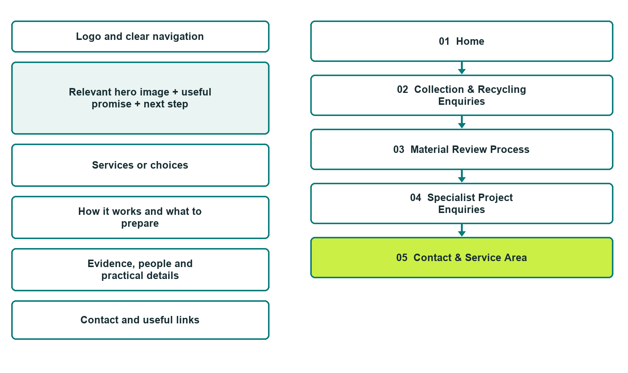

Plan → Draft → Build → Test
Capture edition: five genuine unpublished Website Builder desktop excerpts. Review mobile views on the industry page.
Explore Website Builder and compare plans

Before you build
Your business supplies the facts. Prairie Loop Materials is a fictional teaching example, not a live service.

□ Ask about a material or collection
□ Verified identity, service scope and current contacts
□ Clear enquiry and confirmation steps
□ Choose original photographs and confirm permission to use them.
□ Keep private customer records out of public website forms.

Your audience and the action you want them to take

Facts to verify and people who must approve them
Create your SaaSTech account

01 Home
Give this page one clear job in the customer journey.
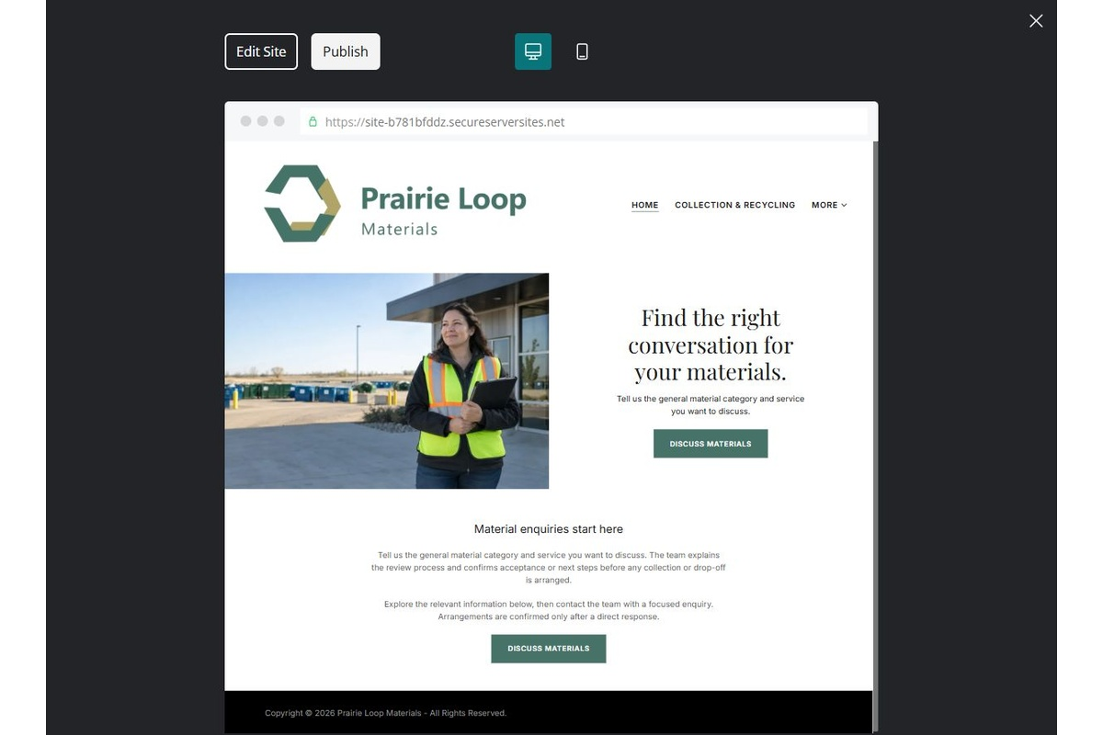
Unpublished Website Builder desktop excerpt. Page content continues below.

Sample wording — adapt and verify
Find the right conversation for your materials.
Tell us the general material category and service you want to discuss. The team explains the review process and confirms acceptance or next steps before any collection or drop-off is arranged.
Explore the relevant information below, then contact the team with a focused enquiry. Arrangements are confirmed only after a direct response.
Suggested button: Ask about a material or collection

Website advice
Separate collection, recycling and specialist enquiries; show only operator-approved acceptance information and avoid environmental outcome claims.

Your draft: Home
Write in the voice of your own business. Use facts you can verify, not promises copied from the example.

Headline and short introduction

Main content and details visitors need

Button wording and destination

Photo choice, permission and facts still to confirm
Partner check: can someone unfamiliar with the business find a useful next step?

02 Collection & Recycling Enquiries
Give this page one clear job in the customer journey.
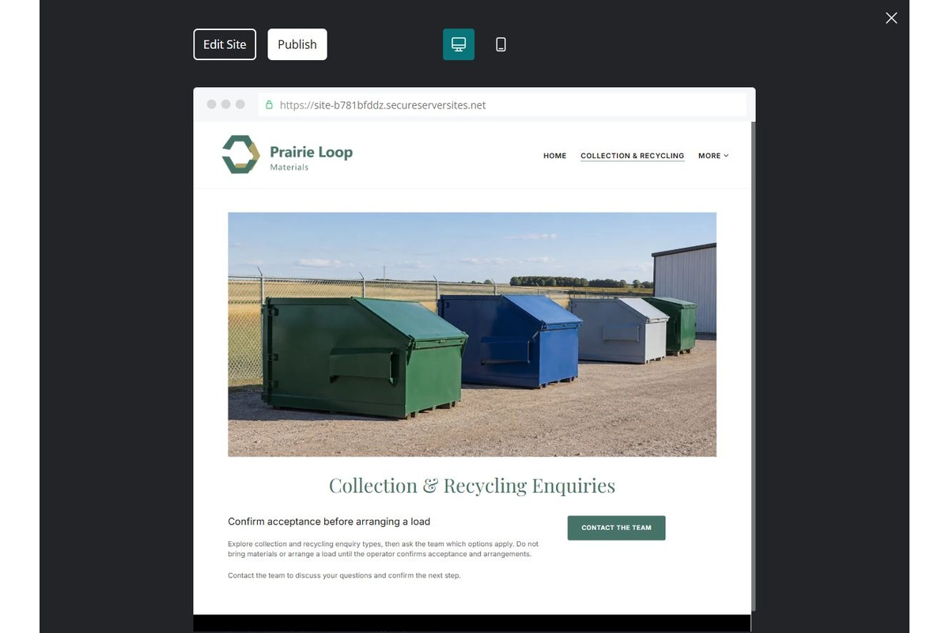
Unpublished Website Builder desktop excerpt. Page content continues below.

Sample wording — adapt and verify
Collection & Recycling Enquiries
Explore collection and recycling enquiry types, then ask the team which options apply. Do not bring materials or arrange a load until the operator confirms acceptance and arrangements.
Contact the team to discuss your questions and confirm the next step.
Suggested button: Contact the team

Website advice
Explain verified service categories and the need for acceptance confirmation.

Your draft: Collection & Recycling Enquiries
Write in the voice of your own business. Use facts you can verify, not promises copied from the example.

Headline and short introduction

Main content and details visitors need

Button wording and destination

Photo choice, permission and facts still to confirm
Partner check: can someone unfamiliar with the business find a useful next step?

03 Material Review Process
Give this page one clear job in the customer journey.
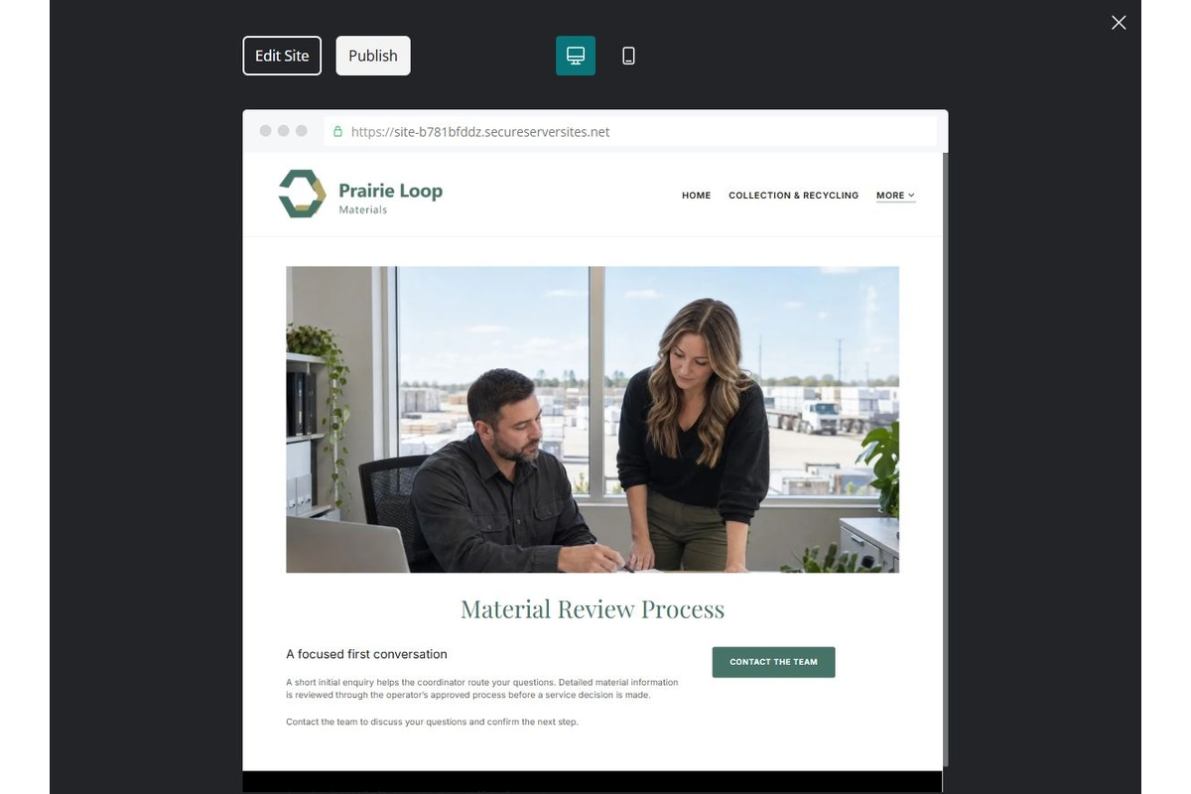
Unpublished Website Builder desktop excerpt. Page content continues below.

Sample wording — adapt and verify
Material Review Process
A short initial enquiry helps the coordinator route your questions. Detailed material information is reviewed through the operator’s approved process before a service decision is made.
Contact the team to discuss your questions and confirm the next step.
Suggested button: Contact the team

Website advice
Direct identification and handling questions to approved staff, with no generic hazardous-material advice.

Your draft: Material Review Process
Write in the voice of your own business. Use facts you can verify, not promises copied from the example.

Headline and short introduction

Main content and details visitors need

Button wording and destination

Photo choice, permission and facts still to confirm
Partner check: can someone unfamiliar with the business find a useful next step?

04 Specialist Project Enquiries
Give this page one clear job in the customer journey.
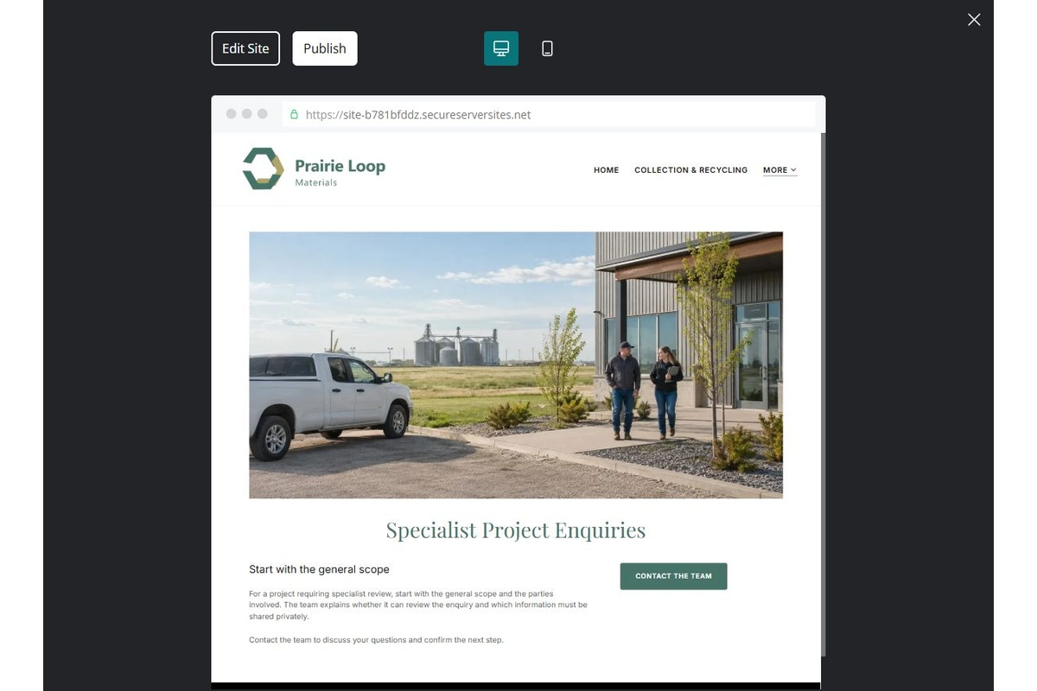
Unpublished Website Builder desktop excerpt. Page content continues below.

Sample wording — adapt and verify
Specialist Project Enquiries
For a project requiring specialist review, start with the general scope and the parties involved. The team explains whether it can review the enquiry and which information must be shared privately.
Contact the team to discuss your questions and confirm the next step.
Suggested button: Contact the team

Website advice
Describe review and referral boundaries without asserting permits, remediation success or expertise not verified.

Your draft: Specialist Project Enquiries
Write in the voice of your own business. Use facts you can verify, not promises copied from the example.

Headline and short introduction

Main content and details visitors need

Button wording and destination

Photo choice, permission and facts still to confirm
Partner check: can someone unfamiliar with the business find a useful next step?

05 Contact & Service Area
Give this page one clear job in the customer journey.
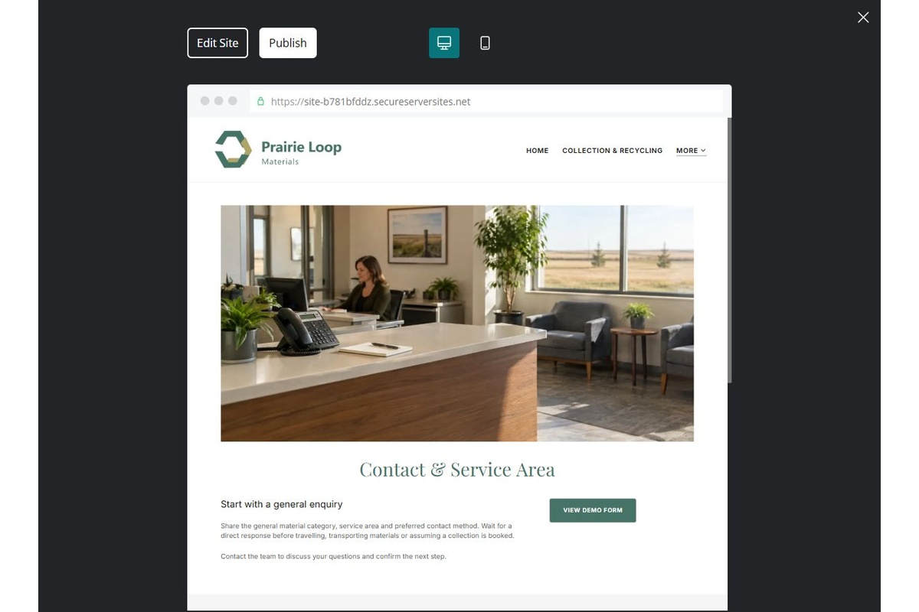
Unpublished Website Builder desktop excerpt. Page content continues below.

Sample wording — adapt and verify
Contact & Service Area
Share the general material category, service area and preferred contact method. Wait for a direct response before travelling, transporting materials or assuming a collection is booked.
Contact the team to discuss your questions and confirm the next step.
Suggested button: Contact the team

Website advice
State confirmed contact routes and separate enquiry from accepted load or booking.

Your draft: Contact & Service Area
Write in the voice of your own business. Use facts you can verify, not promises copied from the example.

Headline and short introduction

Main content and details visitors need

Button wording and destination

Photo choice, permission and facts still to confirm
Partner check: can someone unfamiliar with the business find a useful next step?

Test before publishing
Review the whole journey on a desktop and phone. Compare these desktop excerpts with the mobile captures on the industry page.
□ Fictional business example. Do not infer material acceptance, safe handling, disposal permissions or remediation capability. Obtain operator and qualified-professional review before publishing technical information.
□ Verify contact routes, location, hours, service scope and all commercial terms.
□ Replace fictional identities and AI illustrations or label them accurately.
□ Remove unverified testimonials, results, credentials and availability.
□ Check every link, form and download on desktop and mobile.
□ Keep sensitive documents, access information and payment details out of public forms.
□ Check every link, form destination, download and confirmation message.
□ Check logo contrast, hero framing, text sizes and image loading.
□ Save a named backup and assign a content-review date.

Changes to finish and person responsible

Approval and next review date
Website Builder plans and signup

