

Vacuum Truck & Hydrovac Services
Website workbook
A practical workshop for a 6-page website. Study the example, plan the content and draft your own version in Word or on paper.
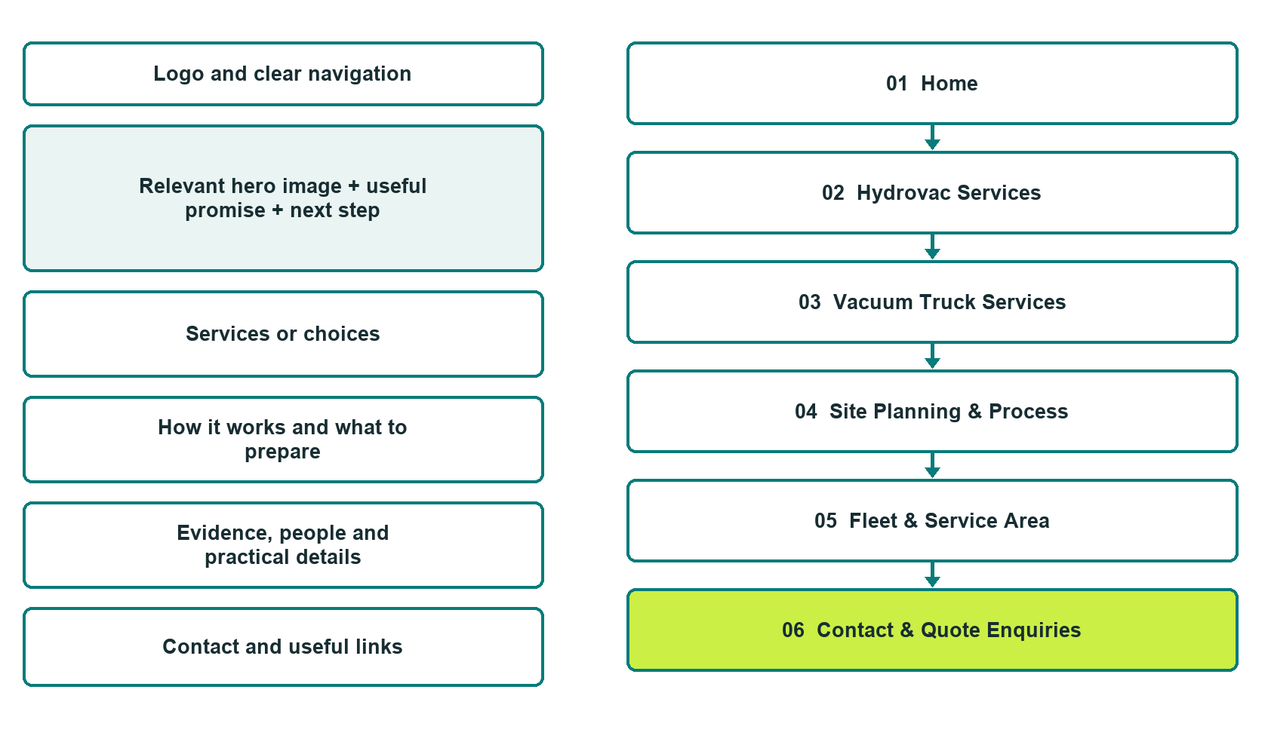

Plan → Draft → Build → Test
Captured demo edition. Study the unpublished six-page example. Paired desktop and mobile previews, Editor Highlights, Themes and Paint settings appear in the industry gallery.
Explore Website Builder and compare plans

Before you build
Your business supplies the facts. Prairie Depth Services is a fictional teaching example, not a live service.

□ Agree the scope, arrangements and authorization separately
□ Replace fictional details with verified operator identity, service scope and contact information.
□ Verify equipment descriptions and image permissions; do not imply generated vehicles are the actual fleet.
□ Choose original photographs and confirm permission to use them.
□ Keep private customer records out of public website forms.

Your audience and the action you want them to take

Facts to verify and people who must approve them
Create your SaaSTech account

01 Home
Give this page one clear job in the customer journey.
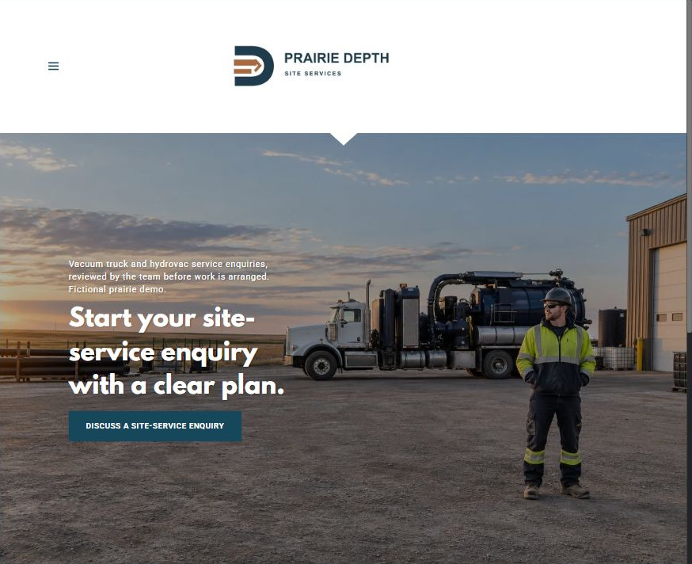
Actual desktop Website Builder preview. Its paired mobile view appears in the industry gallery.

Sample wording — adapt and verify
Start your site-service enquiry with a clear plan.
Prairie Depth Services is a fictional example of a vacuum-truck and hydrovac service website. Explore how a contractor can present verified capabilities and help site coordinators prepare a focused enquiry.
Describe the general service required, approximate area and preferred timing. The team must review suitability, site conditions and requirements before confirming scope or scheduling.
Suggested button: Discuss a site-service enquiry

Website advice
Identify the service scope and route enquiries to a human review.

Your draft: Home
Write in the voice of your own business. Use facts you can verify, not promises copied from the example.

Headline and short introduction

Main content and details visitors need

Button wording and destination

Photo choice, permission and facts still to confirm
Partner check: can someone unfamiliar with the business find a useful next step?

02 Hydrovac Services
Give this page one clear job in the customer journey.
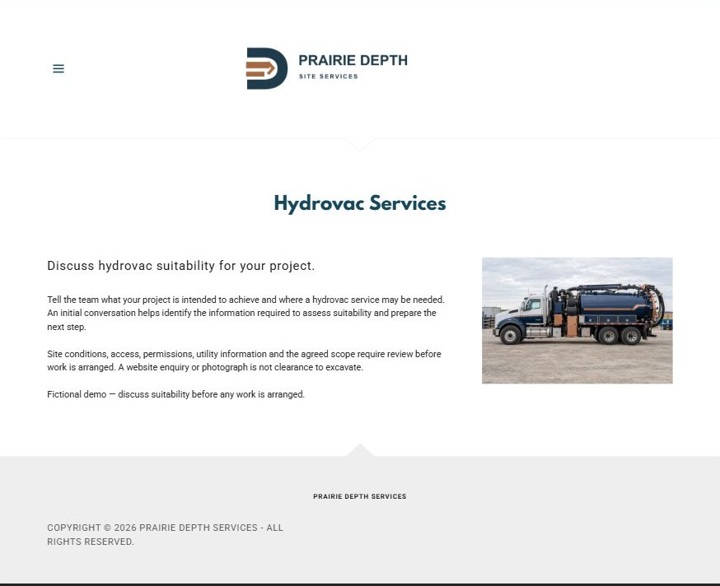
Actual desktop Website Builder preview. Its paired mobile view appears in the industry gallery.

Sample wording — adapt and verify
Discuss hydrovac suitability for your project.
Tell the team what your project is intended to achieve and where a hydrovac service may be needed. An initial conversation helps identify the information required to assess suitability and prepare the next step.
Site conditions, access, permissions, utility information and the agreed scope require review before work is arranged. A website enquiry or photograph is not clearance to excavate.
Suggested button: Ask about hydrovac suitability

Website advice
Explain verified project categories without teaching excavation or promising safety.

Your draft: Hydrovac Services
Write in the voice of your own business. Use facts you can verify, not promises copied from the example.

Headline and short introduction

Main content and details visitors need

Button wording and destination

Photo choice, permission and facts still to confirm
Partner check: can someone unfamiliar with the business find a useful next step?

03 Vacuum Truck Services
Give this page one clear job in the customer journey.
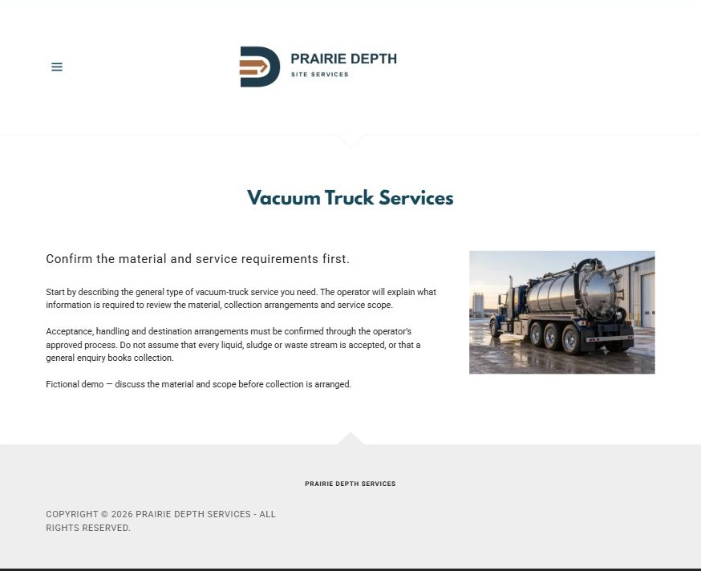
Actual desktop Website Builder preview. Its paired mobile view appears in the industry gallery.

Sample wording — adapt and verify
Confirm the material and service requirements first.
Start by describing the general type of vacuum-truck service you need. The operator will explain what information is required to review the material, collection arrangements and service scope.
Acceptance, handling and destination arrangements must be confirmed through the operator’s approved process. Do not assume that every liquid, sludge or waste stream is accepted, or that a general enquiry books collection.
Suggested button: Discuss a vacuum-truck enquiry

Website advice
Separate service enquiries from permission to collect any particular material.

Your draft: Vacuum Truck Services
Write in the voice of your own business. Use facts you can verify, not promises copied from the example.

Headline and short introduction

Main content and details visitors need

Button wording and destination

Photo choice, permission and facts still to confirm
Partner check: can someone unfamiliar with the business find a useful next step?

04 Site Planning & Process
Give this page one clear job in the customer journey.
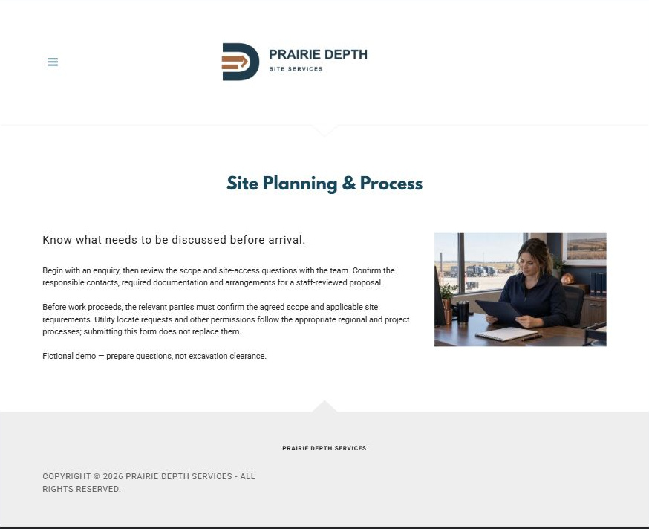
Actual desktop Website Builder preview. Its paired mobile view appears in the industry gallery.

Sample wording — adapt and verify
Know what needs to be discussed before arrival.
Begin with an enquiry, then review the scope and site-access questions with the team. Confirm the responsible contacts, required documentation and arrangements for a staff-reviewed proposal.
Before work proceeds, the relevant parties must confirm the agreed scope and applicable site requirements. Utility locate requests and other permissions follow the appropriate regional and project processes; submitting this form does not replace them.
Suggested button: Prepare your enquiry

Website advice
Show coordination steps, not an operational safety procedure.

Your draft: Site Planning & Process
Write in the voice of your own business. Use facts you can verify, not promises copied from the example.

Headline and short introduction

Main content and details visitors need

Button wording and destination

Photo choice, permission and facts still to confirm
Partner check: can someone unfamiliar with the business find a useful next step?

05 Fleet & Service Area
Give this page one clear job in the customer journey.
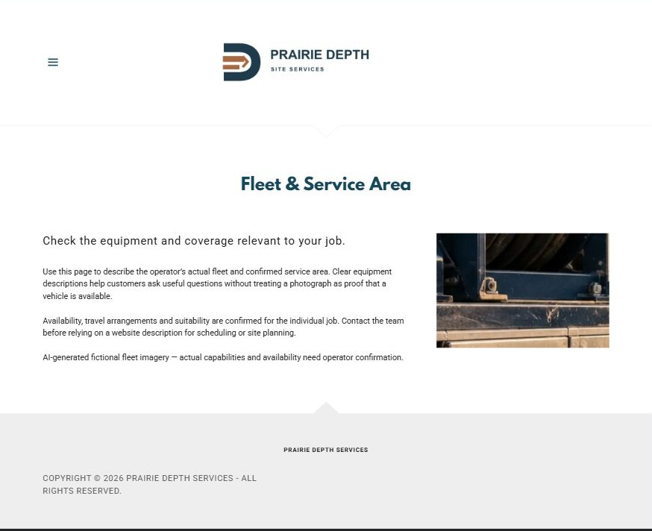
Actual desktop Website Builder preview. Its paired mobile view appears in the industry gallery.

Sample wording — adapt and verify
Check the equipment and coverage relevant to your job.
Use this page to describe the operator’s actual fleet and confirmed service area. Clear equipment descriptions help customers ask useful questions without treating a photograph as proof that a vehicle is available.
Availability, travel arrangements and suitability are confirmed for the individual job. Contact the team before relying on a website description for scheduling or site planning.
Suggested button: Confirm service availability

Website advice
Publish only verified equipment and geographic capabilities.

Your draft: Fleet & Service Area
Write in the voice of your own business. Use facts you can verify, not promises copied from the example.

Headline and short introduction

Main content and details visitors need

Button wording and destination

Photo choice, permission and facts still to confirm
Partner check: can someone unfamiliar with the business find a useful next step?

06 Contact & Quote Enquiries
Give this page one clear job in the customer journey.
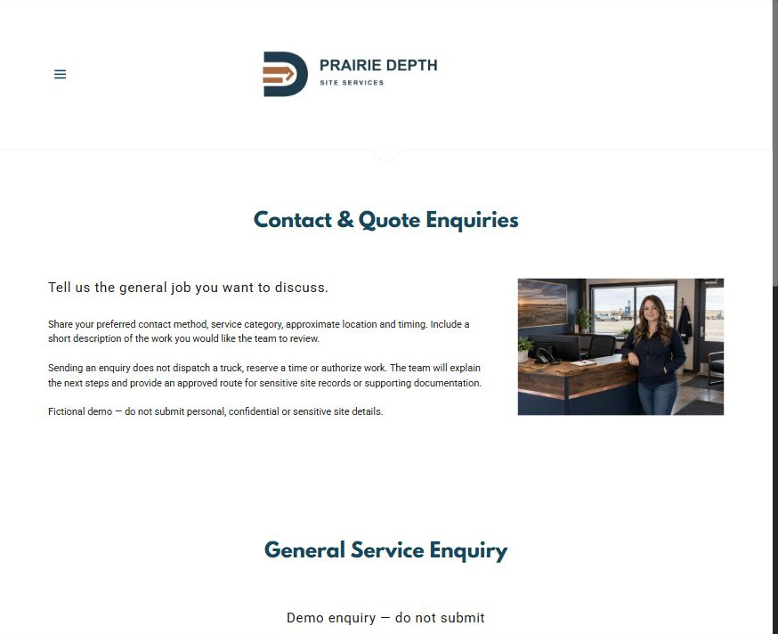
Actual desktop Website Builder preview. Its paired mobile view appears in the industry gallery.

Sample wording — adapt and verify
Tell us the general job you want to discuss.
Share your preferred contact method, service category, approximate location and timing. Include a short description of the work you would like the team to review.
Sending an enquiry does not dispatch a truck, reserve a time or authorize work. The team will explain the next steps and provide an approved route for sensitive site records or supporting documentation.
Suggested button: Send a general enquiry

Website advice
Collect only enough information to begin a staff-reviewed conversation.

Your draft: Contact & Quote Enquiries
Write in the voice of your own business. Use facts you can verify, not promises copied from the example.

Headline and short introduction

Main content and details visitors need

Button wording and destination

Photo choice, permission and facts still to confirm
Partner check: can someone unfamiliar with the business find a useful next step?

Test before publishing
Review the captured desktop and phone journey. The demonstration form has Name, required Email, Phone, General service required and Approximate area and preferred timing. Recipient blank, attachments off. It was not submitted or delivery-tested. Configure approved delivery before launch.
□ Replace fictional details with verified operator identity, service scope and contact information.
□ Verify equipment descriptions and image permissions; do not imply generated vehicles are the actual fleet.
□ Have the operator approve material-acceptance, service-area and enquiry wording.
□ Provide the correct regional utility-locate resource without implying a locate request alone permits work.
□ Keep enquiries distinct from estimates, dispatch, scheduling and work authorization.
□ Test forms and all six pages on desktop and mobile.
□ Check every link, form destination, download and confirmation message.
□ Check logo contrast, hero framing, text sizes and image loading.
□ Save a named backup and assign a content-review date.

Changes to finish and person responsible

Approval and next review date
Website Builder plans and signup

