

Spas, Nail & Aesthetic Studios
Website workbook
A practical workshop for a 5-page website. Study the example, plan the content and draft your own version in Word or on paper.
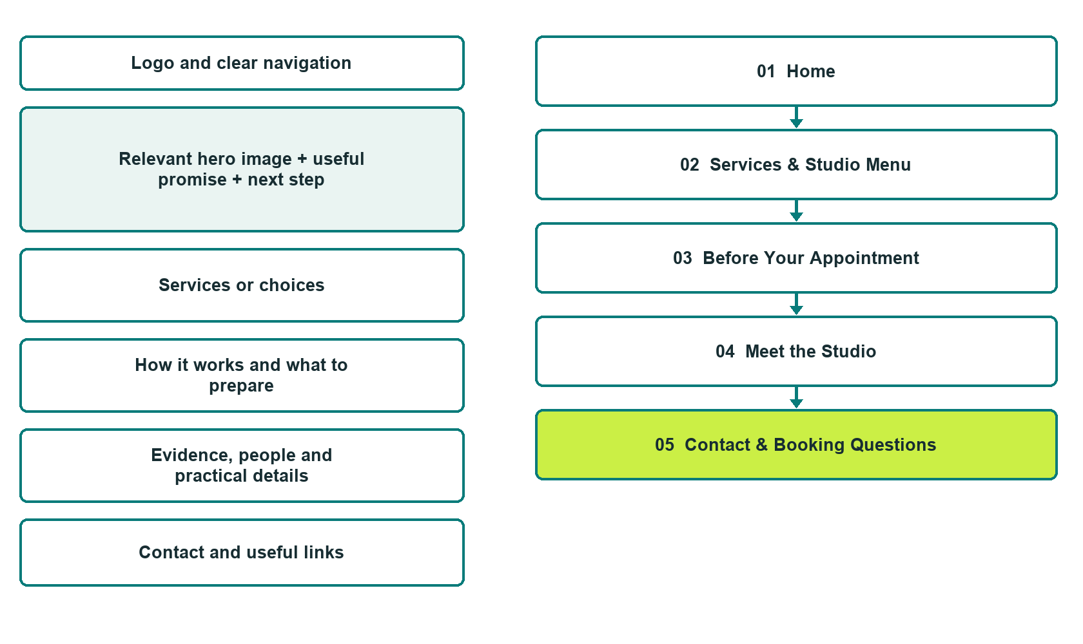

Plan → Draft → Build → Test
Capture edition: five genuine unpublished Website Builder desktop excerpts. Review mobile views on the industry page.
Explore Website Builder and compare plans

Before you build
Your business supplies the facts. Prairie Stillwater Studio is a fictional teaching example, not a live service.
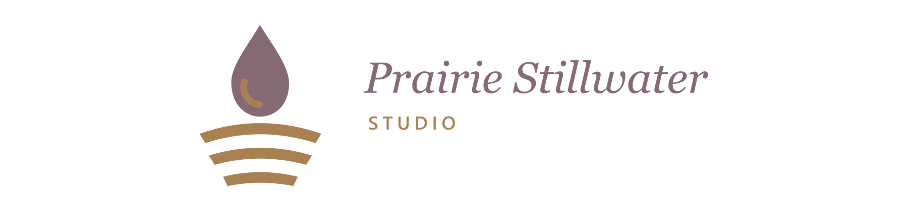
□ Ask about a studio appointment
□ Verified business identity, services and current contact information
□ A clear enquiry, review and confirmation process
□ Choose original photographs and confirm permission to use them.
□ Keep private customer records out of public website forms.

Your audience and the action you want them to take

Facts to verify and people who must approve them
Create your SaaSTech account

01 Home
Give this page one clear job in the customer journey.
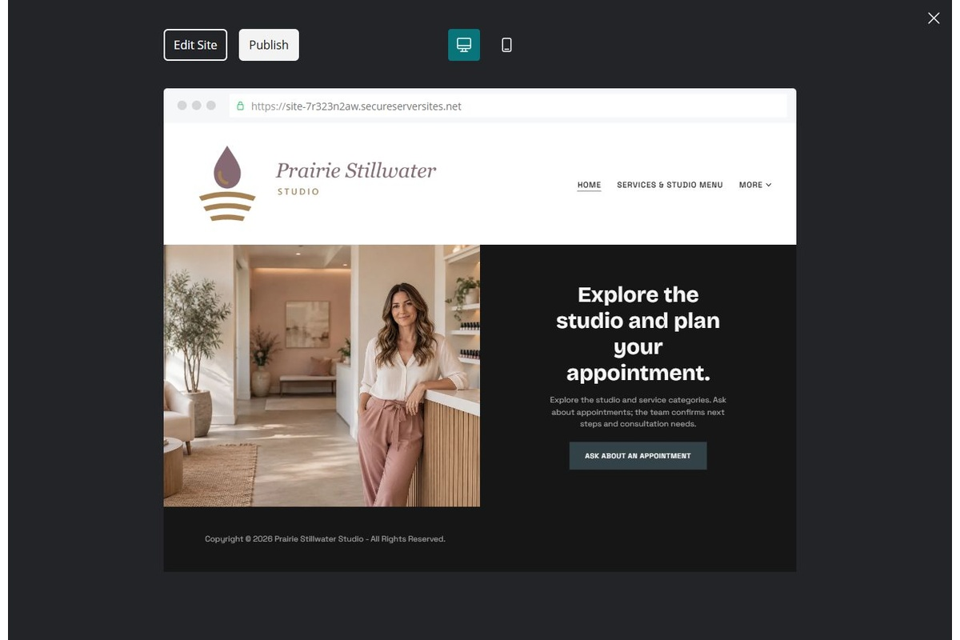
Unpublished Website Builder desktop excerpt. Page content continues below.

Sample wording — adapt and verify
Explore the studio and plan your appointment.
Explore the studio setting, browse the services you want to discuss and ask about current appointment options. The team confirms the appropriate next step and any private consultation requirements.
Use the relevant page to prepare a focused enquiry, then contact the team to confirm the next step.
Suggested button: Ask about a studio appointment

Website advice
Describe operator-approved service categories, appointment arrangements and practitioner roles without medical or outcome claims.

Your draft: Home
Write in the voice of your own business. Use facts you can verify, not promises copied from the example.

Headline and short introduction

Main content and details visitors need

Button wording and destination

Photo choice, permission and facts still to confirm
Partner check: can someone unfamiliar with the business find a useful next step?

02 Services & Studio Menu
Give this page one clear job in the customer journey.
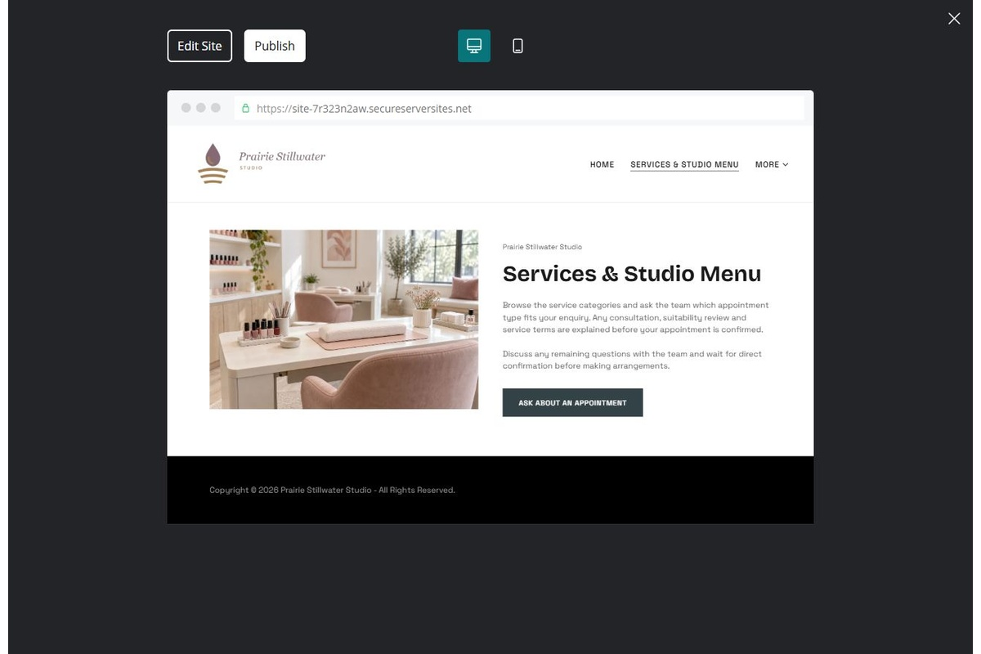
Unpublished Website Builder desktop excerpt. Page content continues below.

Sample wording — adapt and verify
Services & Studio Menu
Browse the service categories and ask the team which appointment type fits your enquiry. Any consultation, suitability review and service terms are explained before your appointment is confirmed.
Discuss any remaining questions with the team and wait for direct confirmation before making arrangements.
Suggested button: Ask about a studio appointment

Website advice
Separate verified nail, spa and aesthetic categories. Publish reviewed descriptions and confirmed prices only.

Your draft: Services & Studio Menu
Write in the voice of your own business. Use facts you can verify, not promises copied from the example.

Headline and short introduction

Main content and details visitors need

Button wording and destination

Photo choice, permission and facts still to confirm
Partner check: can someone unfamiliar with the business find a useful next step?

03 Before Your Appointment
Give this page one clear job in the customer journey.
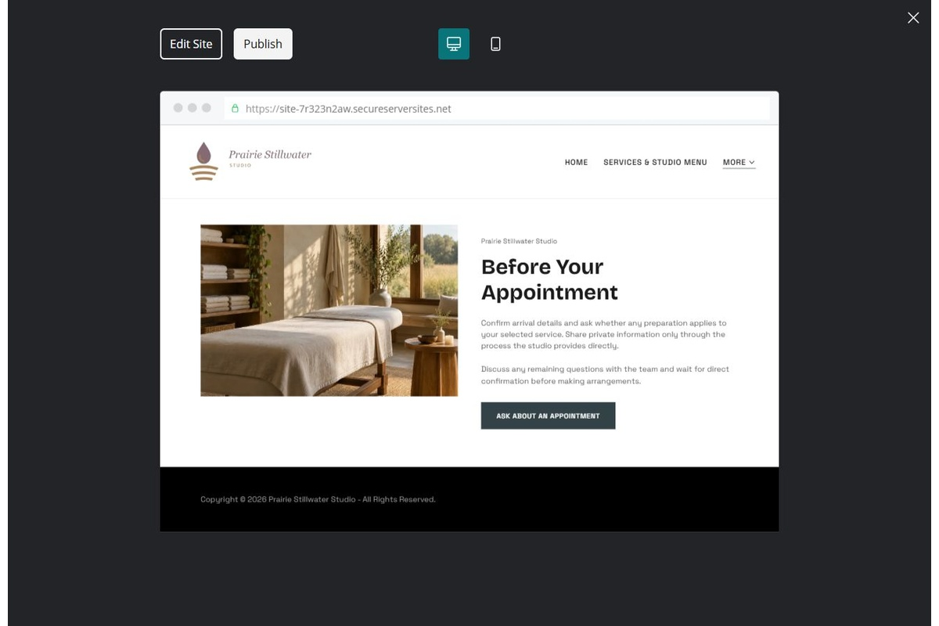
Unpublished Website Builder desktop excerpt. Page content continues below.

Sample wording — adapt and verify
Before Your Appointment
Confirm arrival details and ask whether any preparation applies to your selected service. Share private information only through the process the studio provides directly.
Discuss any remaining questions with the team and wait for direct confirmation before making arrangements.
Suggested button: Ask about a studio appointment

Website advice
Use only service-specific preparation supplied by the operator. Distinguish requests from bookings.

Your draft: Before Your Appointment
Write in the voice of your own business. Use facts you can verify, not promises copied from the example.

Headline and short introduction

Main content and details visitors need

Button wording and destination

Photo choice, permission and facts still to confirm
Partner check: can someone unfamiliar with the business find a useful next step?

04 Meet the Studio
Give this page one clear job in the customer journey.
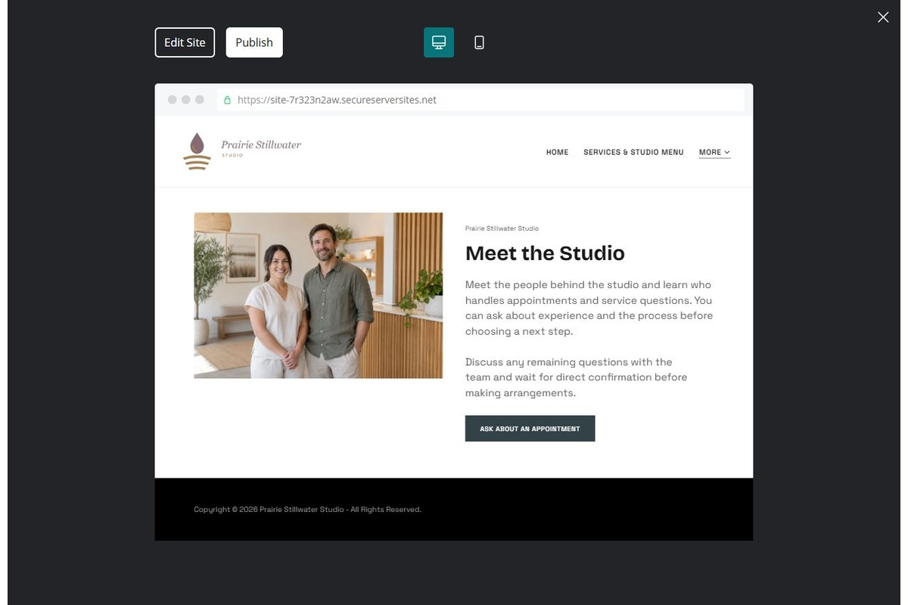
Unpublished Website Builder desktop excerpt. Page content continues below.

Sample wording — adapt and verify
Meet the Studio
Meet the people behind the studio and learn who handles appointments and service questions. You can ask about experience and the process before choosing a next step.
Discuss any remaining questions with the team and wait for direct confirmation before making arrangements.
Suggested button: Ask about a studio appointment

Website advice
Introduce verified team roles and permitted work examples without invented reviews or before-and-after claims.

Your draft: Meet the Studio
Write in the voice of your own business. Use facts you can verify, not promises copied from the example.

Headline and short introduction

Main content and details visitors need

Button wording and destination

Photo choice, permission and facts still to confirm
Partner check: can someone unfamiliar with the business find a useful next step?

05 Contact & Booking Questions
Give this page one clear job in the customer journey.
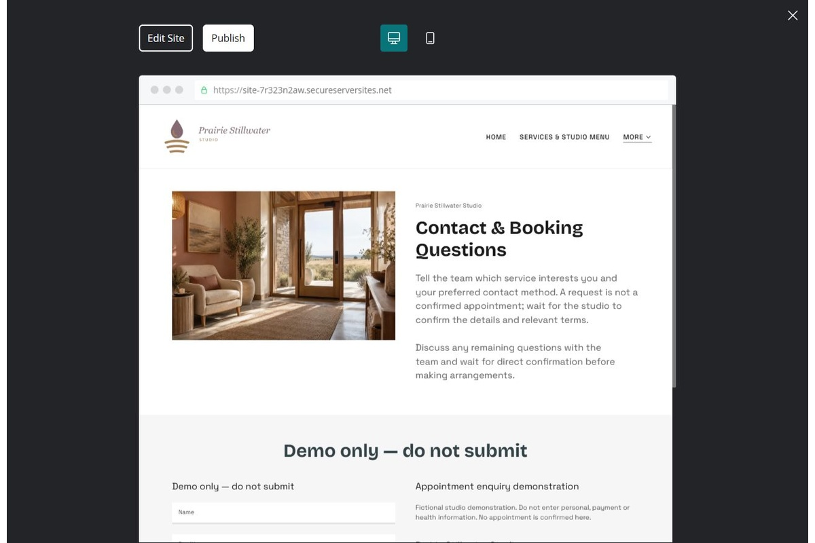
Unpublished Website Builder desktop excerpt. Page content continues below.

Sample wording — adapt and verify
Contact & Booking Questions
Tell the team which service interests you and your preferred contact method. A request is not a confirmed appointment; wait for the studio to confirm the details and relevant terms.
Discuss any remaining questions with the team and wait for direct confirmation before making arrangements.
Suggested button: Ask about a studio appointment

Website advice
Link only to a tested booking route or use an explicitly unconfirmed enquiry form.

Your draft: Contact & Booking Questions
Write in the voice of your own business. Use facts you can verify, not promises copied from the example.

Headline and short introduction

Main content and details visitors need

Button wording and destination

Photo choice, permission and facts still to confirm
Partner check: can someone unfamiliar with the business find a useful next step?

Test before publishing
Review the whole journey on a desktop and phone. Compare these desktop excerpts with the mobile captures on the industry page.
□ Fictional demonstration only. Verify service scope, practitioner qualifications, suitability wording and preparation instructions. Do not publish treatment advice or collect health information through public forms.
□ Verify each offered service, contact route, location and opening arrangement.
□ Remove fictional identity, claims, availability and prices before a real launch.
□ Test every enquiry route and download on desktop and mobile.
□ Keep sensitive information in approved private systems.
□ Obtain operator approval for all public wording and image use.
□ Check every link, form destination, download and confirmation message.
□ Check logo contrast, hero framing, text sizes and image loading.
□ Save a named backup and assign a content-review date.

Changes to finish and person responsible

Approval and next review date
Website Builder plans and signup

