

Snow Removal & Ice Management
Website workbook
A practical workshop for a 6-page website. Study the example, plan the content and draft your own version in Word or on paper.
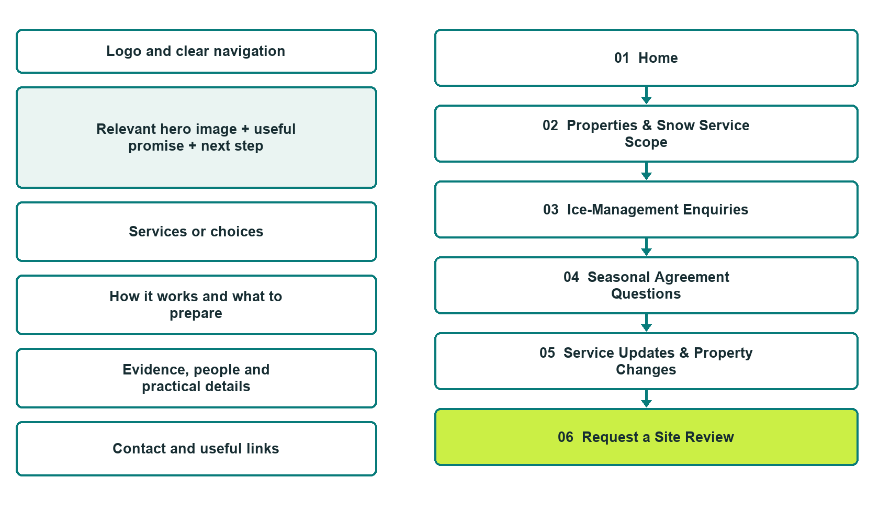

Plan → Draft → Build → Test
Capture edition: six desktop excerpts show the unpublished fictional Website Builder example. The planning wireframe remains an illustration.
Explore Website Builder and compare plans

Before you build
Your business supplies the facts. Prairie Winter Grounds is a fictional teaching example, not a live service.

□ Request a seasonal property discussion
□ Verified business identity, services and current contact information
□ A clear enquiry, review and confirmation process
□ Choose original photographs and confirm permission to use them.
□ Keep private customer records out of public website forms.

Your audience and the action you want them to take

Facts to verify and people who must approve them
Create your SaaSTech account

01 Home
Give this page one clear job in the customer journey.
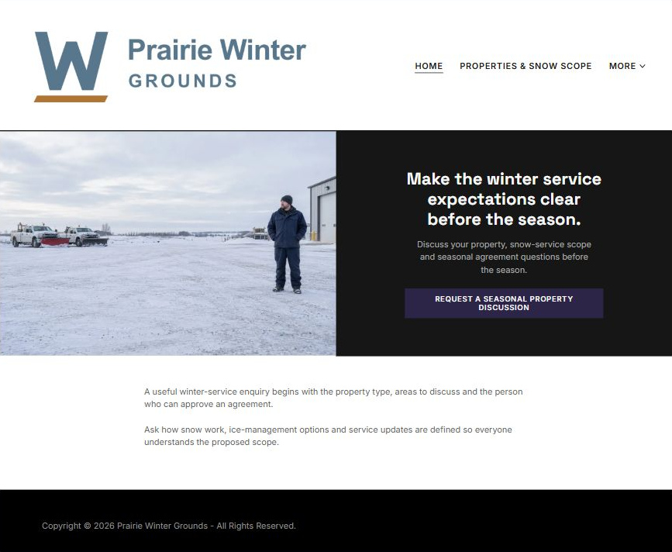
Actual desktop Builder excerpt • lower page content continues

Sample wording — adapt and verify
Make the winter service expectations clear before the season.
A useful winter-service enquiry begins with the property type, areas to discuss and the person who can approve an agreement.
Ask how snow work, ice-management options and service updates are defined so everyone understands the proposed scope.
Suggested button: Request a seasonal property discussion

Website advice
Explain property categories, snow service, separate ice-management enquiries and staff-reviewed seasonal agreements without guaranteeing conditions or response times.

Your draft: Home
Write in the voice of your own business. Use facts you can verify, not promises copied from the example.

Headline and short introduction

Main content and details visitors need

Button wording and destination

Photo choice, permission and facts still to confirm
Partner check: can someone unfamiliar with the business find a useful next step?

02 Properties & Snow Service Scope
Give this page one clear job in the customer journey.
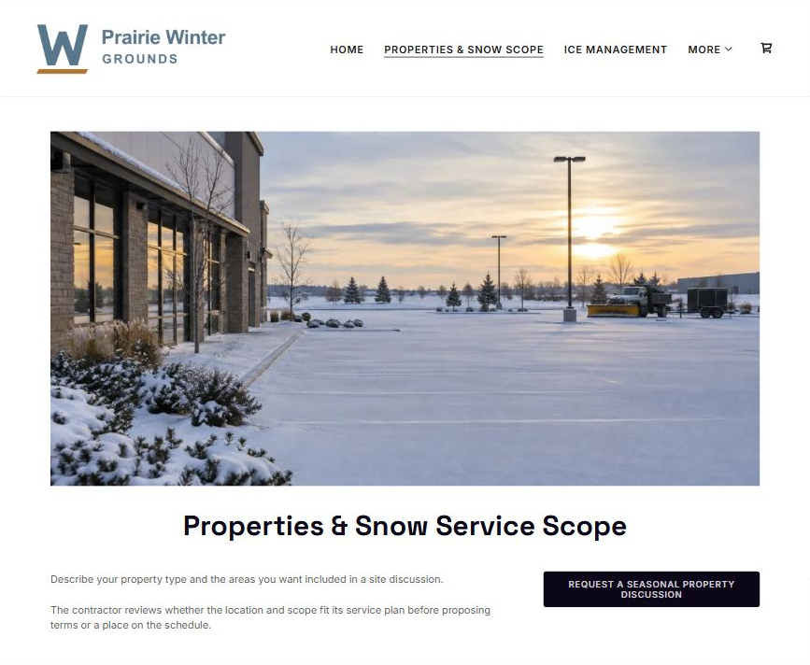
Actual desktop Builder excerpt • lower page content continues

Sample wording — adapt and verify
Properties & Snow Service Scope
Describe your property type and the areas you want included in a site discussion.
The contractor reviews whether the location and scope fit its service plan before proposing terms or a place on the schedule.
Suggested button: Request a seasonal property discussion

Website advice
Distinguish commercial lots, residential properties and multi-unit sites according to confirmed coverage.

Your draft: Properties & Snow Service Scope
Write in the voice of your own business. Use facts you can verify, not promises copied from the example.

Headline and short introduction

Main content and details visitors need

Button wording and destination

Photo choice, permission and facts still to confirm
Partner check: can someone unfamiliar with the business find a useful next step?

03 Ice-Management Enquiries
Give this page one clear job in the customer journey.
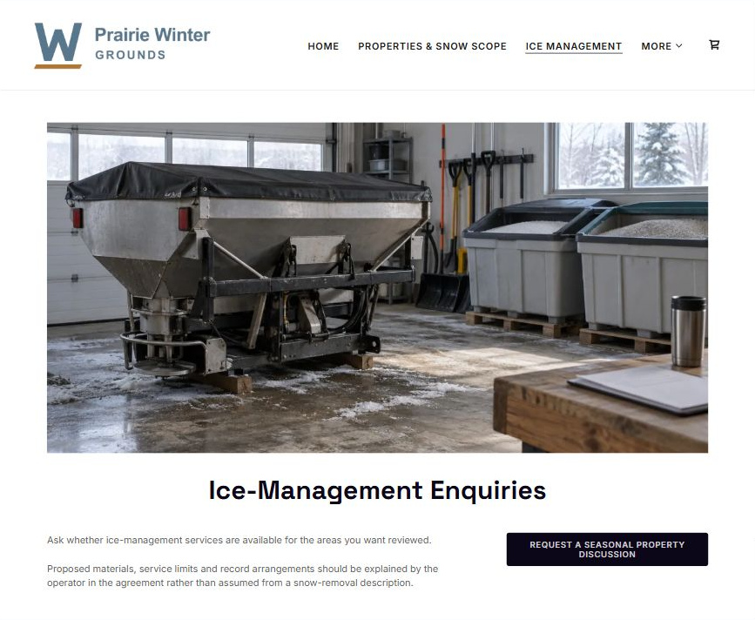
Actual desktop Builder excerpt • lower page content continues

Sample wording — adapt and verify
Ice-Management Enquiries
Ask whether ice-management services are available for the areas you want reviewed.
Proposed materials, service limits and record arrangements should be explained by the operator in the agreement rather than assumed from a snow-removal description.
Suggested button: Request a seasonal property discussion

Website advice
Keep ice-related service options distinct from snow removal and avoid material-use or safety guarantees.

Your draft: Ice-Management Enquiries
Write in the voice of your own business. Use facts you can verify, not promises copied from the example.

Headline and short introduction

Main content and details visitors need

Button wording and destination

Photo choice, permission and facts still to confirm
Partner check: can someone unfamiliar with the business find a useful next step?

04 Seasonal Agreement Questions
Give this page one clear job in the customer journey.
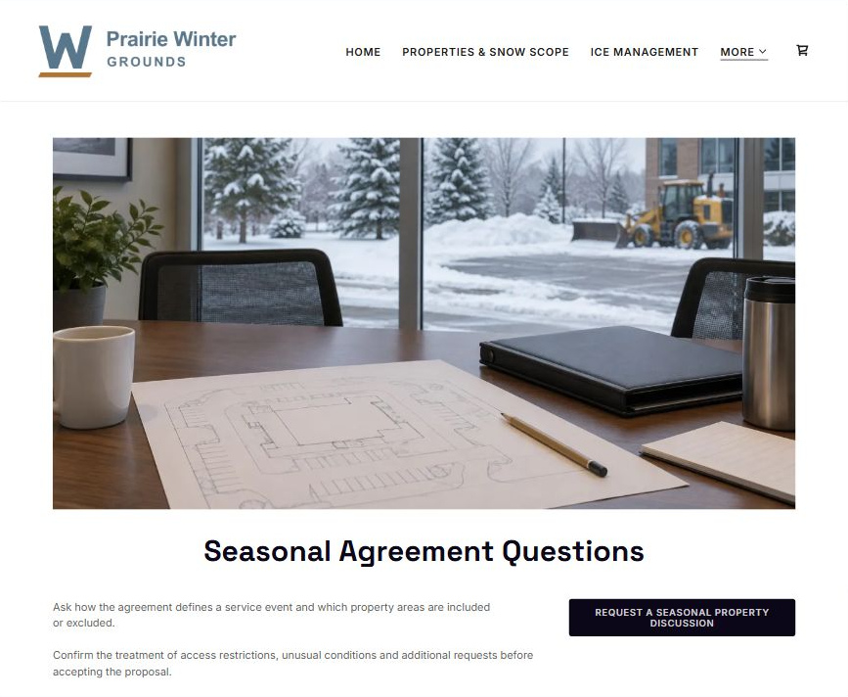
Actual desktop Builder excerpt • lower page content continues

Sample wording — adapt and verify
Seasonal Agreement Questions
Ask how the agreement defines a service event and which property areas are included or excluded.
Confirm the treatment of access restrictions, unusual conditions and additional requests before accepting the proposal.
Suggested button: Request a seasonal property discussion

Website advice
Help property managers discuss included areas, service triggers, exclusions and communication without inventing terms.

Your draft: Seasonal Agreement Questions
Write in the voice of your own business. Use facts you can verify, not promises copied from the example.

Headline and short introduction

Main content and details visitors need

Button wording and destination

Photo choice, permission and facts still to confirm
Partner check: can someone unfamiliar with the business find a useful next step?

05 Service Updates & Property Changes
Give this page one clear job in the customer journey.
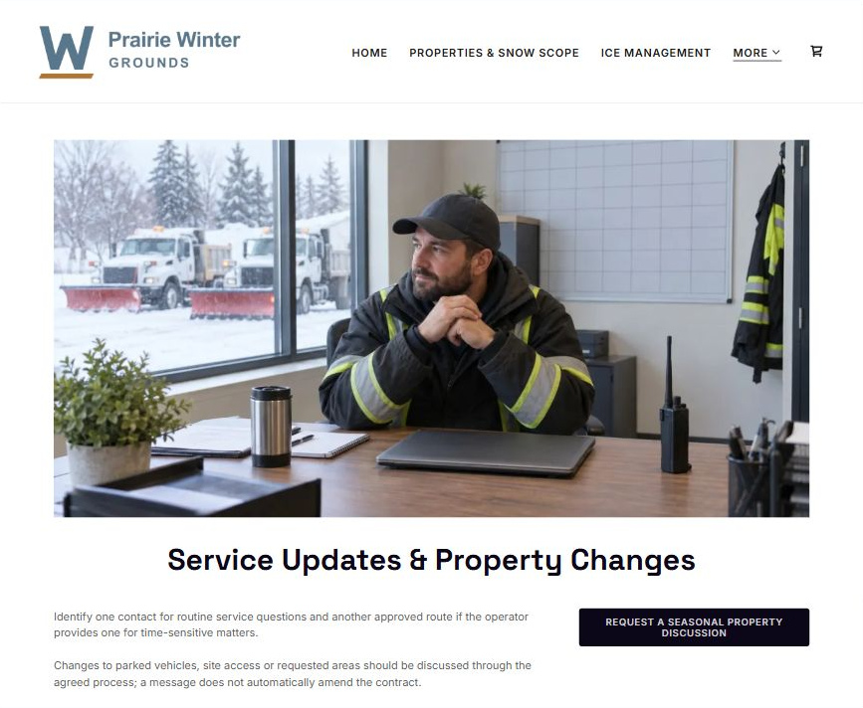
Actual desktop Builder excerpt • lower page content continues

Sample wording — adapt and verify
Service Updates & Property Changes
Identify one contact for routine service questions and another approved route if the operator provides one for time-sensitive matters.
Changes to parked vehicles, site access or requested areas should be discussed through the agreed process; a message does not automatically amend the contract.
Suggested button: Request a seasonal property discussion

Website advice
Explain reviewed communication routes, changed site conditions and administrative visit records without live tracking claims.

Your draft: Service Updates & Property Changes
Write in the voice of your own business. Use facts you can verify, not promises copied from the example.

Headline and short introduction

Main content and details visitors need

Button wording and destination

Photo choice, permission and facts still to confirm
Partner check: can someone unfamiliar with the business find a useful next step?

06 Request a Site Review
Give this page one clear job in the customer journey.
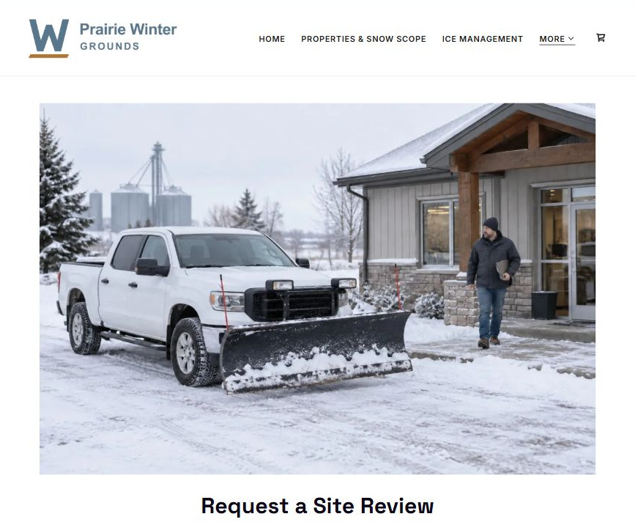
Actual desktop Builder excerpt • lower page content continues

Sample wording — adapt and verify
Request a Site Review
Provide the general location, property category and the scope you want reviewed.
The team confirms whether a site discussion is available and explains the next step before any seasonal service commitment exists.
Suggested button: Request a seasonal property discussion

Website advice
Use a non-sensitive enquiry and make the proposal and seasonal capacity subject to confirmation.

Your draft: Request a Site Review
Write in the voice of your own business. Use facts you can verify, not promises copied from the example.

Headline and short introduction

Main content and details visitors need

Button wording and destination

Photo choice, permission and facts still to confirm
Partner check: can someone unfamiliar with the business find a useful next step?

Test before publishing
Review the whole journey on a desktop and phone. These desktop excerpts show the fictional demo; verify your own content, links and forms before publishing.
□ Fictional demonstration only. Verify coverage, equipment, contract terms and contact arrangements. No weather-response instructions, de-icing application guidance, access assurance or slip-free guarantee is provided. Public forms are not emergency dispatch channels.
□ Verify every service description, contact route and operating detail.
□ Replace fictional identity and example information before a live launch.
□ Test enquiries, links and downloads on desktop and mobile.
□ Keep confidential records in approved private systems.
□ Obtain operator approval for public wording and images.
□ Check every link, form destination, download and confirmation message.
□ Check logo contrast, hero framing, text sizes and image loading.
□ Save a named backup and assign a content-review date.

Changes to finish and person responsible

Approval and next review date
Website Builder plans and signup

