

Sign, Print & Promotional Products
Website workbook
A practical workshop for a 5-page website. Study the example, plan the content and draft your own version in Word or on paper.
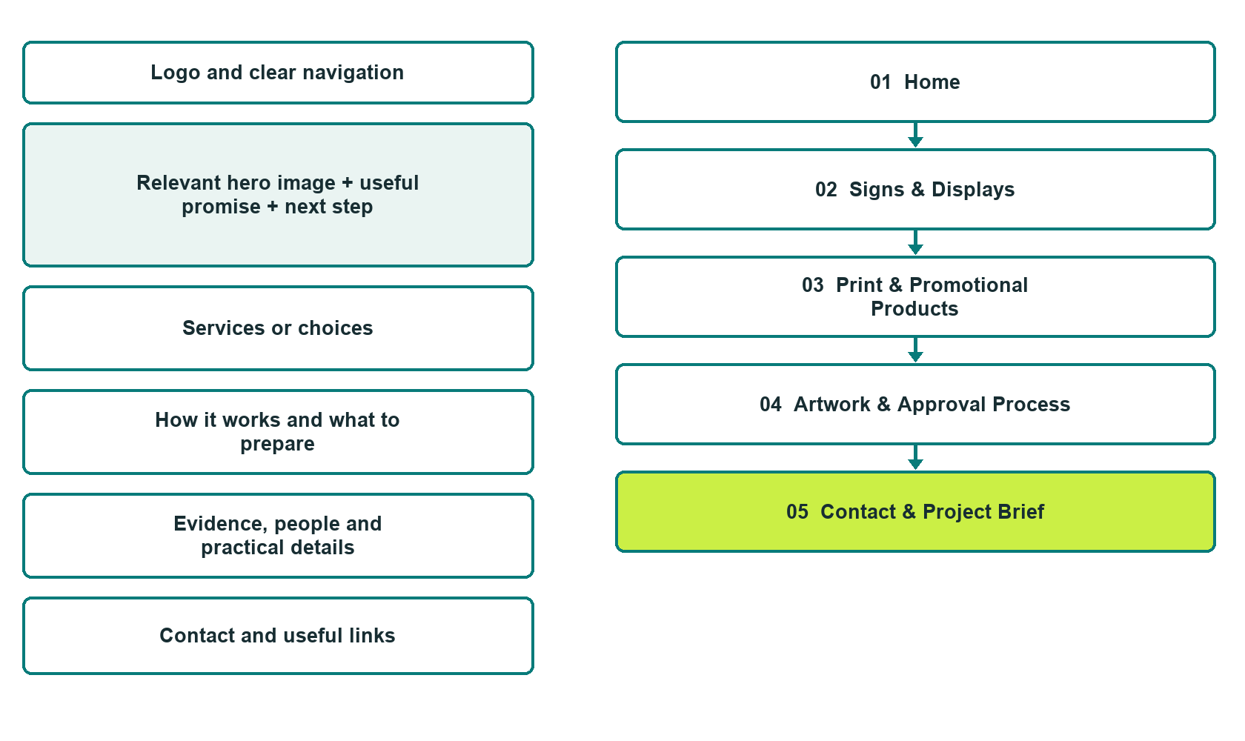

Plan → Draft → Build → Test
Capture edition: five genuine unpublished Website Builder desktop excerpts. Review mobile views on the industry page.
Explore Website Builder and compare plans

Before you build
Your business supplies the facts. Prairie Ink & Signworks is a fictional teaching example, not a live service.

□ Request a print or sign estimate
□ Verified business identity, services and current contact information
□ A clear enquiry, review and confirmation process
□ Choose original photographs and confirm permission to use them.
□ Keep private customer records out of public website forms.

Your audience and the action you want them to take

Facts to verify and people who must approve them
Create your SaaSTech account

01 Home
Give this page one clear job in the customer journey.
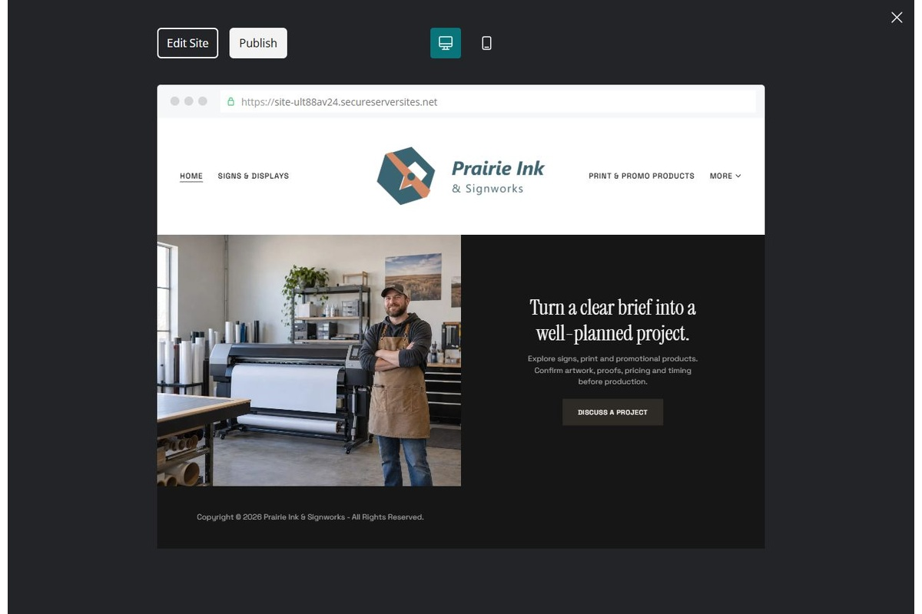
Unpublished Website Builder desktop excerpt. Page content continues below.

Sample wording — adapt and verify
Turn a clear brief into a well-planned project.
Explore project categories and prepare the details the team needs for an estimate. Artwork, proofs, prices and production timing are confirmed before an order moves forward.
Use the relevant page to prepare a focused enquiry, then contact the team to confirm the next step.
Suggested button: Request a print or sign estimate

Website advice
Separate product categories and explain artwork, proof approval, production and fulfilment without inventing prices or deadlines.

Your draft: Home
Write in the voice of your own business. Use facts you can verify, not promises copied from the example.

Headline and short introduction

Main content and details visitors need

Button wording and destination

Photo choice, permission and facts still to confirm
Partner check: can someone unfamiliar with the business find a useful next step?

02 Signs & Displays
Give this page one clear job in the customer journey.
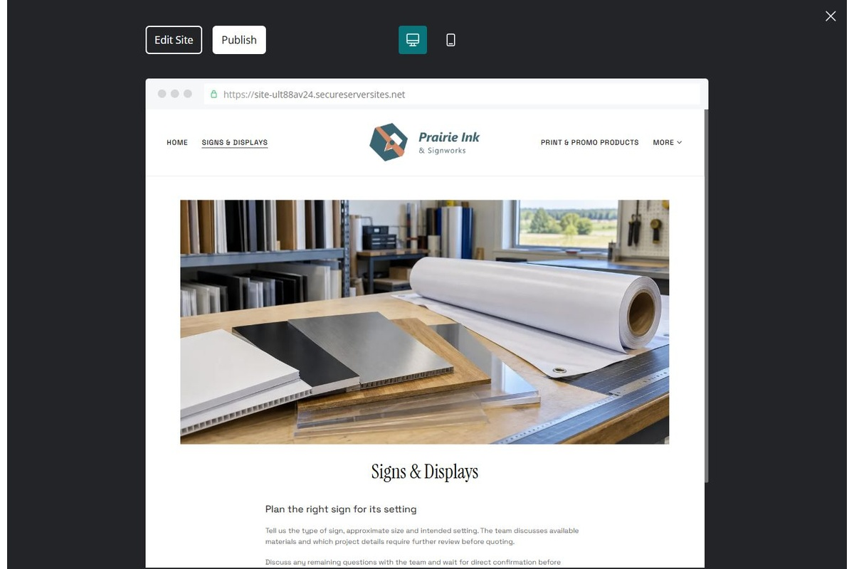
Unpublished Website Builder desktop excerpt. Page content continues below.

Sample wording — adapt and verify
Signs & Displays
Tell us the type of sign, approximate size and intended setting. The team discusses available materials and which project details require further review before quoting.
Discuss any remaining questions with the team and wait for direct confirmation before making arrangements.
Suggested button: Request a print or sign estimate

Website advice
Describe accepted sign and display categories and separate design, manufacture and installation scope.

Your draft: Signs & Displays
Write in the voice of your own business. Use facts you can verify, not promises copied from the example.

Headline and short introduction

Main content and details visitors need

Button wording and destination

Photo choice, permission and facts still to confirm
Partner check: can someone unfamiliar with the business find a useful next step?

03 Print & Promotional Products
Give this page one clear job in the customer journey.
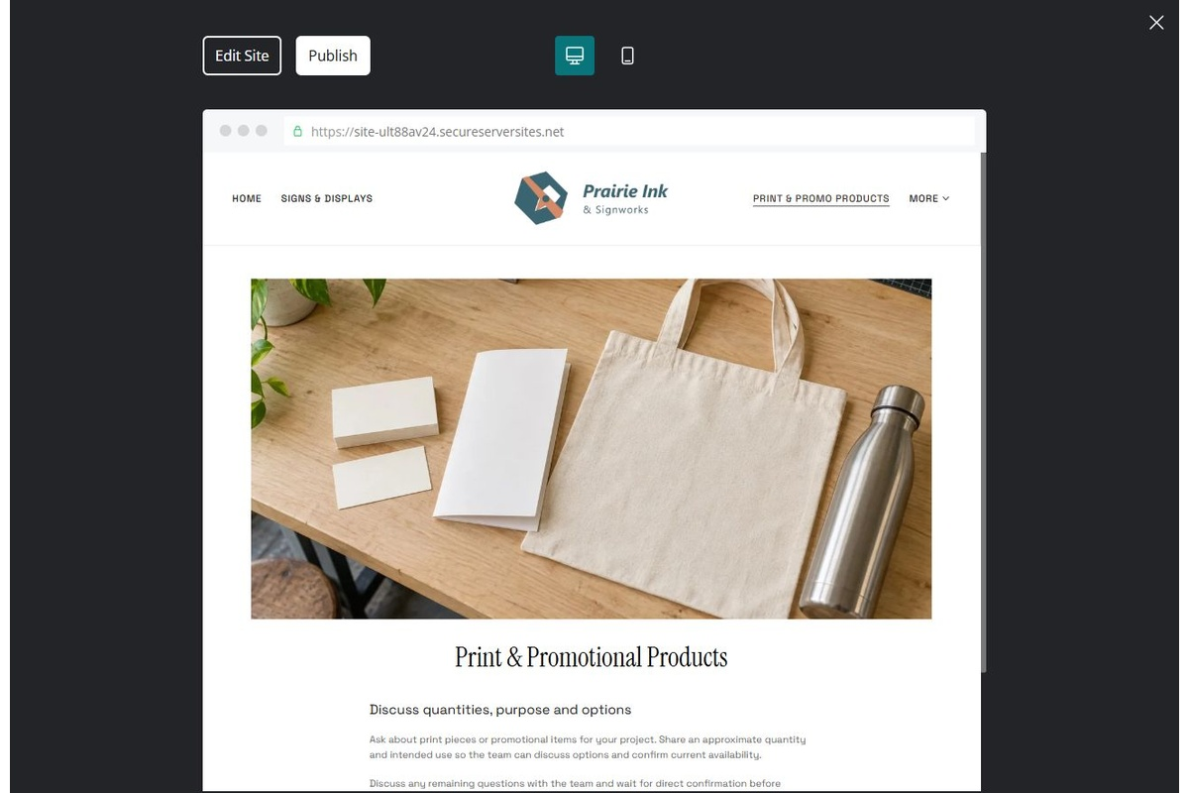
Unpublished Website Builder desktop excerpt. Page content continues below.

Sample wording — adapt and verify
Print & Promotional Products
Ask about print pieces or promotional items for your project. Share an approximate quantity and intended use so the team can discuss options and confirm current availability.
Discuss any remaining questions with the team and wait for direct confirmation before making arrangements.
Suggested button: Request a print or sign estimate

Website advice
Show distinct categories without treating example items as live stock. Explain quantity and artwork review.

Your draft: Print & Promotional Products
Write in the voice of your own business. Use facts you can verify, not promises copied from the example.

Headline and short introduction

Main content and details visitors need

Button wording and destination

Photo choice, permission and facts still to confirm
Partner check: can someone unfamiliar with the business find a useful next step?

04 Artwork & Approval Process
Give this page one clear job in the customer journey.
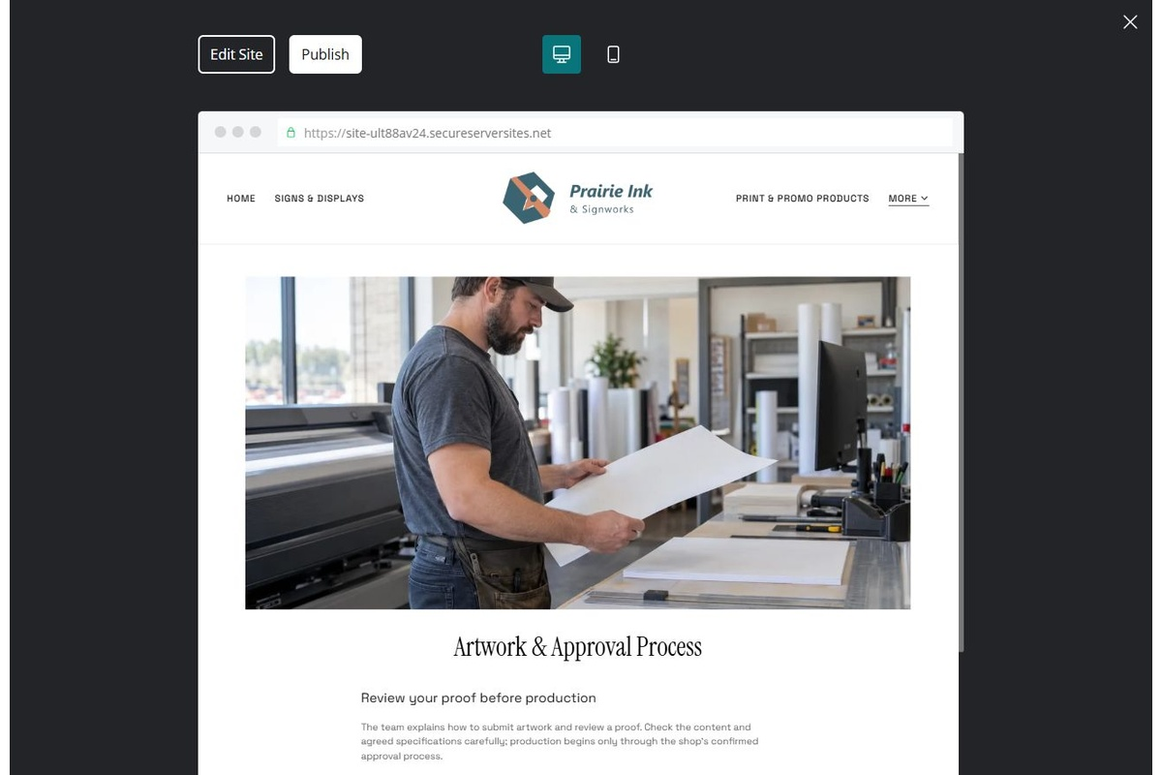
Unpublished Website Builder desktop excerpt. Page content continues below.

Sample wording — adapt and verify
Artwork & Approval Process
The team explains how to submit artwork and review a proof. Check the content and agreed specifications carefully; production begins only through the shop’s confirmed approval process.
Discuss any remaining questions with the team and wait for direct confirmation before making arrangements.
Suggested button: Request a print or sign estimate

Website advice
Explain secure file submission, quote review, proof approval and change handling. Do not imply web enquiry grants production approval.

Your draft: Artwork & Approval Process
Write in the voice of your own business. Use facts you can verify, not promises copied from the example.

Headline and short introduction

Main content and details visitors need

Button wording and destination

Photo choice, permission and facts still to confirm
Partner check: can someone unfamiliar with the business find a useful next step?

05 Contact & Project Brief
Give this page one clear job in the customer journey.
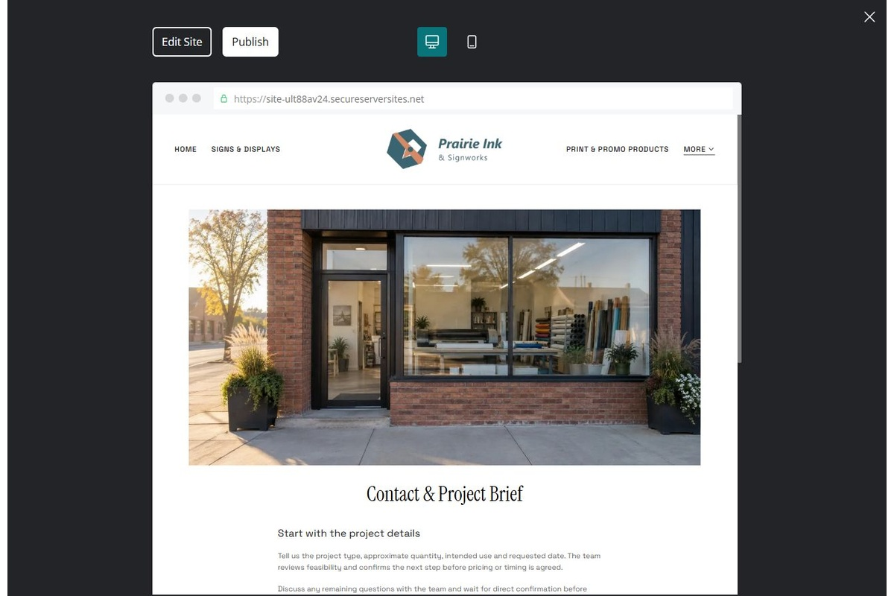
Unpublished Website Builder desktop excerpt. Page content continues below.

Sample wording — adapt and verify
Contact & Project Brief
Tell us the project type, approximate quantity, intended use and requested date. The team reviews feasibility and confirms the next step before pricing or timing is agreed.
Discuss any remaining questions with the team and wait for direct confirmation before making arrangements.
Suggested button: Request a print or sign estimate

Website advice
Collect non-sensitive project basics and make deadlines subject to review.

Your draft: Contact & Project Brief
Write in the voice of your own business. Use facts you can verify, not promises copied from the example.

Headline and short introduction

Main content and details visitors need

Button wording and destination

Photo choice, permission and facts still to confirm
Partner check: can someone unfamiliar with the business find a useful next step?

Test before publishing
Review the whole journey on a desktop and phone. Compare these desktop excerpts with the mobile captures on the industry page.
□ Fictional demonstration only. Confirm materials, installation scope, artwork rights, proof rules and production terms with the operator. Sample images are not completed client work.
□ Verify each offered service, contact route, location and opening arrangement.
□ Remove fictional identity, claims, availability and prices before a real launch.
□ Test every enquiry route and download on desktop and mobile.
□ Keep sensitive information in approved private systems.
□ Obtain operator approval for all public wording and image use.
□ Check every link, form destination, download and confirmation message.
□ Check logo contrast, hero framing, text sizes and image loading.
□ Save a named backup and assign a content-review date.

Changes to finish and person responsible

Approval and next review date
Website Builder plans and signup

