

Septic Services & Portable Toilet Rentals
Website workbook
A practical workshop for a 6-page website. Study the example, plan the content and draft your own version in Word or on paper.
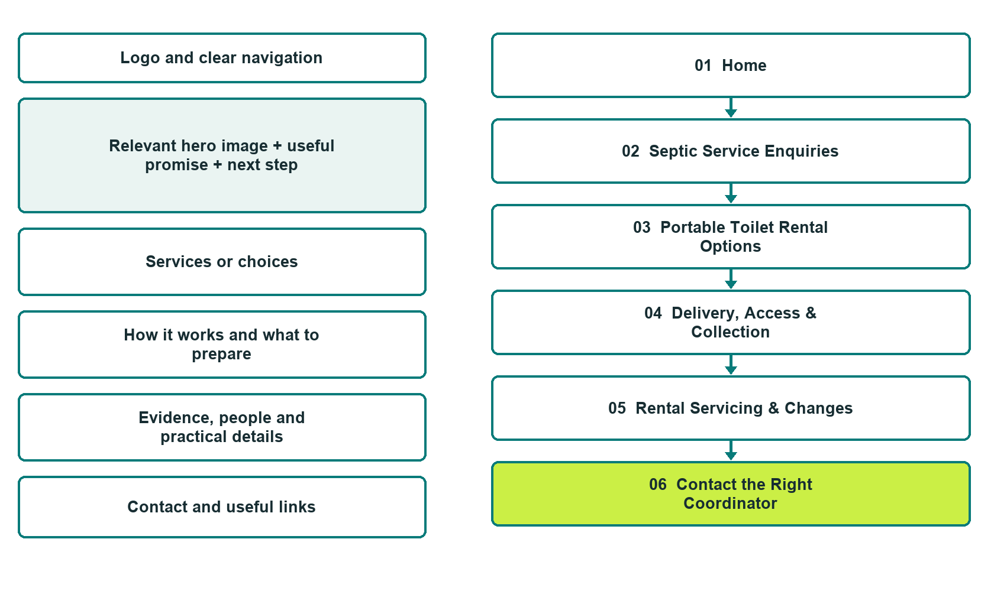

Plan → Draft → Build → Test
Finished-demo edition: authentic desktop captures from the unpublished Prairie Site & Septic Website Builder demo. The front-page wireframe remains a planning illustration.
Explore Website Builder and compare plans

Before you build
Your business supplies the facts. Prairie Site & Septic is a fictional teaching example, not a live service.

□ Contact the coordinator
□ Verified business identity, services and current contact information
□ A clear enquiry, review and confirmation process
□ Choose original photographs and confirm permission to use them.
□ Keep private customer records out of public website forms.

Your audience and the action you want them to take

Facts to verify and people who must approve them
Create your SaaSTech account

01 Home
Give this page one clear job in the customer journey.
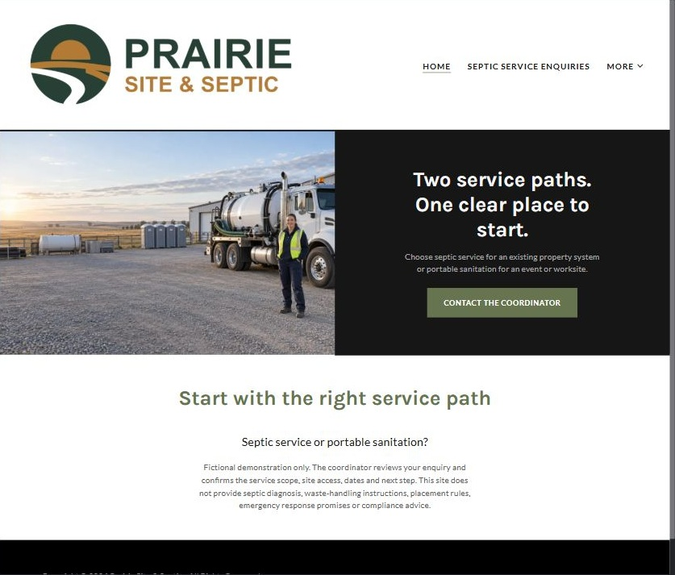
Authentic Website Builder desktop capture • unpublished fictional demo

Sample wording — adapt and verify
Two service paths. One clear place to start.
Choose septic service for an existing property system or portable sanitation for an event or worksite.
Each enquiry asks different questions so the coordinator can review access, scheduling and the scope before agreeing to a visit or rental.
Suggested button: Contact the coordinator

Website advice
Distinct septic-service and portable-toilet rental paths, with site access, rental dates and accepted work confirmed by the operator.

Your draft: Home
Write in the voice of your own business. Use facts you can verify, not promises copied from the example.

Headline and short introduction

Main content and details visitors need

Button wording and destination

Photo choice, permission and facts still to confirm
Partner check: can someone unfamiliar with the business find a useful next step?

02 Septic Service Enquiries
Give this page one clear job in the customer journey.
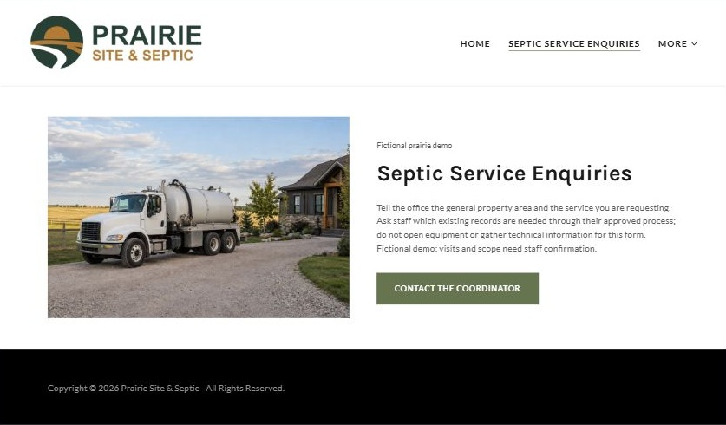
Authentic Website Builder desktop capture • unpublished fictional demo

Sample wording — adapt and verify
Septic Service Enquiries
Tell the office the general property area and the service you are requesting.
Ask which existing records or location details staff need through their approved process; do not open equipment or gather technical information for this form.
Suggested button: Contact the coordinator

Website advice
Describe accepted property-service categories and route system-specific questions to qualified staff without diagnosing problems.

Your draft: Septic Service Enquiries
Write in the voice of your own business. Use facts you can verify, not promises copied from the example.

Headline and short introduction

Main content and details visitors need

Button wording and destination

Photo choice, permission and facts still to confirm
Partner check: can someone unfamiliar with the business find a useful next step?

03 Portable Toilet Rentals
Give this page one clear job in the customer journey.
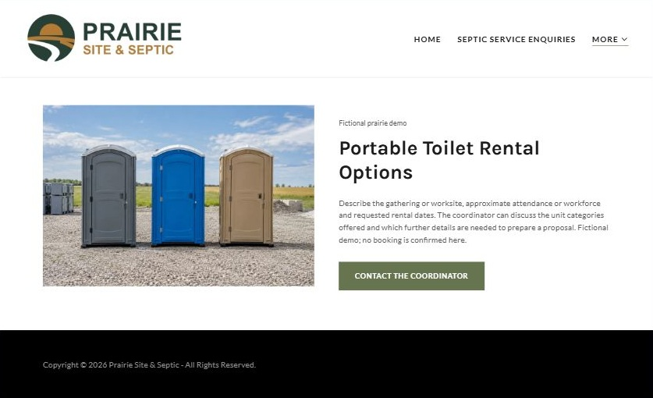
Authentic Website Builder desktop capture • unpublished fictional demo

Sample wording — adapt and verify
Portable Toilet Rentals
Describe the gathering or worksite, approximate attendance or workforce and requested rental dates.
The coordinator can discuss the unit categories offered and which further details are needed to prepare a proposal.
Suggested button: Contact the coordinator

Website advice
Present only verified unit categories and clarify that quantity, suitability and dates require coordinator review.

Your draft: Portable Toilet Rentals
Write in the voice of your own business. Use facts you can verify, not promises copied from the example.

Headline and short introduction

Main content and details visitors need

Button wording and destination

Photo choice, permission and facts still to confirm
Partner check: can someone unfamiliar with the business find a useful next step?

04 Delivery & Collection
Give this page one clear job in the customer journey.
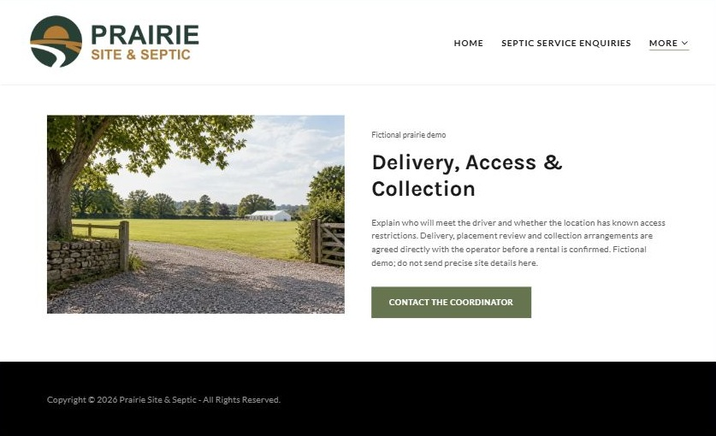
Authentic Website Builder desktop capture • unpublished fictional demo

Sample wording — adapt and verify
Delivery & Collection
Explain who will meet the driver and whether the location has known access restrictions.
Delivery, placement review and collection arrangements are agreed directly with the operator before a rental is confirmed.
Suggested button: Contact the coordinator

Website advice
Gather logistical questions without publishing placement instructions or assuming every site is accessible.

Your draft: Delivery & Collection
Write in the voice of your own business. Use facts you can verify, not promises copied from the example.

Headline and short introduction

Main content and details visitors need

Button wording and destination

Photo choice, permission and facts still to confirm
Partner check: can someone unfamiliar with the business find a useful next step?

05 Servicing & Changes
Give this page one clear job in the customer journey.
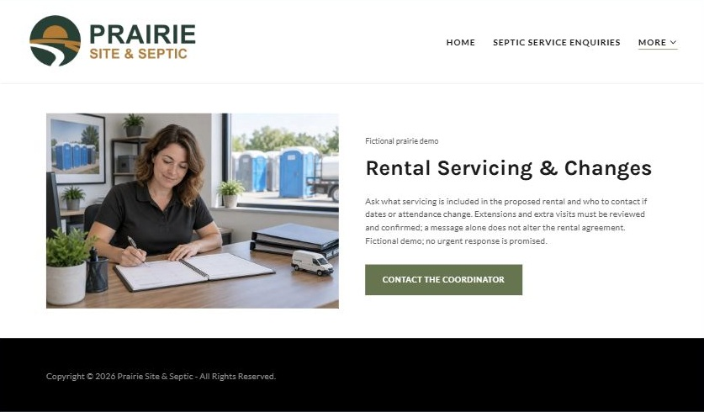
Authentic Website Builder desktop capture • unpublished fictional demo

Sample wording — adapt and verify
Servicing & Changes
Ask what servicing is included in the proposed rental and who to contact if dates or attendance change.
Extensions and extra visits must be reviewed and confirmed; a message alone does not alter the rental agreement.
Suggested button: Contact the coordinator

Website advice
Explain agreed service visits, extension requests and change communication with no operational waste-handling detail.

Your draft: Servicing & Changes
Write in the voice of your own business. Use facts you can verify, not promises copied from the example.

Headline and short introduction

Main content and details visitors need

Button wording and destination

Photo choice, permission and facts still to confirm
Partner check: can someone unfamiliar with the business find a useful next step?

06 Contact the Coordinator
Give this page one clear job in the customer journey.
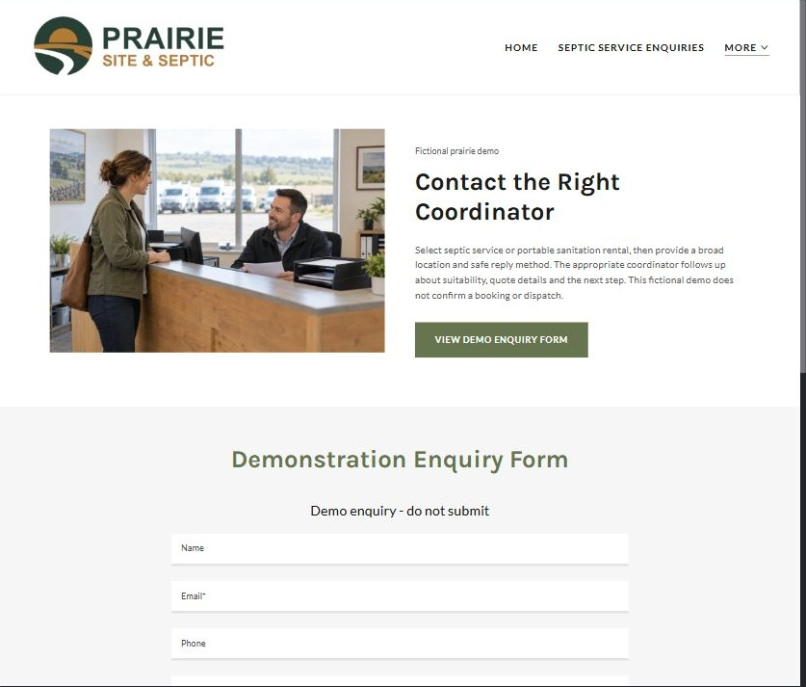
Authentic Website Builder desktop capture • unpublished fictional demo

Sample wording — adapt and verify
Contact the Coordinator
Select septic service or portable sanitation rental, then provide a broad location and safe reply method.
The appropriate coordinator follows up about suitability, quote details and the next step without treating your enquiry as a confirmed dispatch.
Suggested button: View demo enquiry form

Website advice
Give customers separate non-sensitive enquiry routes for an existing property and a temporary rental.

Your draft: Contact the Coordinator
Write in the voice of your own business. Use facts you can verify, not promises copied from the example.

Headline and short introduction

Main content and details visitors need

Button wording and destination

Photo choice, permission and facts still to confirm
Partner check: can someone unfamiliar with the business find a useful next step?

Test before publishing
Review the whole journey on desktop and phone. Use the paired captures, Editor Highlights, Themes and separate Paint gallery on the industry page, then test your own site before publishing.
□ Fictional demonstration only. Verify accepted services, access requirements, rental terms and service areas. No septic diagnosis, waste-handling instructions, placement rules, emergency response promise or compliance advice is provided.
□ Verify every service description, contact route and operating detail.
□ Replace fictional identity and example information before a live launch.
□ Test enquiries, links and downloads on desktop and mobile.
□ Keep confidential records in approved private systems.
□ Obtain operator approval for public wording and images.
□ Check every link, form destination, download and confirmation message.
□ Check logo contrast, hero framing, text sizes and image loading.
□ Save a named backup and assign a content-review date.

Changes to finish and person responsible

Approval and next review date
Website Builder plans and signup

