

Safety Training & Certification Providers
Website workbook
A practical workshop for a 6-page website. Study the example, plan the content and draft your own version in Word or on paper.
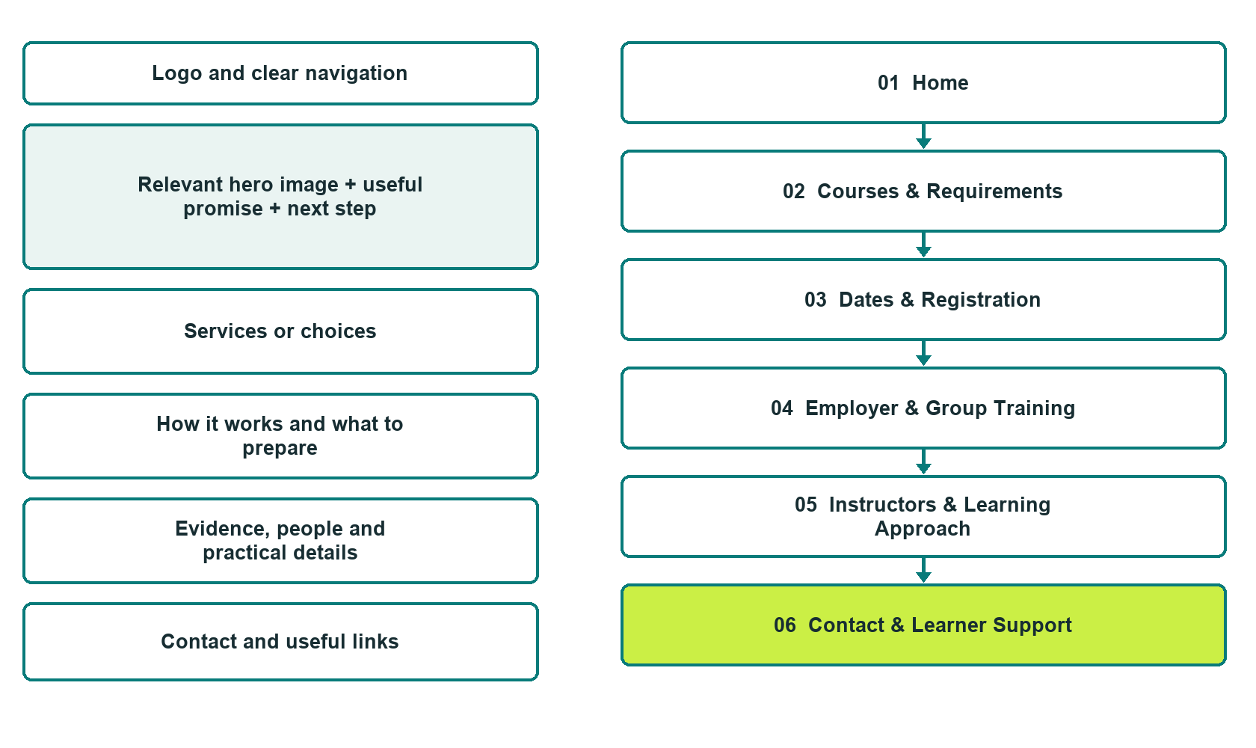

Plan → Draft → Build → Test
Captured demo edition. Study the unpublished six-page example. Paired desktop and mobile previews, Editor Highlights, Themes and Paint settings appear in the industry gallery.
Explore Website Builder and compare plans

Before you build
Your business supplies the facts. Prairie Ready Training is a fictional teaching example, not a live service.

□ Receive confirmed registration and joining information
□ Verify every course title, credential, approval, instructor claim and acceptance statement.
□ Distinguish course completion from a licence, regulatory approval and employer acceptance.
□ Choose original photographs and confirm permission to use them.
□ Keep private customer records out of public website forms.

Your audience and the action you want them to take

Facts to verify and people who must approve them
Create your SaaSTech account

01 Home
Give this page one clear job in the customer journey.
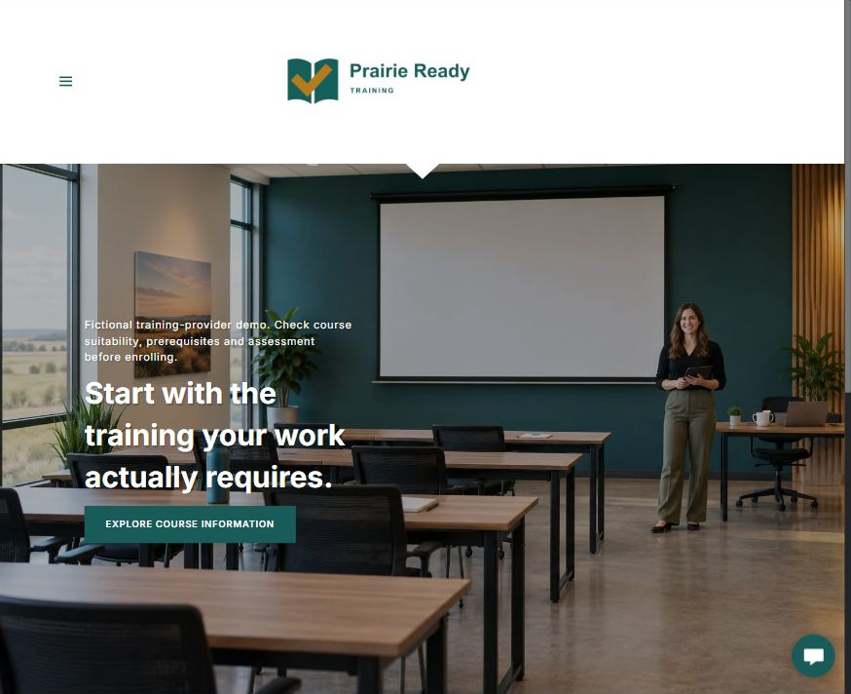
Actual desktop Website Builder preview. Its paired mobile view appears in the industry gallery.

Sample wording — adapt and verify
Start with the training your work actually requires.
Prairie Ready Training is a fictional example of a training-provider website. It demonstrates how to explain course options, suitability and registration without making unsupported approval or qualification claims.
Before enrolling, confirm the course requirements with your employer or the organization that needs the training. Ask the provider about learning objectives, prerequisites, assessment and what any completion document represents.
Suggested button: Explore course information

Website advice
Help learners and employers choose the right information pathway.

Your draft: Home
Write in the voice of your own business. Use facts you can verify, not promises copied from the example.

Headline and short introduction

Main content and details visitors need

Button wording and destination

Photo choice, permission and facts still to confirm
Partner check: can someone unfamiliar with the business find a useful next step?

02 Courses & Requirements
Give this page one clear job in the customer journey.
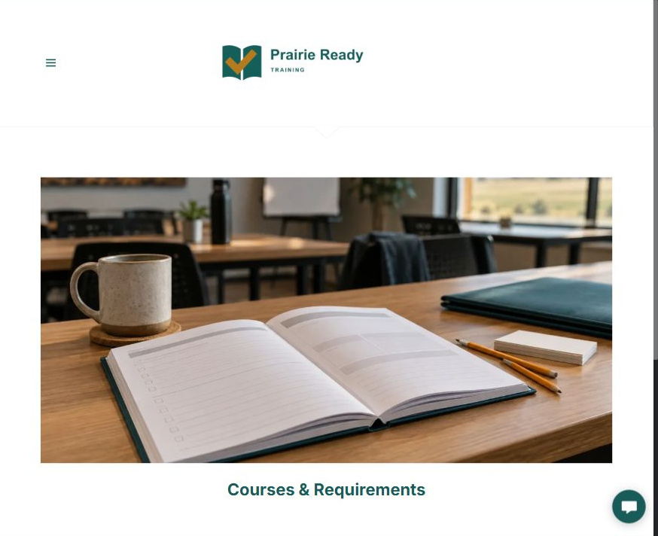
Actual desktop Website Builder preview. Its paired mobile view appears in the industry gallery.

Sample wording — adapt and verify
Check the objectives, prerequisites and next steps.
Each course listing should explain who it is for, the topics covered, delivery method, expected duration and any prerequisites. State the assessment arrangements and the exact document issued, if any.
Confirm whether the course meets the requirements of your role, employer and location before registering. A generic completion certificate should not be described as a licence or a guarantee of workplace acceptance.
Suggested button: Ask about course suitability

Website advice
Give every course the information needed for an informed enquiry.

Your draft: Courses & Requirements
Write in the voice of your own business. Use facts you can verify, not promises copied from the example.

Headline and short introduction

Main content and details visitors need

Button wording and destination

Photo choice, permission and facts still to confirm
Partner check: can someone unfamiliar with the business find a useful next step?

03 Dates & Registration
Give this page one clear job in the customer journey.
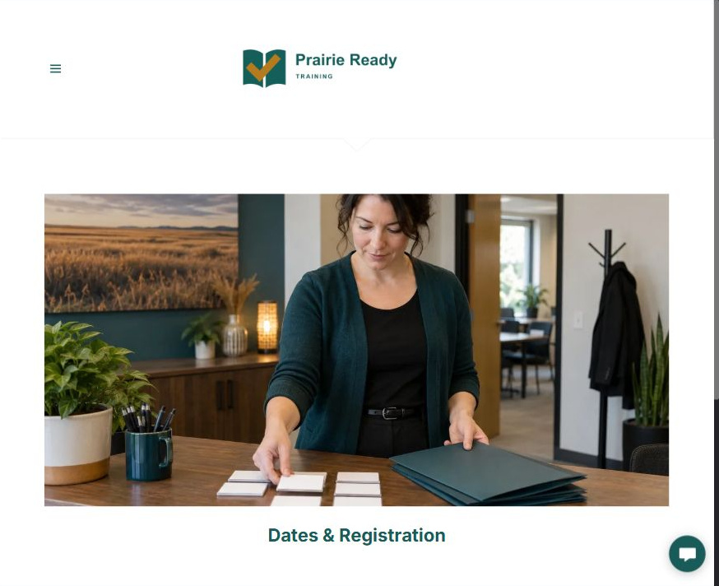
Actual desktop Website Builder preview. Its paired mobile view appears in the industry gallery.

Sample wording — adapt and verify
Confirm your place and preparation details.
Check the provider’s confirmed dates and delivery options, then follow the stated registration process. Before paying or making travel arrangements, review the course details, prerequisites and published cancellation terms.
An enquiry does not reserve a seat. The provider must confirm the place, joining instructions, required preparation and any payment arrangements through its approved process.
Suggested button: Enquire about a course date

Website advice
Distinguish an enquiry, provisional place and confirmed registration.

Your draft: Dates & Registration
Write in the voice of your own business. Use facts you can verify, not promises copied from the example.

Headline and short introduction

Main content and details visitors need

Button wording and destination

Photo choice, permission and facts still to confirm
Partner check: can someone unfamiliar with the business find a useful next step?

04 Employer & Group Training
Give this page one clear job in the customer journey.
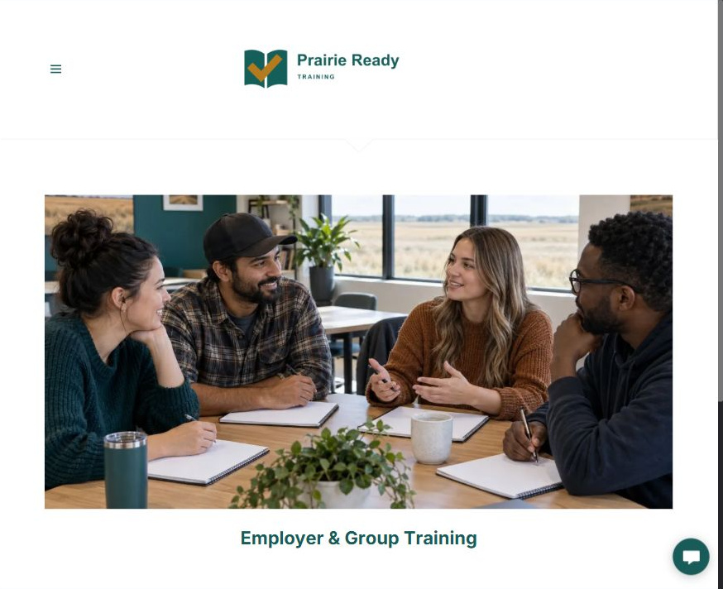
Actual desktop Website Builder preview. Its paired mobile view appears in the industry gallery.

Sample wording — adapt and verify
Plan training around your team’s needs.
Tell the provider about your team, the work context and the training objective you need to discuss. The provider can explain which delivery options it offers and what information is needed to review a group request.
Confirm course suitability, trainer qualifications, facilities and any practical assessment arrangements before scheduling. Employer and site-specific requirements may need additional review beyond a public course description.
Suggested button: Discuss group training

Website advice
Explain how to scope group delivery without promising universal compliance.

Your draft: Employer & Group Training
Write in the voice of your own business. Use facts you can verify, not promises copied from the example.

Headline and short introduction

Main content and details visitors need

Button wording and destination

Photo choice, permission and facts still to confirm
Partner check: can someone unfamiliar with the business find a useful next step?

05 Instructors & Learning Approach
Give this page one clear job in the customer journey.
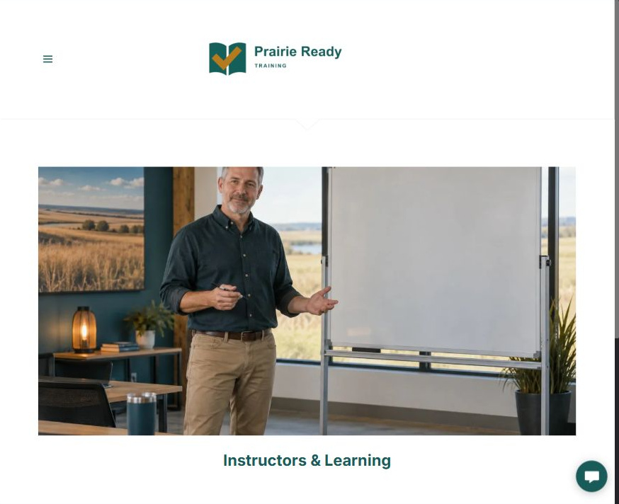
Actual desktop Website Builder preview. Its paired mobile view appears in the industry gallery.

Sample wording — adapt and verify
Know who teaches and how learning is assessed.
Introduce each instructor’s verified experience and the courses they are authorized or qualified to deliver. Explain how learners can ask questions and how the provider checks understanding against the course objectives.
Publish credentials, affiliations and approval statements only with current evidence and permission. Describe the learning approach plainly rather than using a badge that implies a regulator endorses the entire business.
Suggested button: Ask about instructor qualifications

Website advice
Build trust through evidence rather than invented credentials.

Your draft: Instructors & Learning Approach
Write in the voice of your own business. Use facts you can verify, not promises copied from the example.

Headline and short introduction

Main content and details visitors need

Button wording and destination

Photo choice, permission and facts still to confirm
Partner check: can someone unfamiliar with the business find a useful next step?

06 Contact & Learner Support
Give this page one clear job in the customer journey.
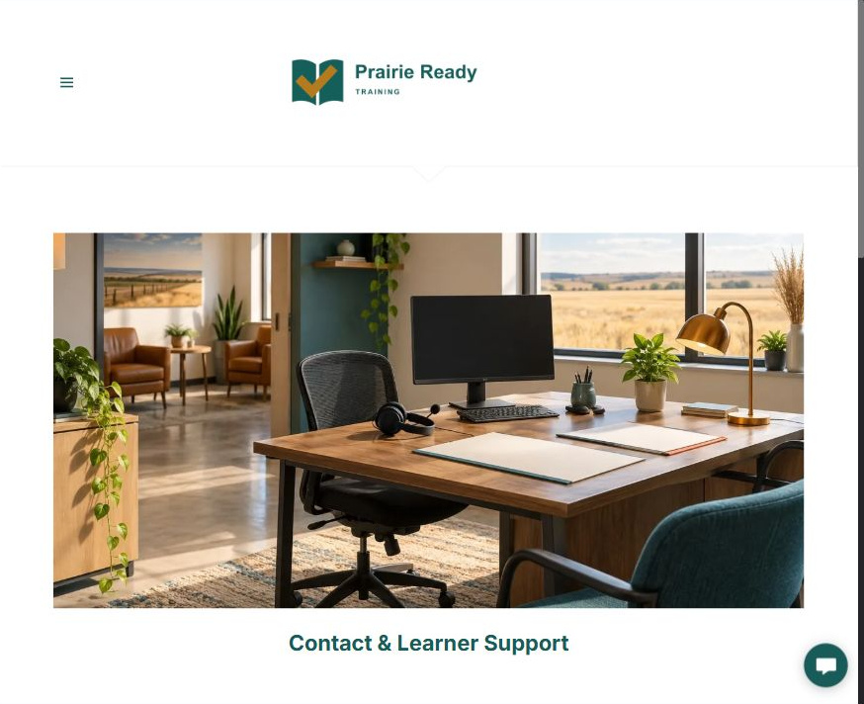
Actual desktop Website Builder preview. Its paired mobile view appears in the industry gallery.

Sample wording — adapt and verify
Ask before you enrol.
Contact the provider if you need help understanding a course description, prerequisites or joining arrangements. Describe your question briefly and share your preferred return contact method.
Do not send identity documents, medical details, payment information or private employment records through a general form. Ask for the approved private route if supporting information is needed, including for an accommodation discussion.
Suggested button: Send a course enquiry

Website advice
Provide an accessible, low-data route for questions.

Your draft: Contact & Learner Support
Write in the voice of your own business. Use facts you can verify, not promises copied from the example.

Headline and short introduction

Main content and details visitors need

Button wording and destination

Photo choice, permission and facts still to confirm
Partner check: can someone unfamiliar with the business find a useful next step?

Test before publishing
Review the captured desktop and phone journey. The demonstration form has Name, required Email, Phone, Course or group-training topic and Brief question - no sensitive information. Recipient blank, attachments off. It was not submitted or delivery-tested. Configure approved delivery before launch.
□ Verify every course title, credential, approval, instructor claim and acceptance statement.
□ Distinguish course completion from a licence, regulatory approval and employer acceptance.
□ Publish dates, prices, validity periods and cancellation terms only after provider approval.
□ Do not use a generated classroom image as evidence of actual facilities or staff.
□ Test accessible course information, registration and alternate enquiry routes on a phone.
□ Keep learner identity, health, payment and assessment records outside general public forms.
□ Check every link, form destination, download and confirmation message.
□ Check logo contrast, hero framing, text sizes and image loading.
□ Save a named backup and assign a content-review date.

Changes to finish and person responsible

Approval and next review date
Website Builder plans and signup

