

Recruitment & Staffing Agencies
Website workbook
A practical workshop for a 5-page website. Study the example, plan the content and draft your own version in Word or on paper.
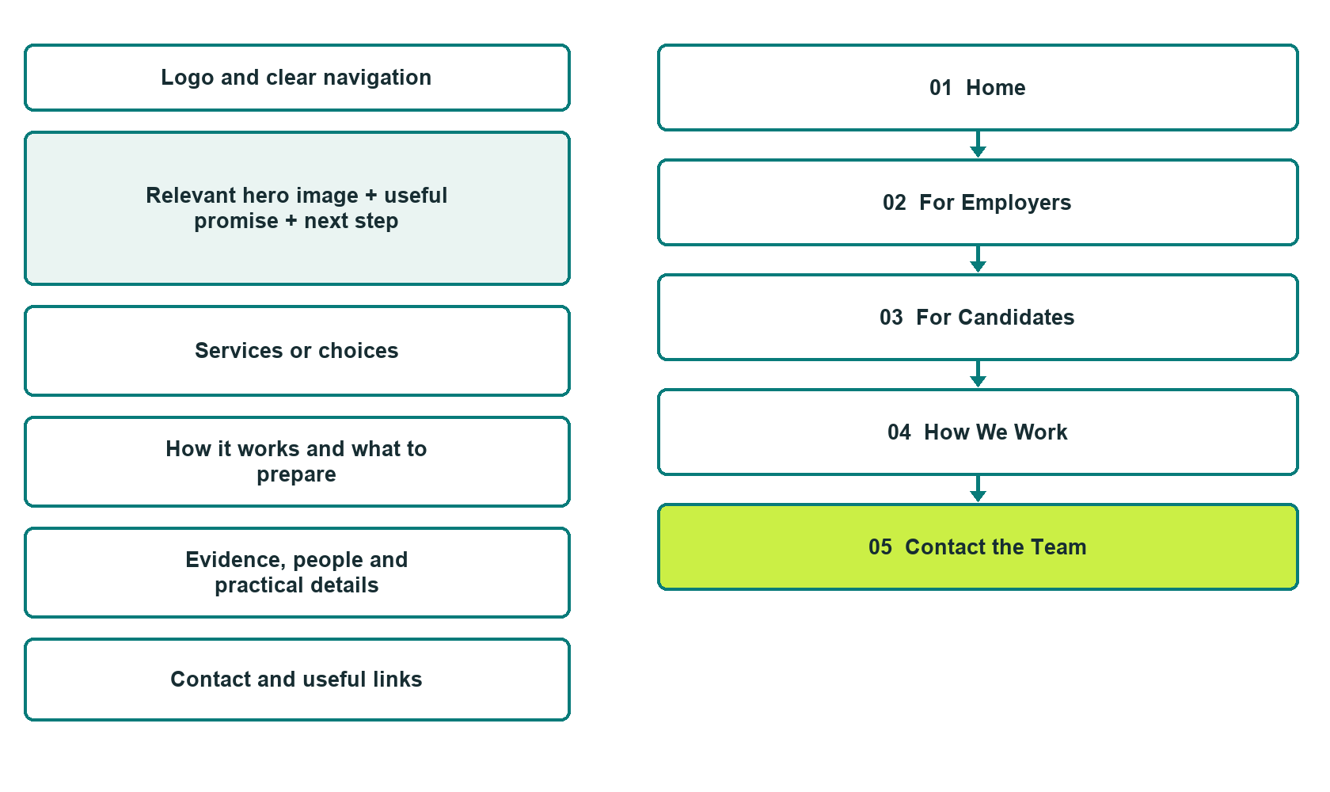

Plan → Draft → Build → Test
Capture edition: five genuine unpublished Website Builder desktop excerpts. Review mobile views on the industry page.
Explore Website Builder and compare plans

Before you build
Your business supplies the facts. Prairie Bridge Talent is a fictional teaching example, not a live service.

□ Start a staffing conversation
□ Verified identity, service scope and current contacts
□ Clear enquiry and confirmation steps
□ Choose original photographs and confirm permission to use them.
□ Keep private customer records out of public website forms.

Your audience and the action you want them to take

Facts to verify and people who must approve them
Create your SaaSTech account

01 Home
Give this page one clear job in the customer journey.
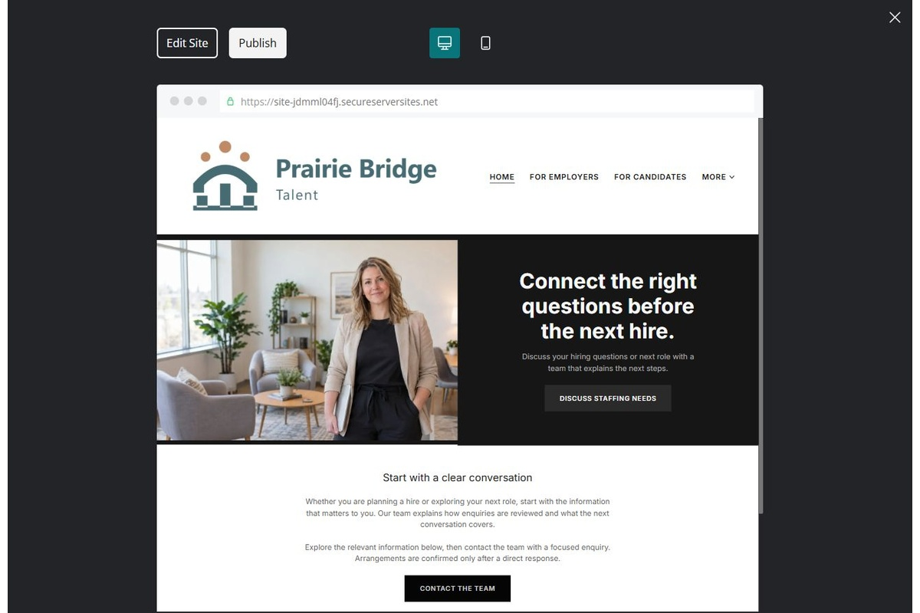
Unpublished Website Builder desktop excerpt. Page content continues below.

Sample wording — adapt and verify
Connect the right questions before the next hire.
Whether you are planning a hire or exploring your next role, start with the information that matters to you. Our team explains how enquiries are reviewed and what the next conversation covers.
Explore the relevant information below, then contact the team with a focused enquiry. Arrangements are confirmed only after a direct response.
Suggested button: Start a staffing conversation

Website advice
Separate employer and candidate journeys, explain the review process and provide safe contact routes without placement promises.

Your draft: Home
Write in the voice of your own business. Use facts you can verify, not promises copied from the example.

Headline and short introduction

Main content and details visitors need

Button wording and destination

Photo choice, permission and facts still to confirm
Partner check: can someone unfamiliar with the business find a useful next step?

02 For Employers
Give this page one clear job in the customer journey.
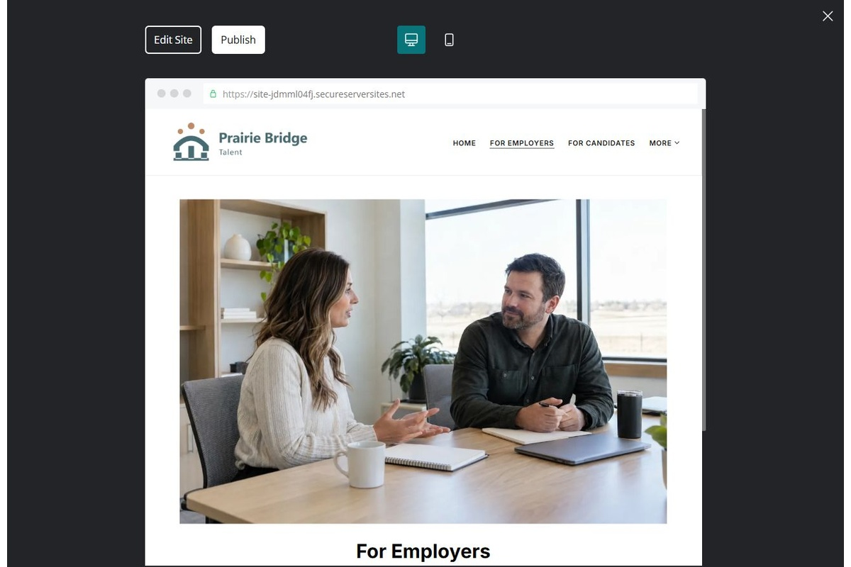
Unpublished Website Builder desktop excerpt. Page content continues below.

Sample wording — adapt and verify
For Employers
Describe the role, location and skills you would like to discuss. We clarify the brief and service arrangements before any search or introductions are agreed.
Contact the team to discuss your questions and confirm the next step.
Suggested button: Contact the team

Website advice
Explain role briefing, agreed scope and candidate review without promising availability or hiring results.

Your draft: For Employers
Write in the voice of your own business. Use facts you can verify, not promises copied from the example.

Headline and short introduction

Main content and details visitors need

Button wording and destination

Photo choice, permission and facts still to confirm
Partner check: can someone unfamiliar with the business find a useful next step?

03 For Candidates
Give this page one clear job in the customer journey.
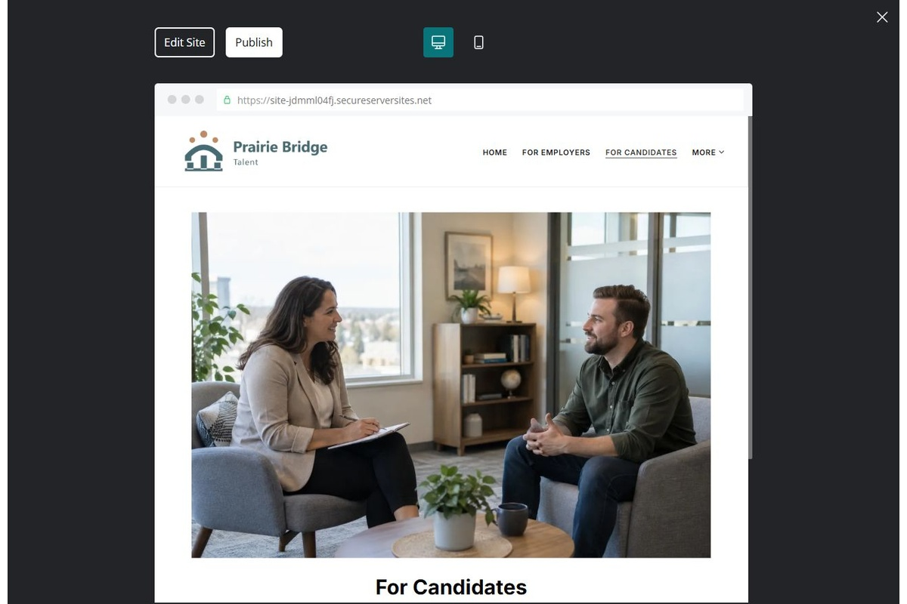
Unpublished Website Builder desktop excerpt. Page content continues below.

Sample wording — adapt and verify
For Candidates
Tell us the type of work you want to explore and how to contact you. We explain the current application route and the information needed for a relevant conversation.
Contact the team to discuss your questions and confirm the next step.
Suggested button: Contact the team

Website advice
Explain how to enquire and where approved private applications go. Do not imply current vacancies.

Your draft: For Candidates
Write in the voice of your own business. Use facts you can verify, not promises copied from the example.

Headline and short introduction

Main content and details visitors need

Button wording and destination

Photo choice, permission and facts still to confirm
Partner check: can someone unfamiliar with the business find a useful next step?

04 How We Work
Give this page one clear job in the customer journey.
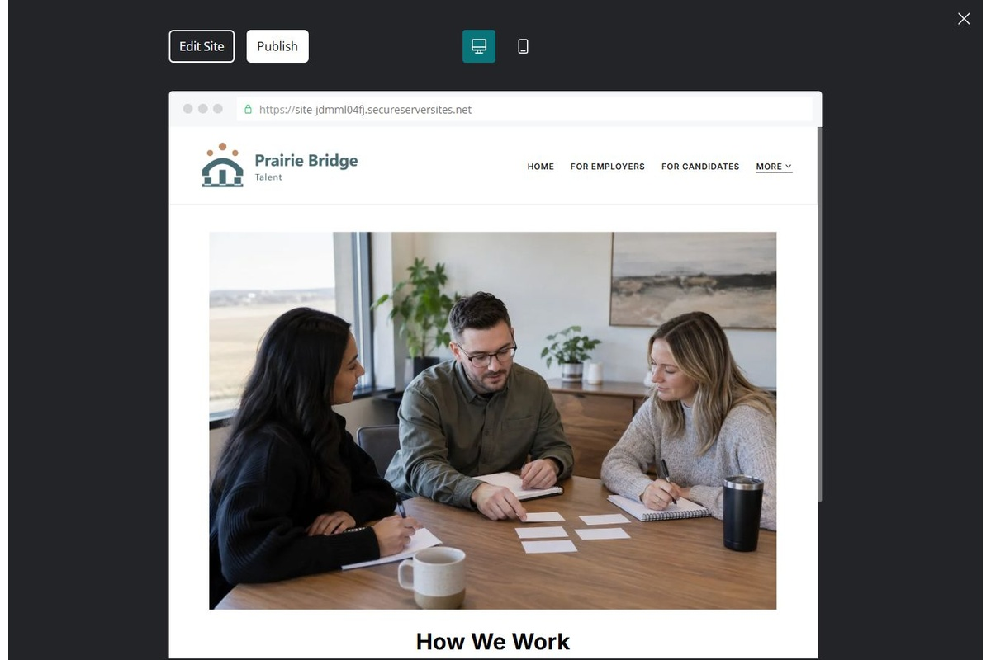
Unpublished Website Builder desktop excerpt. Page content continues below.

Sample wording — adapt and verify
How We Work
We begin by clarifying the request and explaining our process. You will know which next step is proposed and what still needs confirmation before an introduction or arrangement proceeds.
Contact the team to discuss your questions and confirm the next step.
Suggested button: Contact the team

Website advice
Outline enquiry, review, communication and confirmation separately for employers and candidates.

Your draft: How We Work
Write in the voice of your own business. Use facts you can verify, not promises copied from the example.

Headline and short introduction

Main content and details visitors need

Button wording and destination

Photo choice, permission and facts still to confirm
Partner check: can someone unfamiliar with the business find a useful next step?

05 Contact the Team
Give this page one clear job in the customer journey.
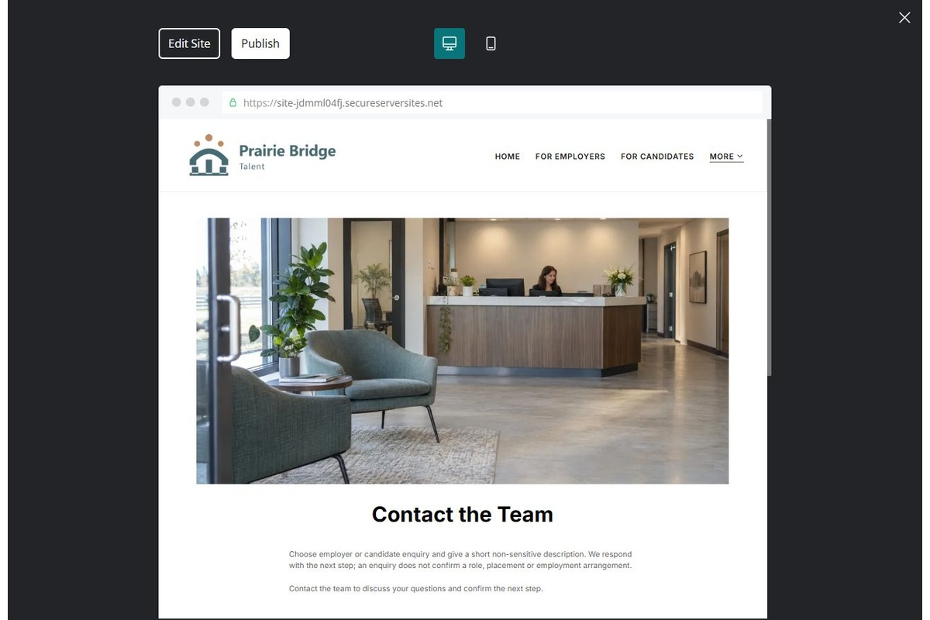
Unpublished Website Builder desktop excerpt. Page content continues below.

Sample wording — adapt and verify
Contact the Team
Choose employer or candidate enquiry and give a short non-sensitive description. We respond with the next step; an enquiry does not confirm a role, placement or employment arrangement.
Contact the team to discuss your questions and confirm the next step.
Suggested button: Contact the team

Website advice
Give verified contacts and a minimal initial form. Route sensitive information privately.

Your draft: Contact the Team
Write in the voice of your own business. Use facts you can verify, not promises copied from the example.

Headline and short introduction

Main content and details visitors need

Button wording and destination

Photo choice, permission and facts still to confirm
Partner check: can someone unfamiliar with the business find a useful next step?

Test before publishing
Review the whole journey on a desktop and phone. Compare these desktop excerpts with the mobile captures on the industry page.
□ Fictional agency example. Verify employment terms, fee arrangements and privacy practices. Do not request identity documents, banking details or full candidate histories through public forms.
□ Verify contact routes, location, hours, service scope and all commercial terms.
□ Replace fictional identities and AI illustrations or label them accurately.
□ Remove unverified testimonials, results, credentials and availability.
□ Check every link, form and download on desktop and mobile.
□ Keep sensitive documents, access information and payment details out of public forms.
□ Check every link, form destination, download and confirmation message.
□ Check logo contrast, hero framing, text sizes and image loading.
□ Save a named backup and assign a content-review date.

Changes to finish and person responsible

Approval and next review date
Website Builder plans and signup

