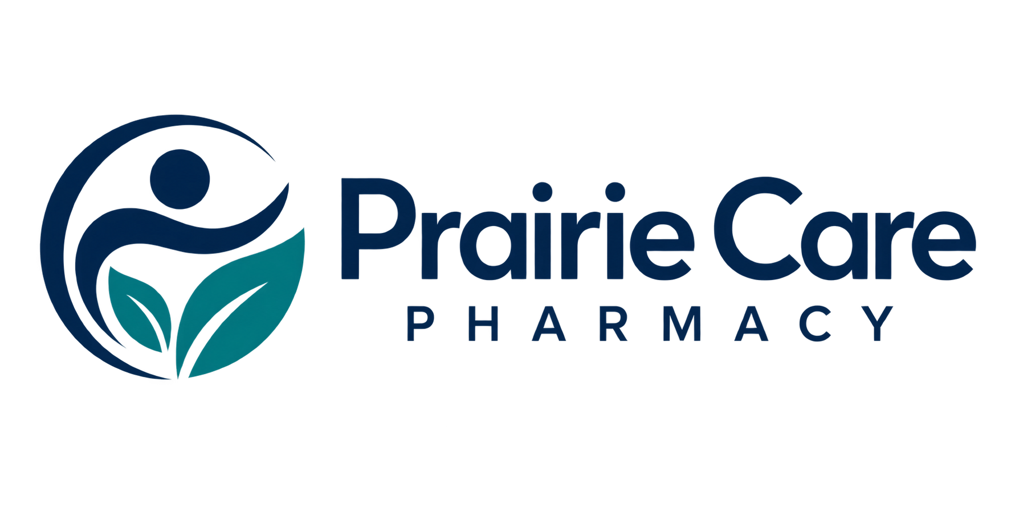

Public website review checklist
Use this review before publishing or updating a pharmacy website. A responsible pharmacy representative should verify public service descriptions and contact details. This is a communications tool, not a regulatory compliance checklist.
Type into the response lines in Microsoft Word, or print and complete by hand. Keep patient and prescription information out of this document.
Website and reviewer

Review date and next review date

Business details
Confirm the business name, address, telephone number, opening hours and holiday exceptions.

Services and team
Check every advertised service, appointment requirement and staff role against current verified information. Obtain permission for names and photos.

Contact routes
Test every link and phone button. Confirm private enquiries are directed to an approved channel. Do not invite prescription uploads through a general form.

Mobile and readability
Open every page on a phone. Check image loading, legible text, logo contrast, navigation and keyboard access.
Corrections and the person responsible

Record the release decision
Pages reviewed and changes required

Facts still awaiting verification and who will verify them

Final reviewer and approval date

Follow up after publication

