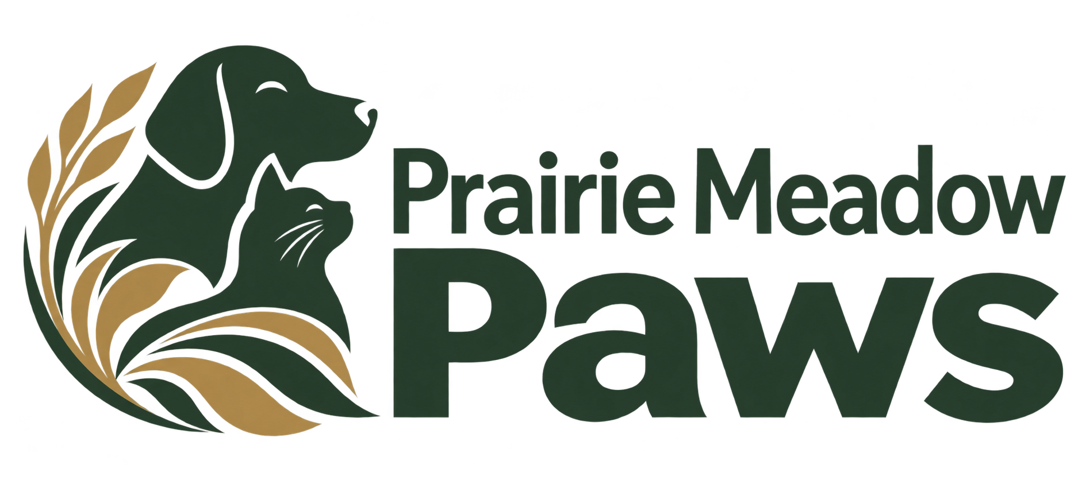

Pet-care service discussion worksheet
Type into the writing spaces or print for handwriting. Use one worksheet per enquiry or job, with references instead of unnecessary personal information.
Working example — adapt to your own approved process. This worksheet is not a contract, certificate or automatic booking. Keep completed records in an access-controlled business system.

Boarding daycare or training interest

General pet category

Dates or attendance pattern to discuss

Accommodation or class-format questions

Confirm the next step
Discuss unanswered questions with the responsible staff member. Record what was agreed, who will act and when a follow-up is due.

Introduction and private intake questions

Belongings and arrival questions

Fees changes and cancellation questions

Confirmed next contact
□ Relevant facts checked with the responsible person.
□ Estimate, timing and any limitations explained separately.
□ Private documents and payments handled through the approved process.

