

Painting, Flooring & Renovations
Website workbook
A practical workshop for a 5-page website. Study the example, plan the content and draft your own version in Word or on paper.
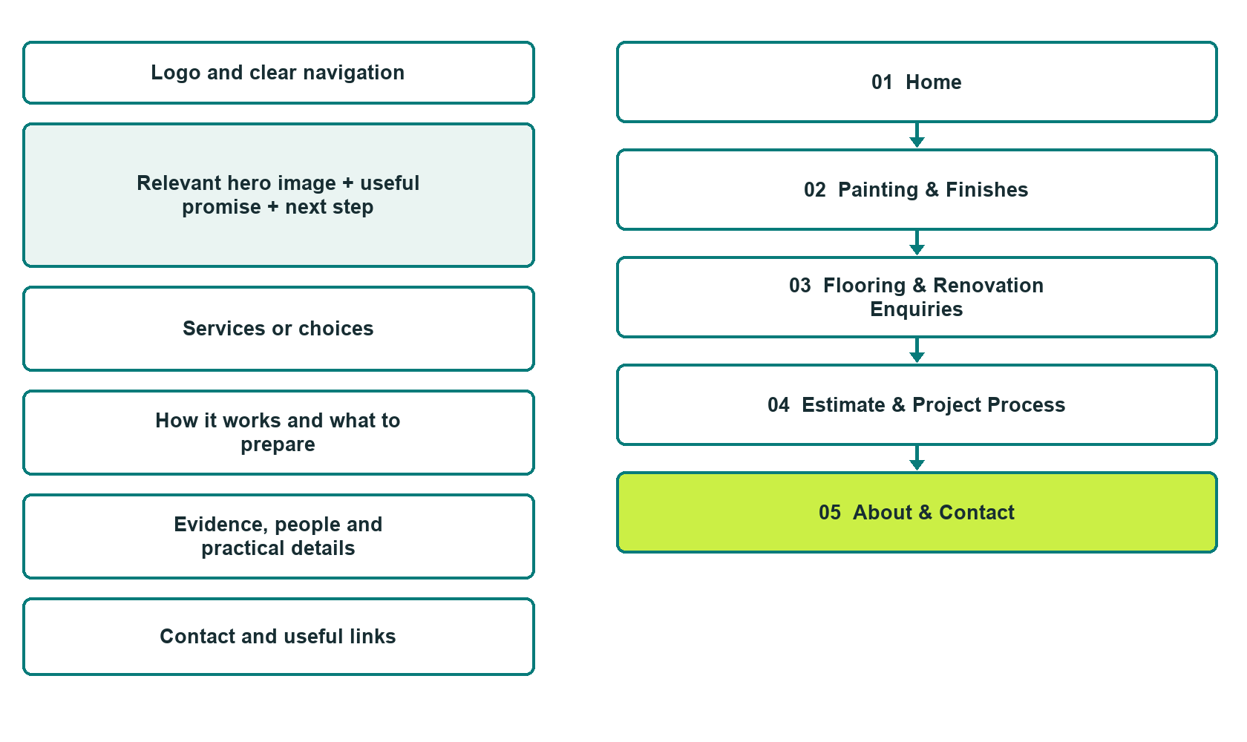

Plan → Draft → Build → Test
Capture edition: five genuine unpublished Website Builder desktop excerpts. The cover wireframe remains illustrative.
Explore Website Builder and compare plans

Before you build
Your business supplies the facts. Prairie Finish Home Works is a fictional teaching example, not a live service.

□ Request a project estimate discussion
□ Verified identity, service scope and current contacts
□ Clear enquiry and confirmation steps
□ Choose original photographs and confirm permission to use them.
□ Keep private customer records out of public website forms.

Your audience and the action you want them to take

Facts to verify and people who must approve them
Create your SaaSTech account

01 Home
Give this page one clear job in the customer journey.
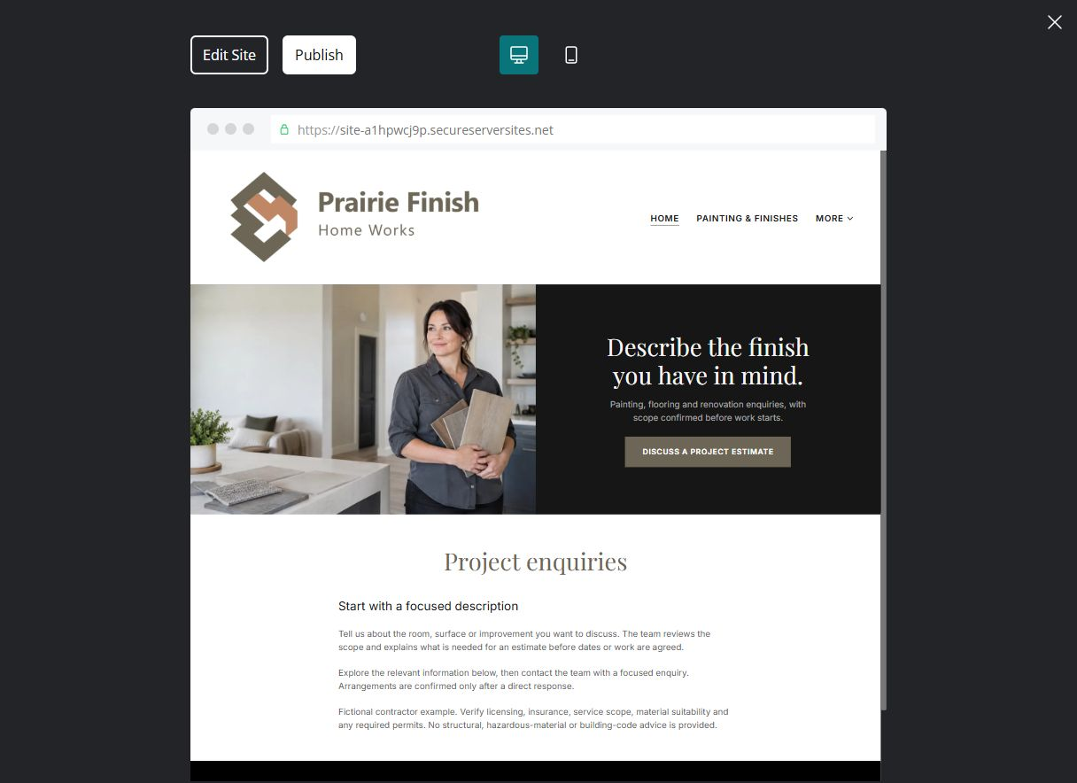
Unpublished Website Builder desktop excerpt. Page content continues below.

Sample wording — adapt and verify
Describe the finish you have in mind.
Tell us about the room, surface or improvement you want to discuss. The team reviews the scope and explains what is needed for an estimate before dates or work are agreed.
Explore the relevant information below, then contact the team with a focused enquiry. Arrangements are confirmed only after a direct response.
Suggested button: Request a project estimate discussion

Website advice
Separate verified painting, flooring and renovation services; explain estimate review and project confirmation without invented guarantees.

Your draft: Home
Write in the voice of your own business. Use facts you can verify, not promises copied from the example.

Headline and short introduction

Main content and details visitors need

Button wording and destination

Photo choice, permission and facts still to confirm
Partner check: can someone unfamiliar with the business find a useful next step?

02 Painting & Finishes
Give this page one clear job in the customer journey.
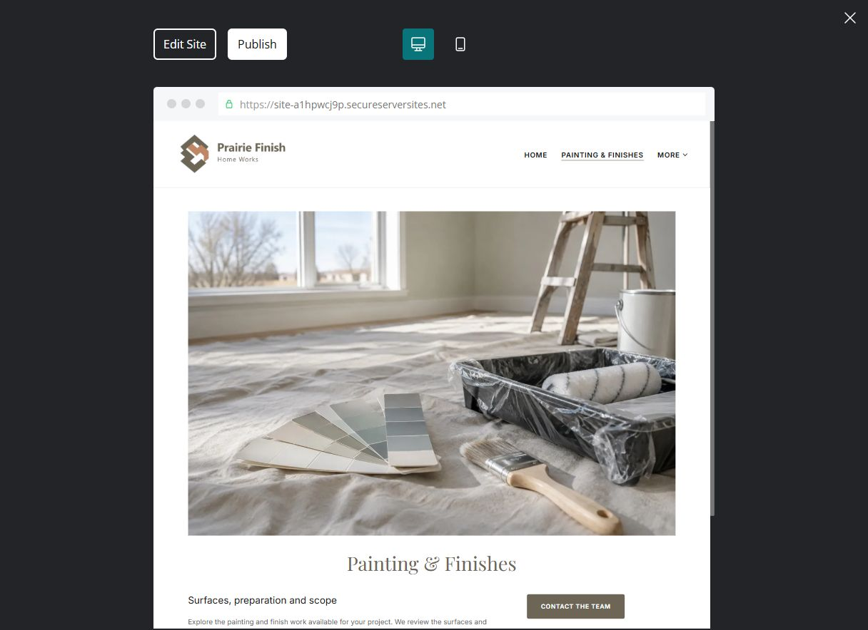
Unpublished Website Builder desktop excerpt. Page content continues below.

Sample wording — adapt and verify
Painting & Finishes
Explore the painting and finish work available for your project. We review the surfaces and expectations before confirming preparation, materials and scope.
Contact the team to discuss your questions and confirm the next step.
Suggested button: Contact the team

Website advice
Explain offered surface and finish categories, with operator-approved scope and exclusions.

Your draft: Painting & Finishes
Write in the voice of your own business. Use facts you can verify, not promises copied from the example.

Headline and short introduction

Main content and details visitors need

Button wording and destination

Photo choice, permission and facts still to confirm
Partner check: can someone unfamiliar with the business find a useful next step?

03 Flooring & Renovation Enquiries
Give this page one clear job in the customer journey.
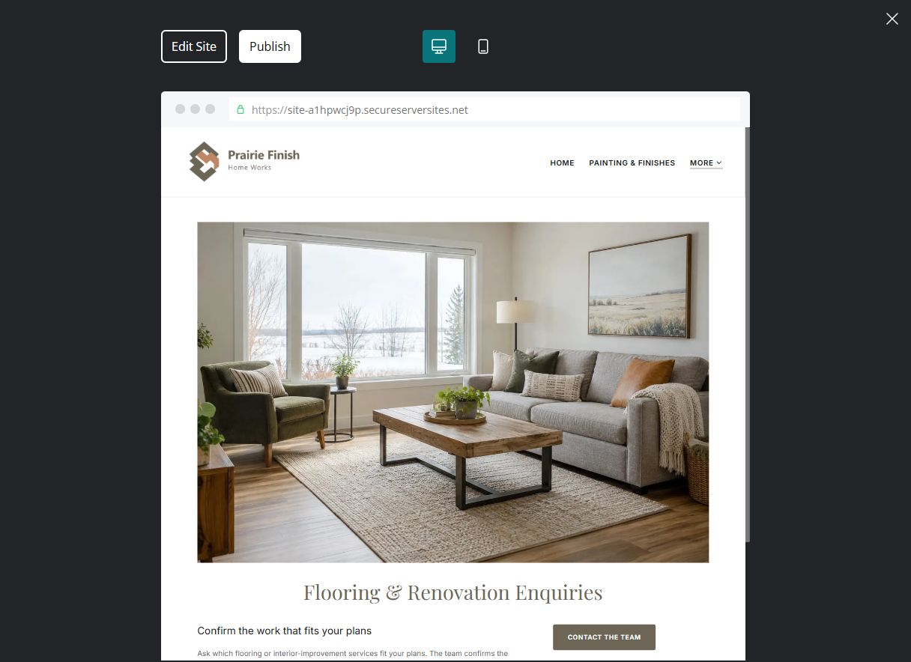
Unpublished Website Builder desktop excerpt. Page content continues below.

Sample wording — adapt and verify
Flooring & Renovation Enquiries
Ask which flooring or interior-improvement services fit your plans. The team confirms the scope and explains when other qualified trades or reviews may be needed.
Contact the team to discuss your questions and confirm the next step.
Suggested button: Contact the team

Website advice
Separate offered flooring work from broader renovation or regulated trades.

Your draft: Flooring & Renovation Enquiries
Write in the voice of your own business. Use facts you can verify, not promises copied from the example.

Headline and short introduction

Main content and details visitors need

Button wording and destination

Photo choice, permission and facts still to confirm
Partner check: can someone unfamiliar with the business find a useful next step?

04 Estimate & Project Process
Give this page one clear job in the customer journey.
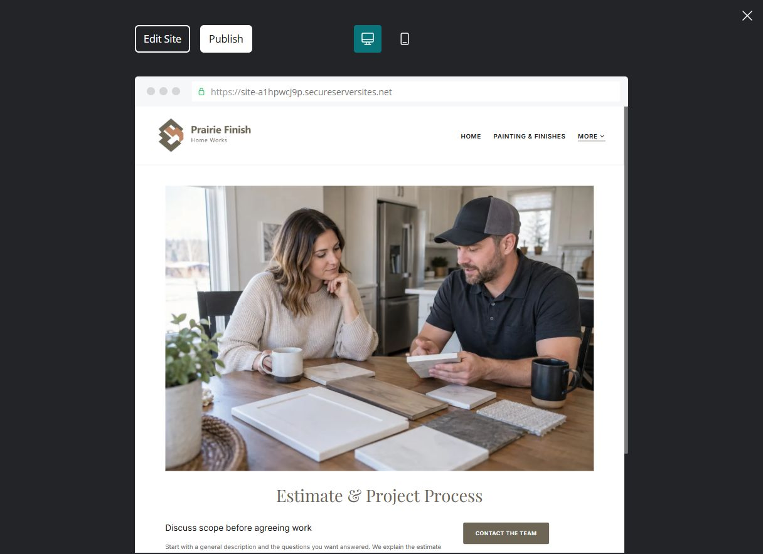
Unpublished Website Builder desktop excerpt. Page content continues below.

Sample wording — adapt and verify
Estimate & Project Process
Start with a general description and the questions you want answered. We explain the estimate process and confirm scope, terms and scheduling separately before work starts.
Contact the team to discuss your questions and confirm the next step.
Suggested button: Contact the team

Website advice
Explain discussion, site review, estimate and agreed changes without promising dates or prices.

Your draft: Estimate & Project Process
Write in the voice of your own business. Use facts you can verify, not promises copied from the example.

Headline and short introduction

Main content and details visitors need

Button wording and destination

Photo choice, permission and facts still to confirm
Partner check: can someone unfamiliar with the business find a useful next step?

05 About & Contact
Give this page one clear job in the customer journey.
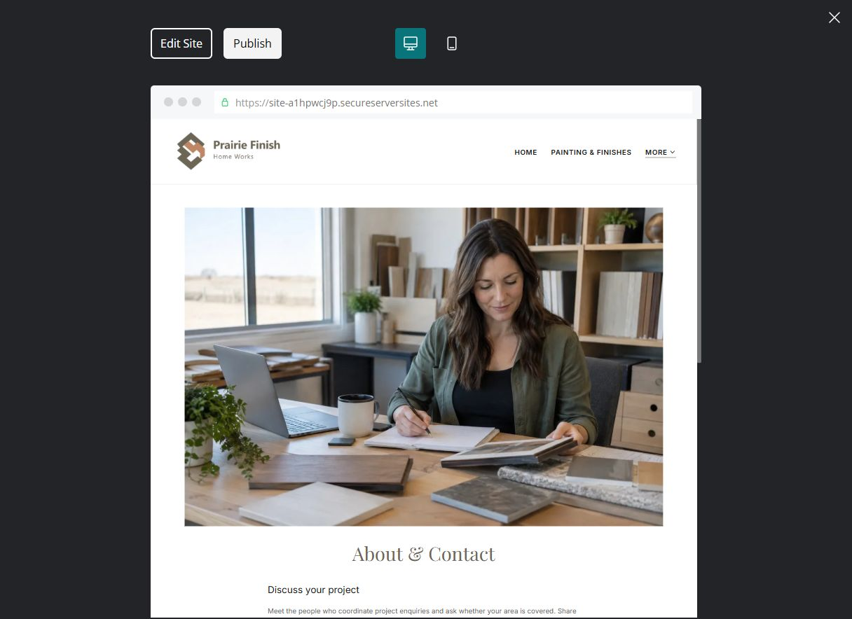
Unpublished Website Builder desktop excerpt. Page content continues below.

Sample wording — adapt and verify
About & Contact
Meet the people who coordinate project enquiries and ask whether your area is covered. Share a short project description and we will explain the next step for discussing an estimate.
Contact the team to discuss your questions and confirm the next step.
Suggested button: Contact the team

Website advice
Show verified team and service area; make public enquiry minimal and non-sensitive.

Your draft: About & Contact
Write in the voice of your own business. Use facts you can verify, not promises copied from the example.

Headline and short introduction

Main content and details visitors need

Button wording and destination

Photo choice, permission and facts still to confirm
Partner check: can someone unfamiliar with the business find a useful next step?

Test before publishing
Review the whole journey on a desktop and phone. Check links, image framing and demo-form privacy before launch.
□ Fictional contractor example. Verify licensing, insurance, service scope, material suitability and any required permits. No structural, hazardous-material or building-code advice is provided.
□ Verify contact routes, location, hours, service scope and all commercial terms.
□ Replace fictional identities and AI illustrations or label them accurately.
□ Remove unverified testimonials, results, credentials and availability.
□ Check every link, form and download on desktop and mobile.
□ Keep sensitive documents, access information and payment details out of public forms.
□ Check every link, form destination, download and confirmation message.
□ Check logo contrast, hero framing, text sizes and image loading.
□ Save a named backup and assign a content-review date.

Changes to finish and person responsible

Approval and next review date
Website Builder plans and signup

