

Oilfield, Mining & Environmental Contractors
Website workbook
A practical workshop for a 5-page website. Study the example, plan the content and draft your own version in Word or on paper.
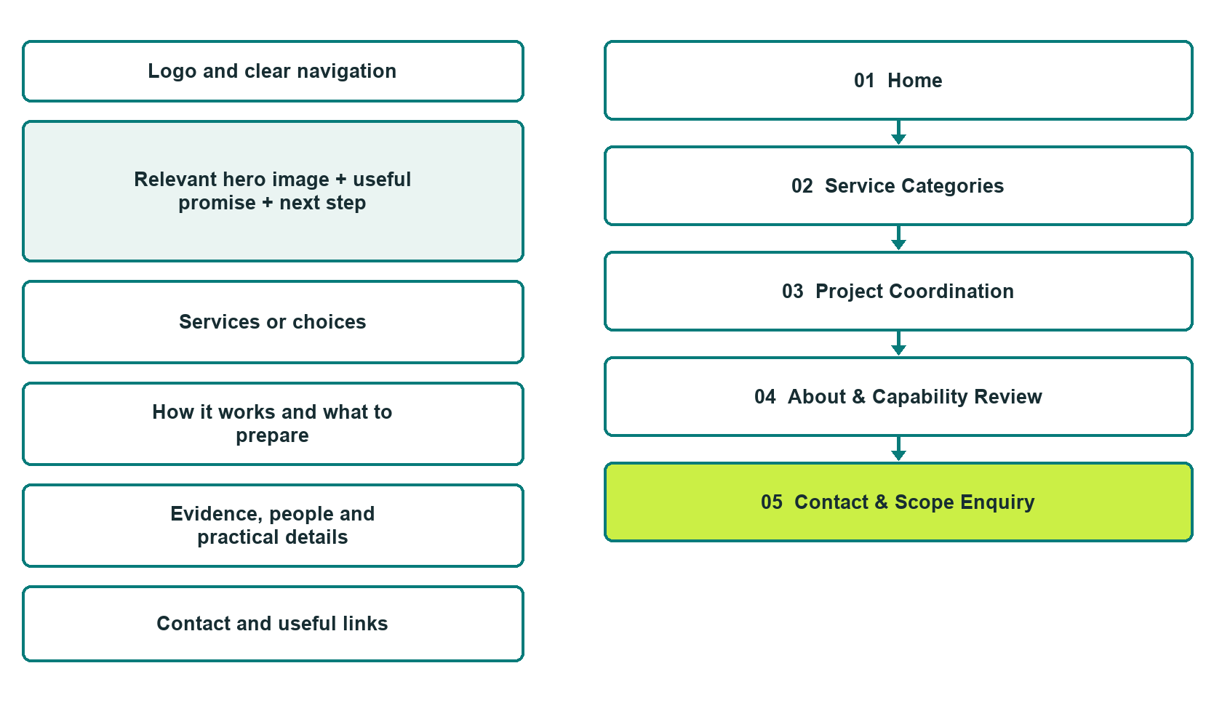

Plan → Draft → Build → Test
Capture edition: five genuine unpublished Website Builder desktop excerpts. Review mobile views on the industry page.
Explore Website Builder and compare plans

Before you build
Your business supplies the facts. Prairie Range Field Services is a fictional teaching example, not a live service.

□ Discuss a field-service enquiry
□ Verified identity, service scope and current contacts
□ Clear enquiry and confirmation steps
□ Choose original photographs and confirm permission to use them.
□ Keep private customer records out of public website forms.

Your audience and the action you want them to take

Facts to verify and people who must approve them
Create your SaaSTech account

01 Home
Give this page one clear job in the customer journey.
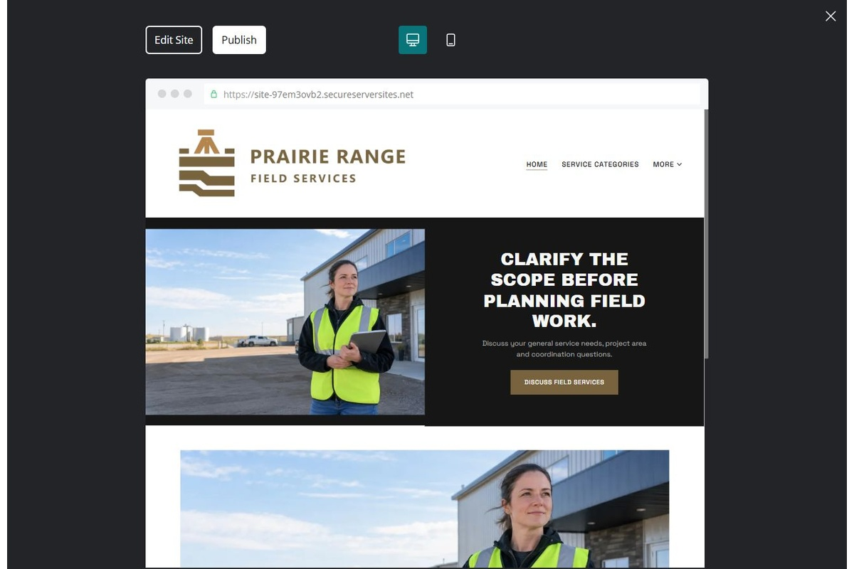
Unpublished Website Builder desktop excerpt. Page content continues below.

Sample wording — adapt and verify
Clarify the scope before planning field work.
Share the general service category and project area you need to discuss. Our coordinator reviews the enquiry and explains which scope, access and documentation questions come next.
Explore the relevant information below, then contact the team with a focused enquiry. Arrangements are confirmed only after a direct response.
Suggested button: Discuss a field-service enquiry

Website advice
Present operator-verified service categories, enquiry review and mobilization discussion without operational instructions or certification claims.

Your draft: Home
Write in the voice of your own business. Use facts you can verify, not promises copied from the example.

Headline and short introduction

Main content and details visitors need

Button wording and destination

Photo choice, permission and facts still to confirm
Partner check: can someone unfamiliar with the business find a useful next step?

02 Service Categories
Give this page one clear job in the customer journey.
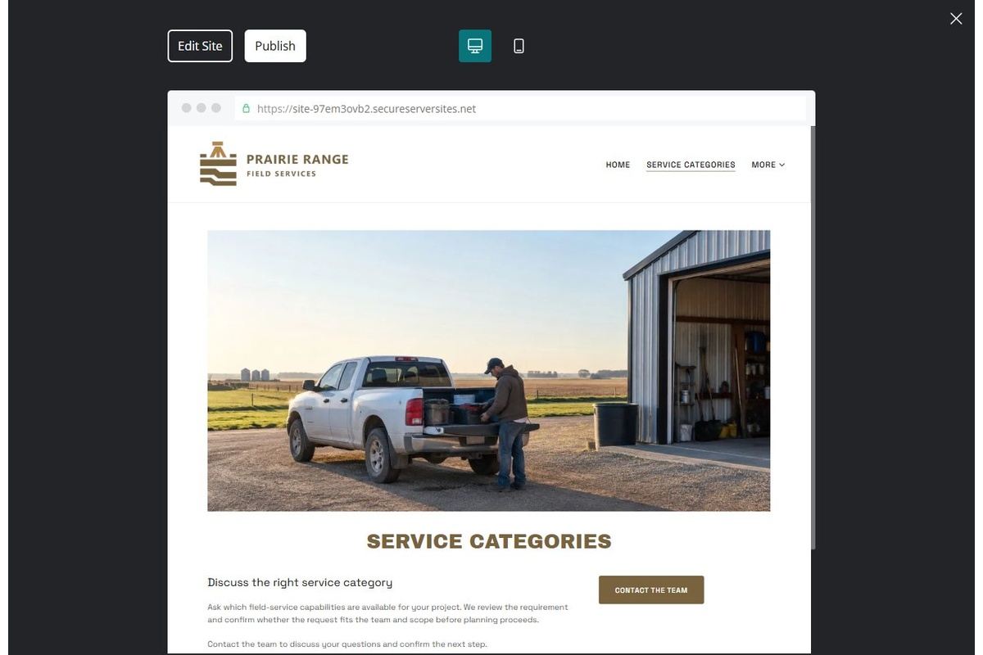
Unpublished Website Builder desktop excerpt. Page content continues below.

Sample wording — adapt and verify
Service Categories
Ask which field-service capabilities are available for your project. We review the requirement and confirm whether the request fits the team and scope before planning proceeds.
Contact the team to discuss your questions and confirm the next step.
Suggested button: Contact the team

Website advice
Separate each verified capability and its limits; avoid implying every industrial or environmental service is offered.

Your draft: Service Categories
Write in the voice of your own business. Use facts you can verify, not promises copied from the example.

Headline and short introduction

Main content and details visitors need

Button wording and destination

Photo choice, permission and facts still to confirm
Partner check: can someone unfamiliar with the business find a useful next step?

03 Project Coordination
Give this page one clear job in the customer journey.
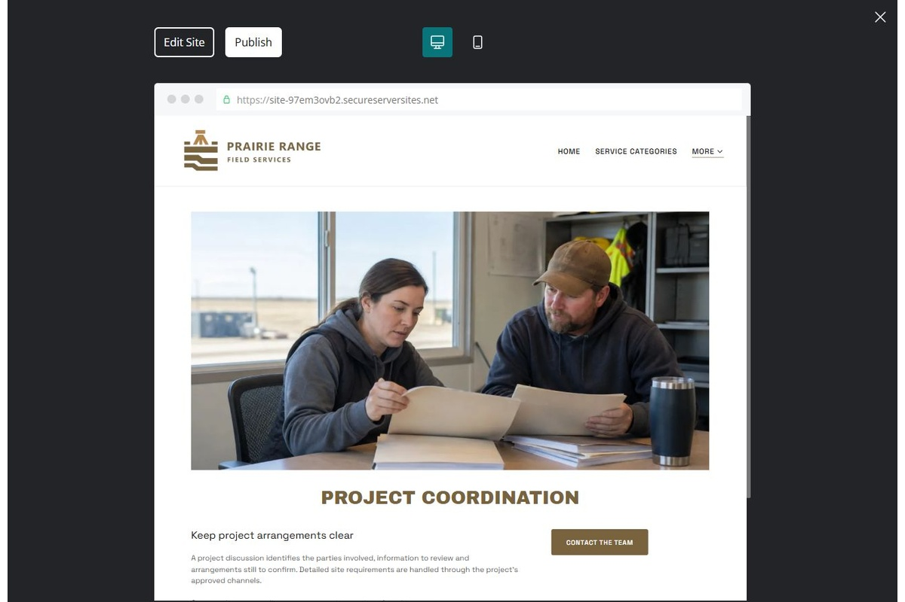
Unpublished Website Builder desktop excerpt. Page content continues below.

Sample wording — adapt and verify
Project Coordination
A project discussion identifies the parties involved, information to review and arrangements still to confirm. Detailed site requirements are handled through the project’s approved channels.
Contact the team to discuss your questions and confirm the next step.
Suggested button: Contact the team

Website advice
Explain scope review, operator requirements and agreed communication. Do not publish site-entry or hazardous-work instructions.

Your draft: Project Coordination
Write in the voice of your own business. Use facts you can verify, not promises copied from the example.

Headline and short introduction

Main content and details visitors need

Button wording and destination

Photo choice, permission and facts still to confirm
Partner check: can someone unfamiliar with the business find a useful next step?

04 About & Capability Review
Give this page one clear job in the customer journey.
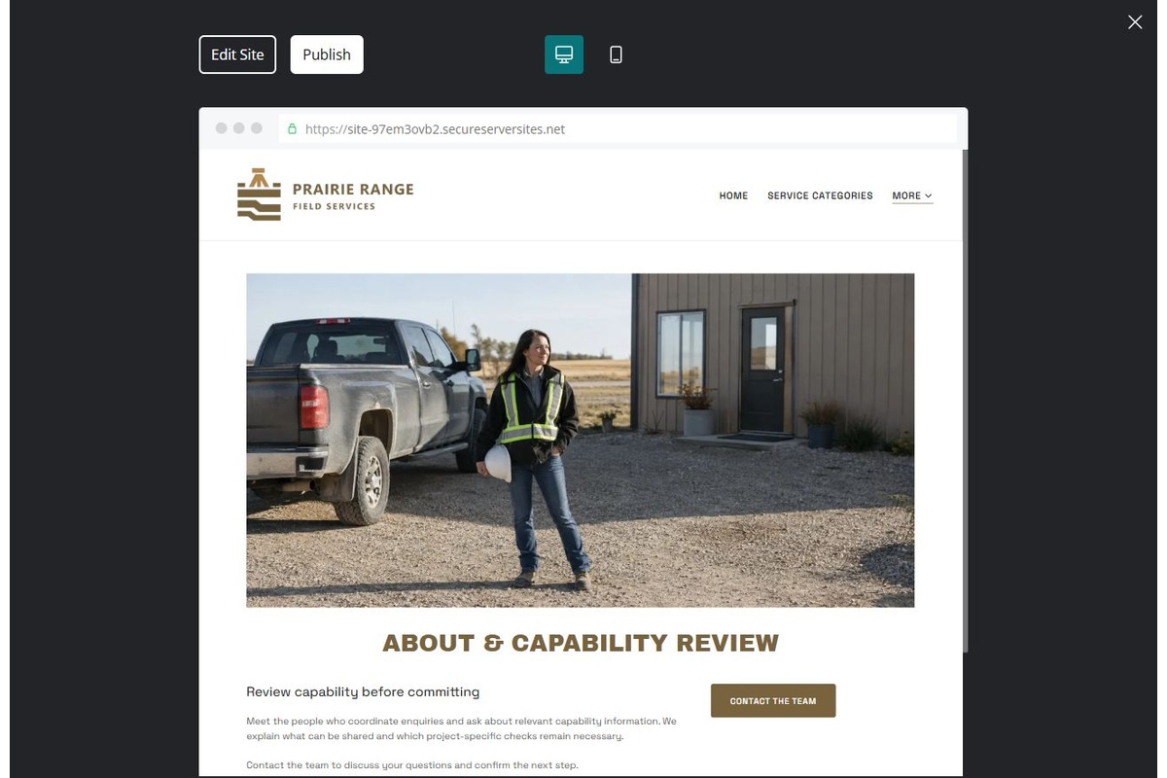
Unpublished Website Builder desktop excerpt. Page content continues below.

Sample wording — adapt and verify
About & Capability Review
Meet the people who coordinate enquiries and ask about relevant capability information. We explain what can be shared and which project-specific checks remain necessary.
Contact the team to discuss your questions and confirm the next step.
Suggested button: Contact the team

Website advice
Publish only verified experience and documents approved for public use. Avoid invented accreditations or case results.

Your draft: About & Capability Review
Write in the voice of your own business. Use facts you can verify, not promises copied from the example.

Headline and short introduction

Main content and details visitors need

Button wording and destination

Photo choice, permission and facts still to confirm
Partner check: can someone unfamiliar with the business find a useful next step?

05 Contact & Scope Enquiry
Give this page one clear job in the customer journey.
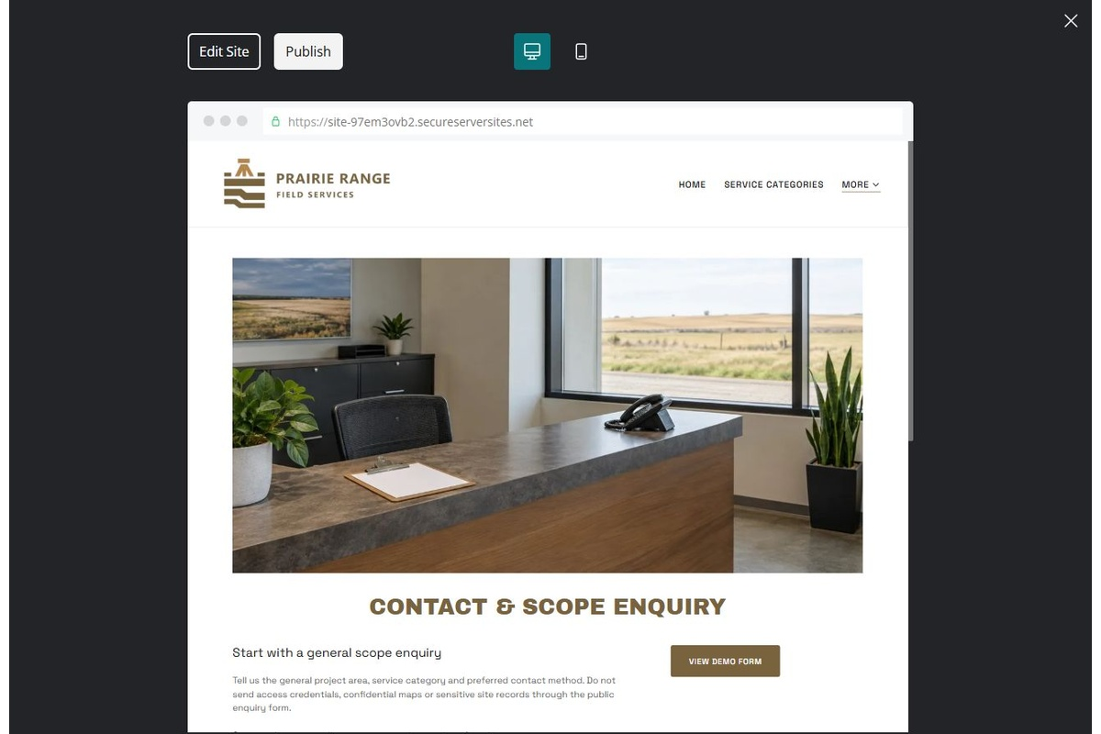
Unpublished Website Builder desktop excerpt. Page content continues below.

Sample wording — adapt and verify
Contact & Scope Enquiry
Tell us the general project area, service category and preferred contact method. Do not send access credentials, confidential maps or sensitive site records through the public enquiry form.
Contact the team to discuss your questions and confirm the next step.
Suggested button: Contact the team

Website advice
Request non-sensitive project context and direct all site documents privately.

Your draft: Contact & Scope Enquiry
Write in the voice of your own business. Use facts you can verify, not promises copied from the example.

Headline and short introduction

Main content and details visitors need

Button wording and destination

Photo choice, permission and facts still to confirm
Partner check: can someone unfamiliar with the business find a useful next step?

Test before publishing
Review the whole journey on a desktop and phone. Compare these desktop excerpts with the mobile captures on the industry page.
□ Fictional contractor example. No technical, environmental or safety guidance is provided. Verify qualifications, service scope, site requirements and permissions with the responsible professionals.
□ Verify contact routes, location, hours, service scope and all commercial terms.
□ Replace fictional identities and AI illustrations or label them accurately.
□ Remove unverified testimonials, results, credentials and availability.
□ Check every link, form and download on desktop and mobile.
□ Keep sensitive documents, access information and payment details out of public forms.
□ Check every link, form destination, download and confirmation message.
□ Check logo contrast, hero framing, text sizes and image loading.
□ Save a named backup and assign a content-review date.

Changes to finish and person responsible

Approval and next review date
Website Builder plans and signup

