

Oilfield Maintenance & Services
Website workbook
A practical workshop for a 6-page website. Study the example, plan the content and draft your own version in Word or on paper.
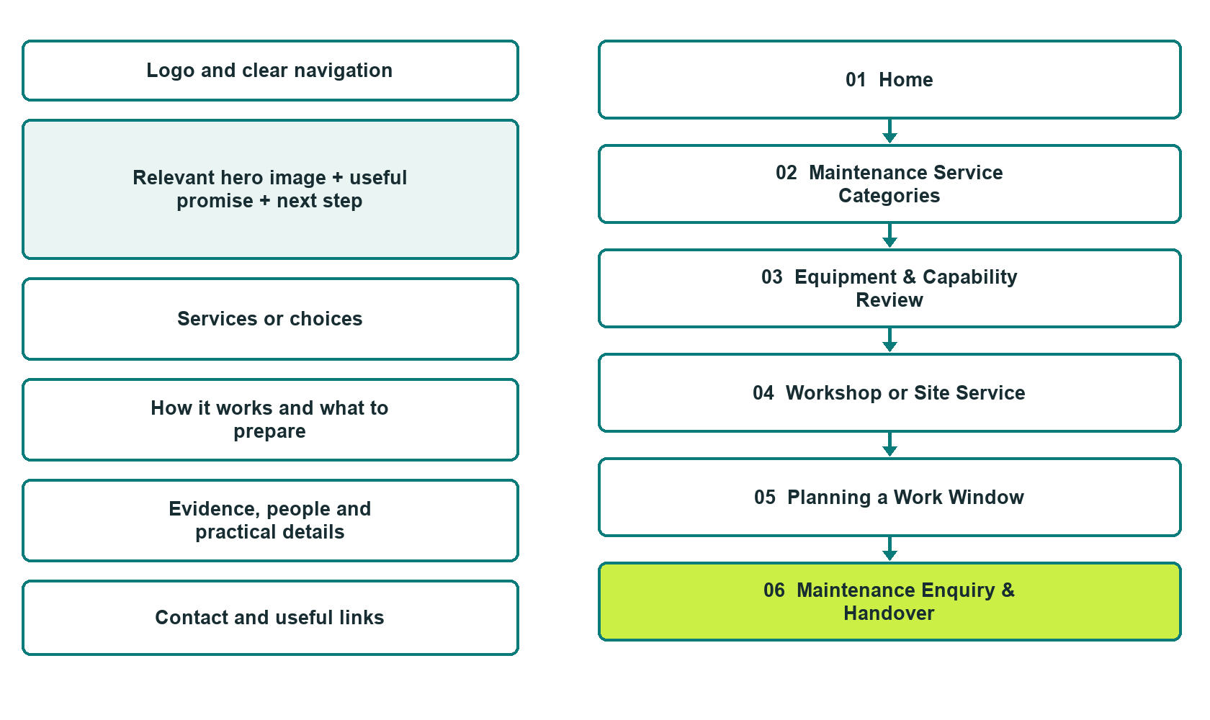

Plan → Draft → Build → Test
Captured demo edition. Study the six-page unpublished example, with paired desktop and mobile views, Editor Highlights, Themes and Paint settings in the industry gallery.
Explore Website Builder and compare plans

Before you build
Your business supplies the facts. Prairie Draw Maintenance is a fictional teaching example, not a live service.

□ Discuss a maintenance scope
□ Verified business identity, services and current contact information
□ A clear enquiry, review and confirmation process
□ Choose original photographs and confirm permission to use them.
□ Keep private customer records out of public website forms.

Your audience and the action you want them to take

Facts to verify and people who must approve them
Create your SaaSTech account

01 Home
Give this page one clear job in the customer journey.
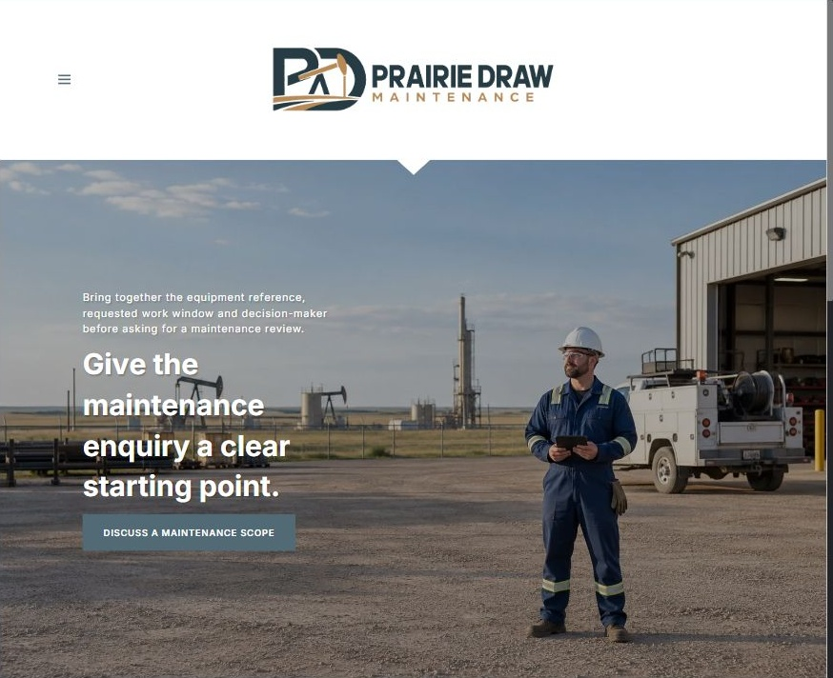
Actual desktop Website Builder preview. Compare its mobile view in the industry gallery.

Sample wording — adapt and verify
Give the maintenance enquiry a clear starting point.
Bring together the equipment reference, requested work window and decision-maker before asking for a maintenance review.
Explore workshop and site-service paths, then let the coordinator confirm which capabilities match the enquiry.
Suggested button: Discuss a maintenance scope

Website advice
A dedicated maintenance-service and equipment-capability guide, separate from broad drilling, mining and construction contracting.

Your draft: Home
Write in the voice of your own business. Use facts you can verify, not promises copied from the example.

Headline and short introduction

Main content and details visitors need

Button wording and destination

Photo choice, permission and facts still to confirm
Partner check: can someone unfamiliar with the business find a useful next step?

02 Maintenance Service Categories
Give this page one clear job in the customer journey.

Actual desktop Website Builder preview. Compare its mobile view in the industry gallery.

Sample wording — adapt and verify
Maintenance Service Categories
Describe the equipment family and the work you want the team to assess.
Existing work orders or service records can be discussed through the approved private route after the coordinator confirms the appropriate reviewer.
Suggested button: Discuss a maintenance scope

Website advice
Separate recurring maintenance enquiries, component work and planned shutdown support without implying that every asset is accepted.

Your draft: Maintenance Service Categories
Write in the voice of your own business. Use facts you can verify, not promises copied from the example.

Headline and short introduction

Main content and details visitors need

Button wording and destination

Photo choice, permission and facts still to confirm
Partner check: can someone unfamiliar with the business find a useful next step?

03 Equipment & Capability Review
Give this page one clear job in the customer journey.

Actual desktop Website Builder preview. Compare its mobile view in the industry gallery.

Sample wording — adapt and verify
Equipment & Capability Review
An equipment name alone may not establish whether the shop can accept the work.
Ask which model details, condition notes and documentation are needed for a capability review before arranging transport or a site visit.
Suggested button: Discuss a maintenance scope

Website advice
Help procurement staff identify relevant equipment before requesting a quote; publish only operator-confirmed capabilities.

Your draft: Equipment & Capability Review
Write in the voice of your own business. Use facts you can verify, not promises copied from the example.

Headline and short introduction

Main content and details visitors need

Button wording and destination

Photo choice, permission and facts still to confirm
Partner check: can someone unfamiliar with the business find a useful next step?

04 Workshop or Site Service
Give this page one clear job in the customer journey.
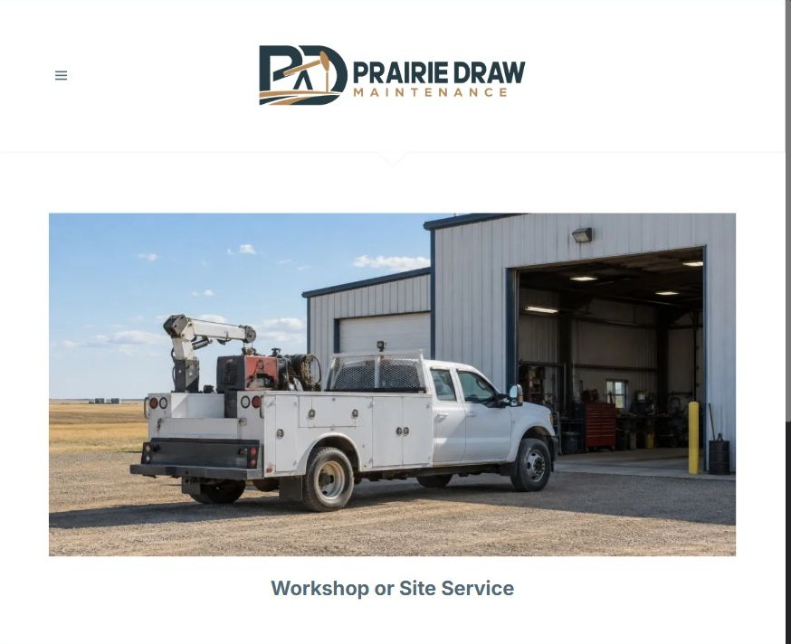
Actual desktop Website Builder preview. Compare its mobile view in the industry gallery.

Sample wording — adapt and verify
Workshop or Site Service
Workshop enquiries begin with equipment acceptance and intake arrangements.
For site work, share the general location and scheduling constraints so the coordinator can discuss the site contact and operator-approved access process privately.
Suggested button: Discuss a maintenance scope

Website advice
Explain the difference between shop intake and a proposed field visit without promising dispatch.

Your draft: Workshop or Site Service
Write in the voice of your own business. Use facts you can verify, not promises copied from the example.

Headline and short introduction

Main content and details visitors need

Button wording and destination

Photo choice, permission and facts still to confirm
Partner check: can someone unfamiliar with the business find a useful next step?

05 Planning a Work Window
Give this page one clear job in the customer journey.
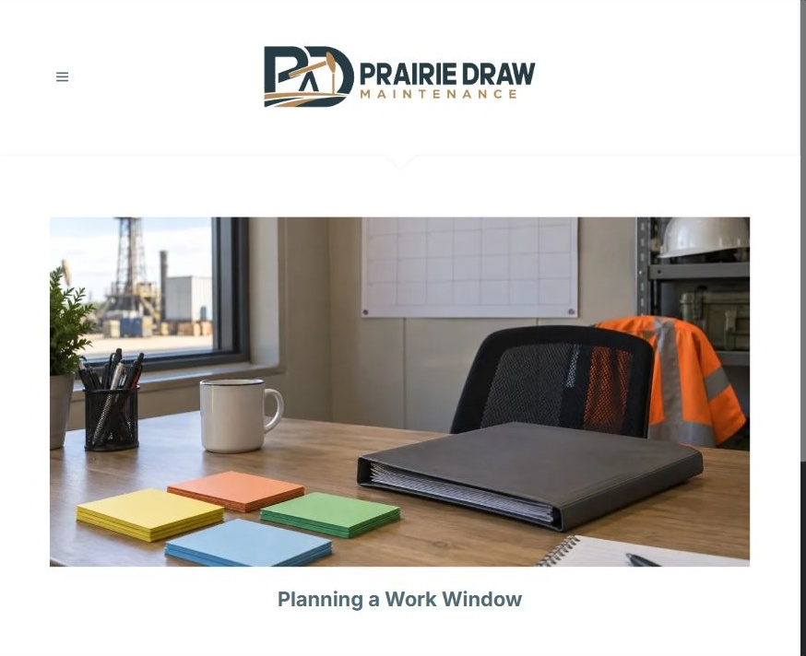
Actual desktop Website Builder preview. Compare its mobile view in the industry gallery.

Sample wording — adapt and verify
Planning a Work Window
List the requested work window and the person who can approve the scope.
If the assessment identifies additional work, ask how revised scope, timing and authorization will be documented before proceeding.
Suggested button: Discuss a maintenance scope

Website advice
Explain scope review, quote questions, authorization and change records for planned maintenance.

Your draft: Planning a Work Window
Write in the voice of your own business. Use facts you can verify, not promises copied from the example.

Headline and short introduction

Main content and details visitors need

Button wording and destination

Photo choice, permission and facts still to confirm
Partner check: can someone unfamiliar with the business find a useful next step?

06 Maintenance Enquiry & Handover
Give this page one clear job in the customer journey.
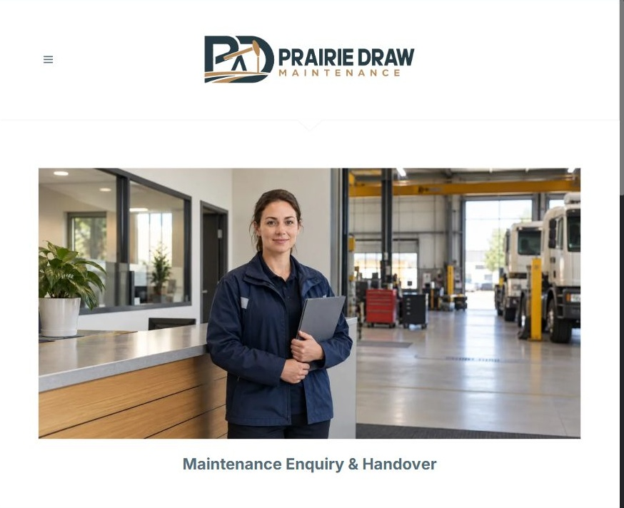
Actual desktop Website Builder preview. Compare its mobile view in the industry gallery.

Sample wording — adapt and verify
Maintenance Enquiry & Handover
Send a short description of the equipment and the work to be reviewed, together with a preferred reply method.
The coordinator explains what an accepted job includes, which handover records will be provided and how outstanding questions are recorded.
Suggested button: Discuss a maintenance scope

Website advice
Use non-sensitive project basics and make both scheduling and completion documentation subject to direct confirmation.

Your draft: Maintenance Enquiry & Handover
Write in the voice of your own business. Use facts you can verify, not promises copied from the example.

Headline and short introduction

Main content and details visitors need

Button wording and destination

Photo choice, permission and facts still to confirm
Partner check: can someone unfamiliar with the business find a useful next step?

Test before publishing
Review the captured desktop and phone journey. The demonstration enquiry form has four fields, no recipient and attachments disabled. It was not submitted or delivery-tested. Configure approved delivery before launch.
□ Fictional demonstration only. Verify equipment capabilities, qualifications, site requirements and availability with the operator. No operating procedures, technical repair instructions or emergency response promises are provided.
□ Verify every service description, contact route and operating detail.
□ Replace fictional identity and example information before a live launch.
□ Test enquiries, links and downloads on desktop and mobile.
□ Keep confidential records in approved private systems.
□ Obtain operator approval for public wording and images.
□ Check every link, form destination, download and confirmation message.
□ Check logo contrast, hero framing, text sizes and image loading.
□ Save a named backup and assign a content-review date.

Changes to finish and person responsible

Approval and next review date
Website Builder plans and signup

