

Office Supplies & Business Equipment
Website workbook
A practical workshop for a 6-page website. Study the example, plan the content and draft your own version in Word or on paper.
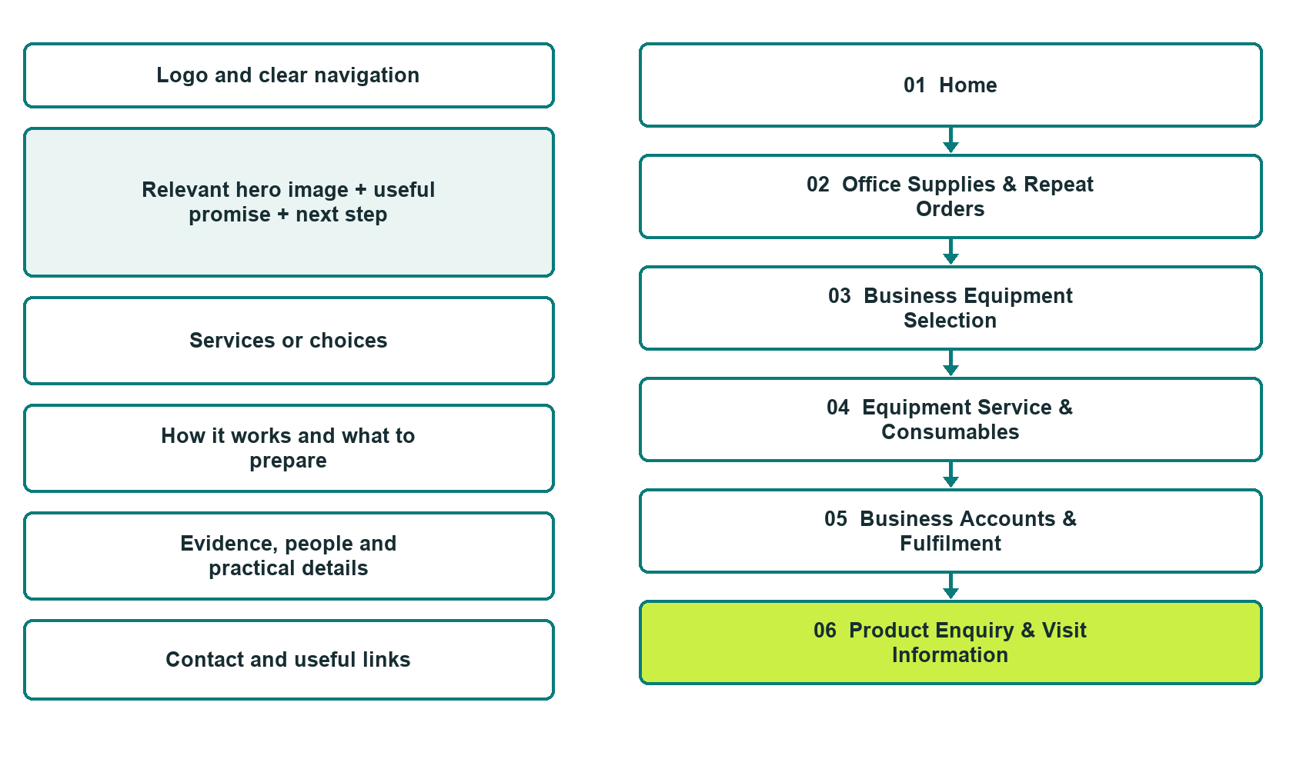

Plan → Draft → Build → Test
Capture edition: six genuine unpublished Website Builder desktop excerpts. Review mobile views on the industry page.
Explore Website Builder and compare plans

Before you build
Your business supplies the facts. Prairie Desk & Business Supply is a fictional teaching example, not a live service.

□ Ask about supplies, equipment or account service
□ Verified business identity, services and current contact information
□ A clear enquiry, review and confirmation process
□ Choose original photographs and confirm permission to use them.
□ Keep private customer records out of public website forms.

Your audience and the action you want them to take

Facts to verify and people who must approve them
Create your SaaSTech account

01 Home
Give this page one clear job in the customer journey.
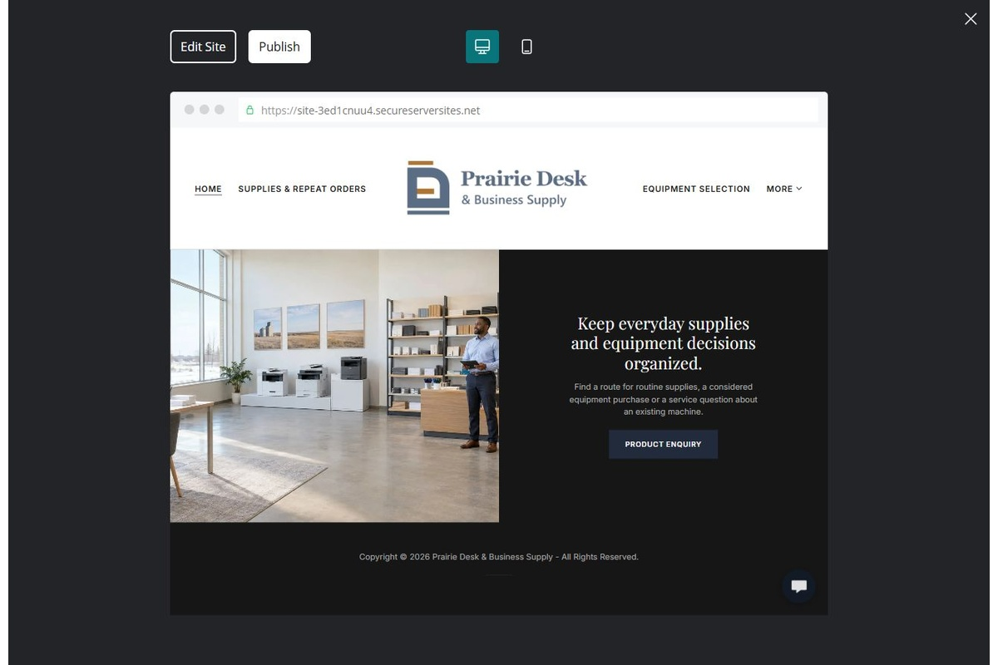
Unpublished Website Builder desktop excerpt. Page content continues below.

Sample wording — adapt and verify
Keep everyday supplies and equipment decisions organized.
Find a route for routine supplies, a considered equipment purchase or a service question about an existing machine.
The team reviews exact product references and business needs before confirming compatibility, a quote or fulfilment.
Suggested button: Ask about supplies, equipment or account service

Website advice
Separate consumable supply orders, business-equipment purchasing and equipment-service enquiries, with verified compatibility and fulfilment arrangements.

Your draft: Home
Write in the voice of your own business. Use facts you can verify, not promises copied from the example.

Headline and short introduction

Main content and details visitors need

Button wording and destination

Photo choice, permission and facts still to confirm
Partner check: can someone unfamiliar with the business find a useful next step?

02 Office Supplies & Repeat Orders
Give this page one clear job in the customer journey.
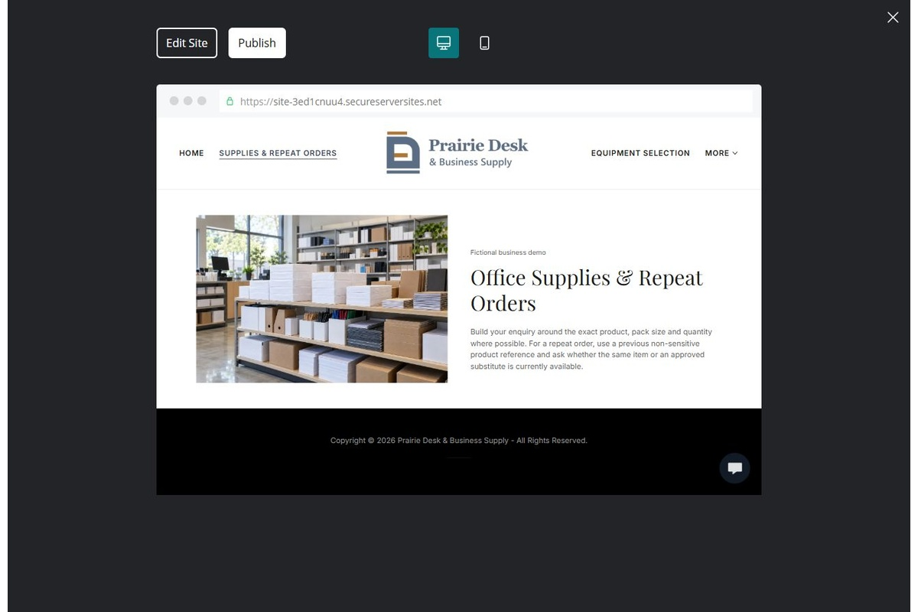
Unpublished Website Builder desktop excerpt. Page content continues below.

Sample wording — adapt and verify
Office Supplies & Repeat Orders
Build your enquiry around the exact product, pack size and quantity where possible.
For a repeat order, use a previous non-sensitive product reference and ask whether the same item or an approved substitute is currently available.
Suggested button: Ask about supplies, equipment or account service

Website advice
Group paper, stationery and everyday workplace supplies with product-reference and substitution questions.

Your draft: Office Supplies & Repeat Orders
Write in the voice of your own business. Use facts you can verify, not promises copied from the example.

Headline and short introduction

Main content and details visitors need

Button wording and destination

Photo choice, permission and facts still to confirm
Partner check: can someone unfamiliar with the business find a useful next step?

03 Business Equipment Selection
Give this page one clear job in the customer journey.
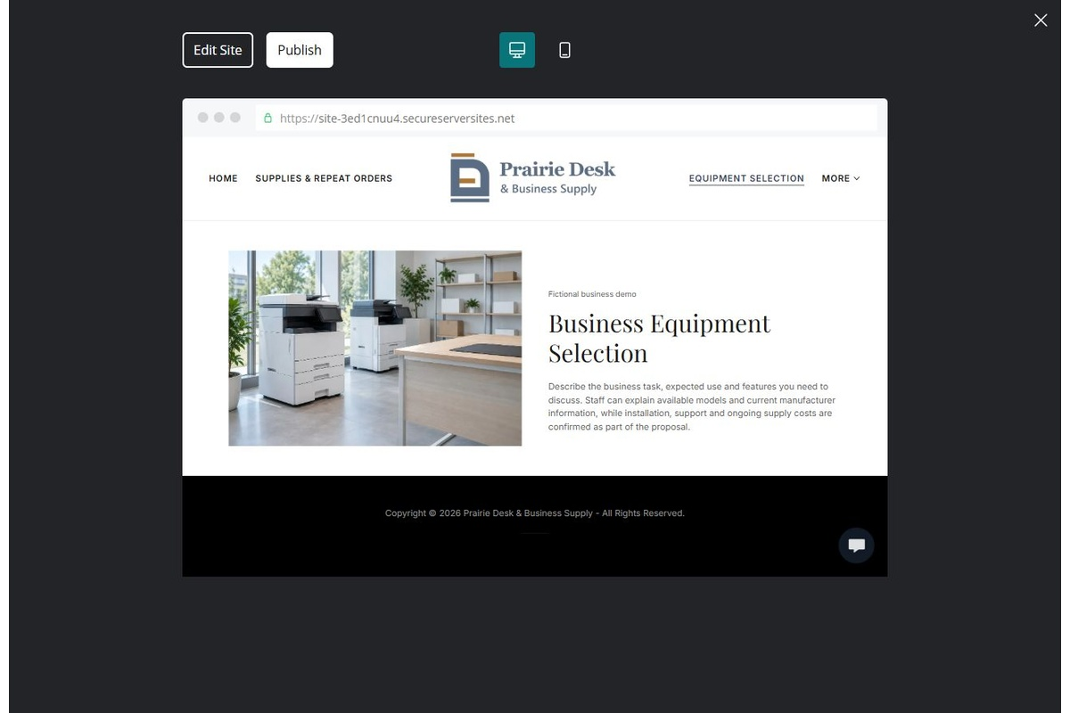
Unpublished Website Builder desktop excerpt. Page content continues below.

Sample wording — adapt and verify
Business Equipment Selection
Describe the business task, expected use and features you need to discuss.
Staff can explain available models and current manufacturer information, while installation, support and ongoing supply costs are confirmed as part of the proposal.
Suggested button: Ask about supplies, equipment or account service

Website advice
Provide a distinct consultation route for printers and other verified equipment categories without inventing specifications.

Your draft: Business Equipment Selection
Write in the voice of your own business. Use facts you can verify, not promises copied from the example.

Headline and short introduction

Main content and details visitors need

Button wording and destination

Photo choice, permission and facts still to confirm
Partner check: can someone unfamiliar with the business find a useful next step?

04 Equipment Service & Consumables
Give this page one clear job in the customer journey.
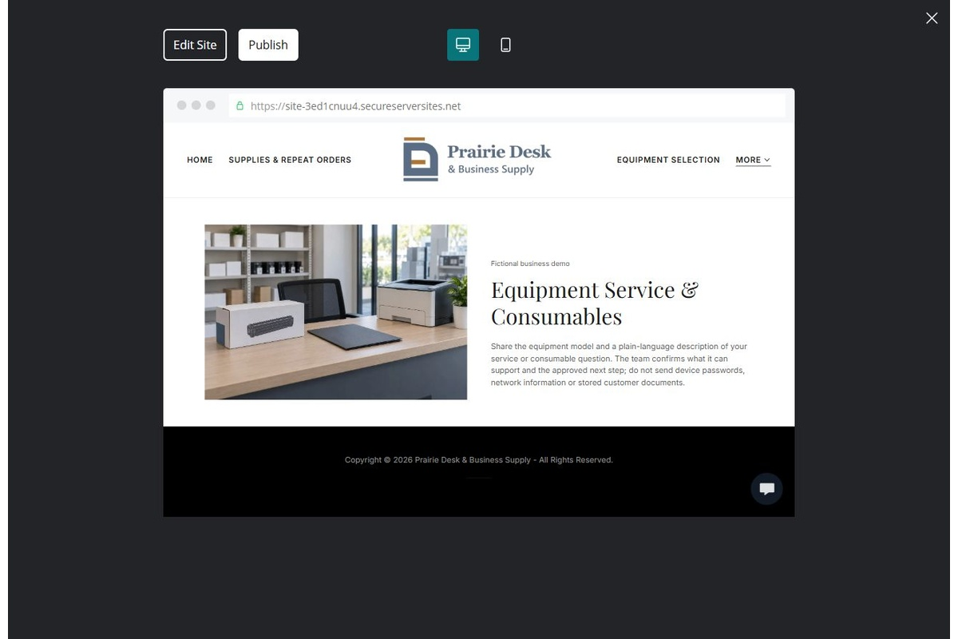
Unpublished Website Builder desktop excerpt. Page content continues below.

Sample wording — adapt and verify
Equipment Service & Consumables
Share the equipment model and a plain-language description of your service or consumable question.
The team confirms what it can support and the approved next step; do not send device passwords, network information or stored customer documents.
Suggested button: Ask about supplies, equipment or account service

Website advice
Separate service intake from compatible toner or parts enquiries; do not provide troubleshooting or request passwords.

Your draft: Equipment Service & Consumables
Write in the voice of your own business. Use facts you can verify, not promises copied from the example.

Headline and short introduction

Main content and details visitors need

Button wording and destination

Photo choice, permission and facts still to confirm
Partner check: can someone unfamiliar with the business find a useful next step?

05 Business Accounts & Fulfilment
Give this page one clear job in the customer journey.
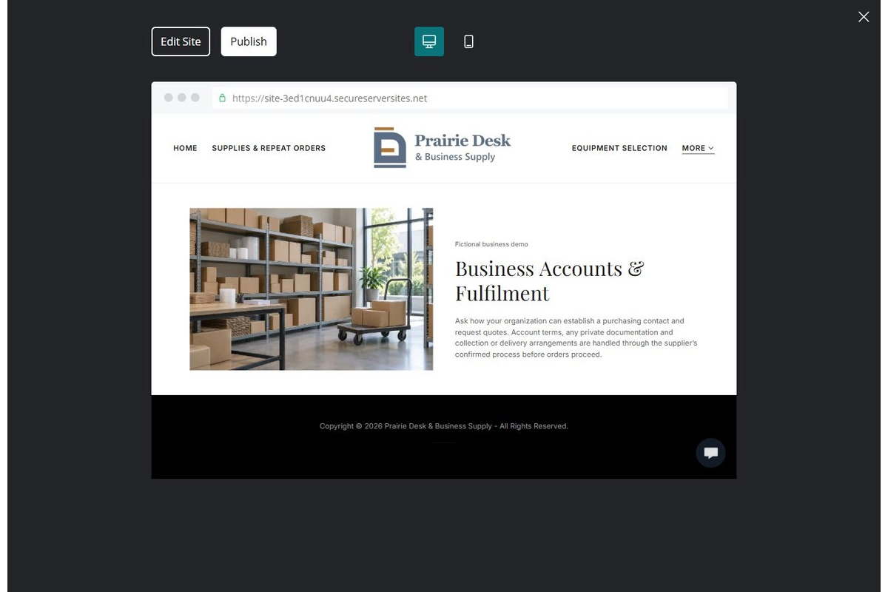
Unpublished Website Builder desktop excerpt. Page content continues below.

Sample wording — adapt and verify
Business Accounts & Fulfilment
Ask how your organization can establish a purchasing contact and request quotes.
Account terms, any private documentation and collection or delivery arrangements are handled through the supplier’s confirmed process before orders proceed.
Suggested button: Ask about supplies, equipment or account service

Website advice
Explain account enquiries, purchasing contacts, quote approval and delivery review without collecting payment or credit records publicly.

Your draft: Business Accounts & Fulfilment
Write in the voice of your own business. Use facts you can verify, not promises copied from the example.

Headline and short introduction

Main content and details visitors need

Button wording and destination

Photo choice, permission and facts still to confirm
Partner check: can someone unfamiliar with the business find a useful next step?

06 Product Enquiry & Visit Information
Give this page one clear job in the customer journey.
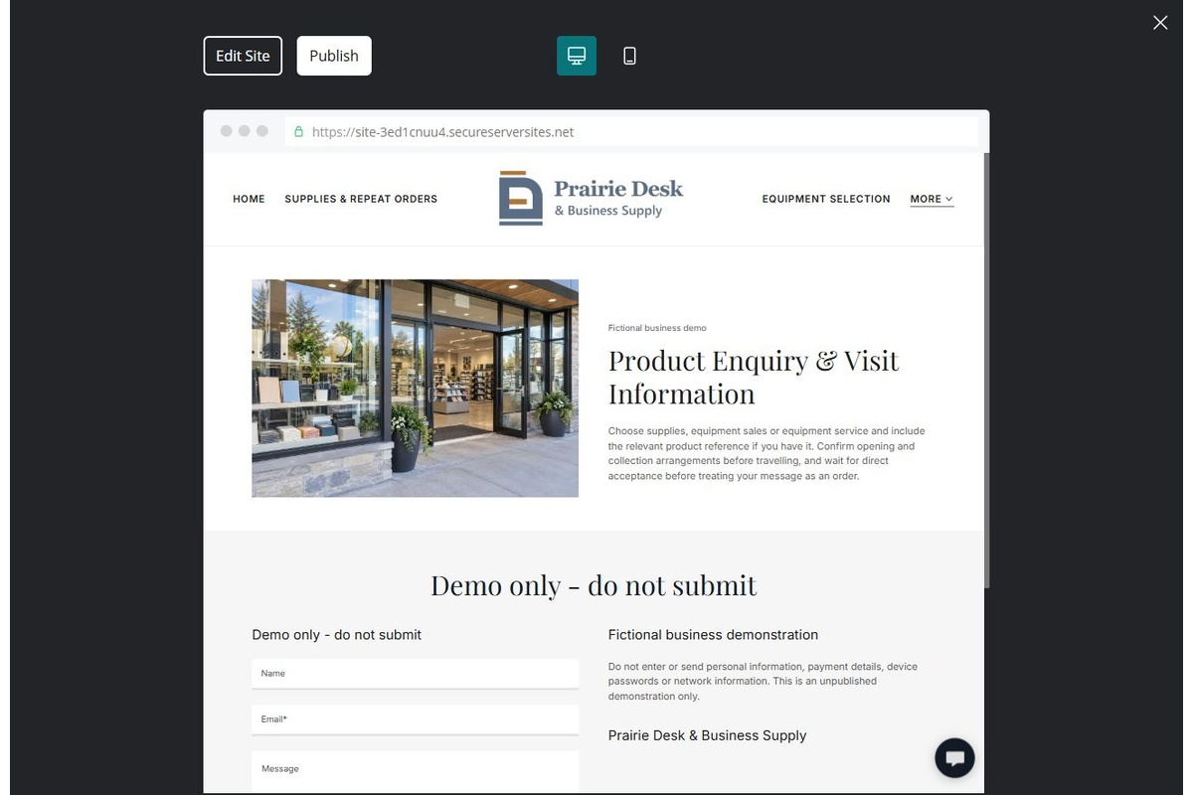
Unpublished Website Builder desktop excerpt. Page content continues below.

Sample wording — adapt and verify
Product Enquiry & Visit Information
Choose supplies, equipment sales or equipment service and include the relevant product reference if you have it.
Confirm opening and collection arrangements before travelling, and wait for direct acceptance before treating your message as an order.
Suggested button: Ask about supplies, equipment or account service

Website advice
Route customers to the right department with current visit details and a clear enquiry-versus-order distinction.

Your draft: Product Enquiry & Visit Information
Write in the voice of your own business. Use facts you can verify, not promises copied from the example.

Headline and short introduction

Main content and details visitors need

Button wording and destination

Photo choice, permission and facts still to confirm
Partner check: can someone unfamiliar with the business find a useful next step?

Test before publishing
Review the whole journey on a desktop and phone. Compare these desktop excerpts with the mobile captures on the industry page.
□ Fictional demonstration only. Verify current products, specifications, compatibility, stock, equipment-service scope and account terms. No live inventory, automatic account approval, manufacturer affiliation or guaranteed delivery is implied; keep financial and device credentials private.
□ Verify every service description, contact route and operating detail.
□ Replace fictional identity and example information before a live launch.
□ Test enquiries, links and downloads on desktop and mobile.
□ Keep confidential records in approved private systems.
□ Obtain operator approval for public wording and images.
□ Check every link, form destination, download and confirmation message.
□ Check logo contrast, hero framing, text sizes and image loading.
□ Save a named backup and assign a content-review date.

Changes to finish and person responsible

Approval and next review date
Website Builder plans and signup

