

Museums, Heritage & Cultural Attractions
Website workbook
A practical workshop for a 5-page website. Study the example, plan the content and draft your own version in Word or on paper.
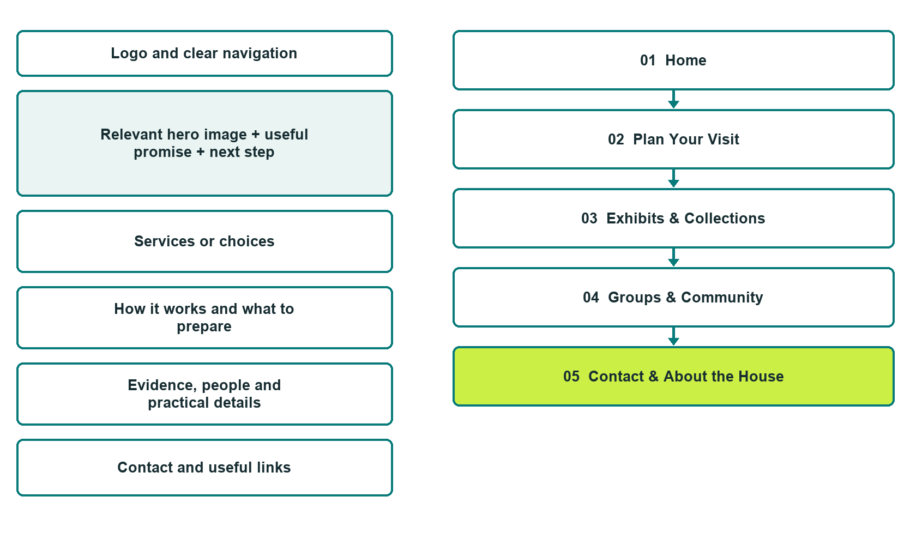

Plan → Draft → Build → Test
Capture edition: five genuine unpublished Website Builder desktop excerpts. The cover wireframe remains illustrative.
Explore Website Builder and compare plans

Before you build
Your business supplies the facts. Prairie Lantern Heritage House is a fictional teaching example, not a live service.

□ Plan a visit enquiry
□ Verified identity, service scope and current contacts
□ Clear enquiry and confirmation steps
□ Choose original photographs and confirm permission to use them.
□ Keep private customer records out of public website forms.

Your audience and the action you want them to take

Facts to verify and people who must approve them
Create your SaaSTech account

01 Home
Give this page one clear job in the customer journey.
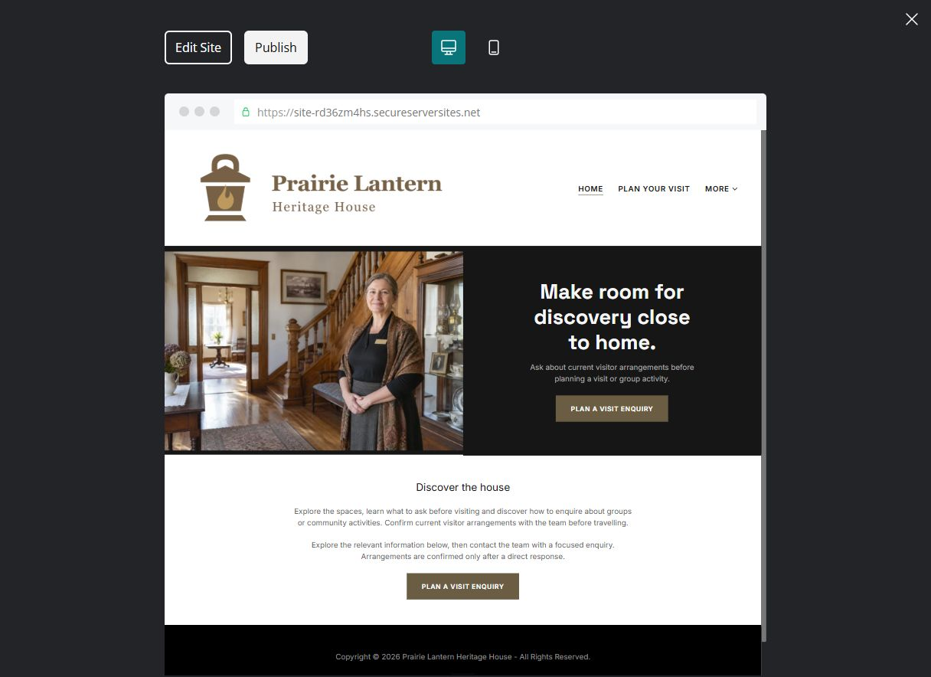
Unpublished Website Builder desktop excerpt. Page content continues below.

Sample wording — adapt and verify
Make room for discovery close to home.
Explore the spaces, learn what to ask before visiting and discover how to enquire about groups or community activities. Confirm current visitor arrangements with the team before travelling.
Explore the relevant information below, then contact the team with a focused enquiry. Arrangements are confirmed only after a direct response.
Suggested button: Plan a visit enquiry

Website advice
Explain current visitor information, exhibits, group enquiries and community participation with accurate permissions and respectful context.

Your draft: Home
Write in the voice of your own business. Use facts you can verify, not promises copied from the example.

Headline and short introduction

Main content and details visitors need

Button wording and destination

Photo choice, permission and facts still to confirm
Partner check: can someone unfamiliar with the business find a useful next step?

02 Plan Your Visit
Give this page one clear job in the customer journey.
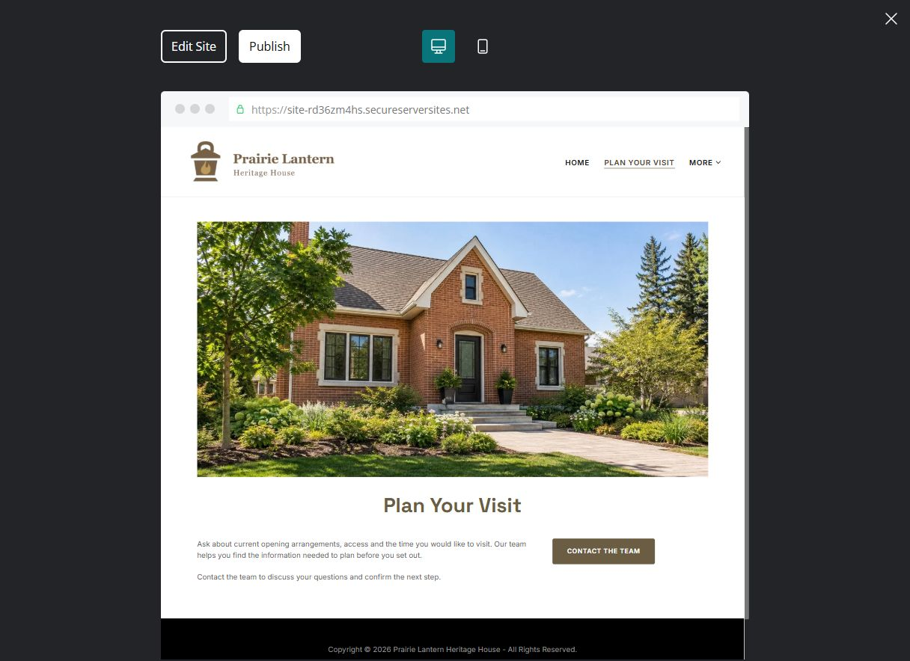
Unpublished Website Builder desktop excerpt. Page content continues below.

Sample wording — adapt and verify
Plan Your Visit
Ask about current opening arrangements, access and the time you would like to visit. Our team helps you find the information needed to plan before you set out.
Contact the team to discuss your questions and confirm the next step.
Suggested button: Contact the team

Website advice
Give verified hours, access, admission and arrival details without inventing availability.

Your draft: Plan Your Visit
Write in the voice of your own business. Use facts you can verify, not promises copied from the example.

Headline and short introduction

Main content and details visitors need

Button wording and destination

Photo choice, permission and facts still to confirm
Partner check: can someone unfamiliar with the business find a useful next step?

03 Exhibits & Collections
Give this page one clear job in the customer journey.
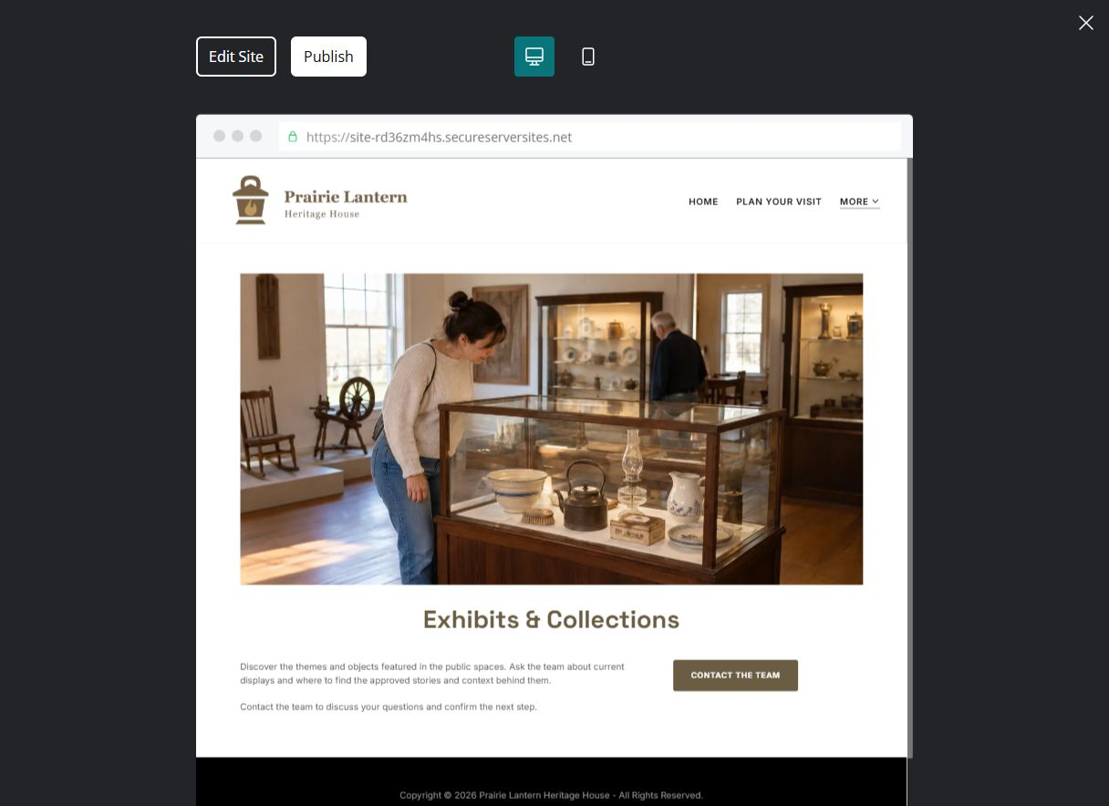
Unpublished Website Builder desktop excerpt. Page content continues below.

Sample wording — adapt and verify
Exhibits & Collections
Discover the themes and objects featured in the public spaces. Ask the team about current displays and where to find the approved stories and context behind them.
Contact the team to discuss your questions and confirm the next step.
Suggested button: Contact the team

Website advice
Use accurate object context and permission-cleared images; illustrative scenes are not collection records.

Your draft: Exhibits & Collections
Write in the voice of your own business. Use facts you can verify, not promises copied from the example.

Headline and short introduction

Main content and details visitors need

Button wording and destination

Photo choice, permission and facts still to confirm
Partner check: can someone unfamiliar with the business find a useful next step?

04 Groups & Community
Give this page one clear job in the customer journey.
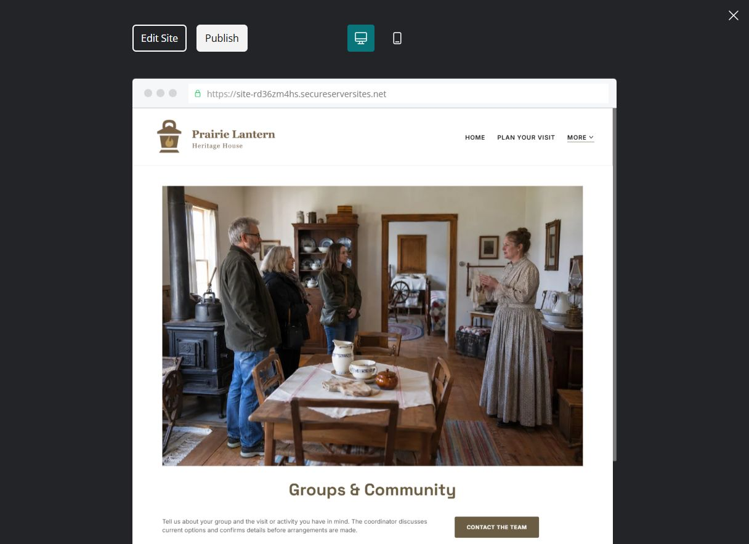
Unpublished Website Builder desktop excerpt. Page content continues below.

Sample wording — adapt and verify
Groups & Community
Tell us about your group and the visit or activity you have in mind. The coordinator discusses current options and confirms details before arrangements are made.
Contact the team to discuss your questions and confirm the next step.
Suggested button: Contact the team

Website advice
Explain group enquiry and participation review without promising dates or programmes.

Your draft: Groups & Community
Write in the voice of your own business. Use facts you can verify, not promises copied from the example.

Headline and short introduction

Main content and details visitors need

Button wording and destination

Photo choice, permission and facts still to confirm
Partner check: can someone unfamiliar with the business find a useful next step?

05 Contact & About the House
Give this page one clear job in the customer journey.
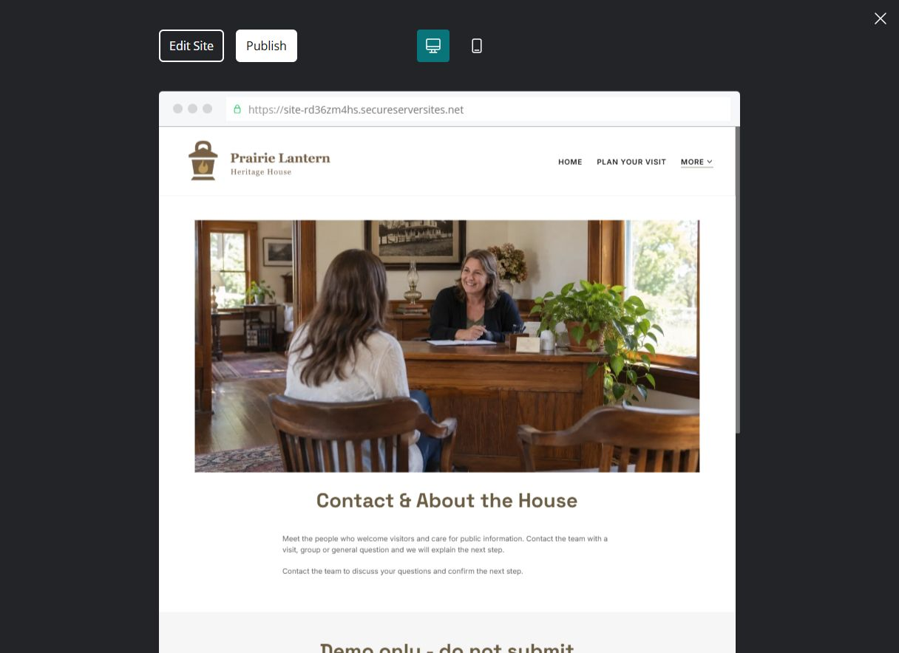
Unpublished Website Builder desktop excerpt. Page content continues below.

Sample wording — adapt and verify
Contact & About the House
Meet the people who welcome visitors and care for public information. Contact the team with a visit, group or general question and we will explain the next step.
Contact the team to discuss your questions and confirm the next step.
Suggested button: Contact the team

Website advice
Introduce verified stewardship and contact routes, respecting collection and personal privacy.

Your draft: Contact & About the House
Write in the voice of your own business. Use facts you can verify, not promises copied from the example.

Headline and short introduction

Main content and details visitors need

Button wording and destination

Photo choice, permission and facts still to confirm
Partner check: can someone unfamiliar with the business find a useful next step?

Test before publishing
Review the whole journey on a desktop and phone. Check links, image framing and demo-form privacy before launch.
□ Fictional attraction example. Verify opening hours, admission, access, collection provenance and permissions. Do not invent historical facts, cultural affiliations or community endorsements.
□ Verify contact routes, location, hours, service scope and all commercial terms.
□ Replace fictional identities and AI illustrations or label them accurately.
□ Remove unverified testimonials, results, credentials and availability.
□ Check every link, form and download on desktop and mobile.
□ Keep sensitive documents, access information and payment details out of public forms.
□ Check every link, form destination, download and confirmation message.
□ Check logo contrast, hero framing, text sizes and image loading.
□ Save a named backup and assign a content-review date.

Changes to finish and person responsible

Approval and next review date
Website Builder plans and signup

