

Moving & Storage Services
Website workbook
A practical workshop for a 5-page website. Study the example, plan the content and draft your own version in Word or on paper.
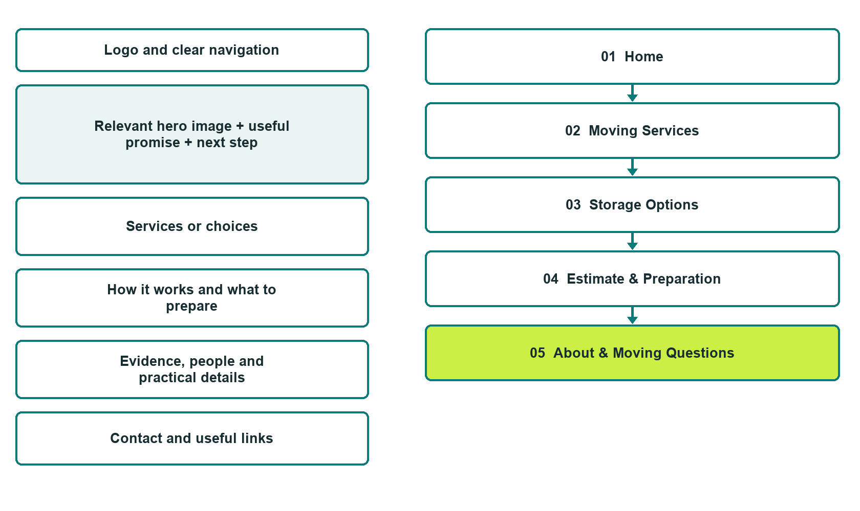

Plan → Draft → Build → Test
Capture edition: five genuine unpublished Website Builder desktop excerpts. The cover wireframe remains illustrative.
Explore Website Builder and compare plans

Before you build
Your business supplies the facts. Prairie Passage Moving is a fictional teaching example, not a live service.

□ Request a moving or storage estimate
□ Verified business identity and current contact information
□ Clear request and confirmation process
□ Choose original photographs and confirm permission to use them.
□ Keep private customer records out of public website forms.

Your audience and the action you want them to take

Facts to verify and people who must approve them
Create your SaaSTech account

01 Home
Give this page one clear job in the customer journey.
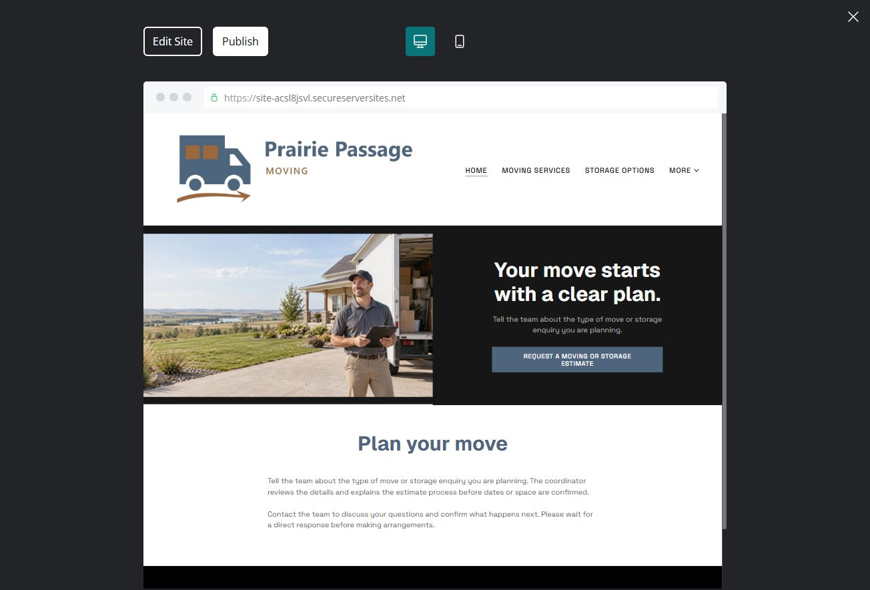
Unpublished Website Builder desktop excerpt. Page content continues below.

Sample wording — adapt and verify
Your move starts with a clear plan.
Tell the team about the type of move or storage enquiry you are planning. The coordinator reviews the details and explains the estimate process before dates or space are confirmed.
Contact the team to discuss your questions and confirm what happens next. Please wait for a direct response before making arrangements.
Suggested button: Request a moving or storage estimate

Website advice
Separate moving, packing and storage enquiries, outline estimate steps and explain what must be confirmed before dates or space are reserved.

Your draft: Home
Write in the voice of your own business. Use facts you can verify, not promises copied from the example.

Headline and short introduction

Main content and details visitors need

Button wording and destination

Photo choice, permission and facts still to confirm
Partner check: can someone unfamiliar with the business find a useful next step?

02 Moving Services
Give this page one clear job in the customer journey.
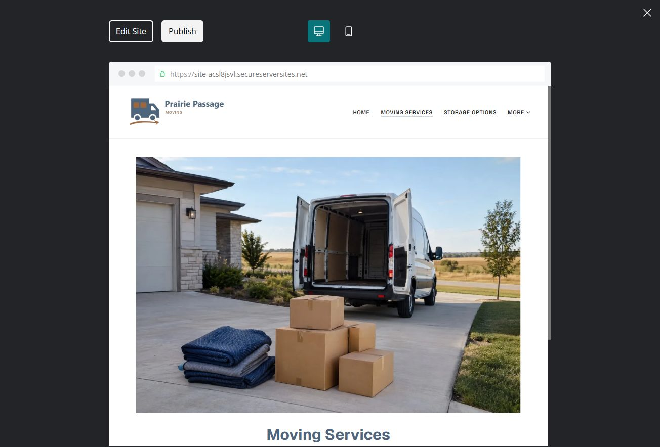
Unpublished Website Builder desktop excerpt. Page content continues below.

Sample wording — adapt and verify
Moving Services
Ask which moving services fit the locations and items you need to discuss. The team reviews access and scope before preparing the next step.
Contact the team to discuss your questions and confirm what happens next. Please wait for a direct response before making arrangements.
Suggested button: Contact the team

Website advice
Describe verified local, longer-distance or packing services separately. Do not imply every item or route is accepted.

Your draft: Moving Services
Write in the voice of your own business. Use facts you can verify, not promises copied from the example.

Headline and short introduction

Main content and details visitors need

Button wording and destination

Photo choice, permission and facts still to confirm
Partner check: can someone unfamiliar with the business find a useful next step?

03 Storage Options
Give this page one clear job in the customer journey.
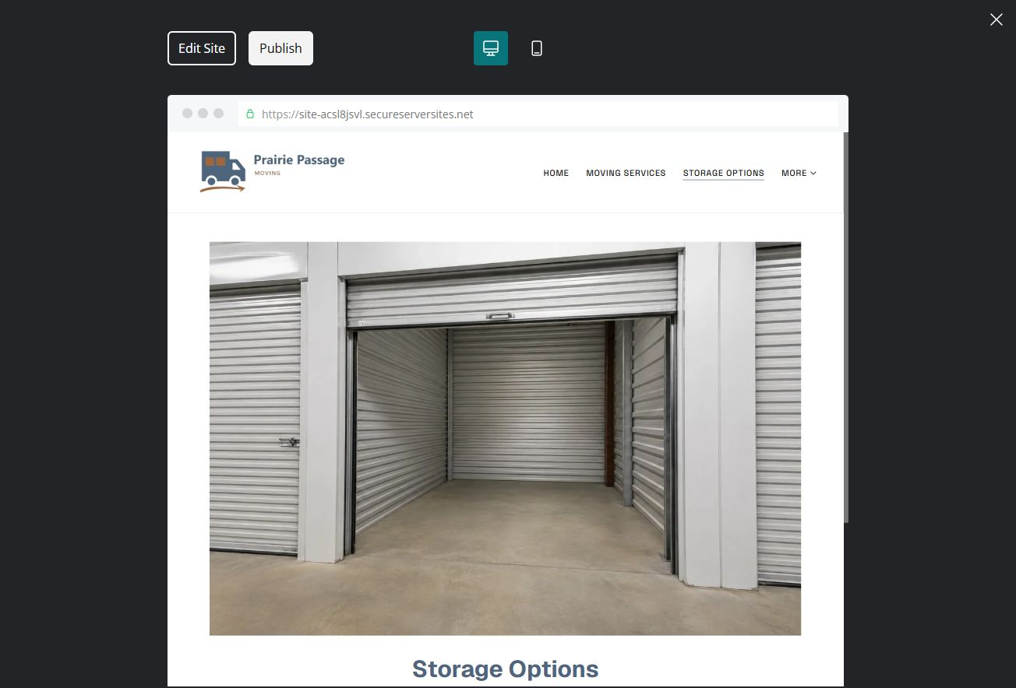
Unpublished Website Builder desktop excerpt. Page content continues below.

Sample wording — adapt and verify
Storage Options
Discuss the size and timing of your storage enquiry with the operator. Confirm suitability, access and terms before reserving space.
Contact the team to discuss your questions and confirm what happens next. Please wait for a direct response before making arrangements.
Suggested button: Contact the team

Website advice
Explain actual storage categories, access arrangements and confirmation steps without inventing unit availability.

Your draft: Storage Options
Write in the voice of your own business. Use facts you can verify, not promises copied from the example.

Headline and short introduction

Main content and details visitors need

Button wording and destination

Photo choice, permission and facts still to confirm
Partner check: can someone unfamiliar with the business find a useful next step?

04 Estimate & Preparation
Give this page one clear job in the customer journey.
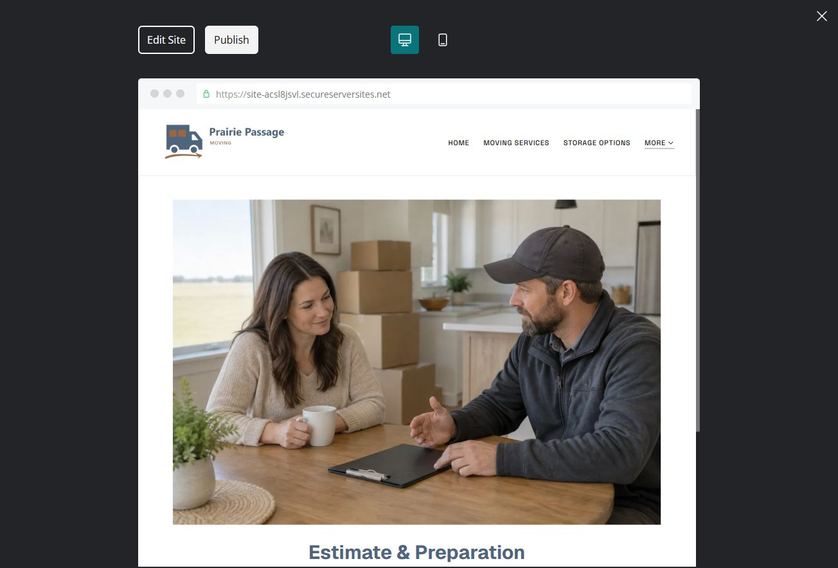
Unpublished Website Builder desktop excerpt. Page content continues below.

Sample wording — adapt and verify
Estimate & Preparation
Prepare a general description of the move and the questions you want answered. The coordinator explains how detailed information is shared and how the estimate is reviewed.
Contact the team to discuss your questions and confirm what happens next. Please wait for a direct response before making arrangements.
Suggested button: Contact the team

Website advice
Explain survey, item information, estimate questions and operator-approved preparation.

Your draft: Estimate & Preparation
Write in the voice of your own business. Use facts you can verify, not promises copied from the example.

Headline and short introduction

Main content and details visitors need

Button wording and destination

Photo choice, permission and facts still to confirm
Partner check: can someone unfamiliar with the business find a useful next step?

05 About & Moving Questions
Give this page one clear job in the customer journey.
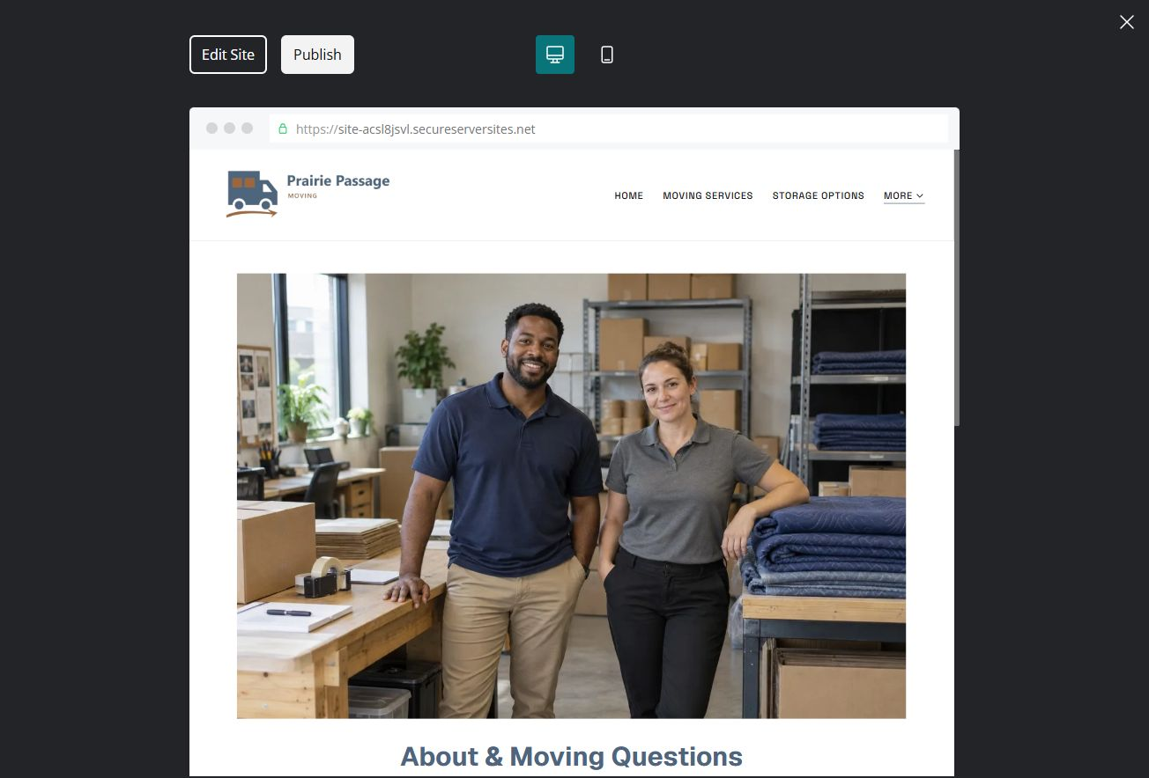
Unpublished Website Builder desktop excerpt. Page content continues below.

Sample wording — adapt and verify
About & Moving Questions
Meet the people who coordinate enquiries and updates. Ask who confirms arrangements and how changes should be communicated before moving day.
Contact the team to discuss your questions and confirm what happens next. Please wait for a direct response before making arrangements.
Suggested button: Contact the team

Website advice
Introduce the team and practical communication process. Use distinct vehicle, packing and staff imagery.

Your draft: About & Moving Questions
Write in the voice of your own business. Use facts you can verify, not promises copied from the example.

Headline and short introduction

Main content and details visitors need

Button wording and destination

Photo choice, permission and facts still to confirm
Partner check: can someone unfamiliar with the business find a useful next step?

Test before publishing
Review the whole journey on a desktop and phone. Check links, image framing and demo-form privacy before launch.
□ Fictional business example only. Verify service area, capacity, insurance, handling limits, prices and terms with the operator; do not collect access codes or identity documents publicly.
□ Verify contact routes, hours, location and every offered service.
□ Remove invented prices, claims, testimonials and availability.
□ Keep sensitive records and payment details out of ordinary public forms.
□ Check all image permissions, downloads and page links on a phone.
□ Check every link, form destination, download and confirmation message.
□ Check logo contrast, hero framing, text sizes and image loading.
□ Save a named backup and assign a content-review date.

Changes to finish and person responsible

Approval and next review date
Website Builder plans and signup

