

Locksmiths & Security Systems
Website workbook
A practical workshop for a 5-page website. Study the example, plan the content and draft your own version in Word or on paper.
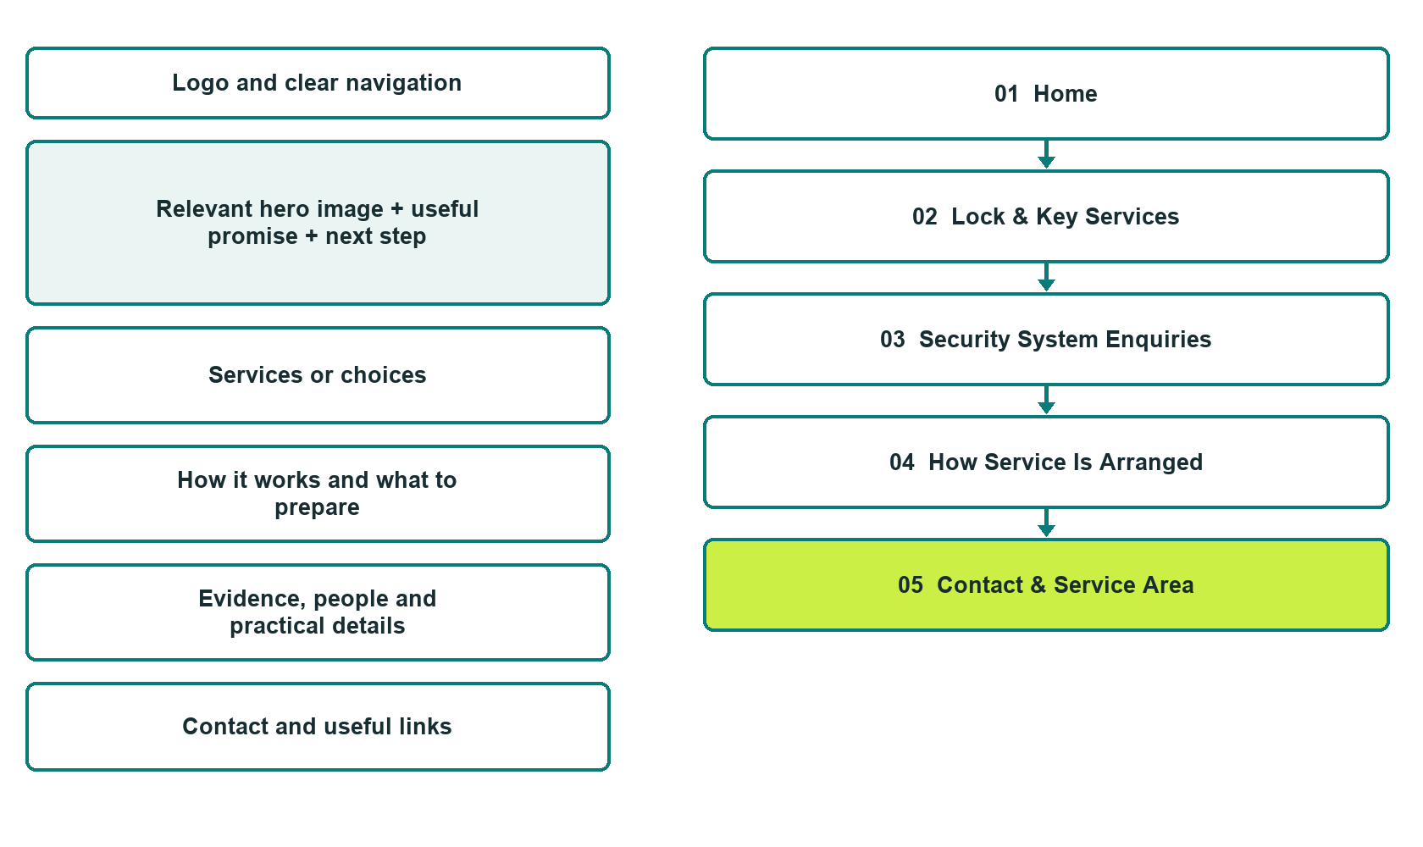

Plan → Draft → Build → Test
Capture edition: five genuine unpublished Website Builder desktop excerpts. Review mobile views on the industry page.
Explore Website Builder and compare plans

Before you build
Your business supplies the facts. Prairie Keyline Security is a fictional teaching example, not a live service.

□ Discuss a service enquiry
□ Verified business identity, services and current contact information
□ A clear enquiry, review and confirmation process
□ Choose original photographs and confirm permission to use them.
□ Keep private customer records out of public website forms.

Your audience and the action you want them to take

Facts to verify and people who must approve them
Create your SaaSTech account

01 Home
Give this page one clear job in the customer journey.
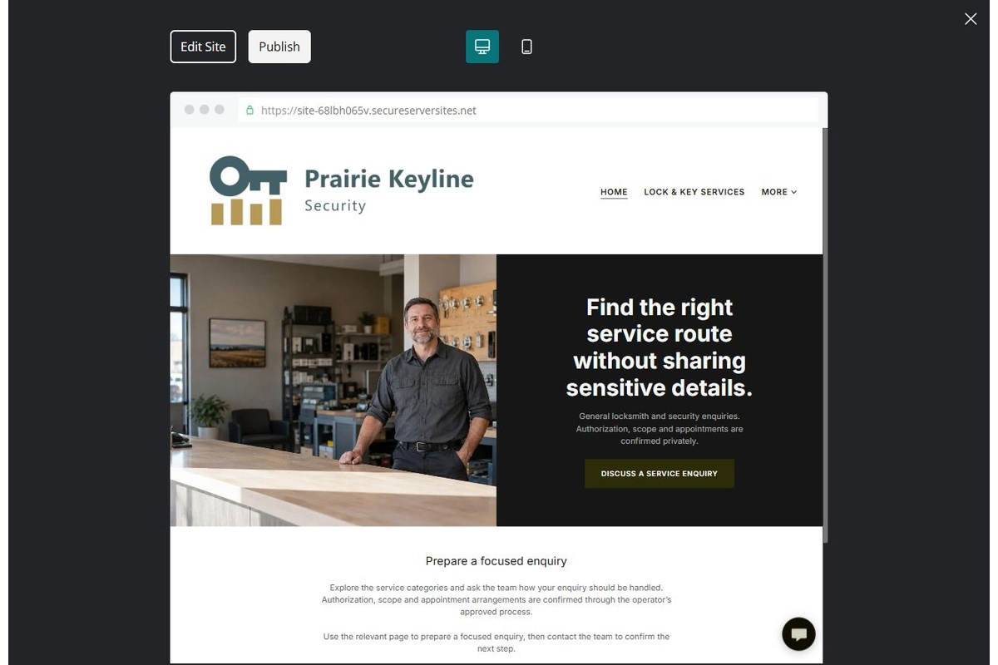
Unpublished Website Builder desktop excerpt. Page content continues below.

Sample wording — adapt and verify
Find the right service route without sharing sensitive details.
Explore the service categories and ask the team how your enquiry should be handled. Authorization, scope and appointment arrangements are confirmed through the operator’s approved process.
Use the relevant page to prepare a focused enquiry, then contact the team to confirm the next step.
Suggested button: Discuss a service enquiry

Website advice
Separate locksmith and security-system enquiries, explain authorization checks and service confirmation without exposing access methods.

Your draft: Home
Write in the voice of your own business. Use facts you can verify, not promises copied from the example.

Headline and short introduction

Main content and details visitors need

Button wording and destination

Photo choice, permission and facts still to confirm
Partner check: can someone unfamiliar with the business find a useful next step?

02 Lock & Key Services
Give this page one clear job in the customer journey.
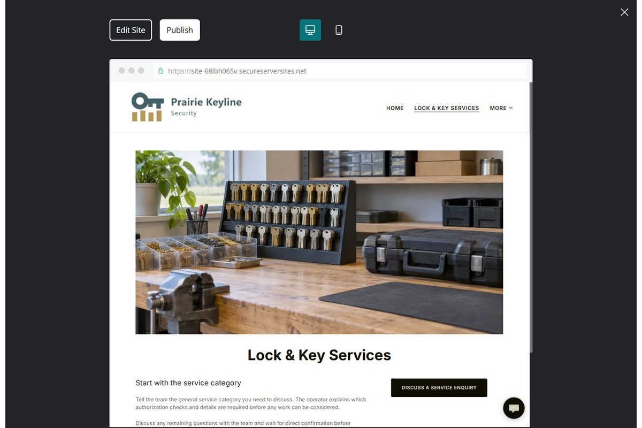
Unpublished Website Builder desktop excerpt. Page content continues below.

Sample wording — adapt and verify
Lock & Key Services
Tell the team the general service category you need to discuss. The operator explains which authorization checks and details are required before any work can be considered.
Discuss any remaining questions with the team and wait for direct confirmation before making arrangements.
Suggested button: Discuss a service enquiry

Website advice
Describe accepted services at a high level and state that authorization and scope are checked privately.

Your draft: Lock & Key Services
Write in the voice of your own business. Use facts you can verify, not promises copied from the example.

Headline and short introduction

Main content and details visitors need

Button wording and destination

Photo choice, permission and facts still to confirm
Partner check: can someone unfamiliar with the business find a useful next step?

03 Security System Enquiries
Give this page one clear job in the customer journey.
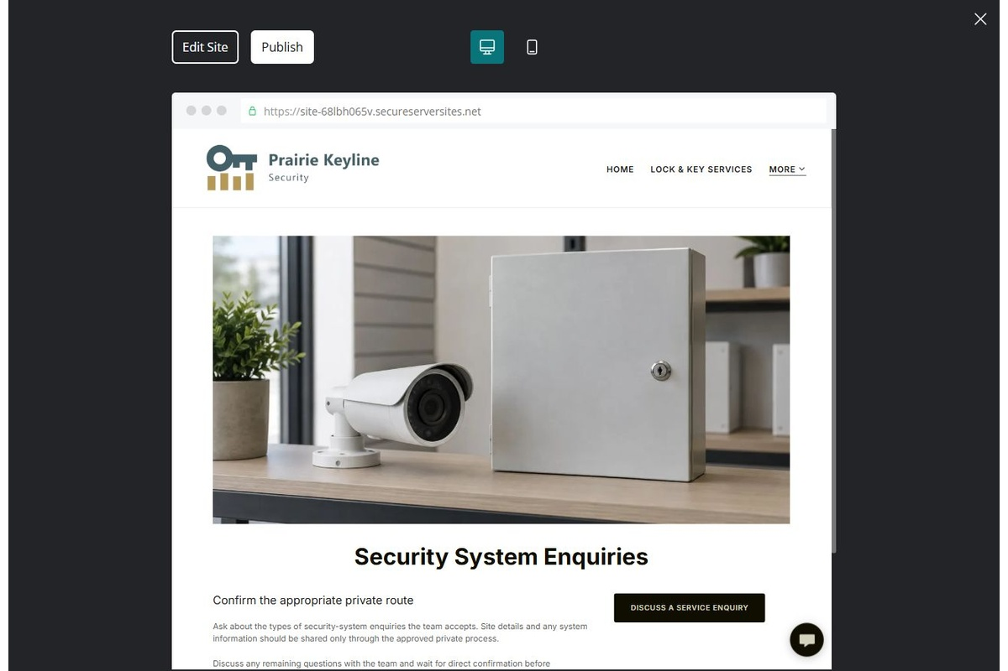
Unpublished Website Builder desktop excerpt. Page content continues below.

Sample wording — adapt and verify
Security System Enquiries
Ask about the types of security-system enquiries the team accepts. Site details and any system information should be shared only through the approved private process.
Discuss any remaining questions with the team and wait for direct confirmation before making arrangements.
Suggested button: Discuss a service enquiry

Website advice
Discuss consultation and service categories without publishing sensitive layouts, technical vulnerabilities or guarantees.

Your draft: Security System Enquiries
Write in the voice of your own business. Use facts you can verify, not promises copied from the example.

Headline and short introduction

Main content and details visitors need

Button wording and destination

Photo choice, permission and facts still to confirm
Partner check: can someone unfamiliar with the business find a useful next step?

04 How Service Is Arranged
Give this page one clear job in the customer journey.
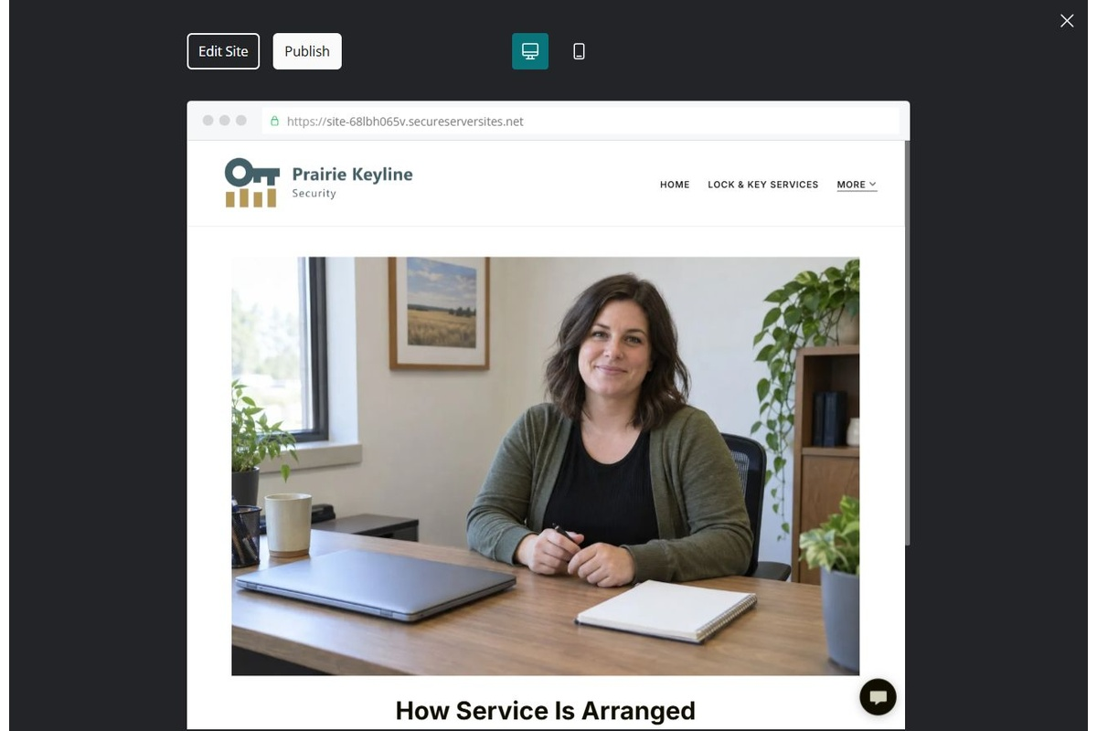
Unpublished Website Builder desktop excerpt. Page content continues below.

Sample wording — adapt and verify
How Service Is Arranged
Start with a general description and contact preference. Staff explains the next step, including any private verification, before confirming availability or dispatch.
Discuss any remaining questions with the team and wait for direct confirmation before making arrangements.
Suggested button: Discuss a service enquiry

Website advice
Explain initial contact, authorization, scope review and confirmed scheduling; publish urgent routes only after operator review.

Your draft: How Service Is Arranged
Write in the voice of your own business. Use facts you can verify, not promises copied from the example.

Headline and short introduction

Main content and details visitors need

Button wording and destination

Photo choice, permission and facts still to confirm
Partner check: can someone unfamiliar with the business find a useful next step?

05 Contact & Service Area
Give this page one clear job in the customer journey.
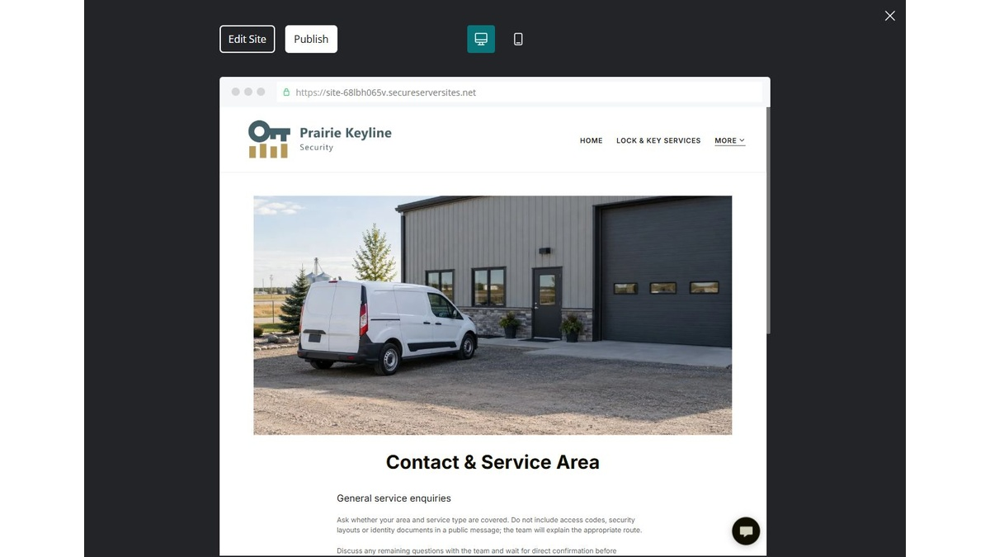
Unpublished Website Builder desktop excerpt. Page content continues below.

Sample wording — adapt and verify
Contact & Service Area
Ask whether your area and service type are covered. Do not include access codes, security layouts or identity documents in a public message; the team will explain the appropriate route.
Discuss any remaining questions with the team and wait for direct confirmation before making arrangements.
Suggested button: Discuss a service enquiry

Website advice
Separate routine requests from reviewed urgent routes and avoid promising round-the-clock response.

Your draft: Contact & Service Area
Write in the voice of your own business. Use facts you can verify, not promises copied from the example.

Headline and short introduction

Main content and details visitors need

Button wording and destination

Photo choice, permission and facts still to confirm
Partner check: can someone unfamiliar with the business find a useful next step?

Test before publishing
Review the whole journey on a desktop and phone. Compare these desktop excerpts with the mobile captures on the industry page.
□ Fictional demonstration only. Verify qualifications, service coverage and urgent contact procedures. Do not publish bypass instructions or collect codes, keys, access credentials, alarm details or identity documents through public forms.
□ Verify each offered service, contact route, location and opening arrangement.
□ Remove fictional identity, claims, availability and prices before a real launch.
□ Test every enquiry route and download on desktop and mobile.
□ Keep sensitive information in approved private systems.
□ Obtain operator approval for all public wording and image use.
□ Check every link, form destination, download and confirmation message.
□ Check logo contrast, hero framing, text sizes and image loading.
□ Save a named backup and assign a content-review date.

Changes to finish and person responsible

Approval and next review date
Website Builder plans and signup

