

Jewellers & Watch Repair
Website workbook
A practical workshop for a 6-page website. Study the example, plan the content and draft your own version in Word or on paper.
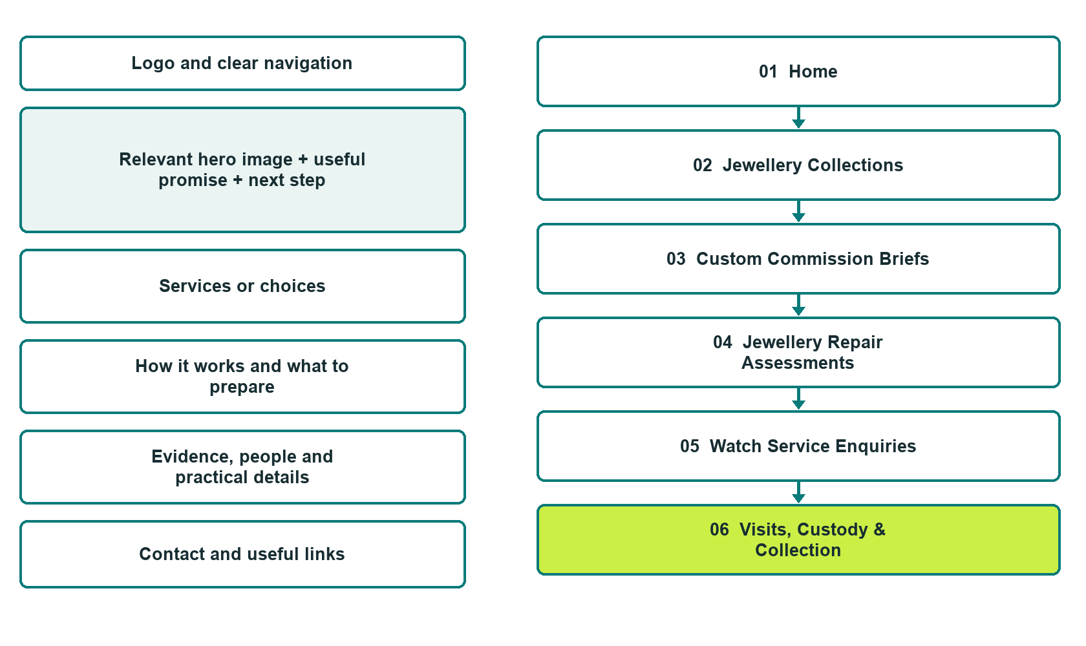

Plan → Draft → Build → Test
Website Builder capture edition: six desktop excerpts from the fictional demo; the wireframe remains a planning illustration.
Explore Website Builder and compare plans

Before you build
Your business supplies the facts. Prairie Juniper Jewellery & Watch is a fictional teaching example, not a live service.
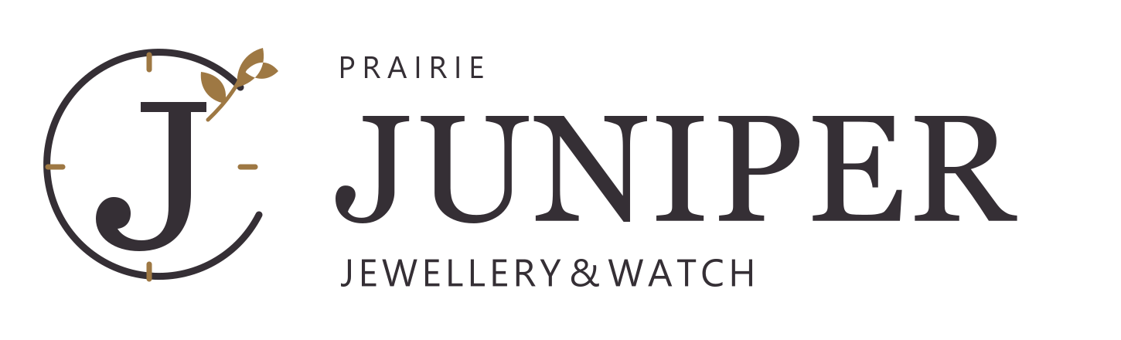
□ Discuss a piece or assessment
□ Verified business identity, services and current contact information
□ A clear enquiry, review and confirmation process
□ Choose original photographs and confirm permission to use them.
□ Keep private customer records out of public website forms.

Your audience and the action you want them to take

Facts to verify and people who must approve them
Create your SaaSTech account

01 Home
Give this page one clear job in the customer journey.
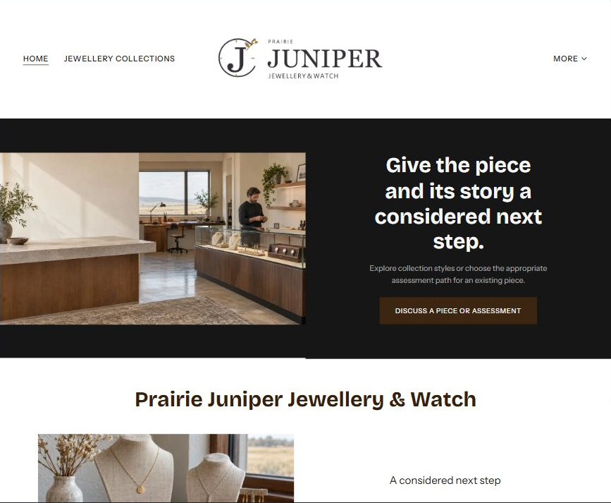
Actual Website Builder desktop excerpt from the fictional demo

Sample wording — adapt and verify
Give the piece and its story a considered next step.
Explore collection styles or choose the appropriate assessment path for an existing piece.
The studio confirms what it can accept and explains how proposals, permissions and collection arrangements are recorded.
Suggested button: Discuss a piece or assessment

Website advice
Separate jewellery collections, custom commissions, jewellery assessment and watch service; use reviewed material descriptions and documented approval and custody arrangements.

Your draft: Home
Write in the voice of your own business. Use facts you can verify, not promises copied from the example.

Headline and short introduction

Main content and details visitors need

Button wording and destination

Photo choice, permission and facts still to confirm
Partner check: can someone unfamiliar with the business find a useful next step?

02 Jewellery Collections
Give this page one clear job in the customer journey.
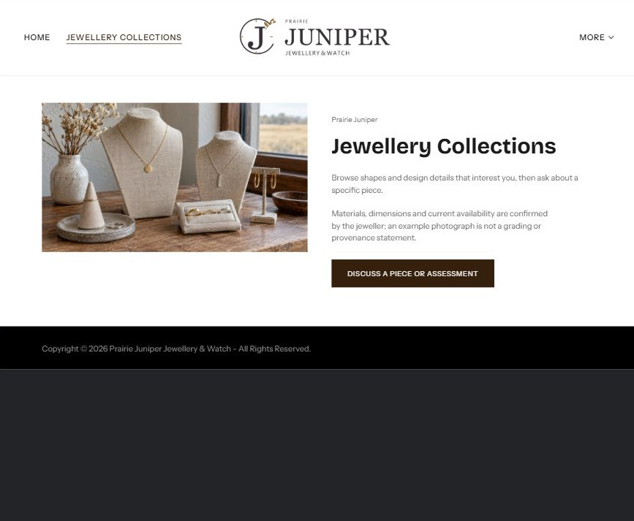
Actual Website Builder desktop excerpt from the fictional demo

Sample wording — adapt and verify
Jewellery Collections
Browse shapes and design details that interest you, then ask about a specific piece.
Materials, dimensions and current availability are confirmed by the jeweller; an example photograph is not a grading or provenance statement.
Suggested button: Discuss a piece or assessment

Website advice
Present style-led examples with verified material and availability information before any purchase claim.

Your draft: Jewellery Collections
Write in the voice of your own business. Use facts you can verify, not promises copied from the example.

Headline and short introduction

Main content and details visitors need

Button wording and destination

Photo choice, permission and facts still to confirm
Partner check: can someone unfamiliar with the business find a useful next step?

03 Custom Commission Briefs
Give this page one clear job in the customer journey.
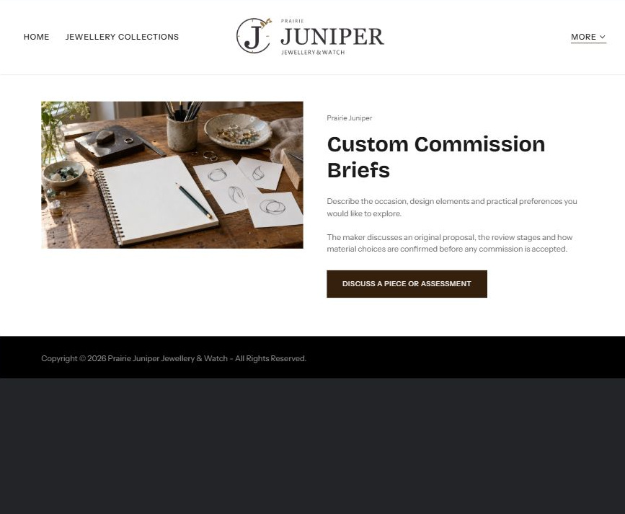
Actual Website Builder desktop excerpt from the fictional demo

Sample wording — adapt and verify
Custom Commission Briefs
Describe the occasion, design elements and practical preferences you would like to explore.
The maker discusses an original proposal, the review stages and how material choices are confirmed before any commission is accepted.
Suggested button: Discuss a piece or assessment

Website advice
Explain design conversations and permissions without treating reference images as permission to copy another maker.

Your draft: Custom Commission Briefs
Write in the voice of your own business. Use facts you can verify, not promises copied from the example.

Headline and short introduction

Main content and details visitors need

Button wording and destination

Photo choice, permission and facts still to confirm
Partner check: can someone unfamiliar with the business find a useful next step?

04 Jewellery Repair Assessments
Give this page one clear job in the customer journey.
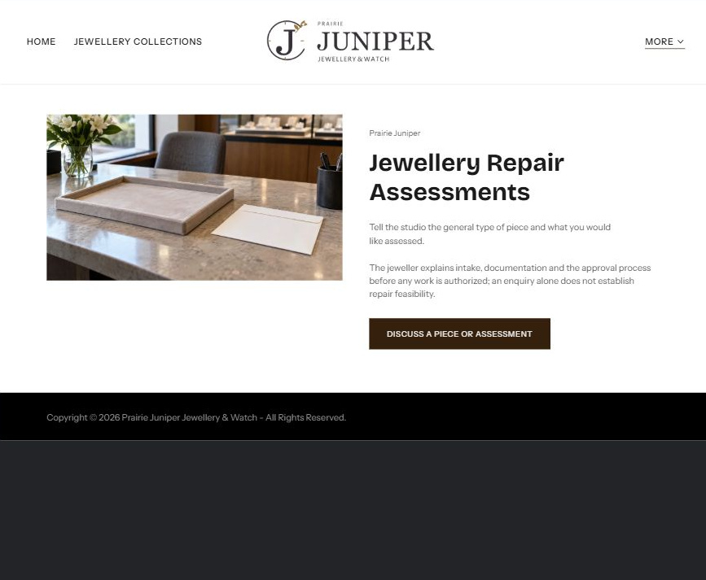
Actual Website Builder desktop excerpt from the fictional demo

Sample wording — adapt and verify
Jewellery Repair Assessments
Tell the studio the general type of piece and what you would like assessed.
The jeweller explains intake, documentation and the approval process before any work is authorized; an enquiry alone does not establish repair feasibility.
Suggested button: Discuss a piece or assessment

Website advice
Separate inspection and estimates from authorized work and make acceptance subject to review.

Your draft: Jewellery Repair Assessments
Write in the voice of your own business. Use facts you can verify, not promises copied from the example.

Headline and short introduction

Main content and details visitors need

Button wording and destination

Photo choice, permission and facts still to confirm
Partner check: can someone unfamiliar with the business find a useful next step?

05 Watch Service Enquiries
Give this page one clear job in the customer journey.
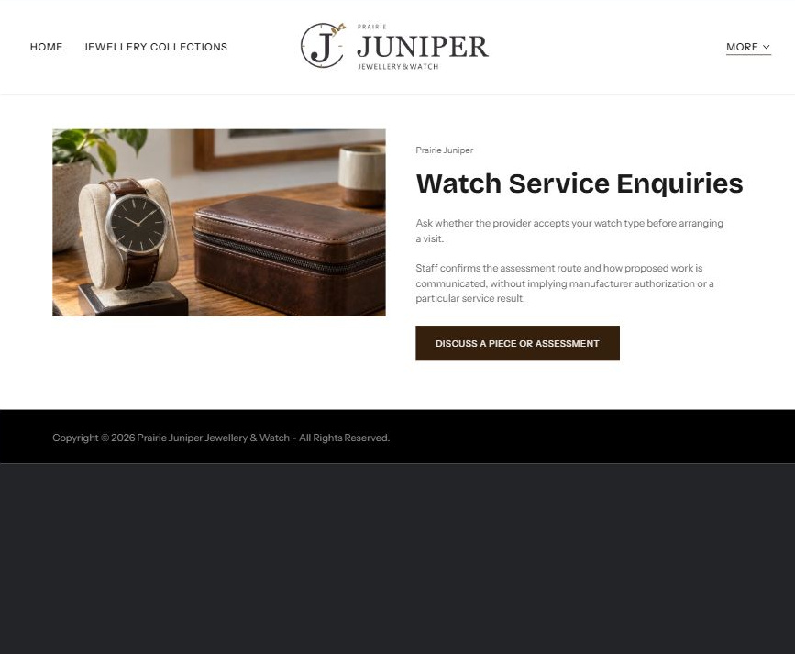
Actual Website Builder desktop excerpt from the fictional demo

Sample wording — adapt and verify
Watch Service Enquiries
Ask whether the provider accepts your watch type before arranging a visit.
Staff confirms the assessment route and how proposed work is communicated, without implying manufacturer authorization or a particular service result.
Suggested button: Discuss a piece or assessment

Website advice
Provide a distinct watch route with exact brand and model acceptance reviewed by the operator.

Your draft: Watch Service Enquiries
Write in the voice of your own business. Use facts you can verify, not promises copied from the example.

Headline and short introduction

Main content and details visitors need

Button wording and destination

Photo choice, permission and facts still to confirm
Partner check: can someone unfamiliar with the business find a useful next step?

06 Visits, Custody & Collection
Give this page one clear job in the customer journey.
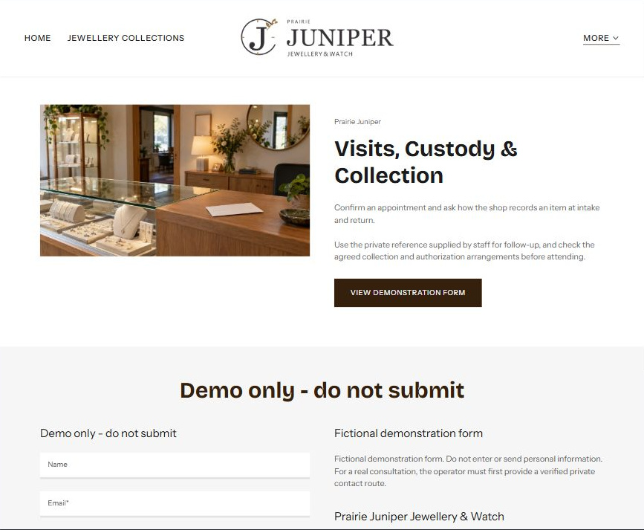
Actual Website Builder desktop excerpt from the fictional demo

Sample wording — adapt and verify
Visits, Custody & Collection
Confirm an appointment and ask how the shop records an item at intake and return.
Use the private reference supplied by staff for follow-up, and check the agreed collection and authorization arrangements before attending.
Suggested button: Discuss a piece or assessment

Website advice
Explain private reference-based handover without requesting valuables, identity documents or detailed inventories through public forms.

Your draft: Visits, Custody & Collection
Write in the voice of your own business. Use facts you can verify, not promises copied from the example.

Headline and short introduction

Main content and details visitors need

Button wording and destination

Photo choice, permission and facts still to confirm
Partner check: can someone unfamiliar with the business find a useful next step?

Test before publishing
Review the whole journey on a desktop and phone. Use these first-screen examples to plan your own pages, then verify your complete website.
□ Fictional business demonstration. Do not invent gemstone grading, metal purity, provenance, appraisal credentials, valuations or brand authorization. All collection images are illustrative. Confirm accepted work and private custody procedures; no cleaning, repair or valuation advice is provided.
□ Verify every service description, contact route and operating detail.
□ Replace fictional identity and example information before a live launch.
□ Test enquiries, links and downloads on desktop and mobile.
□ Keep confidential records in approved private systems.
□ Obtain operator approval for public wording and images.
□ Check every link, form destination, download and confirmation message.
□ Check logo contrast, hero framing, text sizes and image loading.
□ Save a named backup and assign a content-review date.

Changes to finish and person responsible

Approval and next review date
Website Builder plans and signup

