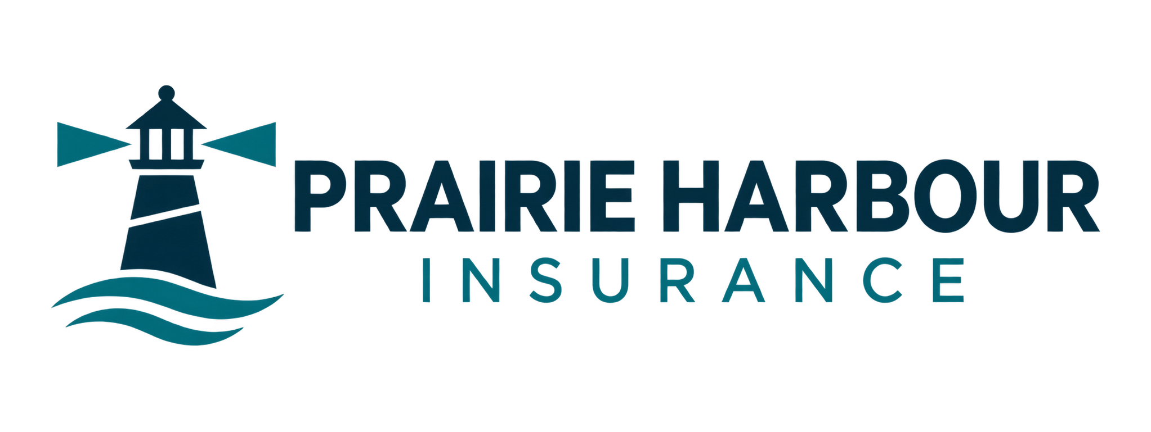

Website content planner
Plan the public information for your brokerage before writing each page. Prairie Harbour Insurance is the fictional worked example; use your own verified business details.
Type in the response lines in Word, or print and write by hand.
Business name and person preparing the content

Primary visitor and the question they need answered

Communities served and insurance categories actually arranged

Main website action and what happens after someone requests it

Facts and photographs to gather with permission

Plan your six pages
For each page, note the key message, evidence needed and next useful action. Use the workshop workbook for a longer first draft.
Home — Audience, service area and a clear introduction

Personal Insurance — Actual categories and useful questions

Business Insurance — Activities served and the consultation process

Meet the Brokers — Verified roles and permission-cleared portraits

Claims and Resources — Verified contacts, instructions and review dates

Request a Quote — Minimum contact fields and reply expectations

Keep confidential client information out of website drafts. A public enquiry is not an insurance application or confirmation of coverage.

