

Heavy Equipment Repair & Diesel Shops
Website workbook
A practical workshop for a 6-page website. Study the example, plan the content and draft your own version in Word or on paper.
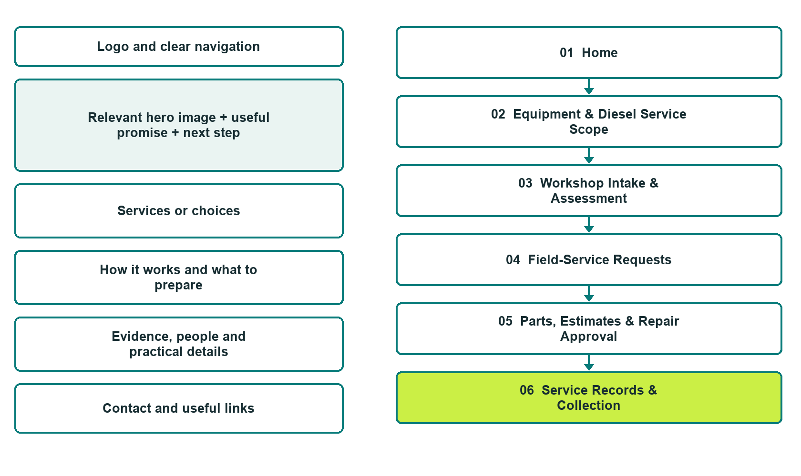

Plan → Draft → Build → Test
Website Builder capture edition: six actual desktop views from the fictional demo; the wireframe remains a planning illustration.
Explore Website Builder and compare plans

Before you build
Your business supplies the facts. Prairie Torque Equipment Service is a fictional teaching example, not a live service.

□ Request an equipment service assessment
□ Verified business identity, services and current contact information
□ A clear enquiry, review and confirmation process
□ Choose original photographs and confirm permission to use them.
□ Keep private customer records out of public website forms.

Your audience and the action you want them to take

Facts to verify and people who must approve them
Create your SaaSTech account

01 Home
Give this page one clear job in the customer journey.
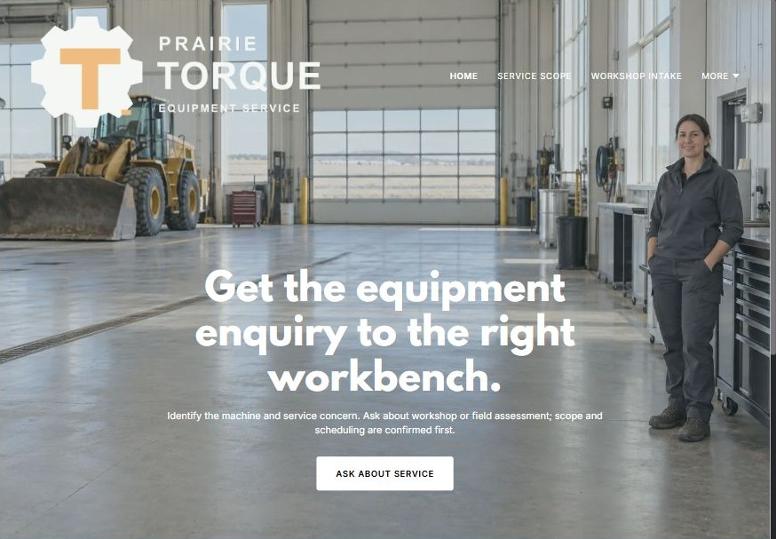
Actual Website Builder desktop capture from the fictional demo

Sample wording — adapt and verify
Get the equipment enquiry to the right workbench.
Identify the machine, describe the service concern and ask whether the shop can assess it.
Workshop and field enquiries follow different arrangements, and repair scope is confirmed through the operator’s authorization process.
Suggested button: Request an equipment service assessment

Website advice
Explain equipment compatibility, workshop intake, field-service enquiries and repair authorization without promising diagnosis or universal brand coverage.

Your draft: Home
Write in the voice of your own business. Use facts you can verify, not promises copied from the example.

Headline and short introduction

Main content and details visitors need

Button wording and destination

Photo choice, permission and facts still to confirm
Partner check: can someone unfamiliar with the business find a useful next step?

02 Equipment & Diesel Service Scope
Give this page one clear job in the customer journey.
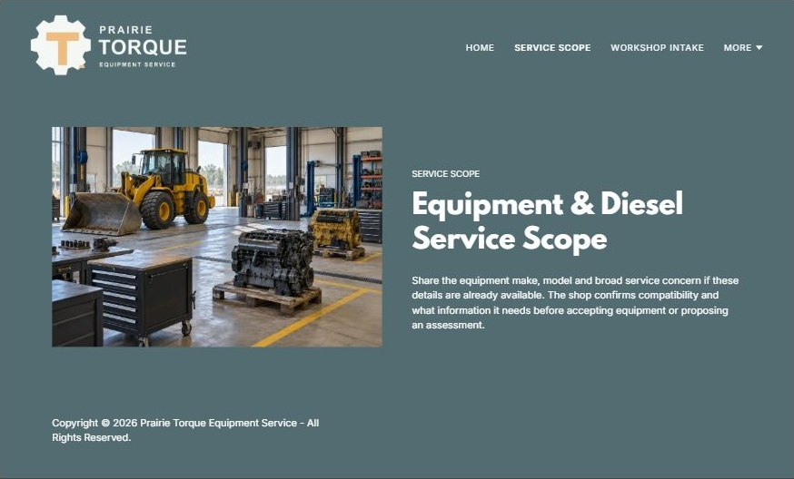
Actual Website Builder desktop capture from the fictional demo

Sample wording — adapt and verify
Equipment & Diesel Service Scope
Share the equipment make, model and broad service concern if these details are already available.
The shop confirms compatibility and what information it needs before accepting equipment or proposing an assessment.
Suggested button: Request an equipment service assessment

Website advice
Organize heavy equipment, commercial diesel and component-service categories without implying that every model is supported.

Your draft: Equipment & Diesel Service Scope
Write in the voice of your own business. Use facts you can verify, not promises copied from the example.

Headline and short introduction

Main content and details visitors need

Button wording and destination

Photo choice, permission and facts still to confirm
Partner check: can someone unfamiliar with the business find a useful next step?

03 Workshop Intake & Assessment
Give this page one clear job in the customer journey.
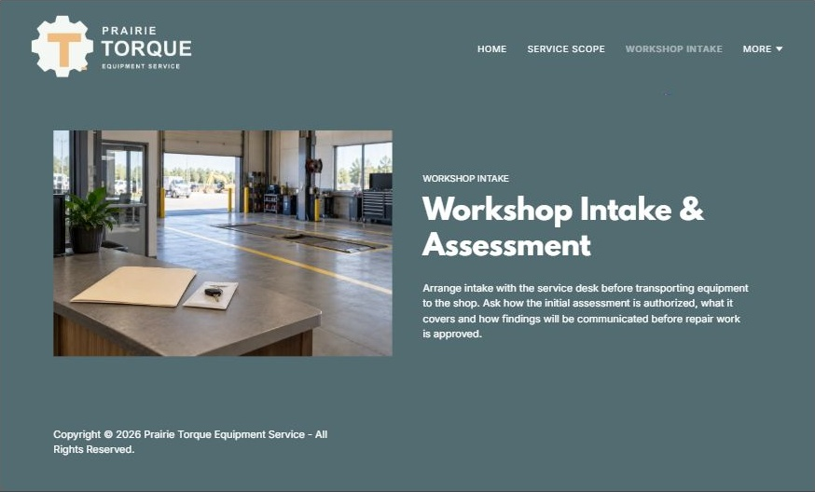
Actual Website Builder desktop capture from the fictional demo

Sample wording — adapt and verify
Workshop Intake & Assessment
Arrange intake with the service desk before transporting equipment to the shop.
Ask how the initial assessment is authorized, what it covers and how findings will be communicated before repair work is approved.
Suggested button: Request an equipment service assessment

Website advice
Explain acceptance, arrival coordination and assessment authorization without publishing technical diagnostic steps.

Your draft: Workshop Intake & Assessment
Write in the voice of your own business. Use facts you can verify, not promises copied from the example.

Headline and short introduction

Main content and details visitors need

Button wording and destination

Photo choice, permission and facts still to confirm
Partner check: can someone unfamiliar with the business find a useful next step?

04 Field-Service Requests
Give this page one clear job in the customer journey.
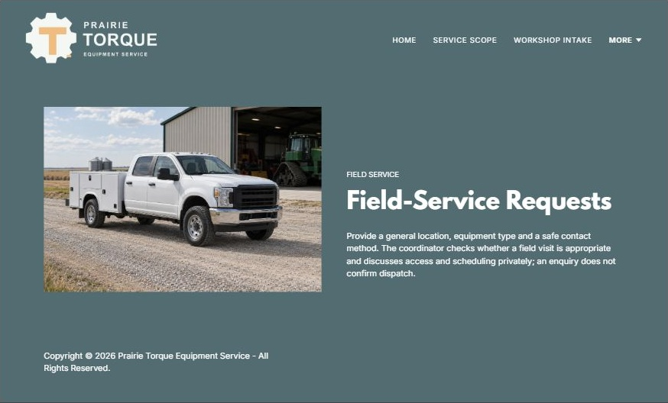
Actual Website Builder desktop capture from the fictional demo

Sample wording — adapt and verify
Field-Service Requests
Provide a general location, equipment type and a safe contact method.
The coordinator checks whether a field visit is appropriate and discusses access and scheduling privately; an enquiry does not confirm dispatch.
Suggested button: Request an equipment service assessment

Website advice
Describe staff-reviewed location and equipment questions while keeping response times and dispatch conditional.

Your draft: Field-Service Requests
Write in the voice of your own business. Use facts you can verify, not promises copied from the example.

Headline and short introduction

Main content and details visitors need

Button wording and destination

Photo choice, permission and facts still to confirm
Partner check: can someone unfamiliar with the business find a useful next step?

05 Parts, Estimates & Repair Approval
Give this page one clear job in the customer journey.
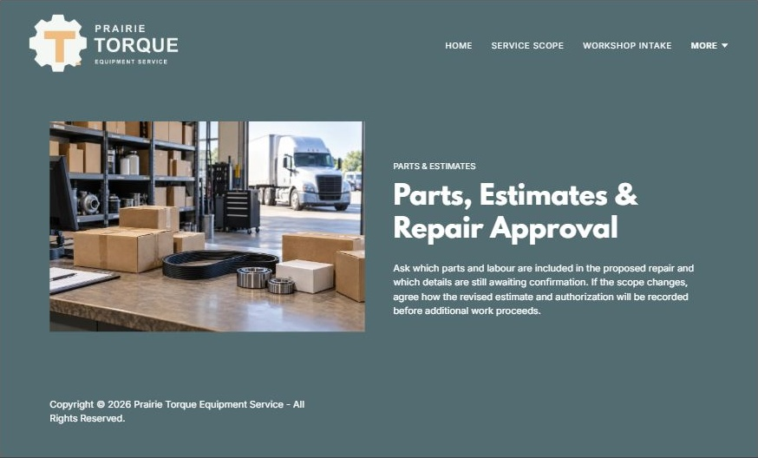
Actual Website Builder desktop capture from the fictional demo

Sample wording — adapt and verify
Parts, Estimates & Repair Approval
Ask which parts and labour are included in the proposed repair and which details are still awaiting confirmation.
If the scope changes, agree how the revised estimate and authorization will be recorded before additional work proceeds.
Suggested button: Request an equipment service assessment

Website advice
Help customers understand assessed scope, parts availability and revised approvals without claiming inventory or delivery dates.

Your draft: Parts, Estimates & Repair Approval
Write in the voice of your own business. Use facts you can verify, not promises copied from the example.

Headline and short introduction

Main content and details visitors need

Button wording and destination

Photo choice, permission and facts still to confirm
Partner check: can someone unfamiliar with the business find a useful next step?

06 Service Records & Collection
Give this page one clear job in the customer journey.
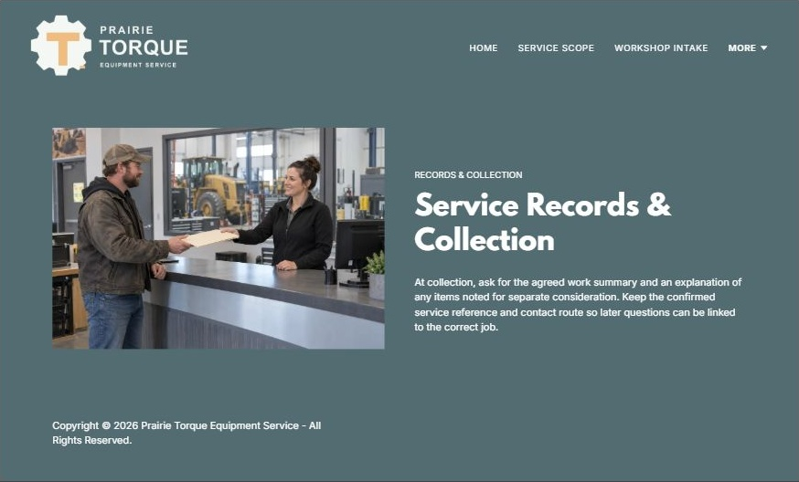
Actual Website Builder desktop capture from the fictional demo

Sample wording — adapt and verify
Service Records & Collection
At collection, ask for the agreed work summary and an explanation of any items noted for separate consideration.
Keep the confirmed service reference and contact route so later questions can be linked to the correct job.
Suggested button: Request an equipment service assessment

Website advice
Explain handover questions and future service coordination without diagnosing remaining equipment condition.

Your draft: Service Records & Collection
Write in the voice of your own business. Use facts you can verify, not promises copied from the example.

Headline and short introduction

Main content and details visitors need

Button wording and destination

Photo choice, permission and facts still to confirm
Partner check: can someone unfamiliar with the business find a useful next step?

Test before publishing
Review the whole journey on a desktop and phone. Use the genuine example captures to plan your own pages, then verify your finished website.
□ Fictional demonstration only. Verify accepted equipment, technician qualifications, diagnostic capabilities and availability. No mechanical troubleshooting, operating guidance, safety inspection assurance or repair outcome guarantee is provided.
□ Verify every service description, contact route and operating detail.
□ Replace fictional identity and example information before a live launch.
□ Test enquiries, links and downloads on desktop and mobile.
□ Keep confidential records in approved private systems.
□ Obtain operator approval for public wording and images.
□ Check every link, form destination, download and confirmation message.
□ Check logo contrast, hero framing, text sizes and image loading.
□ Save a named backup and assign a content-review date.

Changes to finish and person responsible

Approval and next review date
Website Builder plans and signup

