

Hearing Clinics & Hearing Aid Providers
Website workbook
A practical workshop for a 6-page website. Study the example, plan the content and draft your own version in Word or on paper.
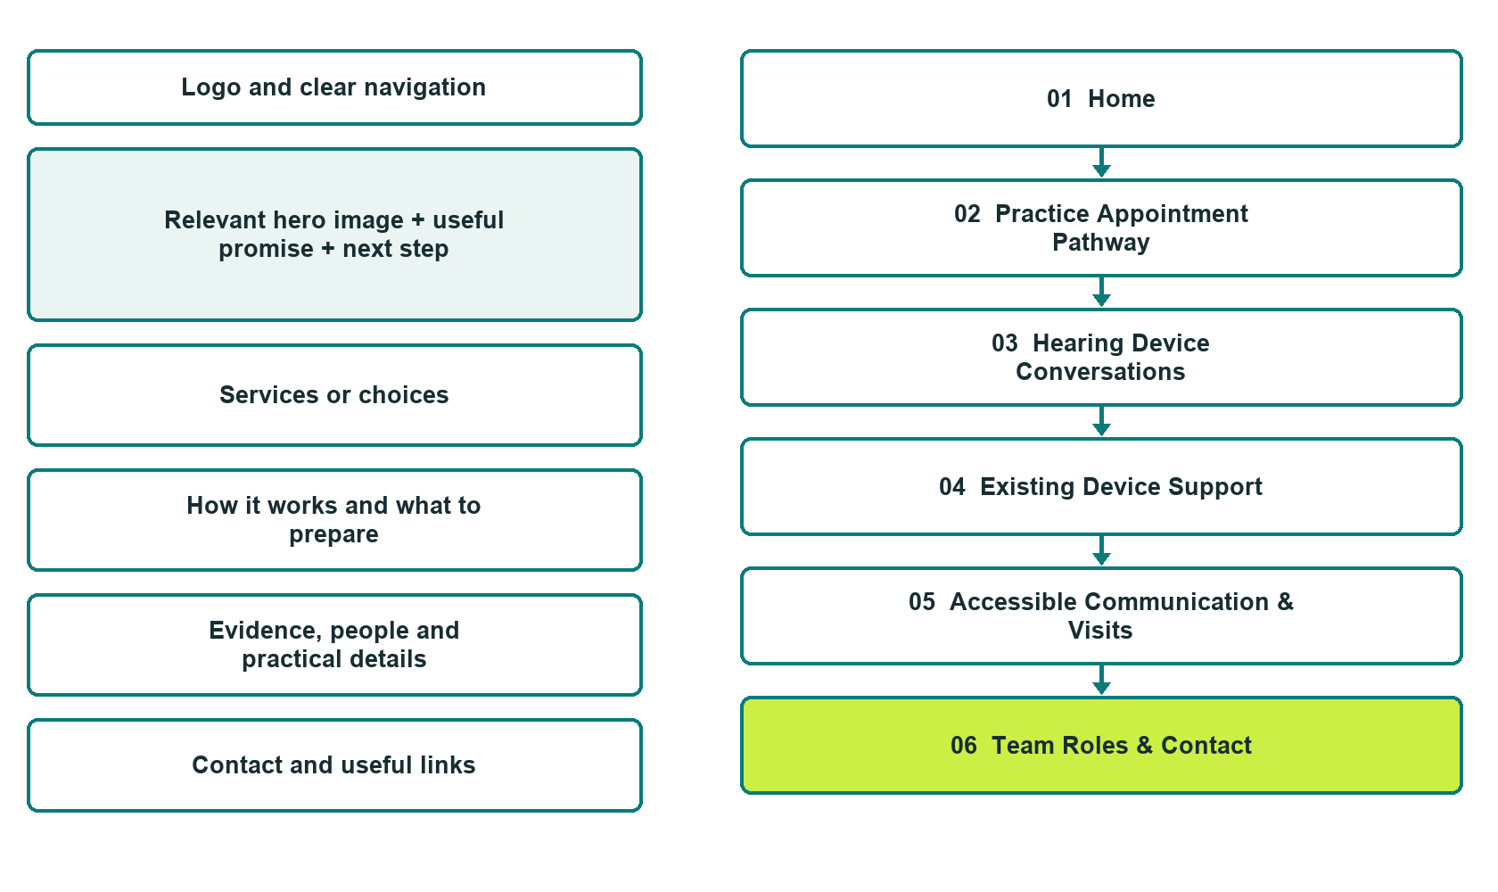

Plan → Draft → Build → Test
Website Builder capture edition: six actual desktop views from the fictional demo; the wireframe remains a planning illustration.
Explore Website Builder and compare plans

Before you build
Your business supplies the facts. Prairie Clearbrook Hearing is a fictional teaching example, not a live service.

□ Ask about an appointment or device support
□ Verified business identity, services and current contact information
□ A clear enquiry, review and confirmation process
□ Choose original photographs and confirm permission to use them.
□ Keep private customer records out of public website forms.

Your audience and the action you want them to take

Facts to verify and people who must approve them
Create your SaaSTech account

01 Home
Give this page one clear job in the customer journey.
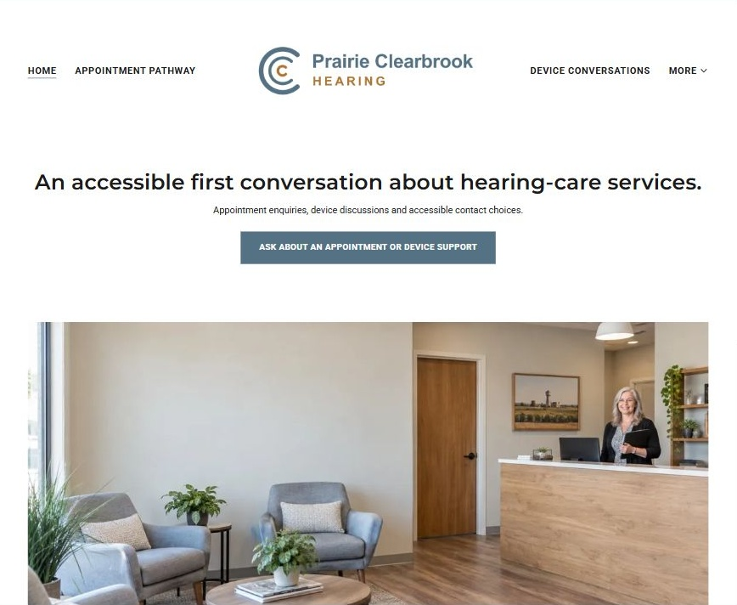
Actual Website Builder desktop capture from the fictional demo

Sample wording — adapt and verify
An accessible first conversation about hearing-care services.
Find a comfortable way to contact the practice and understand the available enquiry paths.
Staff confirms whether your question concerns an appointment, a device discussion or support for an existing arrangement.
Suggested button: Ask about an appointment or device support

Website advice
Separate clinical appointment enquiries, device discussions and administrative support with accessible contact choices and a private information process.

Your draft: Home
Write in the voice of your own business. Use facts you can verify, not promises copied from the example.

Headline and short introduction

Main content and details visitors need

Button wording and destination

Photo choice, permission and facts still to confirm
Partner check: can someone unfamiliar with the business find a useful next step?

02 Practice Appointment Pathway
Give this page one clear job in the customer journey.
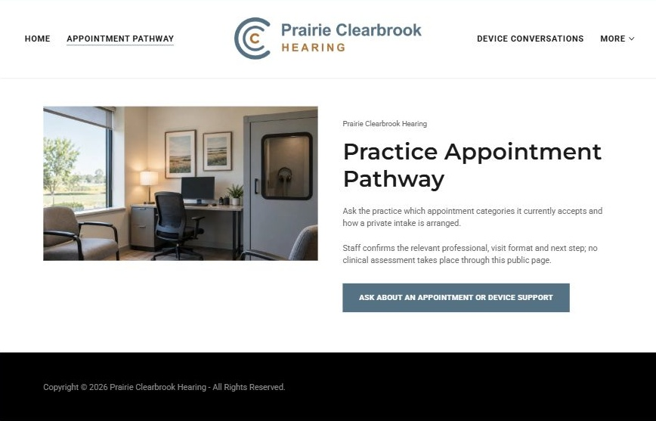
Actual Website Builder desktop capture from the fictional demo

Sample wording — adapt and verify
Practice Appointment Pathway
Ask the practice which appointment categories it currently accepts and how a private intake is arranged.
Staff confirms the relevant professional, visit format and next step; no clinical assessment takes place through this public page.
Suggested button: Ask about an appointment or device support

Website advice
Describe administrative access to verified hearing-care appointments without interpreting symptoms or tests.

Your draft: Practice Appointment Pathway
Write in the voice of your own business. Use facts you can verify, not promises copied from the example.

Headline and short introduction

Main content and details visitors need

Button wording and destination

Photo choice, permission and facts still to confirm
Partner check: can someone unfamiliar with the business find a useful next step?

03 Hearing Device Conversations
Give this page one clear job in the customer journey.
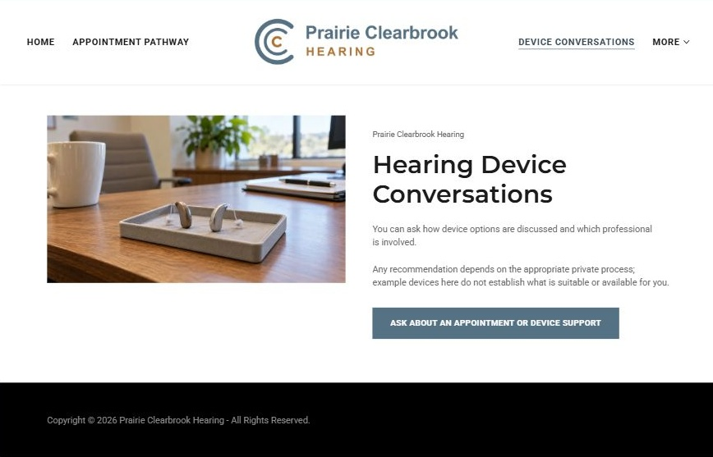
Actual Website Builder desktop capture from the fictional demo

Sample wording — adapt and verify
Hearing Device Conversations
You can ask how device options are discussed and which professional is involved.
Any recommendation depends on the appropriate private process; example devices here do not establish what is suitable or available for you.
Suggested button: Ask about an appointment or device support

Website advice
Present device discussions as professional consultations rather than a catalogue promising suitability.

Your draft: Hearing Device Conversations
Write in the voice of your own business. Use facts you can verify, not promises copied from the example.

Headline and short introduction

Main content and details visitors need

Button wording and destination

Photo choice, permission and facts still to confirm
Partner check: can someone unfamiliar with the business find a useful next step?

04 Existing Device Support
Give this page one clear job in the customer journey.
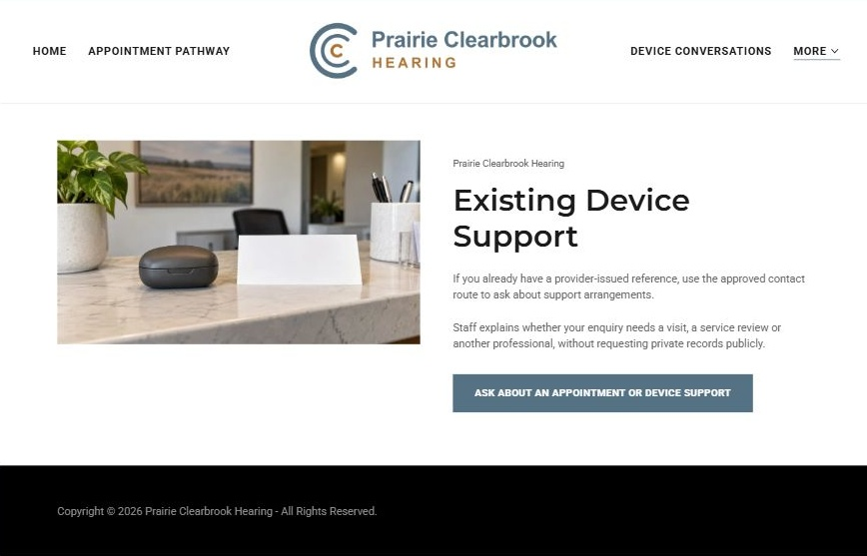
Actual Website Builder desktop capture from the fictional demo

Sample wording — adapt and verify
Existing Device Support
If you already have a provider-issued reference, use the approved contact route to ask about support arrangements.
Staff explains whether your enquiry needs a visit, a service review or another professional, without requesting private records publicly.
Suggested button: Ask about an appointment or device support

Website advice
Route administrative service enquiries without offering self-repair, adjustment or clinical troubleshooting instructions.

Your draft: Existing Device Support
Write in the voice of your own business. Use facts you can verify, not promises copied from the example.

Headline and short introduction

Main content and details visitors need

Button wording and destination

Photo choice, permission and facts still to confirm
Partner check: can someone unfamiliar with the business find a useful next step?

05 Accessible Communication & Visits
Give this page one clear job in the customer journey.
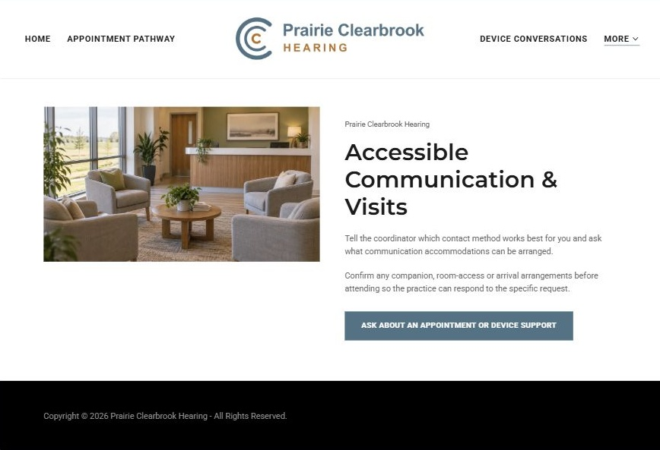
Actual Website Builder desktop capture from the fictional demo

Sample wording — adapt and verify
Accessible Communication & Visits
Tell the coordinator which contact method works best for you and ask what communication accommodations can be arranged.
Confirm any companion, room-access or arrival arrangements before attending so the practice can respond to the specific request.
Suggested button: Ask about an appointment or device support

Website advice
Invite communication and access preferences without making unverified accessibility guarantees.

Your draft: Accessible Communication & Visits
Write in the voice of your own business. Use facts you can verify, not promises copied from the example.

Headline and short introduction

Main content and details visitors need

Button wording and destination

Photo choice, permission and facts still to confirm
Partner check: can someone unfamiliar with the business find a useful next step?

06 Team Roles & Contact
Give this page one clear job in the customer journey.
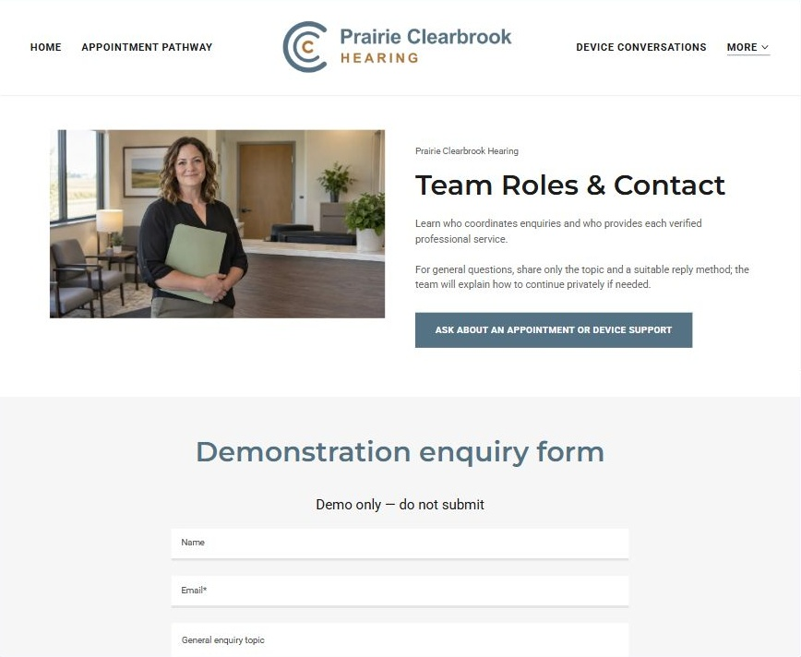
Actual Website Builder desktop capture from the fictional demo

Sample wording — adapt and verify
Team Roles & Contact
Learn who coordinates enquiries and who provides each verified professional service.
For general questions, share only the topic and a suitable reply method; the team will explain how to continue privately if needed.
Suggested button: Ask about an appointment or device support

Website advice
Distinguish verified clinical professionals from reception and device-support staff and keep identities permission-cleared.

Your draft: Team Roles & Contact
Write in the voice of your own business. Use facts you can verify, not promises copied from the example.

Headline and short introduction

Main content and details visitors need

Button wording and destination

Photo choice, permission and facts still to confirm
Partner check: can someone unfamiliar with the business find a useful next step?

Test before publishing
Review the whole journey on a desktop and phone. Use the genuine example captures to plan your own pages, then verify your finished website.
□ Fictional practice demonstration. Verify practitioner registration, service scope and every device claim. No diagnosis, treatment, device suitability or hearing outcome is promised. Keep symptoms, audiograms, prescriptions and health histories out of public forms; this is not an urgent-care assessment route.
□ Verify every service description, contact route and operating detail.
□ Replace fictional identity and example information before a live launch.
□ Test enquiries, links and downloads on desktop and mobile.
□ Keep confidential records in approved private systems.
□ Obtain operator approval for public wording and images.
□ Check every link, form destination, download and confirmation message.
□ Check logo contrast, hero framing, text sizes and image loading.
□ Save a named backup and assign a content-review date.

Changes to finish and person responsible

Approval and next review date
Website Builder plans and signup

