

Health Food & Specialty Grocery
Website workbook
A practical workshop for a 5-page website. Study the example, plan the content and draft your own version in Word or on paper.
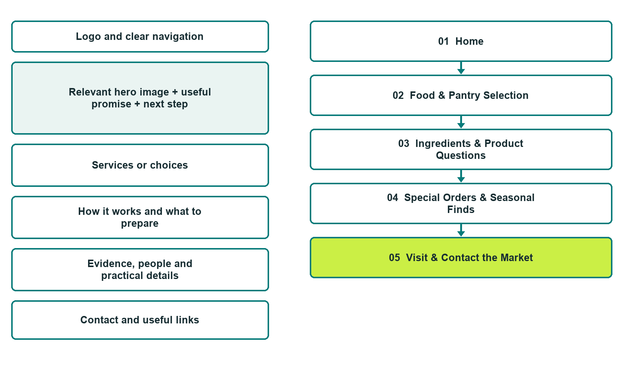

Plan → Draft → Build → Test
Capture edition: five genuine unpublished Website Builder desktop excerpts. Review mobile views on the industry page.
Explore Website Builder and compare plans

Before you build
Your business supplies the facts. Prairie Pantry Market is a fictional teaching example, not a live service.

□ Ask about current products
□ Verified business identity, services and current contact information
□ A clear enquiry, review and confirmation process
□ Choose original photographs and confirm permission to use them.
□ Keep private customer records out of public website forms.

Your audience and the action you want them to take

Facts to verify and people who must approve them
Create your SaaSTech account

01 Home
Give this page one clear job in the customer journey.
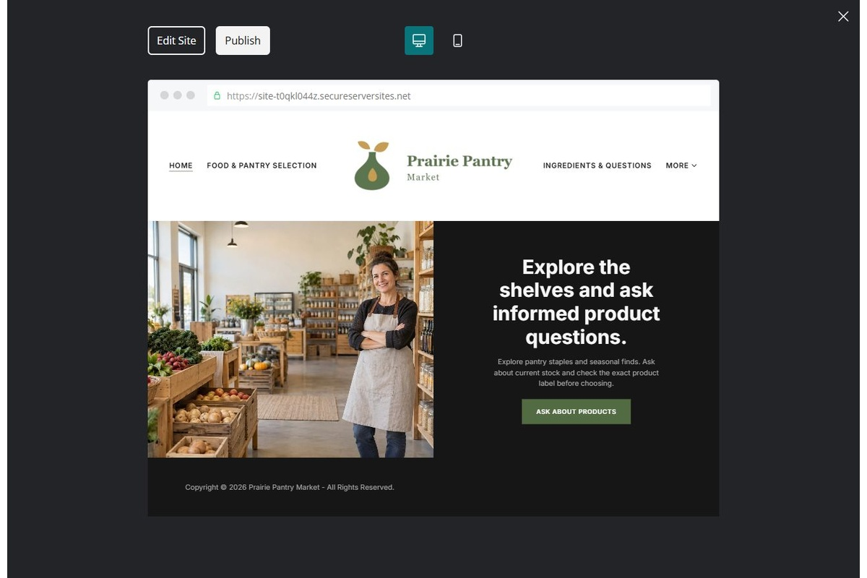
Unpublished Website Builder desktop excerpt. Page content continues below.

Sample wording — adapt and verify
Explore the shelves and ask informed product questions.
Discover the types of products featured in the market and contact the team about current stock. Confirm the exact product label and details that matter to you before choosing.
Use the relevant page to prepare a focused enquiry, then contact the team to confirm the next step.
Suggested button: Ask about current products

Website advice
Present food categories, current stock enquiries and shop information without health promises or unsupported dietary guarantees.

Your draft: Home
Write in the voice of your own business. Use facts you can verify, not promises copied from the example.

Headline and short introduction

Main content and details visitors need

Button wording and destination

Photo choice, permission and facts still to confirm
Partner check: can someone unfamiliar with the business find a useful next step?

02 Food & Pantry Selection
Give this page one clear job in the customer journey.
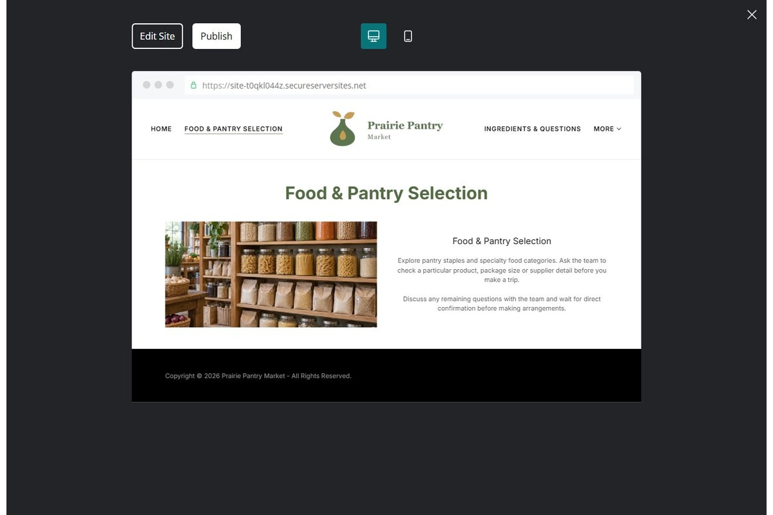
Unpublished Website Builder desktop excerpt. Page content continues below.

Sample wording — adapt and verify
Food & Pantry Selection
Explore pantry staples and specialty food categories. Ask the team to check a particular product, package size or supplier detail before you make a trip.
Discuss any remaining questions with the team and wait for direct confirmation before making arrangements.
Suggested button: Ask about current products

Website advice
Use accurate categories and current product photographs; distinguish examples from available stock.

Your draft: Food & Pantry Selection
Write in the voice of your own business. Use facts you can verify, not promises copied from the example.

Headline and short introduction

Main content and details visitors need

Button wording and destination

Photo choice, permission and facts still to confirm
Partner check: can someone unfamiliar with the business find a useful next step?

03 Ingredients & Product Questions
Give this page one clear job in the customer journey.
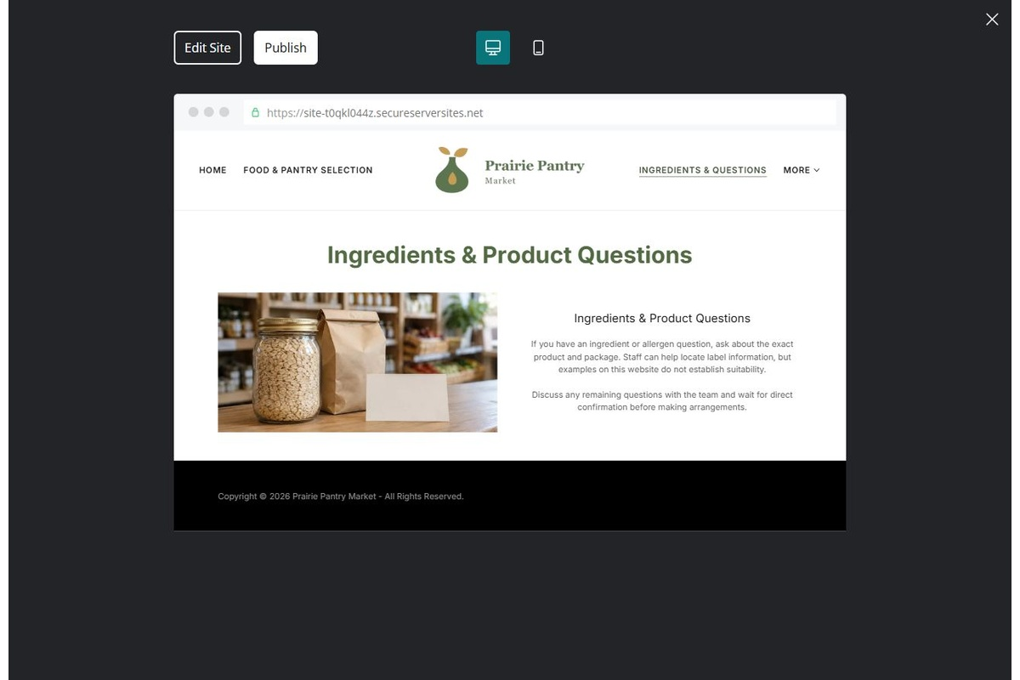
Unpublished Website Builder desktop excerpt. Page content continues below.

Sample wording — adapt and verify
Ingredients & Product Questions
If you have an ingredient or allergen question, ask about the exact product and package. Staff can help locate label information, but examples on this website do not establish suitability.
Discuss any remaining questions with the team and wait for direct confirmation before making arrangements.
Suggested button: Ask about current products

Website advice
Direct customers to exact current labels and reviewed supplier information. Do not guarantee suitability.

Your draft: Ingredients & Product Questions
Write in the voice of your own business. Use facts you can verify, not promises copied from the example.

Headline and short introduction

Main content and details visitors need

Button wording and destination

Photo choice, permission and facts still to confirm
Partner check: can someone unfamiliar with the business find a useful next step?

04 Special Orders & Seasonal Finds
Give this page one clear job in the customer journey.
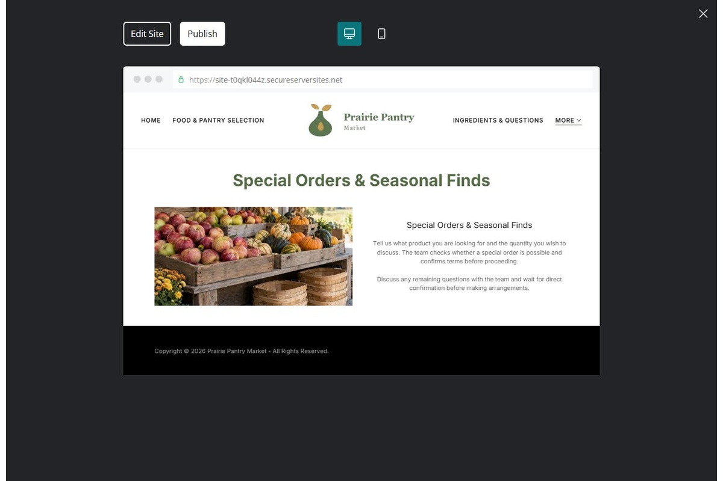
Unpublished Website Builder desktop excerpt. Page content continues below.

Sample wording — adapt and verify
Special Orders & Seasonal Finds
Tell us what product you are looking for and the quantity you wish to discuss. The team checks whether a special order is possible and confirms terms before proceeding.
Discuss any remaining questions with the team and wait for direct confirmation before making arrangements.
Suggested button: Ask about current products

Website advice
Explain request review, supplier checks and customer confirmation without promising availability.

Your draft: Special Orders & Seasonal Finds
Write in the voice of your own business. Use facts you can verify, not promises copied from the example.

Headline and short introduction

Main content and details visitors need

Button wording and destination

Photo choice, permission and facts still to confirm
Partner check: can someone unfamiliar with the business find a useful next step?

05 Visit & Contact the Market
Give this page one clear job in the customer journey.
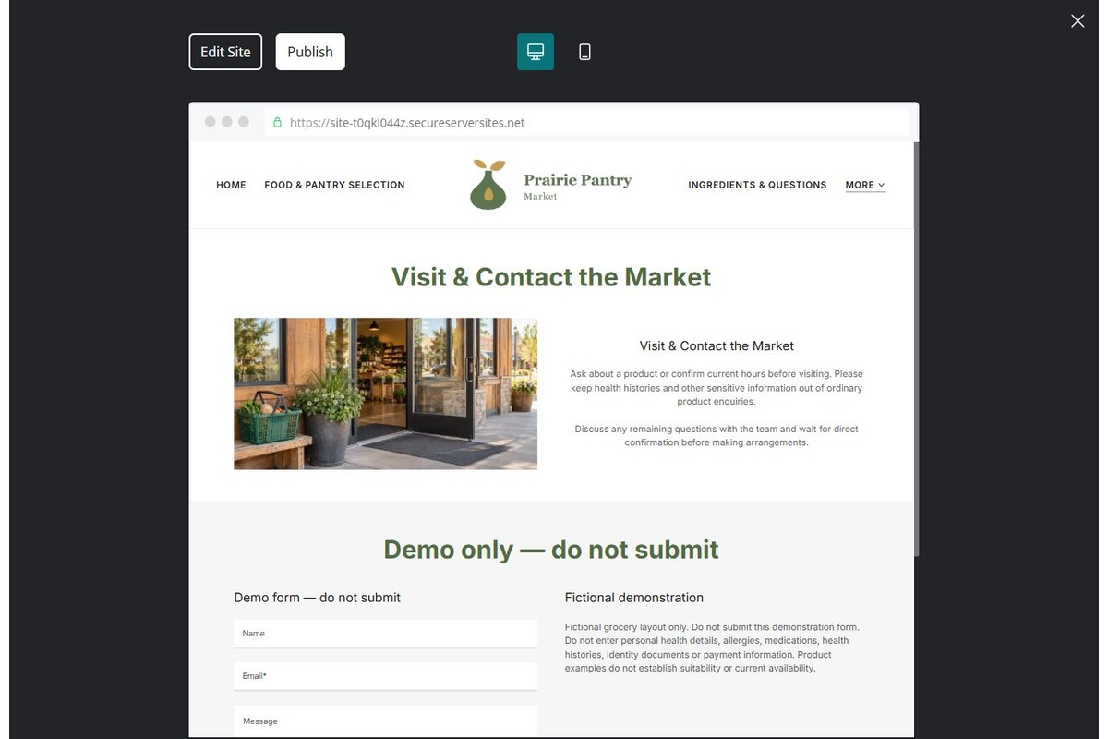
Unpublished Website Builder desktop excerpt. Page content continues below.

Sample wording — adapt and verify
Visit & Contact the Market
Ask about a product or confirm current hours before visiting. Please keep health histories and other sensitive information out of ordinary product enquiries.
Discuss any remaining questions with the team and wait for direct confirmation before making arrangements.
Suggested button: Ask about current products

Website advice
Show verified opening arrangements and an enquiry route that avoids sensitive personal health details.

Your draft: Visit & Contact the Market
Write in the voice of your own business. Use facts you can verify, not promises copied from the example.

Headline and short introduction

Main content and details visitors need

Button wording and destination

Photo choice, permission and facts still to confirm
Partner check: can someone unfamiliar with the business find a useful next step?

Test before publishing
Review the whole journey on a desktop and phone. Compare these desktop excerpts with the mobile captures on the industry page.
□ Fictional demonstration only. Product labels and supplier information must guide ingredient and allergen questions. Do not provide health or nutrition advice, therapeutic claims or blanket allergen-free assurances.
□ Verify each offered service, contact route, location and opening arrangement.
□ Remove fictional identity, claims, availability and prices before a real launch.
□ Test every enquiry route and download on desktop and mobile.
□ Keep sensitive information in approved private systems.
□ Obtain operator approval for all public wording and image use.
□ Check every link, form destination, download and confirmation message.
□ Check logo contrast, hero framing, text sizes and image loading.
□ Save a named backup and assign a content-review date.

Changes to finish and person responsible

Approval and next review date
Website Builder plans and signup

