

Hardware, Building & Farm Supply
Website workbook
A practical workshop for a 5-page website. Study the example, plan the content and draft your own version in Word or on paper.
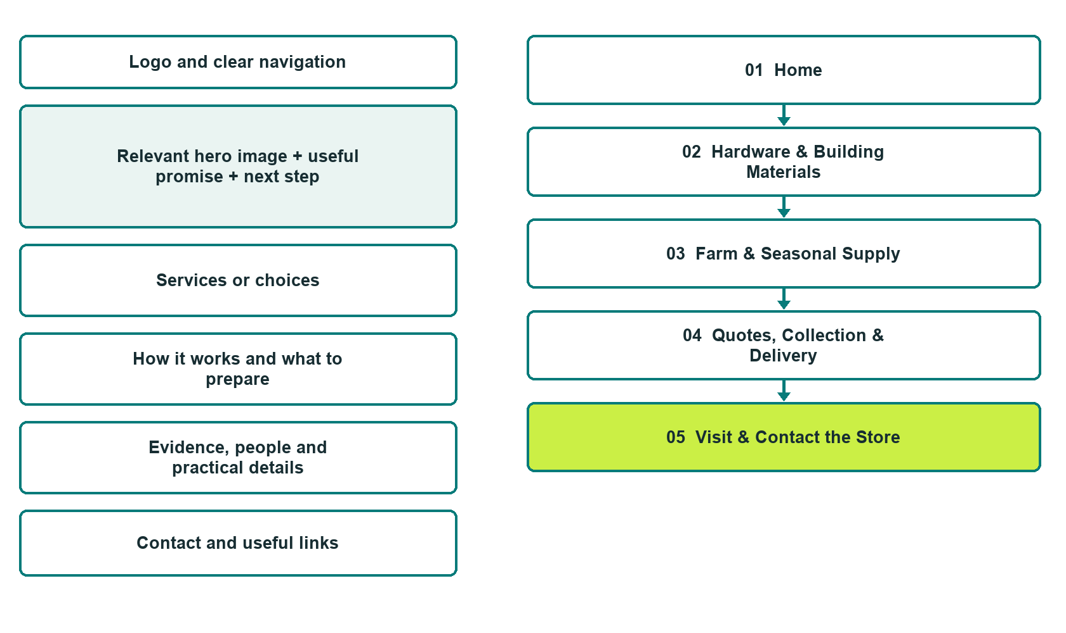

Plan → Draft → Build → Test
Capture edition: five genuine unpublished Website Builder desktop excerpts. Review mobile views on the industry page.
Explore Website Builder and compare plans

Before you build
Your business supplies the facts. Prairie Junction Supply is a fictional teaching example, not a live service.

□ Ask about products or a supply quote
□ Verified business identity, services and current contact information
□ A clear enquiry, review and confirmation process
□ Choose original photographs and confirm permission to use them.
□ Keep private customer records out of public website forms.

Your audience and the action you want them to take

Facts to verify and people who must approve them
Create your SaaSTech account

01 Home
Give this page one clear job in the customer journey.
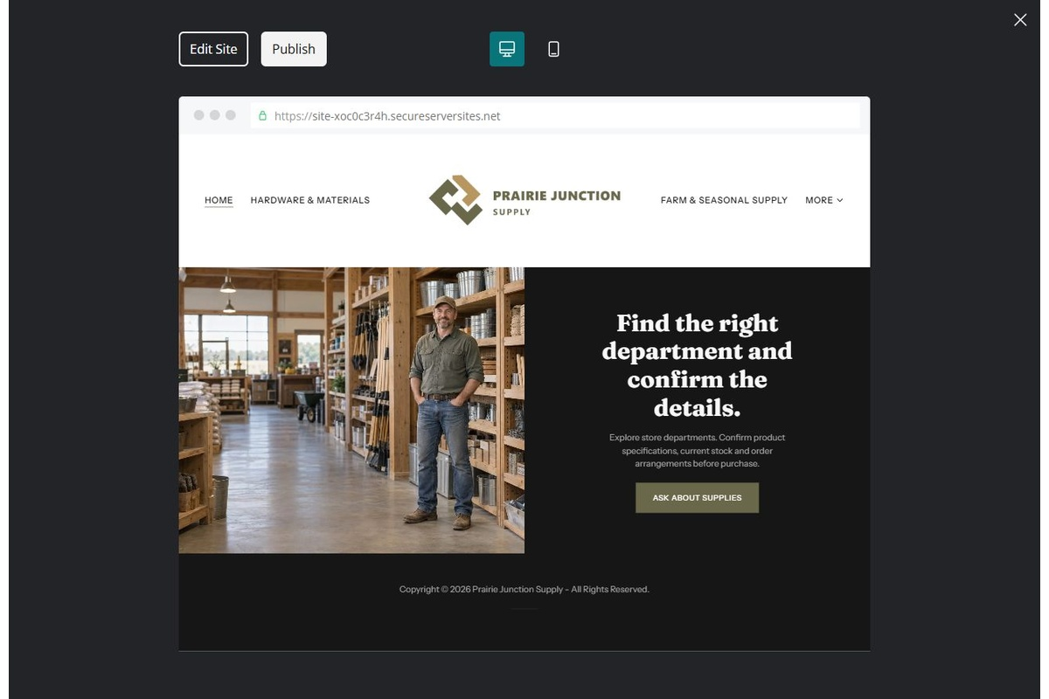
Unpublished Website Builder desktop excerpt. Page content continues below.

Sample wording — adapt and verify
Find the right department and confirm the details.
Explore the store departments and ask about the products your project needs. The team confirms stock, specifications and order arrangements before purchase.
Use the relevant page to prepare a focused enquiry, then contact the team to confirm the next step.
Suggested button: Ask about products or a supply quote

Website advice
Organize product departments, stock enquiries and trade-order conversations without implying technical suitability or live inventory.

Your draft: Home
Write in the voice of your own business. Use facts you can verify, not promises copied from the example.

Headline and short introduction

Main content and details visitors need

Button wording and destination

Photo choice, permission and facts still to confirm
Partner check: can someone unfamiliar with the business find a useful next step?

02 Hardware & Building Materials
Give this page one clear job in the customer journey.
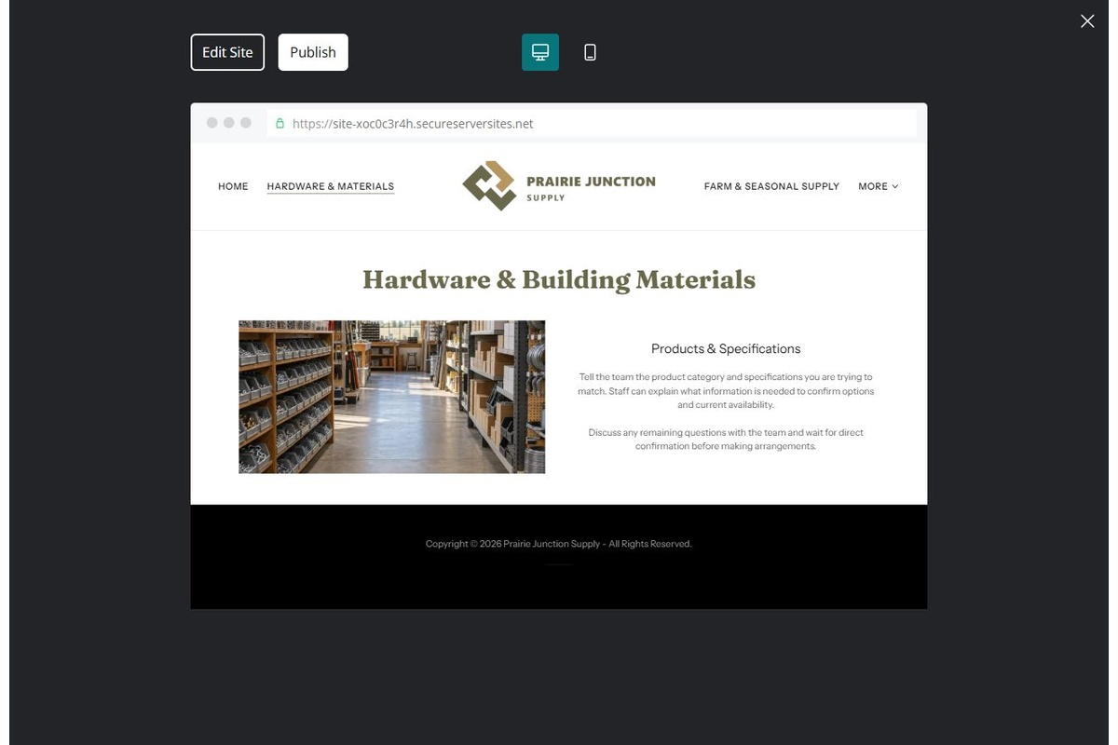
Unpublished Website Builder desktop excerpt. Page content continues below.

Sample wording — adapt and verify
Hardware & Building Materials
Tell the team the product category and specifications you are trying to match. Staff can explain what information is needed to confirm options and current availability.
Discuss any remaining questions with the team and wait for direct confirmation before making arrangements.
Suggested button: Ask about products or a supply quote

Website advice
Group useful product categories and route technical questions to qualified staff or manufacturer information.

Your draft: Hardware & Building Materials
Write in the voice of your own business. Use facts you can verify, not promises copied from the example.

Headline and short introduction

Main content and details visitors need

Button wording and destination

Photo choice, permission and facts still to confirm
Partner check: can someone unfamiliar with the business find a useful next step?

03 Farm & Seasonal Supply
Give this page one clear job in the customer journey.
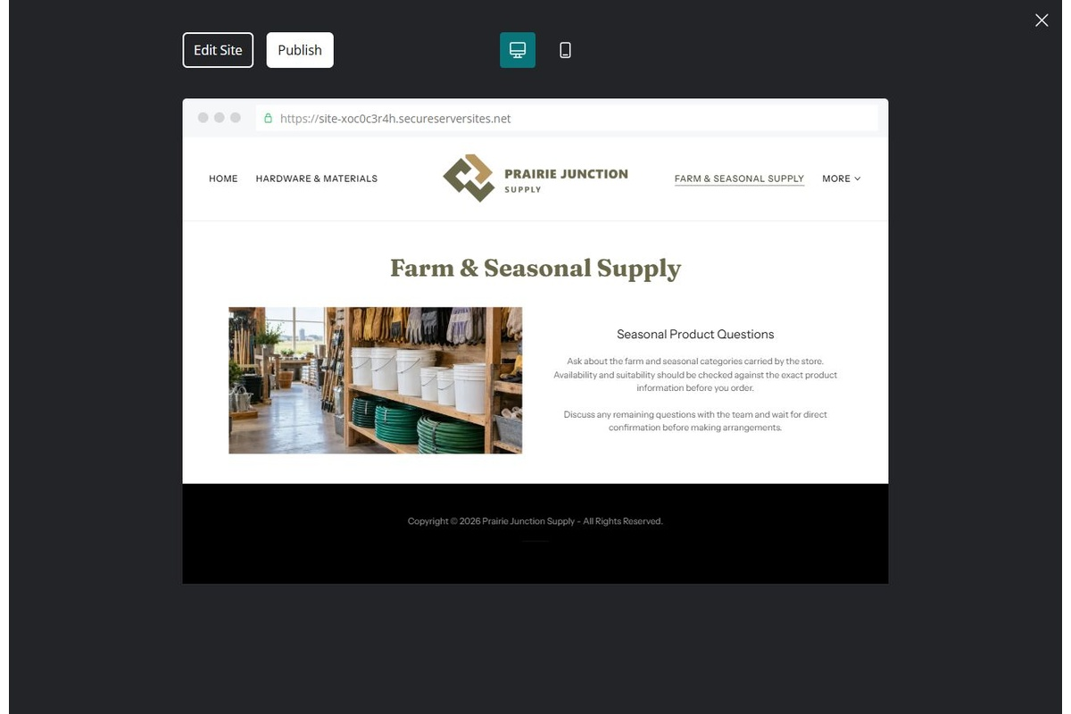
Unpublished Website Builder desktop excerpt. Page content continues below.

Sample wording — adapt and verify
Farm & Seasonal Supply
Ask about the farm and seasonal categories carried by the store. Availability and suitability should be checked against the exact product information before you order.
Discuss any remaining questions with the team and wait for direct confirmation before making arrangements.
Suggested button: Ask about products or a supply quote

Website advice
Separate seasonal examples from current stock and avoid unsupported suitability claims.

Your draft: Farm & Seasonal Supply
Write in the voice of your own business. Use facts you can verify, not promises copied from the example.

Headline and short introduction

Main content and details visitors need

Button wording and destination

Photo choice, permission and facts still to confirm
Partner check: can someone unfamiliar with the business find a useful next step?

04 Quotes, Collection & Delivery
Give this page one clear job in the customer journey.
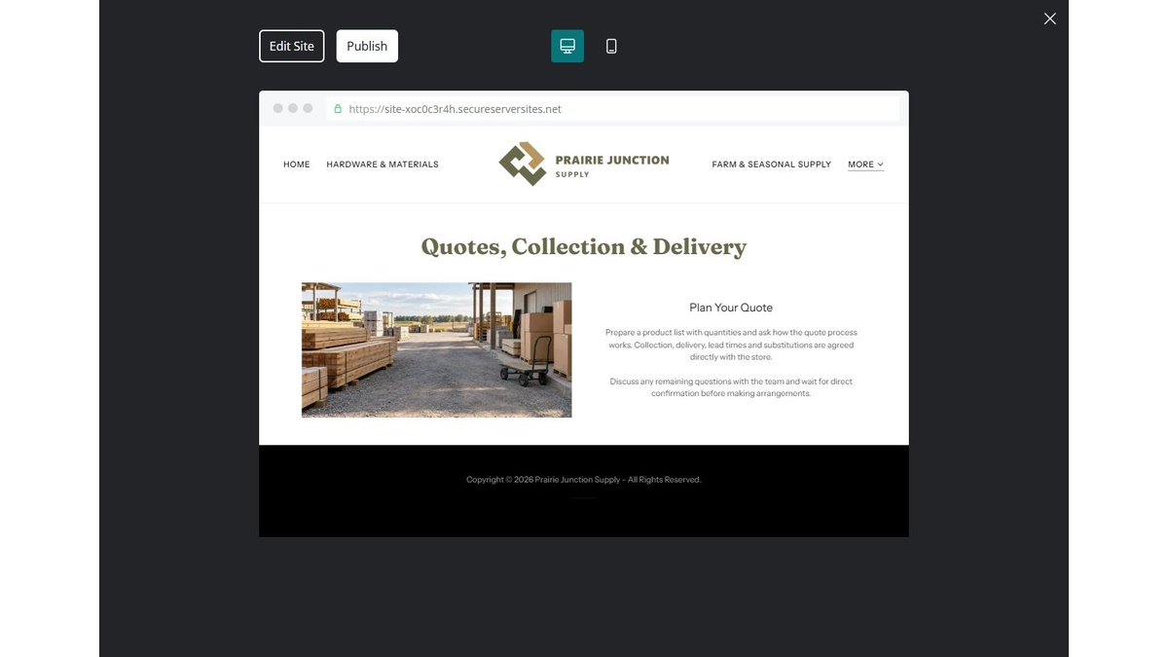
Unpublished Website Builder desktop excerpt. Page content continues below.

Sample wording — adapt and verify
Quotes, Collection & Delivery
Prepare a product list with quantities and ask how the quote process works. Collection, delivery, lead times and substitutions are agreed directly with the store.
Discuss any remaining questions with the team and wait for direct confirmation before making arrangements.
Suggested button: Ask about products or a supply quote

Website advice
Explain list submission, specification review and confirmation of fulfilment terms.

Your draft: Quotes, Collection & Delivery
Write in the voice of your own business. Use facts you can verify, not promises copied from the example.

Headline and short introduction

Main content and details visitors need

Button wording and destination

Photo choice, permission and facts still to confirm
Partner check: can someone unfamiliar with the business find a useful next step?

05 Visit & Contact the Store
Give this page one clear job in the customer journey.
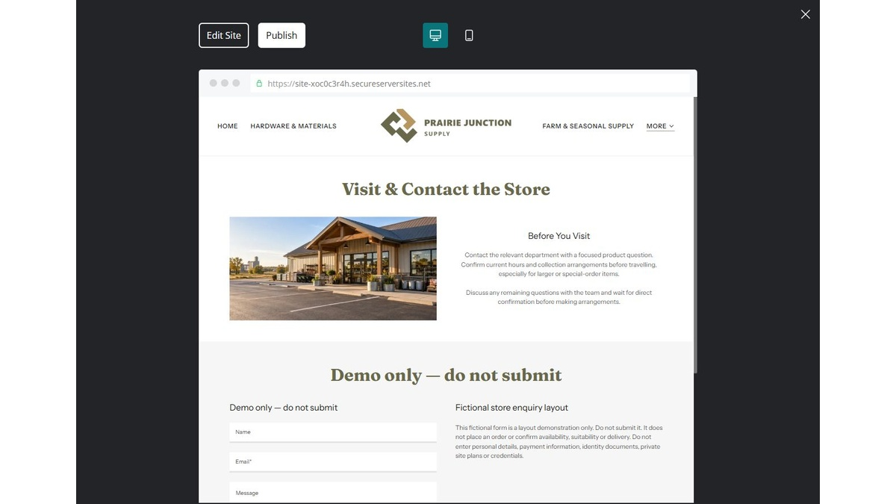
Unpublished Website Builder desktop excerpt. Page content continues below.

Sample wording — adapt and verify
Visit & Contact the Store
Contact the relevant department with a focused product question. Confirm current hours and collection arrangements before travelling, especially for larger or special-order items.
Discuss any remaining questions with the team and wait for direct confirmation before making arrangements.
Suggested button: Ask about products or a supply quote

Website advice
Publish verified hours, location and department contact routes. Do not advertise unavailable services.

Your draft: Visit & Contact the Store
Write in the voice of your own business. Use facts you can verify, not promises copied from the example.

Headline and short introduction

Main content and details visitors need

Button wording and destination

Photo choice, permission and facts still to confirm
Partner check: can someone unfamiliar with the business find a useful next step?

Test before publishing
Review the whole journey on a desktop and phone. Compare these desktop excerpts with the mobile captures on the industry page.
□ Fictional demonstration only. Verify product specifications, availability, safety information, delivery and terms with the supplier. Do not provide construction, chemical or equipment-use instructions.
□ Verify each offered service, contact route, location and opening arrangement.
□ Remove fictional identity, claims, availability and prices before a real launch.
□ Test every enquiry route and download on desktop and mobile.
□ Keep sensitive information in approved private systems.
□ Obtain operator approval for all public wording and image use.
□ Check every link, form destination, download and confirmation message.
□ Check logo contrast, hero framing, text sizes and image loading.
□ Save a named backup and assign a content-review date.

Changes to finish and person responsible

Approval and next review date
Website Builder plans and signup

