

Garage Door, Window & Door Companies
Website workbook
A practical workshop for a 6-page website. Study the example, plan the content and draft your own version in Word or on paper.
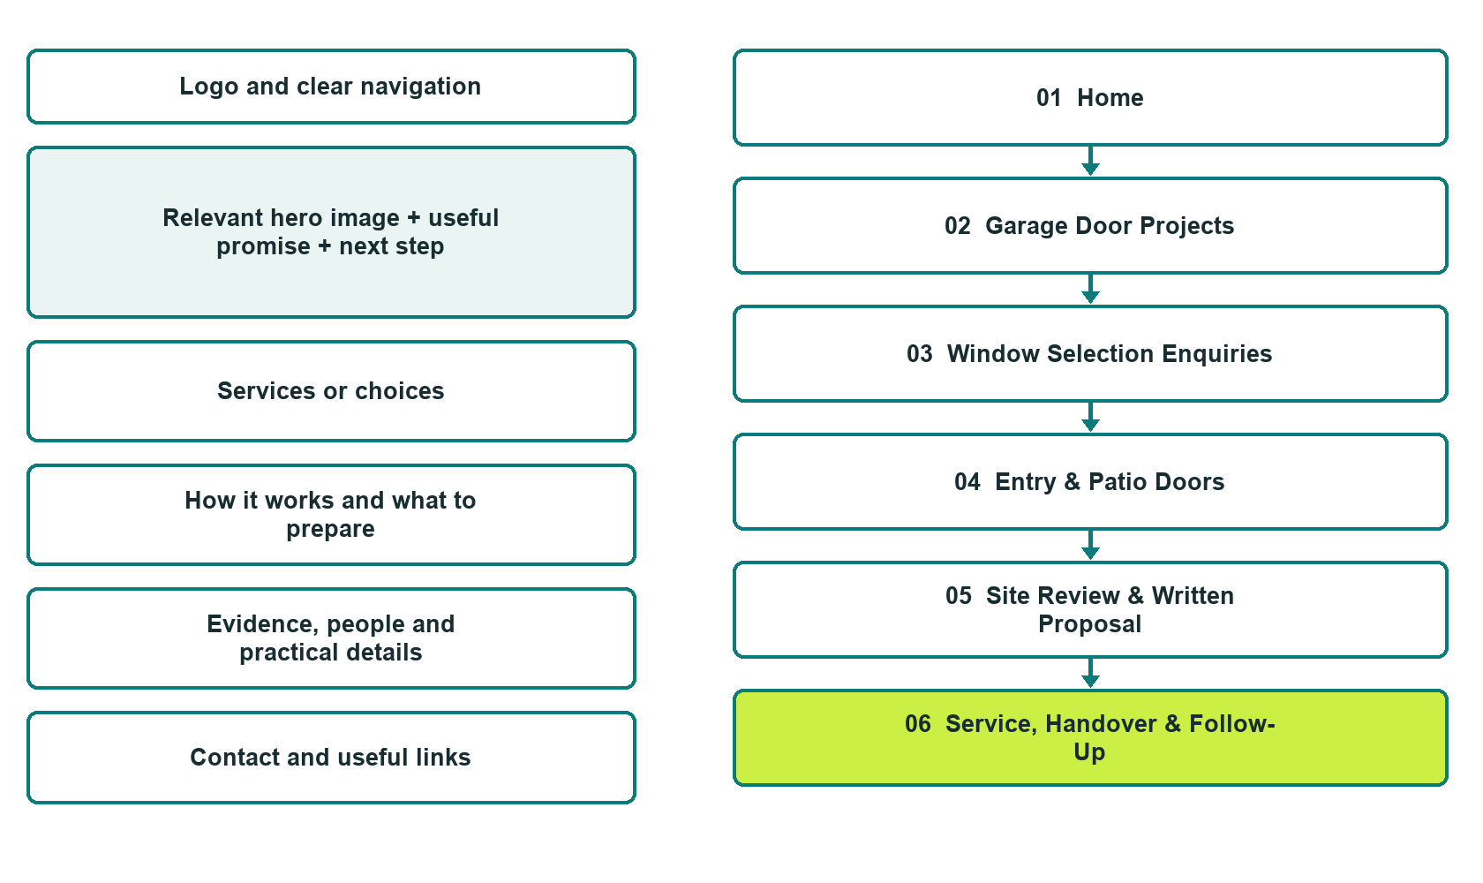

Plan → Draft → Build → Test
Website Builder capture edition: six desktop excerpts from the fictional demo; the wireframe remains a planning illustration.
Explore Website Builder and compare plans

Before you build
Your business supplies the facts. Prairie Threshold Door & Window is a fictional teaching example, not a live service.

□ Request a product or service review
□ Verified business identity, services and current contact information
□ A clear enquiry, review and confirmation process
□ Choose original photographs and confirm permission to use them.
□ Keep private customer records out of public website forms.

Your audience and the action you want them to take

Facts to verify and people who must approve them
Create your SaaSTech account

01 Home
Give this page one clear job in the customer journey.
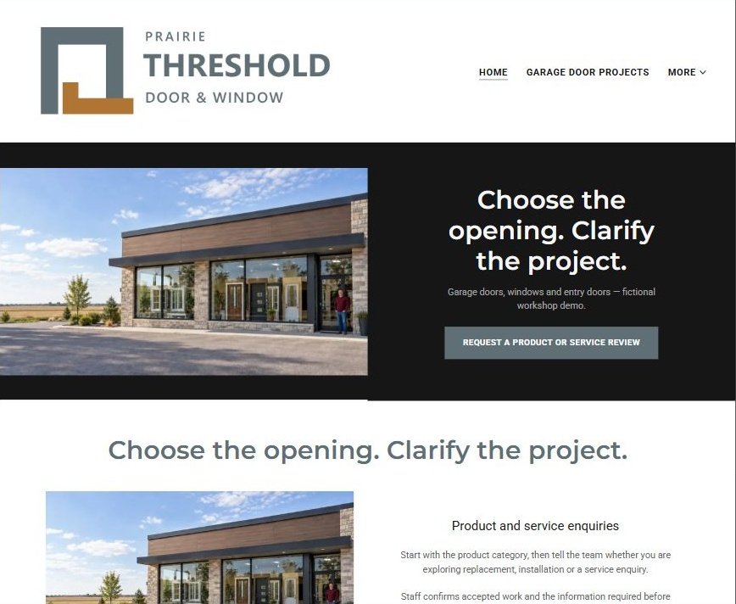
Actual Website Builder desktop excerpt from the fictional demo

Sample wording — adapt and verify
Choose the opening. Clarify the project.
Start with the product category, then tell the team whether you are exploring replacement, installation or a service enquiry.
Staff confirms accepted work and the information required before discussing an estimate.
Suggested button: Request a product or service review

Website advice
Separate garage doors, windows and entry doors, distinguish product selection from repair and installation, and route estimates to staff review.

Your draft: Home
Write in the voice of your own business. Use facts you can verify, not promises copied from the example.

Headline and short introduction

Main content and details visitors need

Button wording and destination

Photo choice, permission and facts still to confirm
Partner check: can someone unfamiliar with the business find a useful next step?

02 Garage Door Projects
Give this page one clear job in the customer journey.
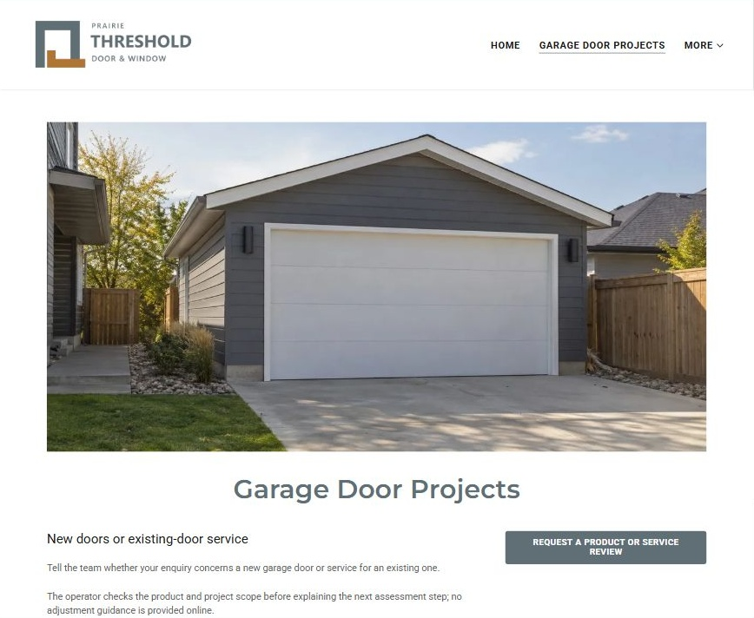
Actual Website Builder desktop excerpt from the fictional demo

Sample wording — adapt and verify
Garage Door Projects
Tell the team whether your enquiry concerns a new garage door or service for an existing one.
The operator checks the product and project scope before explaining the next assessment step; no adjustment guidance is provided online.
Suggested button: Request a product or service review

Website advice
Give garage-door sales and service their own enquiry path, without extending scope to all mechanisms or brands.

Your draft: Garage Door Projects
Write in the voice of your own business. Use facts you can verify, not promises copied from the example.

Headline and short introduction

Main content and details visitors need

Button wording and destination

Photo choice, permission and facts still to confirm
Partner check: can someone unfamiliar with the business find a useful next step?

03 Window Selection Enquiries
Give this page one clear job in the customer journey.
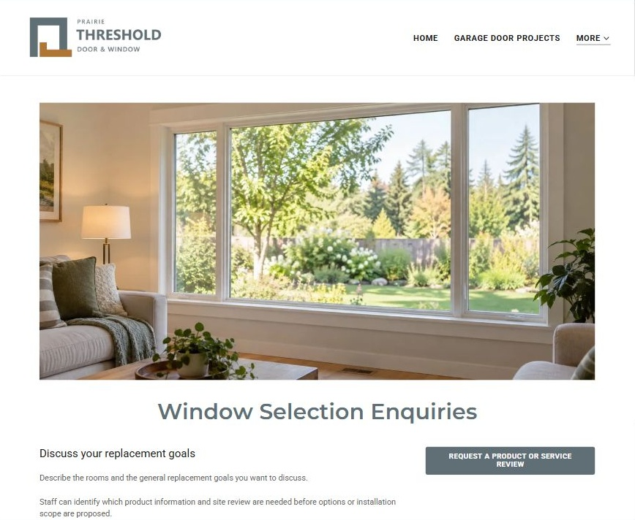
Actual Website Builder desktop excerpt from the fictional demo

Sample wording — adapt and verify
Window Selection Enquiries
Describe the rooms and the general replacement goals you want to discuss.
Staff can identify which product information and site review are needed before options or installation scope are proposed.
Suggested button: Request a product or service review

Website advice
Discuss window categories and verified product information without prescribing technical performance or retrofit methods.

Your draft: Window Selection Enquiries
Write in the voice of your own business. Use facts you can verify, not promises copied from the example.

Headline and short introduction

Main content and details visitors need

Button wording and destination

Photo choice, permission and facts still to confirm
Partner check: can someone unfamiliar with the business find a useful next step?

04 Entry & Patio Doors
Give this page one clear job in the customer journey.
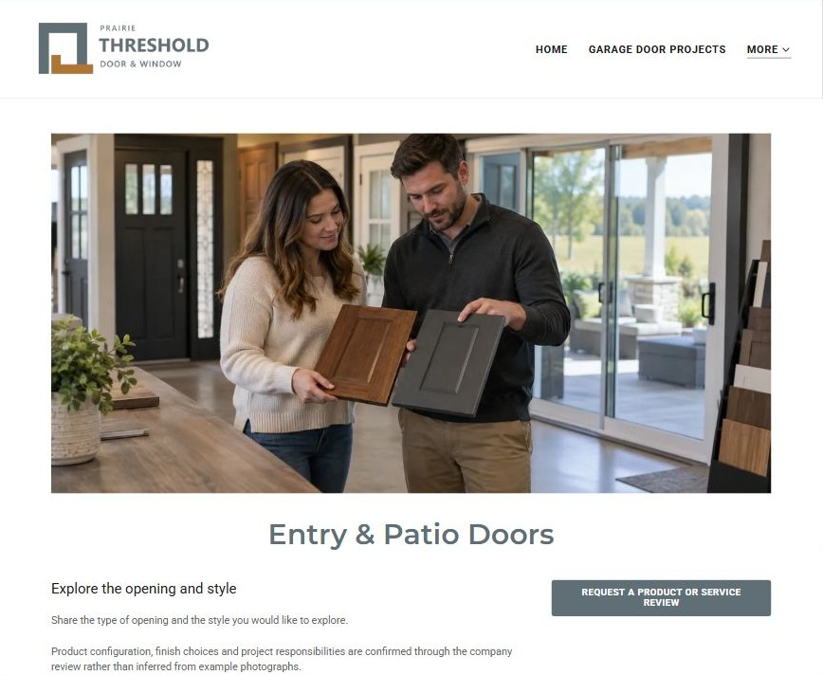
Actual Website Builder desktop excerpt from the fictional demo

Sample wording — adapt and verify
Entry & Patio Doors
Share the type of opening and the style you would like to explore.
Product configuration, finish choices and project responsibilities are confirmed through the company review rather than inferred from example photographs.
Suggested button: Request a product or service review

Website advice
Separate pedestrian entry and patio-door projects from vehicle-access doors and window products.

Your draft: Entry & Patio Doors
Write in the voice of your own business. Use facts you can verify, not promises copied from the example.

Headline and short introduction

Main content and details visitors need

Button wording and destination

Photo choice, permission and facts still to confirm
Partner check: can someone unfamiliar with the business find a useful next step?

05 Site Review & Written Proposal
Give this page one clear job in the customer journey.
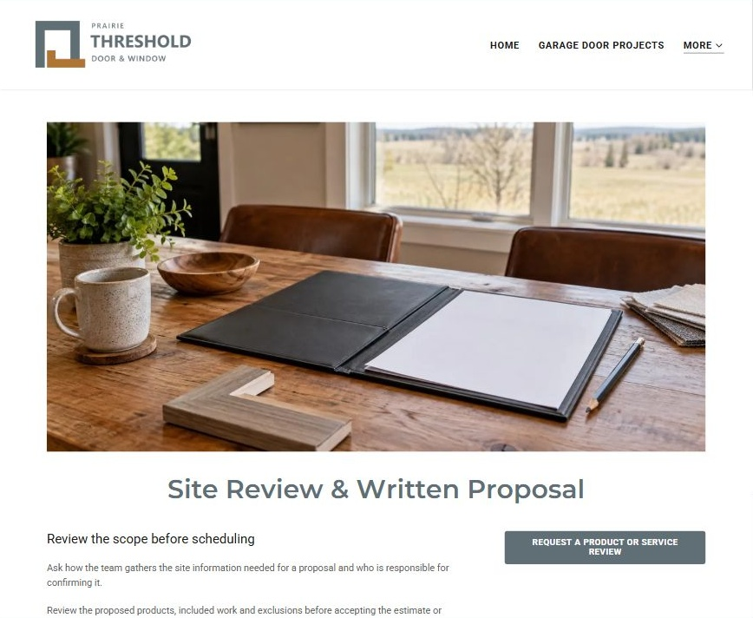
Actual Website Builder desktop excerpt from the fictional demo

Sample wording — adapt and verify
Site Review & Written Proposal
Ask how the team gathers the site information needed for a proposal and who is responsible for confirming it.
Review the proposed products, included work and exclusions before accepting the estimate or scheduling arrangements.
Suggested button: Request a product or service review

Website advice
Explain measurement responsibility, permission and proposal review without offering do-it-yourself measuring or structural advice.

Your draft: Site Review & Written Proposal
Write in the voice of your own business. Use facts you can verify, not promises copied from the example.

Headline and short introduction

Main content and details visitors need

Button wording and destination

Photo choice, permission and facts still to confirm
Partner check: can someone unfamiliar with the business find a useful next step?

06 Service, Handover & Follow-Up
Give this page one clear job in the customer journey.
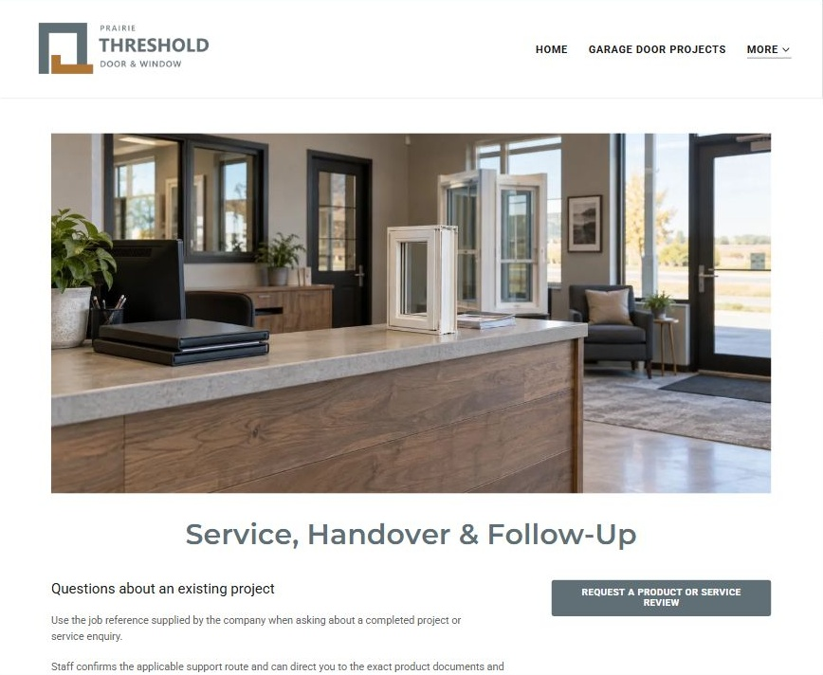
Actual Website Builder desktop excerpt from the fictional demo

Sample wording — adapt and verify
Service, Handover & Follow-Up
Use the job reference supplied by the company when asking about a completed project or service enquiry.
Staff confirms the applicable support route and can direct you to the exact product documents and agreed terms.
Suggested button: Request a product or service review

Website advice
Route existing-job questions and manufacturer information without promising warranties or emergency response.

Your draft: Service, Handover & Follow-Up
Write in the voice of your own business. Use facts you can verify, not promises copied from the example.

Headline and short introduction

Main content and details visitors need

Button wording and destination

Photo choice, permission and facts still to confirm
Partner check: can someone unfamiliar with the business find a useful next step?

Test before publishing
Review the whole journey on a desktop and phone. Use these first-screen examples to plan your own pages, then verify your complete website.
□ Fictional company demonstration. Verify each product category, installation role, manufacturer claim and service area. No spring adjustment, electrical, structural, glazing, security or installation instructions are provided; image examples are not completed jobs or live stock.
□ Verify every service description, contact route and operating detail.
□ Replace fictional identity and example information before a live launch.
□ Test enquiries, links and downloads on desktop and mobile.
□ Keep confidential records in approved private systems.
□ Obtain operator approval for public wording and images.
□ Check every link, form destination, download and confirmation message.
□ Check logo contrast, hero framing, text sizes and image loading.
□ Save a named backup and assign a content-review date.

Changes to finish and person responsible

Approval and next review date
Website Builder plans and signup

