

Furniture, Mattress & Home Décor Stores
Website workbook
A practical workshop for a 6-page website. Study the example, plan the content and draft your own version in Word or on paper.
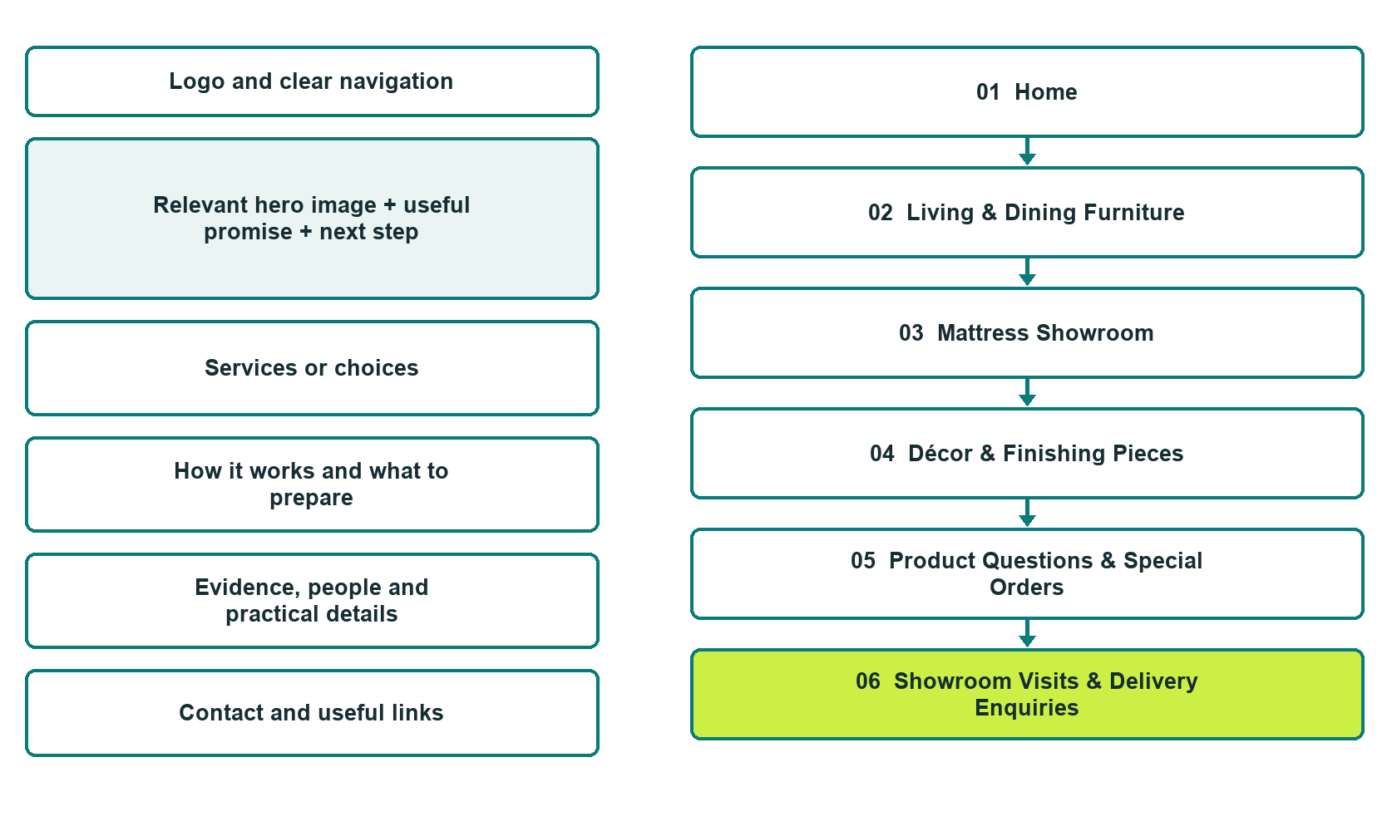

Plan → Draft → Build → Test
Website Builder capture edition: six desktop excerpts from the fictional demo; the wireframe remains a planning illustration.
Explore Website Builder and compare plans

Before you build
Your business supplies the facts. Prairie Hearth Home Store is a fictional teaching example, not a live service.

□ Ask about a showroom item
□ Verified business identity, services and current contact information
□ A clear enquiry, review and confirmation process
□ Choose original photographs and confirm permission to use them.
□ Keep private customer records out of public website forms.

Your audience and the action you want them to take

Facts to verify and people who must approve them
Create your SaaSTech account

01 Home
Give this page one clear job in the customer journey.
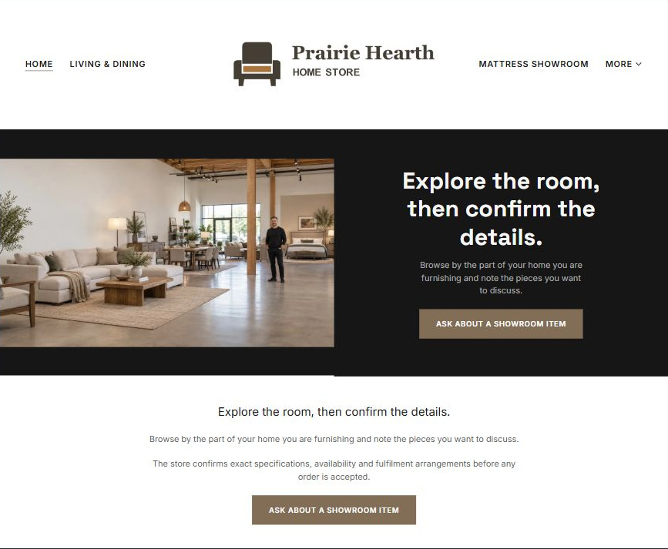
Actual Website Builder desktop excerpt from the fictional demo

Sample wording — adapt and verify
Explore the room, then confirm the details.
Browse by the part of your home you are furnishing and note the pieces you want to discuss.
The store confirms exact specifications, availability and fulfilment arrangements before any order is accepted.
Suggested button: Ask about a showroom item

Website advice
Organize furniture, mattress and décor browsing into distinct categories with item-specific enquiries, showroom arrangements and reviewed delivery or order terms.

Your draft: Home
Write in the voice of your own business. Use facts you can verify, not promises copied from the example.

Headline and short introduction

Main content and details visitors need

Button wording and destination

Photo choice, permission and facts still to confirm
Partner check: can someone unfamiliar with the business find a useful next step?

02 Living & Dining Furniture
Give this page one clear job in the customer journey.
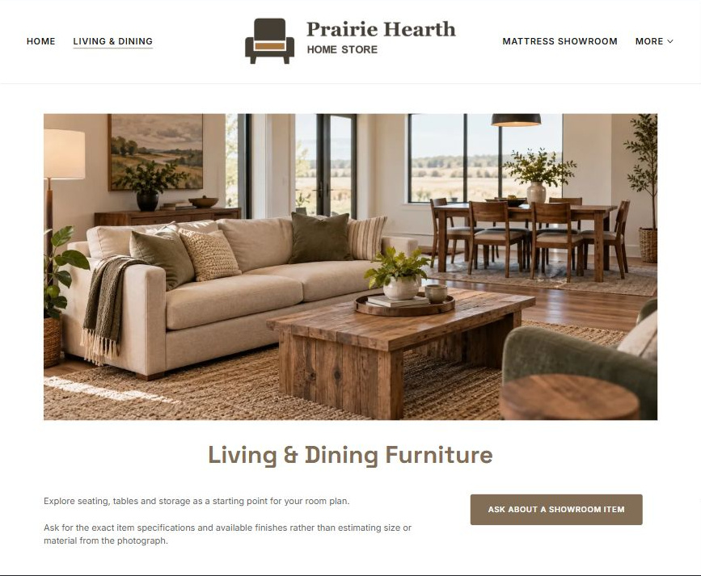
Actual Website Builder desktop excerpt from the fictional demo

Sample wording — adapt and verify
Living & Dining Furniture
Explore seating, tables and storage as a starting point for your room plan.
Ask for the exact item specifications and available finishes rather than estimating size or material from the photograph.
Suggested button: Ask about a showroom item

Website advice
Organize larger furniture by room and intended use while making exact dimensions and availability subject to product checks.

Your draft: Living & Dining Furniture
Write in the voice of your own business. Use facts you can verify, not promises copied from the example.

Headline and short introduction

Main content and details visitors need

Button wording and destination

Photo choice, permission and facts still to confirm
Partner check: can someone unfamiliar with the business find a useful next step?

03 Mattress Showroom
Give this page one clear job in the customer journey.
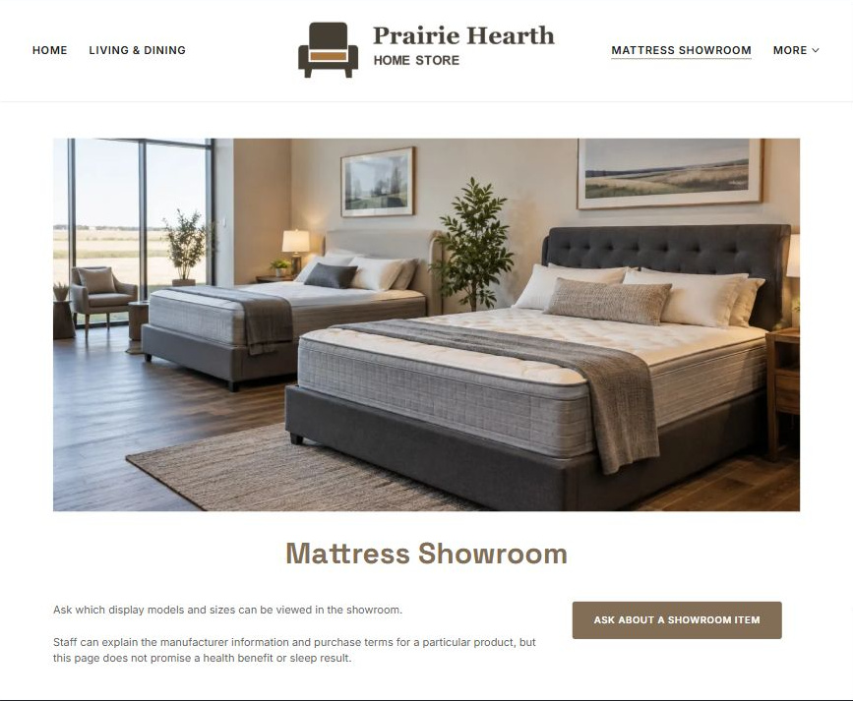
Actual Website Builder desktop excerpt from the fictional demo

Sample wording — adapt and verify
Mattress Showroom
Ask which display models and sizes can be viewed in the showroom.
Staff can explain the manufacturer information and purchase terms for a particular product, but this page does not promise a health benefit or sleep result.
Suggested button: Ask about a showroom item

Website advice
Keep mattress browsing separate from medical or sleep advice and make comfort preferences subjective.

Your draft: Mattress Showroom
Write in the voice of your own business. Use facts you can verify, not promises copied from the example.

Headline and short introduction

Main content and details visitors need

Button wording and destination

Photo choice, permission and facts still to confirm
Partner check: can someone unfamiliar with the business find a useful next step?

04 Décor & Finishing Pieces
Give this page one clear job in the customer journey.
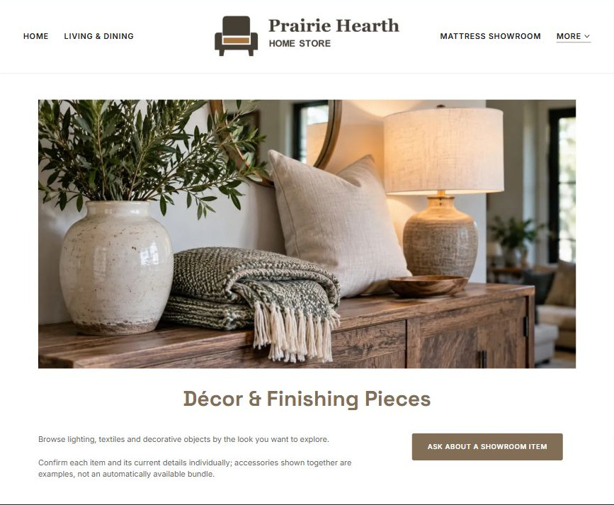
Actual Website Builder desktop excerpt from the fictional demo

Sample wording — adapt and verify
Décor & Finishing Pieces
Browse lighting, textiles and decorative objects by the look you want to explore.
Confirm each item and its current details individually; accessories shown together are examples, not an automatically available bundle.
Suggested button: Ask about a showroom item

Website advice
Give smaller home accessories their own enquiry and styling context without implying a complete staged room is sold as a package.

Your draft: Décor & Finishing Pieces
Write in the voice of your own business. Use facts you can verify, not promises copied from the example.

Headline and short introduction

Main content and details visitors need

Button wording and destination

Photo choice, permission and facts still to confirm
Partner check: can someone unfamiliar with the business find a useful next step?

05 Product Questions & Special Orders
Give this page one clear job in the customer journey.
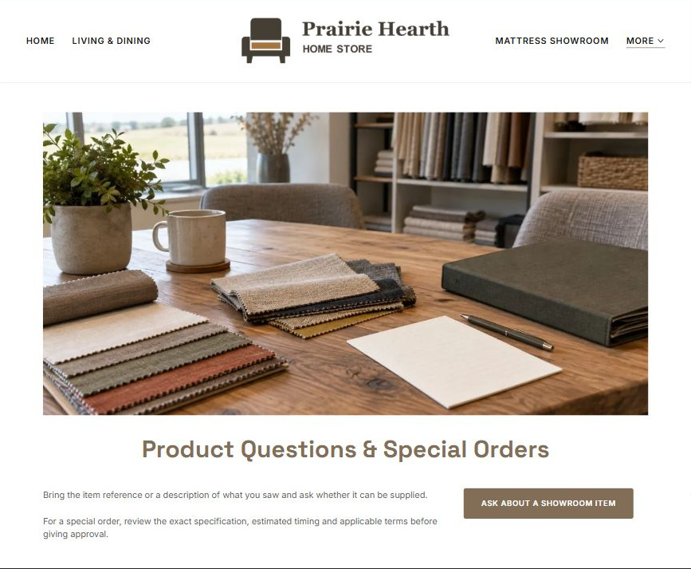
Actual Website Builder desktop excerpt from the fictional demo

Sample wording — adapt and verify
Product Questions & Special Orders
Bring the item reference or a description of what you saw and ask whether it can be supplied.
For a special order, review the exact specification, estimated timing and applicable terms before giving approval.
Suggested button: Ask about a showroom item

Website advice
Explain product reference, supplier review and accepted-order confirmation without claiming live stock or guaranteed dates.

Your draft: Product Questions & Special Orders
Write in the voice of your own business. Use facts you can verify, not promises copied from the example.

Headline and short introduction

Main content and details visitors need

Button wording and destination

Photo choice, permission and facts still to confirm
Partner check: can someone unfamiliar with the business find a useful next step?

06 Showroom Visits & Delivery Enquiries
Give this page one clear job in the customer journey.
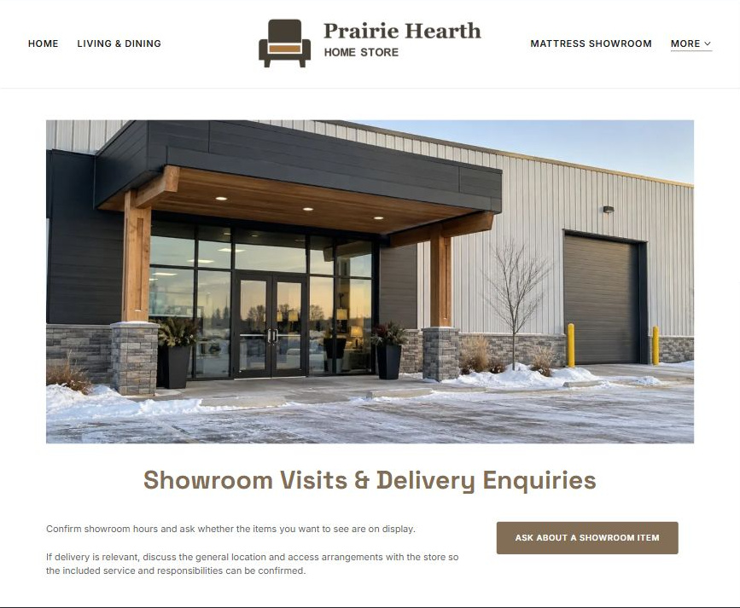
Actual Website Builder desktop excerpt from the fictional demo

Sample wording — adapt and verify
Showroom Visits & Delivery Enquiries
Confirm showroom hours and ask whether the items you want to see are on display.
If delivery is relevant, discuss the general location and access arrangements with the store so the included service and responsibilities can be confirmed.
Suggested button: Ask about a showroom item

Website advice
Separate visiting, collection and delivery arrangements and put access review with the store rather than offering handling guidance.

Your draft: Showroom Visits & Delivery Enquiries
Write in the voice of your own business. Use facts you can verify, not promises copied from the example.

Headline and short introduction

Main content and details visitors need

Button wording and destination

Photo choice, permission and facts still to confirm
Partner check: can someone unfamiliar with the business find a useful next step?

Test before publishing
Review the whole journey on a desktop and phone. Use these first-screen examples to plan your own pages, then verify your complete website.
□ Fictional store demonstration. Images are illustrative, not live stock. Verify dimensions, materials, prices, warranties, delivery and returns before launch; do not promise mattress health benefits, sleep outcomes, suitability or free delivery.
□ Verify every service description, contact route and operating detail.
□ Replace fictional identity and example information before a live launch.
□ Test enquiries, links and downloads on desktop and mobile.
□ Keep confidential records in approved private systems.
□ Obtain operator approval for public wording and images.
□ Check every link, form destination, download and confirmation message.
□ Check logo contrast, hero framing, text sizes and image loading.
□ Save a named backup and assign a content-review date.

Changes to finish and person responsible

Approval and next review date
Website Builder plans and signup

