

Funeral Homes & Memorial Services
Website workbook
A practical workshop for a 5-page website. Study the example, plan the content and draft your own version in Word or on paper.
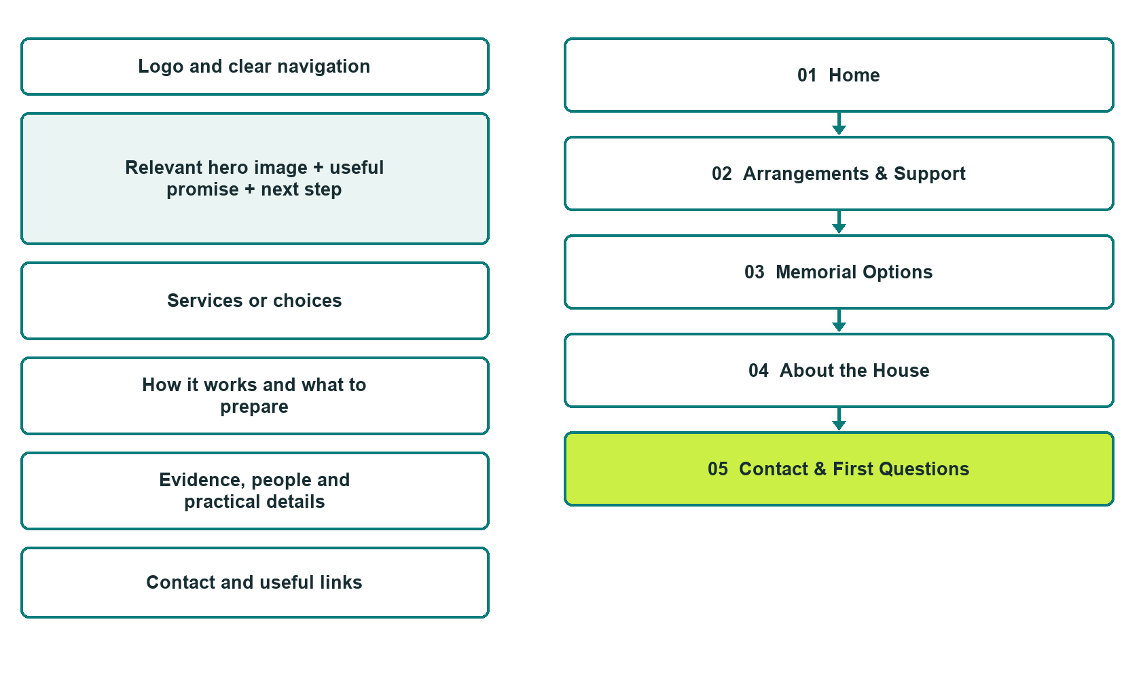

Plan → Draft → Build → Test
Capture edition: five genuine unpublished Website Builder desktop excerpts. Review mobile views on the industry page.
Explore Website Builder and compare plans

Before you build
Your business supplies the facts. Prairie Remembrance House is a fictional teaching example, not a live service.

□ Speak with the arrangements team
□ Verified business identity, services and current contact information
□ A clear enquiry, review and confirmation process
□ Choose original photographs and confirm permission to use them.
□ Keep private customer records out of public website forms.

Your audience and the action you want them to take

Facts to verify and people who must approve them
Create your SaaSTech account

01 Home
Give this page one clear job in the customer journey.
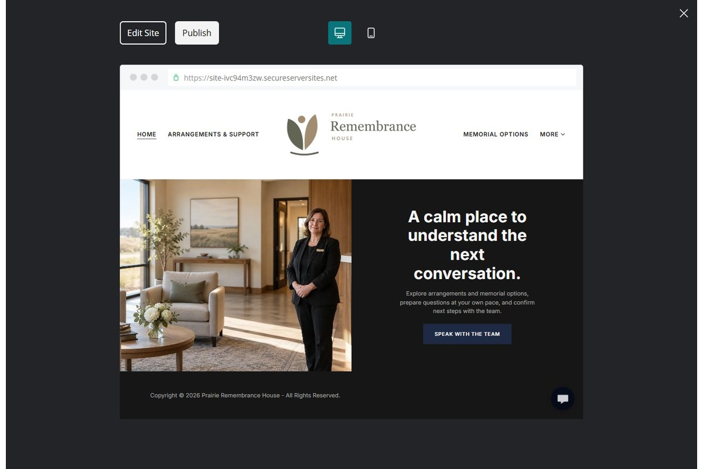
Unpublished Website Builder desktop excerpt. Page content continues below.

Sample wording — adapt and verify
A calm place to understand the next conversation.
Find the right contact, explore the arrangement process and prepare questions at your own pace. A team member explains which options and next steps apply to your enquiry.
Use the relevant page to prepare a focused enquiry, then contact the team to confirm the next step.
Suggested button: Speak with the arrangements team

Website advice
Explain verified arrangement services, memorial options and contact routes with respectful language and clearly confirmed details.

Your draft: Home
Write in the voice of your own business. Use facts you can verify, not promises copied from the example.

Headline and short introduction

Main content and details visitors need

Button wording and destination

Photo choice, permission and facts still to confirm
Partner check: can someone unfamiliar with the business find a useful next step?

02 Arrangements & Support
Give this page one clear job in the customer journey.
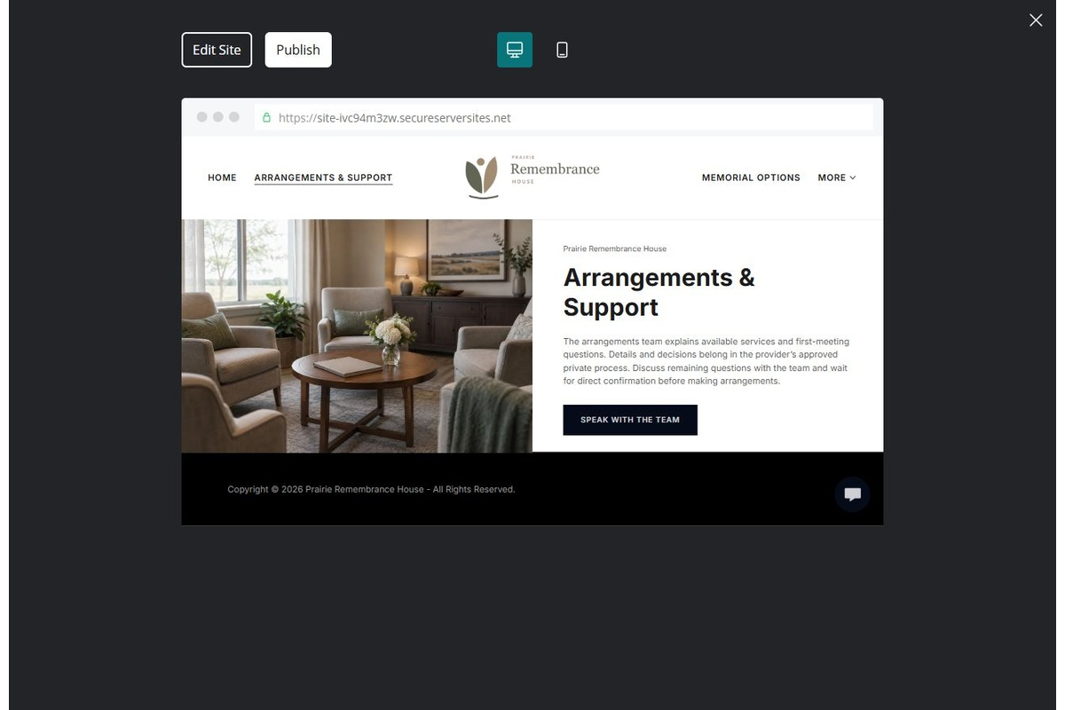
Unpublished Website Builder desktop excerpt. Page content continues below.

Sample wording — adapt and verify
Arrangements & Support
The arrangements team can explain the services currently offered and the questions usually discussed in a first meeting. Details and decisions are recorded through the provider’s approved private process.
Discuss any remaining questions with the team and wait for direct confirmation before making arrangements.
Suggested button: Speak with the arrangements team

Website advice
Explain services offered and who discusses individual arrangements. Avoid legal instructions and invented availability.

Your draft: Arrangements & Support
Write in the voice of your own business. Use facts you can verify, not promises copied from the example.

Headline and short introduction

Main content and details visitors need

Button wording and destination

Photo choice, permission and facts still to confirm
Partner check: can someone unfamiliar with the business find a useful next step?

03 Memorial Options
Give this page one clear job in the customer journey.
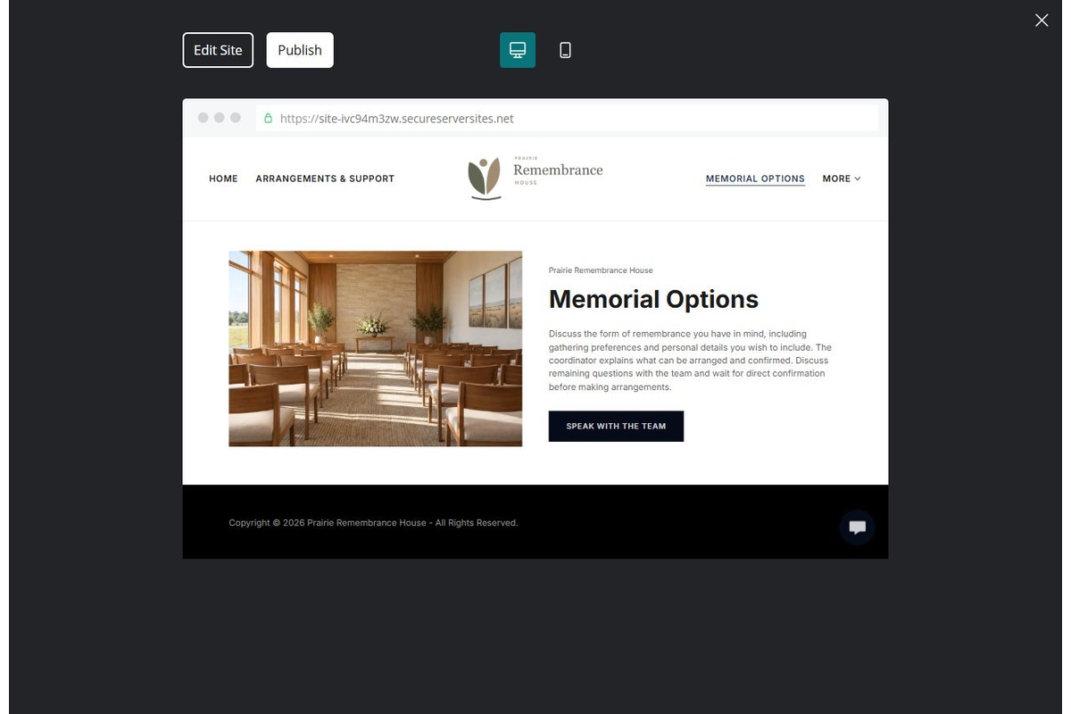
Unpublished Website Builder desktop excerpt. Page content continues below.

Sample wording — adapt and verify
Memorial Options
Discuss the form of remembrance you have in mind, including gathering preferences and personal details you wish to include. The coordinator explains what can be arranged and confirmed.
Discuss any remaining questions with the team and wait for direct confirmation before making arrangements.
Suggested button: Speak with the arrangements team

Website advice
Present respectful examples without implying specific packages, customs or prices apply to everyone.

Your draft: Memorial Options
Write in the voice of your own business. Use facts you can verify, not promises copied from the example.

Headline and short introduction

Main content and details visitors need

Button wording and destination

Photo choice, permission and facts still to confirm
Partner check: can someone unfamiliar with the business find a useful next step?

04 About the House
Give this page one clear job in the customer journey.
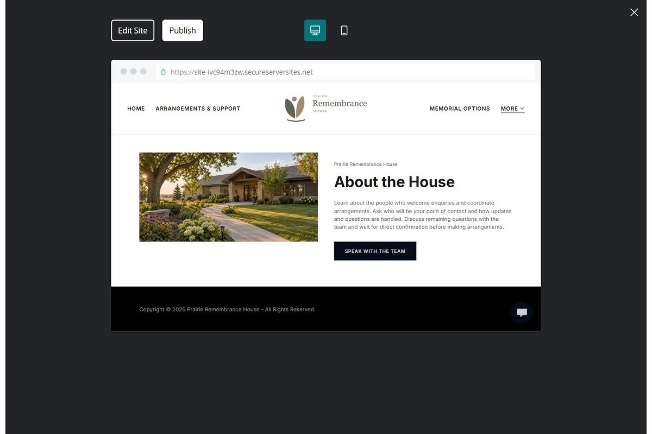
Unpublished Website Builder desktop excerpt. Page content continues below.

Sample wording — adapt and verify
About the House
Learn about the people who welcome enquiries and coordinate arrangements. Ask who will be your point of contact and how updates and questions are handled.
Discuss any remaining questions with the team and wait for direct confirmation before making arrangements.
Suggested button: Speak with the arrangements team

Website advice
Introduce verified staff and the setting without unsupported qualifications or testimonials.

Your draft: About the House
Write in the voice of your own business. Use facts you can verify, not promises copied from the example.

Headline and short introduction

Main content and details visitors need

Button wording and destination

Photo choice, permission and facts still to confirm
Partner check: can someone unfamiliar with the business find a useful next step?

05 Contact & First Questions
Give this page one clear job in the customer journey.
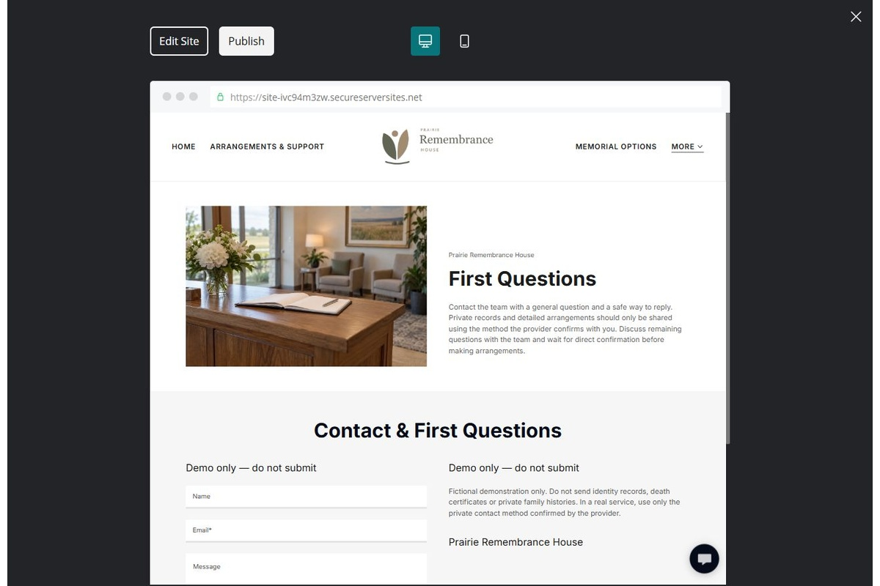
Unpublished Website Builder desktop excerpt. Page content continues below.

Sample wording — adapt and verify
Contact & First Questions
Contact the team with a general question and a safe way to reply. Private records and detailed arrangements should only be shared using the method the provider confirms with you.
Discuss any remaining questions with the team and wait for direct confirmation before making arrangements.
Suggested button: Speak with the arrangements team

Website advice
Distinguish general enquiries from operator-approved urgent contact procedures. Keep the public form minimal.

Your draft: Contact & First Questions
Write in the voice of your own business. Use facts you can verify, not promises copied from the example.

Headline and short introduction

Main content and details visitors need

Button wording and destination

Photo choice, permission and facts still to confirm
Partner check: can someone unfamiliar with the business find a useful next step?

Test before publishing
Review the whole journey on a desktop and phone. Compare these desktop excerpts with the mobile captures on the industry page.
□ Fictional demonstration only. Operator review is required for legal, disposition, pricing and urgent-contact information. Do not request identity records, death certificates or private family histories through public forms.
□ Verify each offered service, contact route, location and opening arrangement.
□ Remove fictional identity, claims, availability and prices before a real launch.
□ Test every enquiry route and download on desktop and mobile.
□ Keep sensitive information in approved private systems.
□ Obtain operator approval for all public wording and image use.
□ Check every link, form destination, download and confirmation message.
□ Check logo contrast, hero framing, text sizes and image loading.
□ Save a named backup and assign a content-review date.

Changes to finish and person responsible

Approval and next review date
Website Builder plans and signup

