

Franchise & Quick-Service Restaurants
Website workbook
A practical workshop for a 6-page website. Study the example, plan the content and draft your own version in Word or on paper.
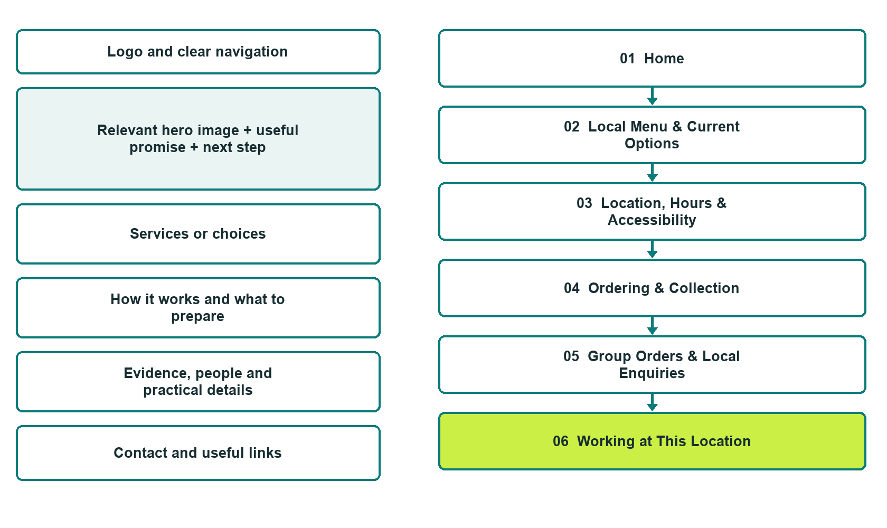

Plan → Draft → Build → Test
Capture edition: six genuine unpublished Website Builder desktop excerpts. Review mobile views on the industry page.
Explore Website Builder and compare plans

Before you build
Your business supplies the facts. Prairie Counter Kitchen is a fictional teaching example, not a live service.

□ Explore the local menu and confirmed visit options
□ Verified business identity, services and current contact information
□ A clear enquiry, review and confirmation process
□ Choose original photographs and confirm permission to use them.
□ Keep private customer records out of public website forms.

Your audience and the action you want them to take

Facts to verify and people who must approve them
Create your SaaSTech account

01 Home
Give this page one clear job in the customer journey.
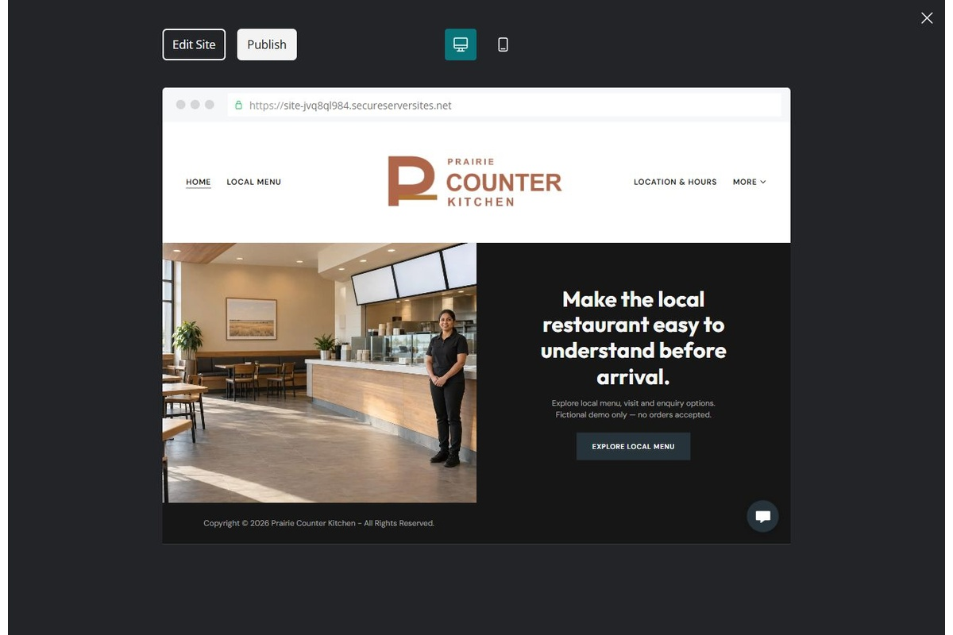
Unpublished Website Builder desktop excerpt. Page content continues below.

Sample wording — adapt and verify
Make the local restaurant easy to understand before arrival.
Find the menu categories, location information and the right contact for a group order or employment enquiry.
Any future franchise branding and purchase links must be approved and tested; the demonstration does not accept orders.
Suggested button: Explore the local menu and confirmed visit options

Website advice
A fictional quick-service location concept with separate menu, visit, group-order and employment routes; franchise affiliation and ordering links require brand approval and verification.

Your draft: Home
Write in the voice of your own business. Use facts you can verify, not promises copied from the example.

Headline and short introduction

Main content and details visitors need

Button wording and destination

Photo choice, permission and facts still to confirm
Partner check: can someone unfamiliar with the business find a useful next step?

02 Local Menu & Current Options
Give this page one clear job in the customer journey.
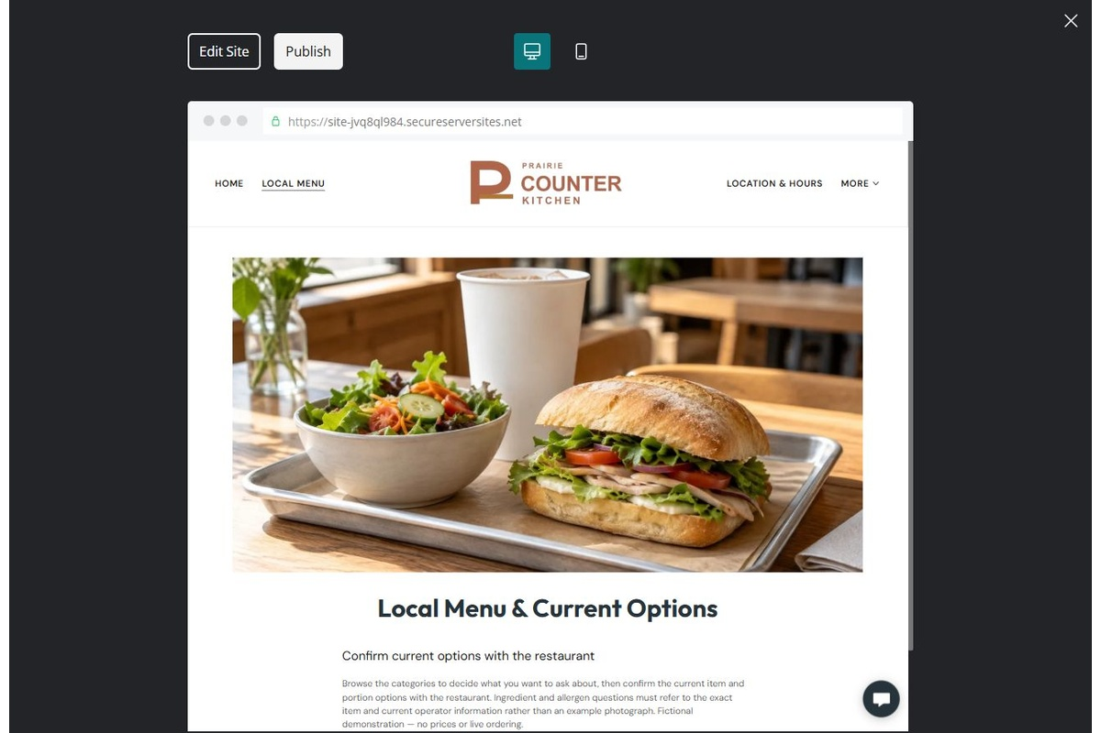
Unpublished Website Builder desktop excerpt. Page content continues below.

Sample wording — adapt and verify
Local Menu & Current Options
Browse the categories to decide what you want to ask about, then confirm the current item and portion options with the restaurant.
Ingredient and allergen questions must refer to the exact item and current operator information rather than an example photograph.
Suggested button: Explore the local menu and confirmed visit options

Website advice
Organize operator-approved food and drink categories with exact current item information, not invented prices or availability.

Your draft: Local Menu & Current Options
Write in the voice of your own business. Use facts you can verify, not promises copied from the example.

Headline and short introduction

Main content and details visitors need

Button wording and destination

Photo choice, permission and facts still to confirm
Partner check: can someone unfamiliar with the business find a useful next step?

03 Location, Hours & Accessibility
Give this page one clear job in the customer journey.
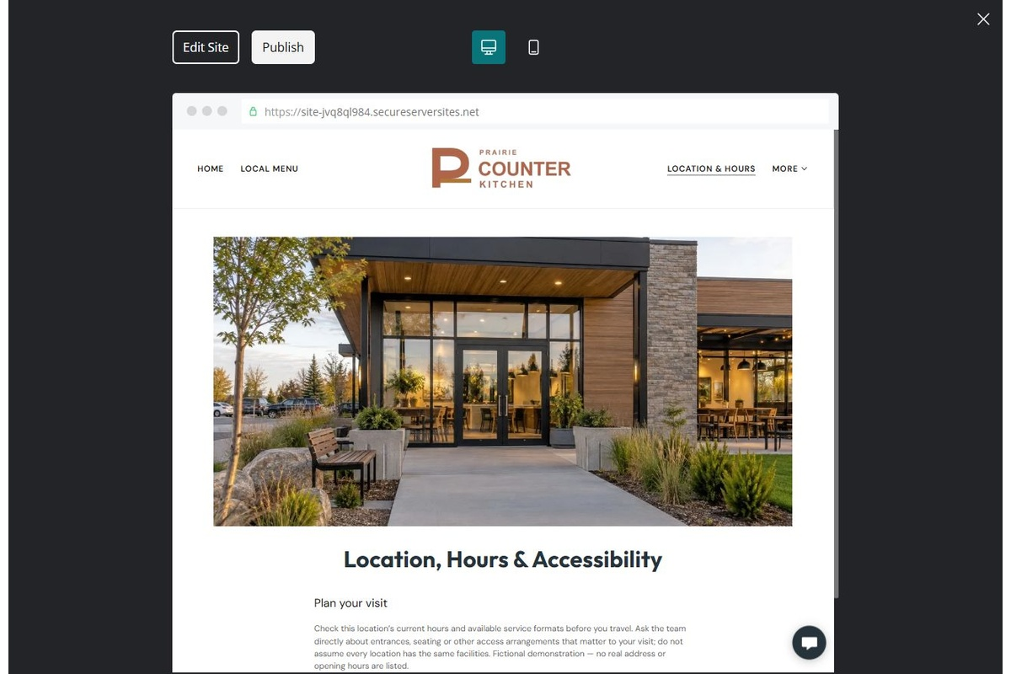
Unpublished Website Builder desktop excerpt. Page content continues below.

Sample wording — adapt and verify
Location, Hours & Accessibility
Check this location’s current hours and available service formats before you travel.
Ask the team directly about entrances, seating or other access arrangements that matter to your visit; do not assume every location has the same facilities.
Suggested button: Explore the local menu and confirmed visit options

Website advice
Provide verified local visit information separately from any wider franchise or brand directory.

Your draft: Location, Hours & Accessibility
Write in the voice of your own business. Use facts you can verify, not promises copied from the example.

Headline and short introduction

Main content and details visitors need

Button wording and destination

Photo choice, permission and facts still to confirm
Partner check: can someone unfamiliar with the business find a useful next step?

04 Ordering & Collection
Give this page one clear job in the customer journey.
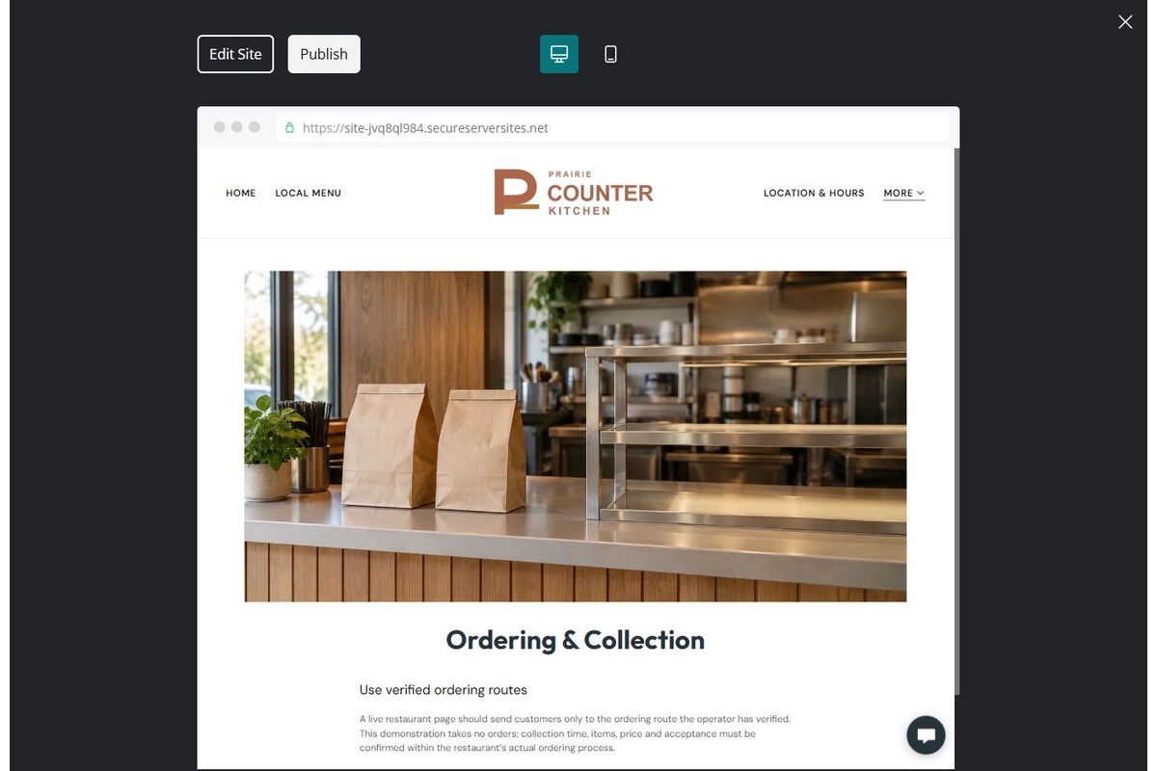
Unpublished Website Builder desktop excerpt. Page content continues below.

Sample wording — adapt and verify
Ordering & Collection
A live restaurant page should send customers only to the ordering route the operator has verified.
This demonstration takes no orders; collection time, items, price and acceptance must be confirmed within the restaurant’s actual ordering process.
Suggested button: Explore the local menu and confirmed visit options

Website advice
Use only tested operator-approved ordering destinations and explain the difference between a contact message and a purchase.

Your draft: Ordering & Collection
Write in the voice of your own business. Use facts you can verify, not promises copied from the example.

Headline and short introduction

Main content and details visitors need

Button wording and destination

Photo choice, permission and facts still to confirm
Partner check: can someone unfamiliar with the business find a useful next step?

05 Group Orders & Local Enquiries
Give this page one clear job in the customer journey.
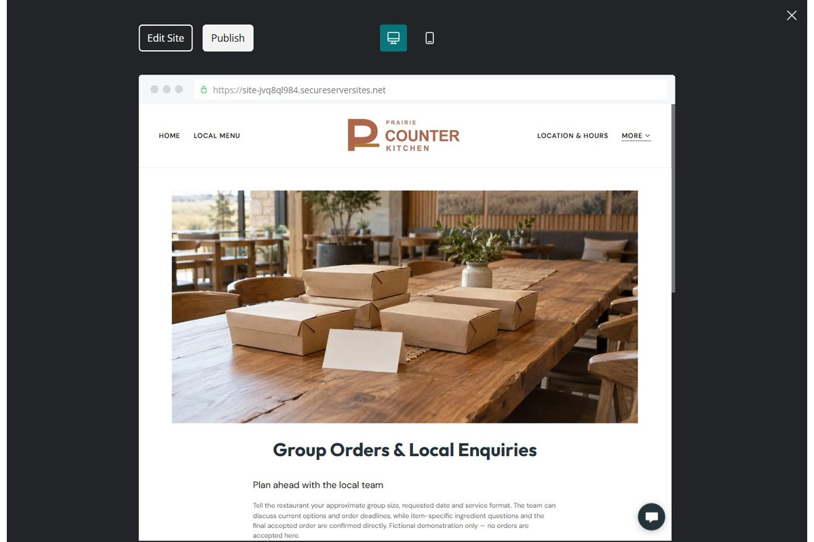
Unpublished Website Builder desktop excerpt. Page content continues below.

Sample wording — adapt and verify
Group Orders & Local Enquiries
Tell the restaurant your approximate group size, requested date and service format.
The team can discuss current options and order deadlines, while item-specific ingredient questions and the final accepted order are confirmed directly.
Suggested button: Explore the local menu and confirmed visit options

Website advice
Separate advance group requests from ordinary ordering, with feasibility and exact product questions reviewed by staff.

Your draft: Group Orders & Local Enquiries
Write in the voice of your own business. Use facts you can verify, not promises copied from the example.

Headline and short introduction

Main content and details visitors need

Button wording and destination

Photo choice, permission and facts still to confirm
Partner check: can someone unfamiliar with the business find a useful next step?

06 Working at This Location
Give this page one clear job in the customer journey.
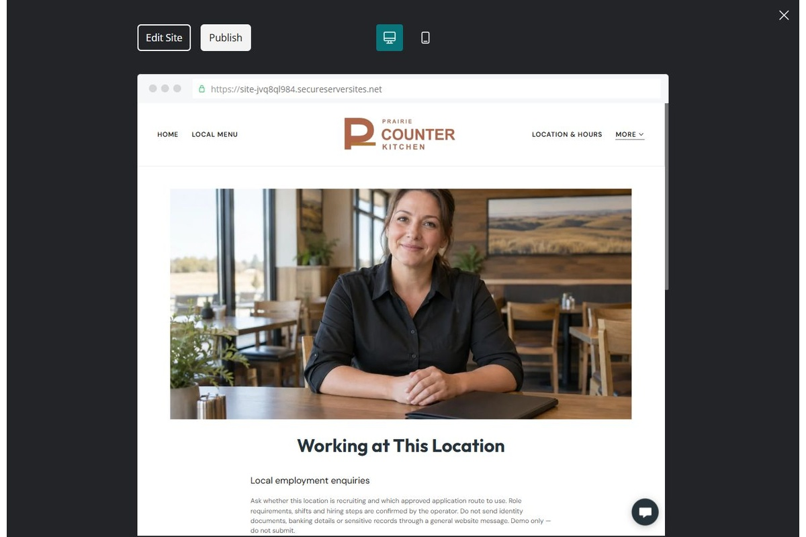
Unpublished Website Builder desktop excerpt. Page content continues below.

Sample wording — adapt and verify
Working at This Location
Ask whether this location is recruiting and which approved application route to use.
Role requirements, shifts and hiring steps are confirmed by the operator; do not send identity documents, banking details or other sensitive records through a general website message.
Suggested button: Ask about working here

Website advice
Offer a local employment enquiry route with verified openings and a privacy-conscious application handoff.

Your draft: Working at This Location
Write in the voice of your own business. Use facts you can verify, not promises copied from the example.

Headline and short introduction

Main content and details visitors need

Button wording and destination

Photo choice, permission and facts still to confirm
Partner check: can someone unfamiliar with the business find a useful next step?

Test before publishing
Review the whole journey on a desktop and phone. Compare these desktop excerpts with the mobile captures on the industry page.
□ Fictional demonstration only, not an authorized franchise. Verify brand permission, location details, current menu, prices, ingredients, allergens, offers and ordering links before publication. No allergen-free assurance, live order placement or food-safety advice is provided.
□ Verify every service description, contact route and operating detail.
□ Replace fictional identity and example information before a live launch.
□ Test enquiries, links and downloads on desktop and mobile.
□ Keep confidential records in approved private systems.
□ Obtain operator approval for public wording and images.
□ Check every link, form destination, download and confirmation message.
□ Check logo contrast, hero framing, text sizes and image loading.
□ Save a named backup and assign a content-review date.

Changes to finish and person responsible

Approval and next review date
Website Builder plans and signup

