

Florists, Garden Centres & Greenhouses
Website workbook
A practical workshop for a 5-page website. Study the example, plan the content and draft your own version in Word or on paper.
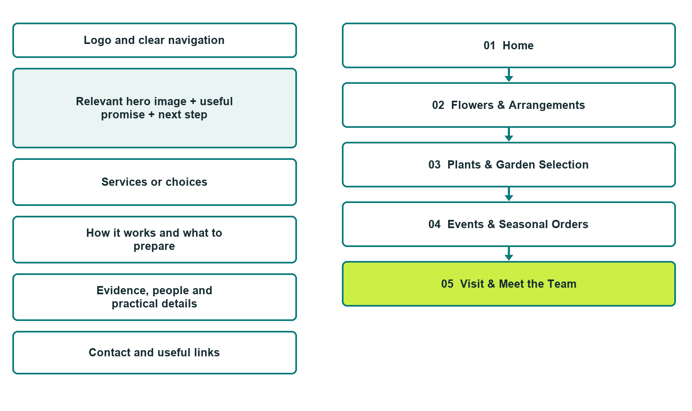

Plan → Draft → Build → Test
Capture edition: five genuine unpublished Website Builder desktop excerpts. The cover wireframe remains illustrative.
Explore Website Builder and compare plans

Before you build
Your business supplies the facts. Prairie Petal Garden House is a fictional teaching example, not a live service.

□ Ask about flowers plants or a seasonal order
□ Verified business identity and current contact information
□ Clear request and confirmation process
□ Choose original photographs and confirm permission to use them.
□ Keep private customer records out of public website forms.

Your audience and the action you want them to take

Facts to verify and people who must approve them
Create your SaaSTech account

01 Home
Give this page one clear job in the customer journey.
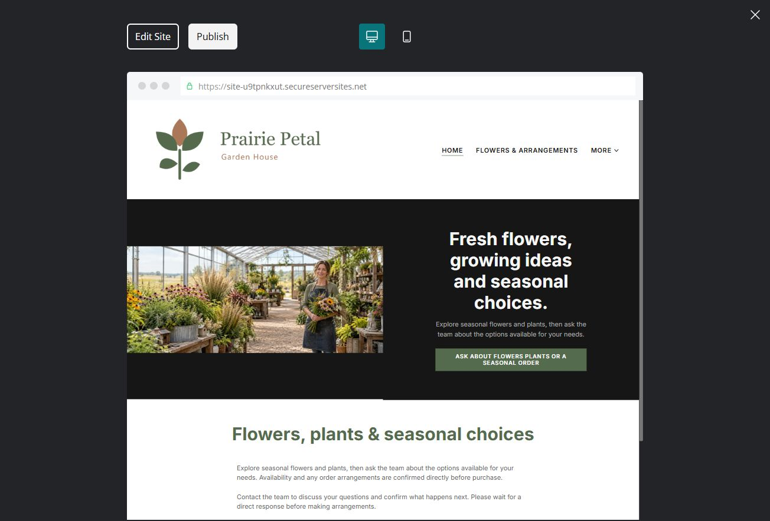
Unpublished Website Builder desktop excerpt. Page content continues below.

Sample wording — adapt and verify
Fresh flowers, growing ideas and seasonal choices.
Explore seasonal flowers and plants, then ask the team about the options available for your needs. Availability and any order arrangements are confirmed directly before purchase.
Contact the team to discuss your questions and confirm what happens next. Please wait for a direct response before making arrangements.
Suggested button: Ask about flowers plants or a seasonal order

Website advice
Separate flowers, plants and event orders with current availability and clear order-confirmation expectations. Avoid unsupported plant-care, toxicity or delivery promises.

Your draft: Home
Write in the voice of your own business. Use facts you can verify, not promises copied from the example.

Headline and short introduction

Main content and details visitors need

Button wording and destination

Photo choice, permission and facts still to confirm
Partner check: can someone unfamiliar with the business find a useful next step?

02 Flowers & Arrangements
Give this page one clear job in the customer journey.
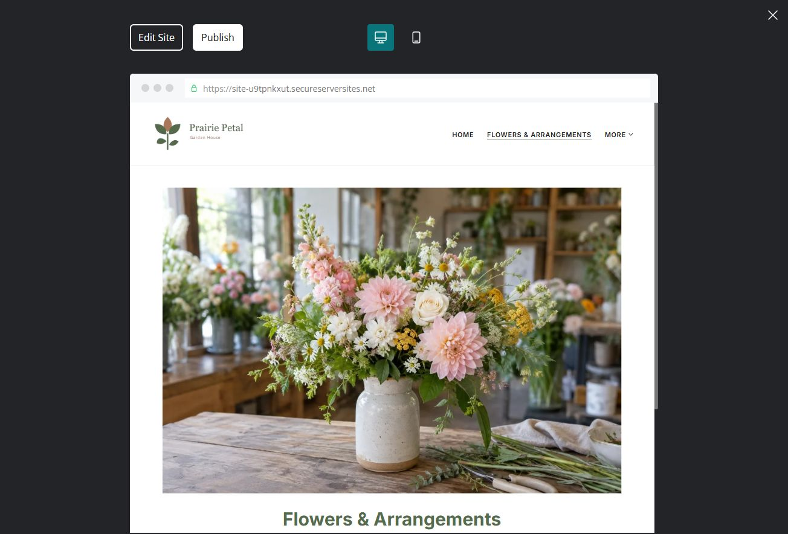
Unpublished Website Builder desktop excerpt. Page content continues below.

Sample wording — adapt and verify
Flowers & Arrangements
Tell us the occasion, colours and timing you would like to discuss. The florist explains current options and confirms the arrangement before an order is accepted.
Contact the team to discuss your questions and confirm what happens next. Please wait for a direct response before making arrangements.
Suggested button: Contact the team

Website advice
Show distinct arrangement examples with operator-approved descriptions. Separate pictured examples from live stock.

Your draft: Flowers & Arrangements
Write in the voice of your own business. Use facts you can verify, not promises copied from the example.

Headline and short introduction

Main content and details visitors need

Button wording and destination

Photo choice, permission and facts still to confirm
Partner check: can someone unfamiliar with the business find a useful next step?

03 Plants & Garden Selection
Give this page one clear job in the customer journey.
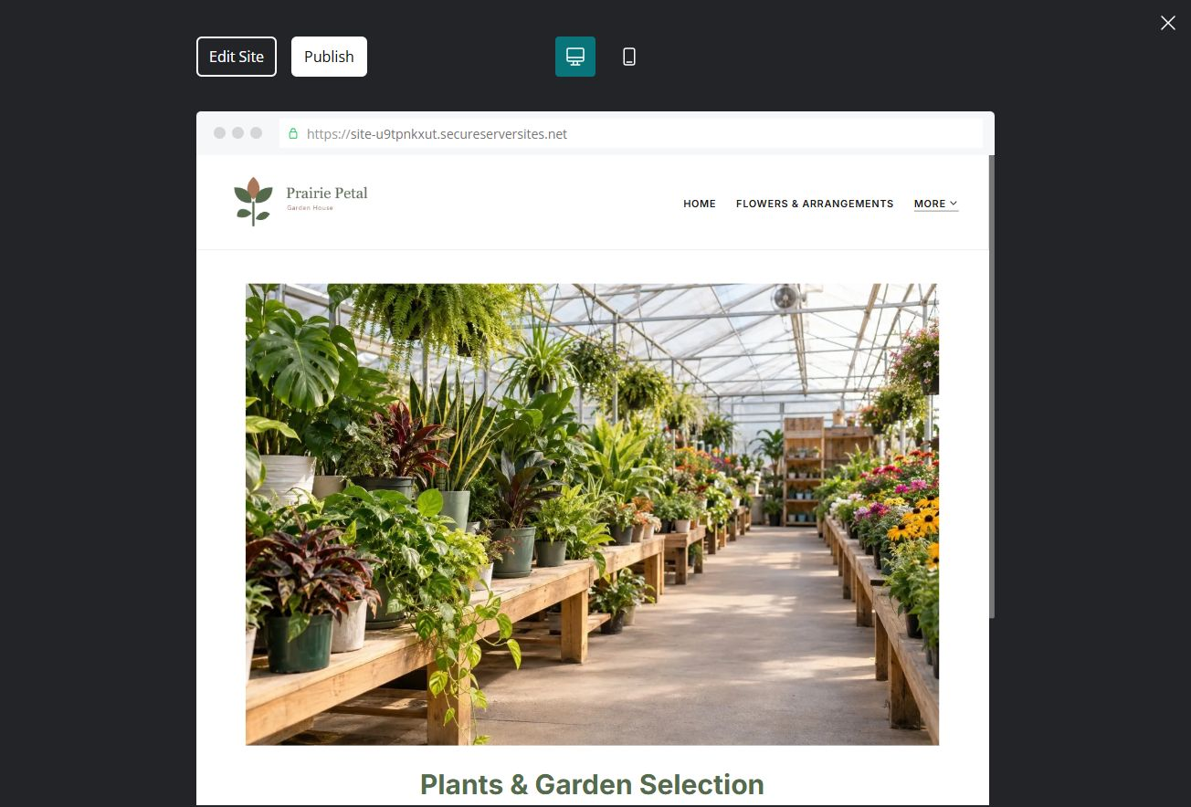
Unpublished Website Builder desktop excerpt. Page content continues below.

Sample wording — adapt and verify
Plants & Garden Selection
Browse the types of plants and garden items featured in the shop. Ask the team to confirm current stock and the information relevant to your intended setting.
Contact the team to discuss your questions and confirm what happens next. Please wait for a direct response before making arrangements.
Suggested button: Contact the team

Website advice
Group current categories with clear availability enquiries. Have staff review any care or suitability guidance.

Your draft: Plants & Garden Selection
Write in the voice of your own business. Use facts you can verify, not promises copied from the example.

Headline and short introduction

Main content and details visitors need

Button wording and destination

Photo choice, permission and facts still to confirm
Partner check: can someone unfamiliar with the business find a useful next step?

04 Events & Seasonal Orders
Give this page one clear job in the customer journey.
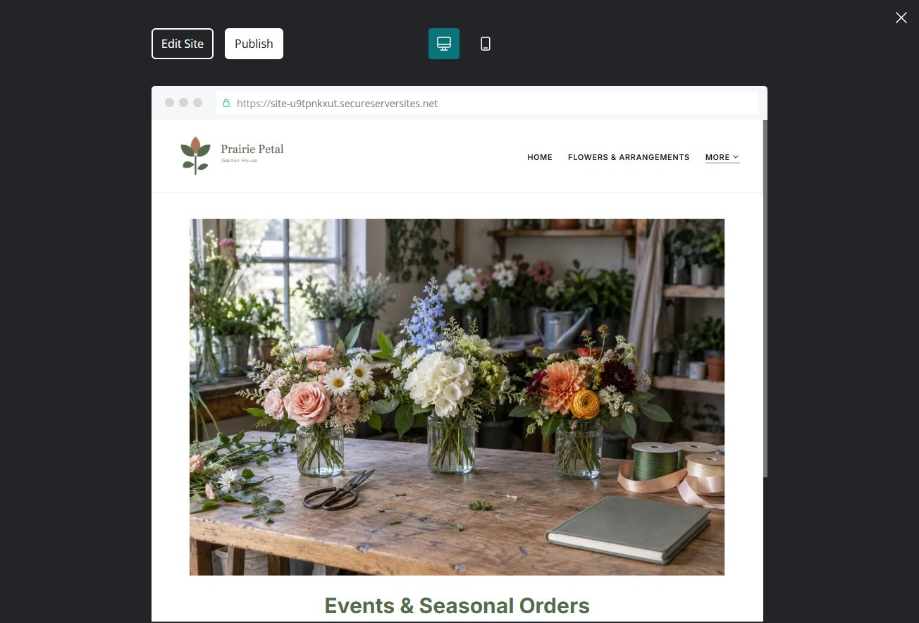
Unpublished Website Builder desktop excerpt. Page content continues below.

Sample wording — adapt and verify
Events & Seasonal Orders
Share the event date, general style and approximate scale of your request. The team discusses availability and a proposal before the order is confirmed.
Contact the team to discuss your questions and confirm what happens next. Please wait for a direct response before making arrangements.
Suggested button: Contact the team

Website advice
Explain consultation, lead-time discussion, estimate and confirmation steps without invented deadlines.

Your draft: Events & Seasonal Orders
Write in the voice of your own business. Use facts you can verify, not promises copied from the example.

Headline and short introduction

Main content and details visitors need

Button wording and destination

Photo choice, permission and facts still to confirm
Partner check: can someone unfamiliar with the business find a useful next step?

05 Visit & Meet the Team
Give this page one clear job in the customer journey.
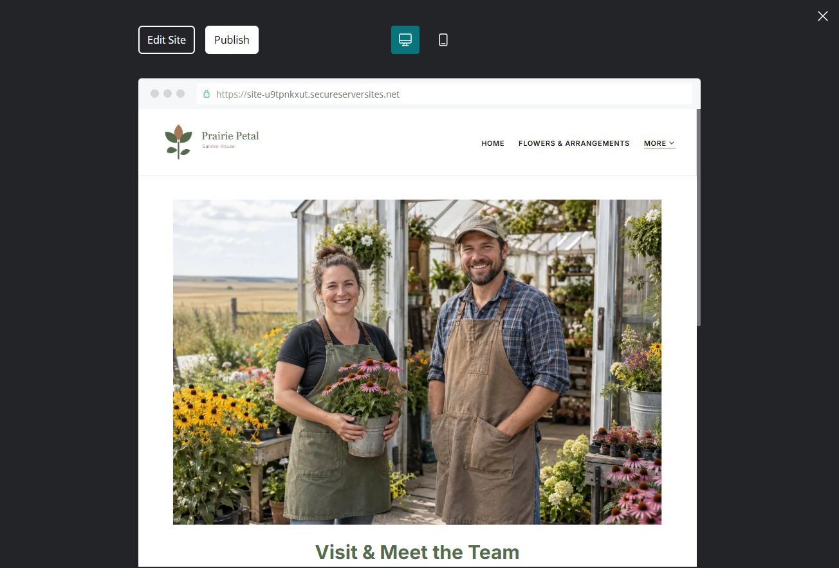
Unpublished Website Builder desktop excerpt. Page content continues below.

Sample wording — adapt and verify
Visit & Meet the Team
Meet the people who help customers choose and plan. Confirm current hours and arrival details before visiting, especially during seasonal changes.
Contact the team to discuss your questions and confirm what happens next. Please wait for a direct response before making arrangements.
Suggested button: Contact the team

Website advice
Show real store access, seasonal hours and staff roles. Use unique greenhouse and shop photographs.

Your draft: Visit & Meet the Team
Write in the voice of your own business. Use facts you can verify, not promises copied from the example.

Headline and short introduction

Main content and details visitors need

Button wording and destination

Photo choice, permission and facts still to confirm
Partner check: can someone unfamiliar with the business find a useful next step?

Test before publishing
Review the whole journey on a desktop and phone. Check links, image framing and demo-form privacy before launch.
□ Fictional retail example only. Verify stock, care wording, suitability, delivery coverage and order terms with the operator before publication.
□ Verify contact routes, hours, location and every offered service.
□ Remove invented prices, claims, testimonials and availability.
□ Keep sensitive records and payment details out of ordinary public forms.
□ Check all image permissions, downloads and page links on a phone.
□ Check every link, form destination, download and confirmation message.
□ Check logo contrast, hero framing, text sizes and image loading.
□ Save a named backup and assign a content-review date.

Changes to finish and person responsible

Approval and next review date
Website Builder plans and signup

