

Commercial Fishing, Aquaculture & Seafood Businesses
Website workbook
A practical workshop for a 6-page website. Study the example, plan the content and draft your own version in Word or on paper.
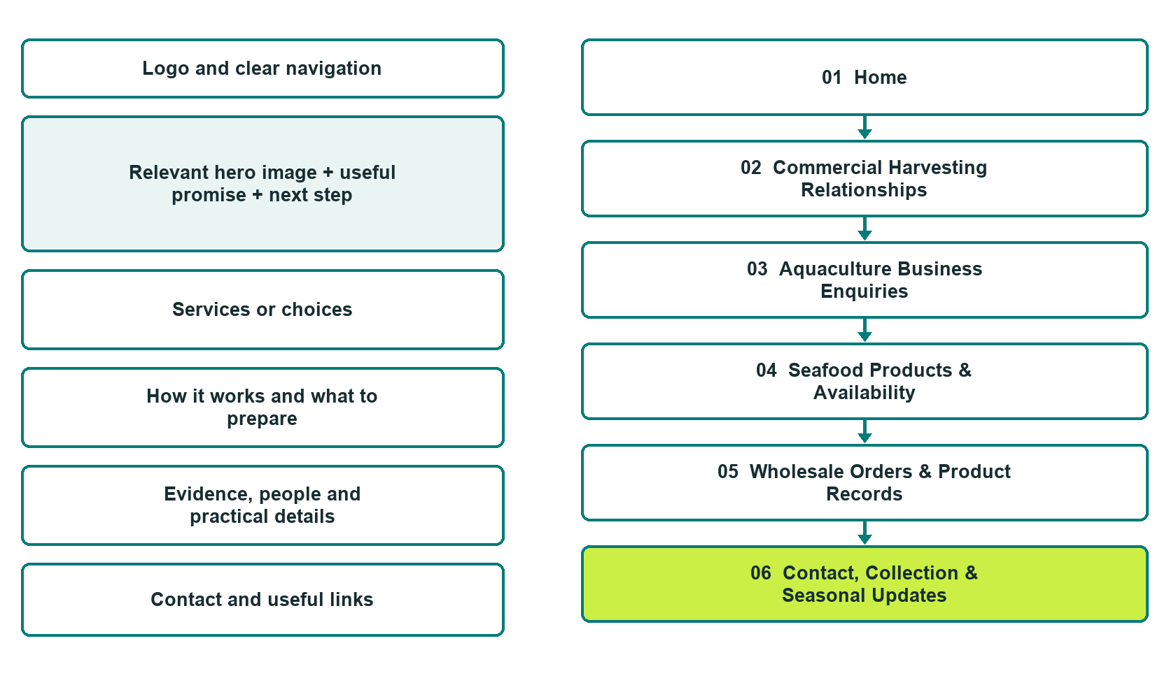

Plan → Draft → Build → Test
Website Builder capture edition: six desktop excerpts from the fictional demo; the wireframe remains a planning illustration.
Explore Website Builder and compare plans

Before you build
Your business supplies the facts. Prairie Lakes Fish & Seafood is a fictional teaching example, not a live service.

□ Choose a harvest, aquaculture or supply enquiry
□ Verified business identity, services and current contact information
□ A clear enquiry, review and confirmation process
□ Choose original photographs and confirm permission to use them.
□ Keep private customer records out of public website forms.

Your audience and the action you want them to take

Facts to verify and people who must approve them
Create your SaaSTech account

01 Home
Give this page one clear job in the customer journey.
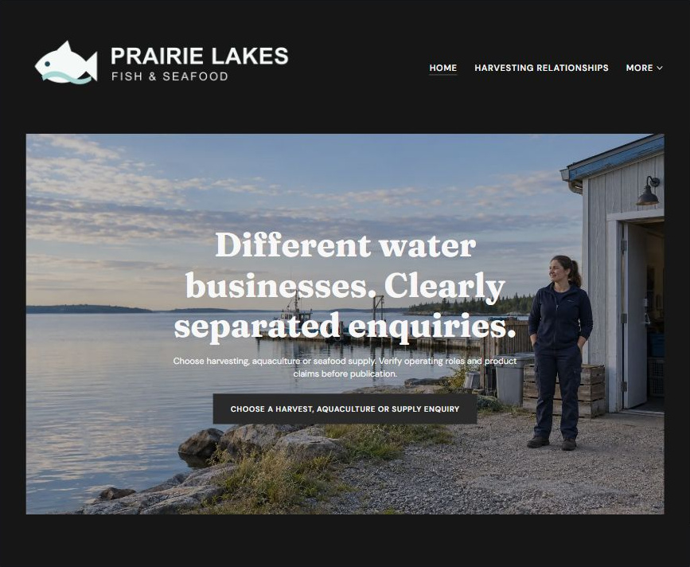
Actual Website Builder desktop excerpt from the fictional demo

Sample wording — adapt and verify
Different water businesses. Clearly separated enquiries.
Explore three different business conversations: harvesting relationships, aquaculture enquiries and seafood purchasing.
Each path identifies its own questions, and every operating role and product claim must be confirmed before this demonstration is published.
Suggested button: Choose a harvest, aquaculture or supply enquiry

Website advice
Distinguish commercial harvesting, aquaculture and seafood supply as separate business paths; do not imply that one company operates all three without verification.

Your draft: Home
Write in the voice of your own business. Use facts you can verify, not promises copied from the example.

Headline and short introduction

Main content and details visitors need

Button wording and destination

Photo choice, permission and facts still to confirm
Partner check: can someone unfamiliar with the business find a useful next step?

02 Commercial Harvesting Relationships
Give this page one clear job in the customer journey.
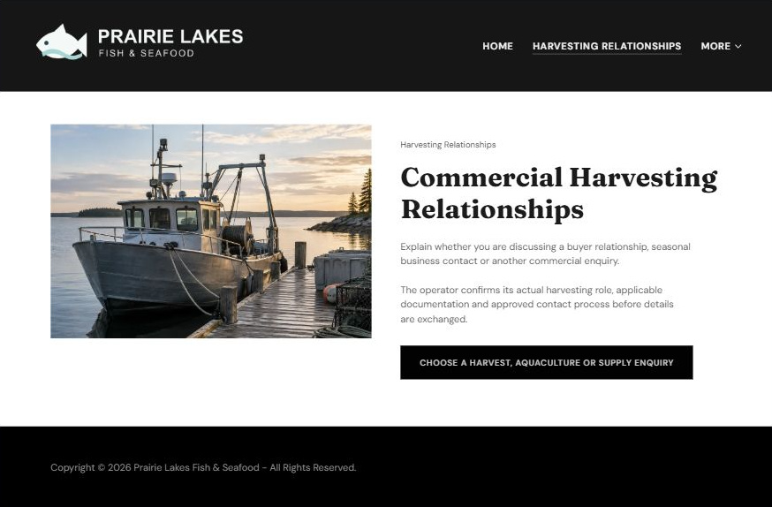
Actual Website Builder desktop excerpt from the fictional demo

Sample wording — adapt and verify
Commercial Harvesting Relationships
Explain whether you are discussing a buyer relationship, seasonal business contact or another commercial enquiry.
The operator confirms its actual harvesting role, applicable documentation and approved contact process before details are exchanged.
Suggested button: Choose a harvest, aquaculture or supply enquiry

Website advice
Present a distinct business-to-business enquiry path for verified harvesters without implying public charter services or licensing.

Your draft: Commercial Harvesting Relationships
Write in the voice of your own business. Use facts you can verify, not promises copied from the example.

Headline and short introduction

Main content and details visitors need

Button wording and destination

Photo choice, permission and facts still to confirm
Partner check: can someone unfamiliar with the business find a useful next step?

03 Aquaculture Business Enquiries
Give this page one clear job in the customer journey.
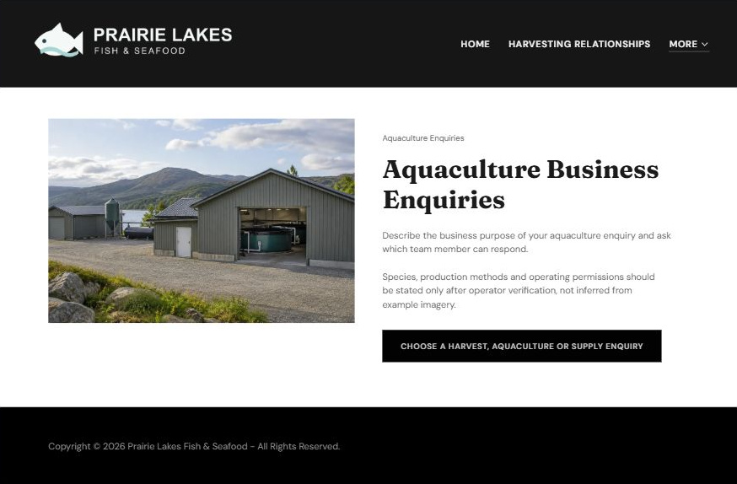
Actual Website Builder desktop excerpt from the fictional demo

Sample wording — adapt and verify
Aquaculture Business Enquiries
Describe the business purpose of your aquaculture enquiry and ask which team member can respond.
Species, production methods and operating permissions should be stated only after operator verification, not inferred from example imagery.
Suggested button: Choose a harvest, aquaculture or supply enquiry

Website advice
Separate farm-business questions from wild harvesting and product retail; use only confirmed facility descriptions.

Your draft: Aquaculture Business Enquiries
Write in the voice of your own business. Use facts you can verify, not promises copied from the example.

Headline and short introduction

Main content and details visitors need

Button wording and destination

Photo choice, permission and facts still to confirm
Partner check: can someone unfamiliar with the business find a useful next step?

04 Seafood Products & Availability
Give this page one clear job in the customer journey.
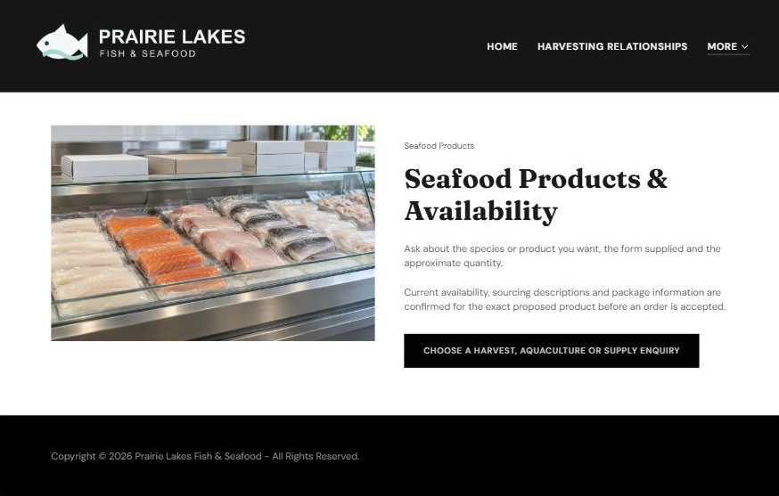
Actual Website Builder desktop excerpt from the fictional demo

Sample wording — adapt and verify
Seafood Products & Availability
Ask about the species or product you want, the form supplied and the approximate quantity.
Current availability, sourcing descriptions and package information are confirmed for the exact proposed product before an order is accepted.
Suggested button: Choose a harvest, aquaculture or supply enquiry

Website advice
Create a clear purchasing route with exact product, form, pack and quantity questions, without inventing live stock.

Your draft: Seafood Products & Availability
Write in the voice of your own business. Use facts you can verify, not promises copied from the example.

Headline and short introduction

Main content and details visitors need

Button wording and destination

Photo choice, permission and facts still to confirm
Partner check: can someone unfamiliar with the business find a useful next step?

05 Wholesale Orders & Product Records
Give this page one clear job in the customer journey.
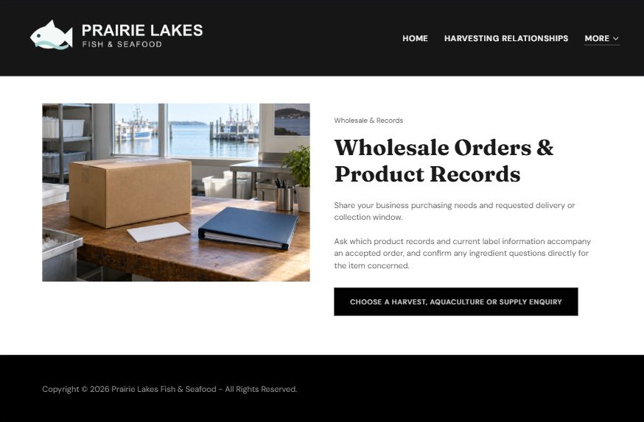
Actual Website Builder desktop excerpt from the fictional demo

Sample wording — adapt and verify
Wholesale Orders & Product Records
Share your business purchasing needs and requested delivery or collection window.
Ask which product records and current label information accompany an accepted order, and confirm any ingredient questions directly for the item concerned.
Suggested button: Choose a harvest, aquaculture or supply enquiry

Website advice
Explain business-account discussion and product-specific documentation without asserting traceability certifications or suitability.

Your draft: Wholesale Orders & Product Records
Write in the voice of your own business. Use facts you can verify, not promises copied from the example.

Headline and short introduction

Main content and details visitors need

Button wording and destination

Photo choice, permission and facts still to confirm
Partner check: can someone unfamiliar with the business find a useful next step?

06 Contact, Collection & Seasonal Updates
Give this page one clear job in the customer journey.
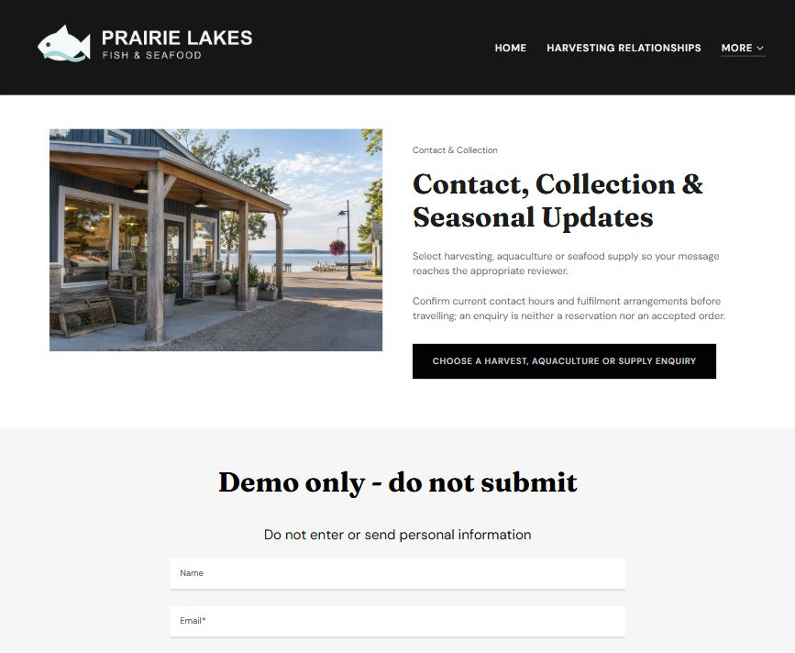
Actual Website Builder desktop excerpt from the fictional demo

Sample wording — adapt and verify
Contact, Collection & Seasonal Updates
Select harvesting, aquaculture or seafood supply so your message reaches the appropriate reviewer.
Confirm current contact hours and fulfilment arrangements before travelling; an enquiry is neither a reservation nor an accepted order.
Suggested button: Choose a harvest, aquaculture or supply enquiry

Website advice
Route seasonal business and purchasing enquiries while keeping hours, stock and fulfilment subject to confirmation.

Your draft: Contact, Collection & Seasonal Updates
Write in the voice of your own business. Use facts you can verify, not promises copied from the example.

Headline and short introduction

Main content and details visitors need

Button wording and destination

Photo choice, permission and facts still to confirm
Partner check: can someone unfamiliar with the business find a useful next step?

Test before publishing
Review the whole journey on a desktop and phone. Use these first-screen examples to plan your own pages, then verify your complete website.
□ Fictional demonstration only. This multi-category concept is not a claim that the sample company holds harvesting or aquaculture authority. Verify operating scope, sourcing, species, availability, food information and sales terms. No fisheries, husbandry, handling or food-safety instructions are provided.
□ Verify every service description, contact route and operating detail.
□ Replace fictional identity and example information before a live launch.
□ Test enquiries, links and downloads on desktop and mobile.
□ Keep confidential records in approved private systems.
□ Obtain operator approval for public wording and images.
□ Check every link, form destination, download and confirmation message.
□ Check logo contrast, hero framing, text sizes and image loading.
□ Save a named backup and assign a content-review date.

Changes to finish and person responsible

Approval and next review date
Website Builder plans and signup

