

First Nations Governments & Band Offices
Website workbook
A practical workshop for a 6-page website. Study the example, plan the content and draft your own version in Word or on paper.
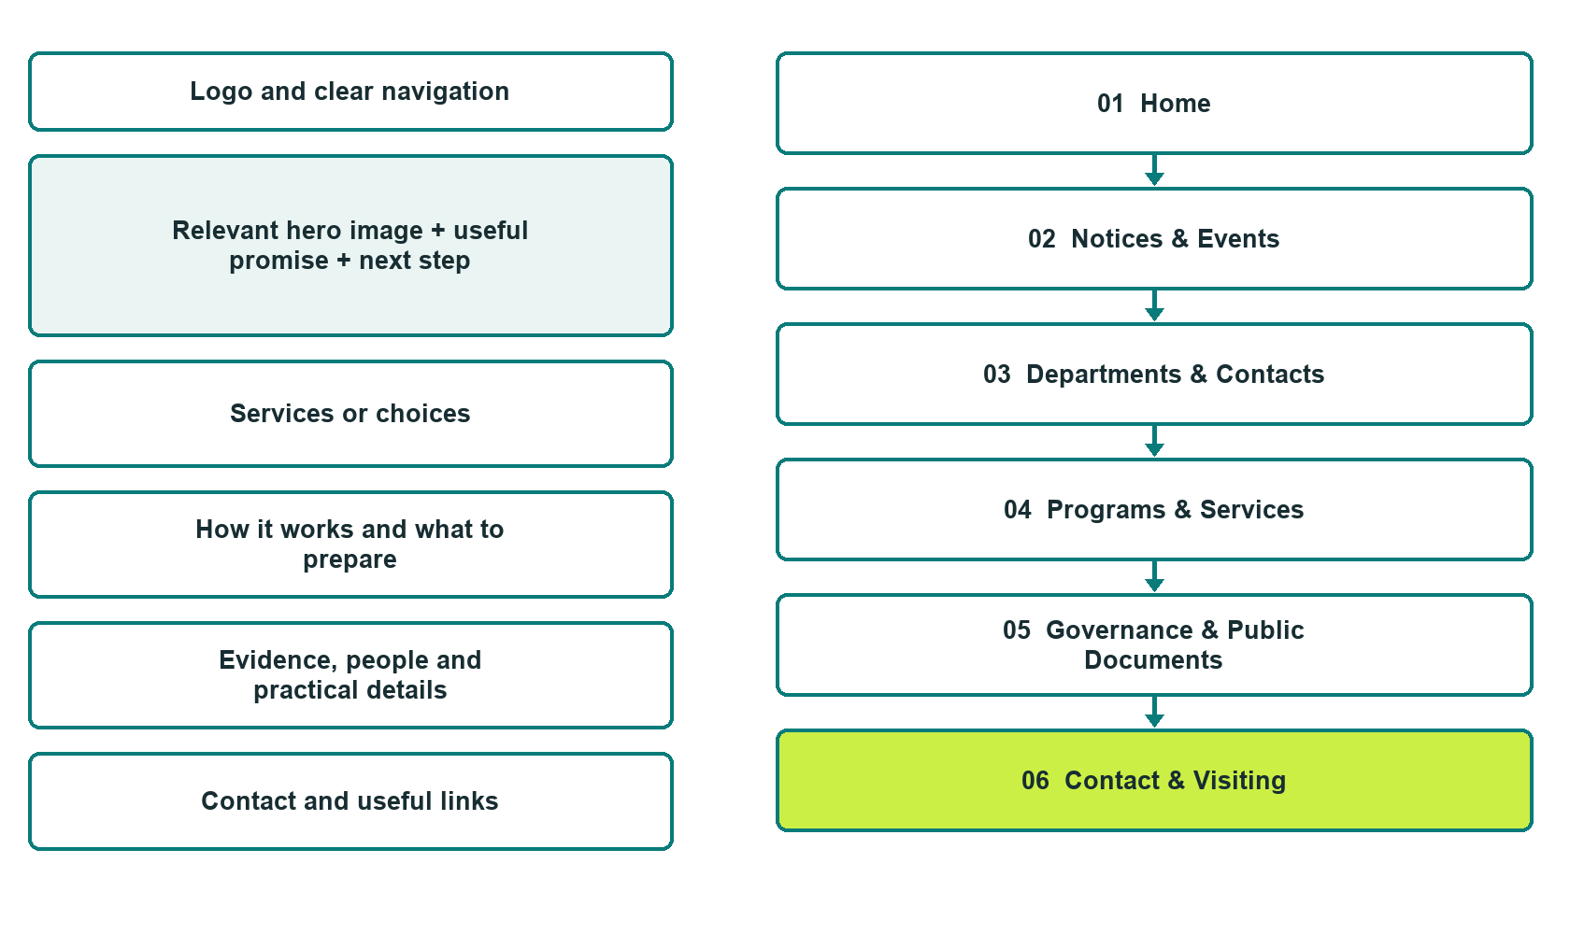

Plan → Draft → Build → Test
Capture edition: six genuine unpublished Website Builder desktop excerpts. The cover wireframe remains illustrative.
Explore Website Builder and compare plans

Before you build
The Nation approves the facts and publication decisions. Community Office Demo is a fictional teaching example, not a live service.

□ Contact the responsible office through its confirmed route
□ Obtain Nation approval of name, identity, language, imagery and every public statement.
□ Confirm ownership, access, hosting, retention and publication decisions with the Nation; this draft does not certify compliance with any governance framework.
□ Choose original photographs and confirm permission to use them.
□ Keep private member and case records out of public website forms.

Your audience and the action you want them to take

Facts to verify and people who must approve them
Create your SaaSTech account

01 Home
Give this page one clear job in the public information journey.
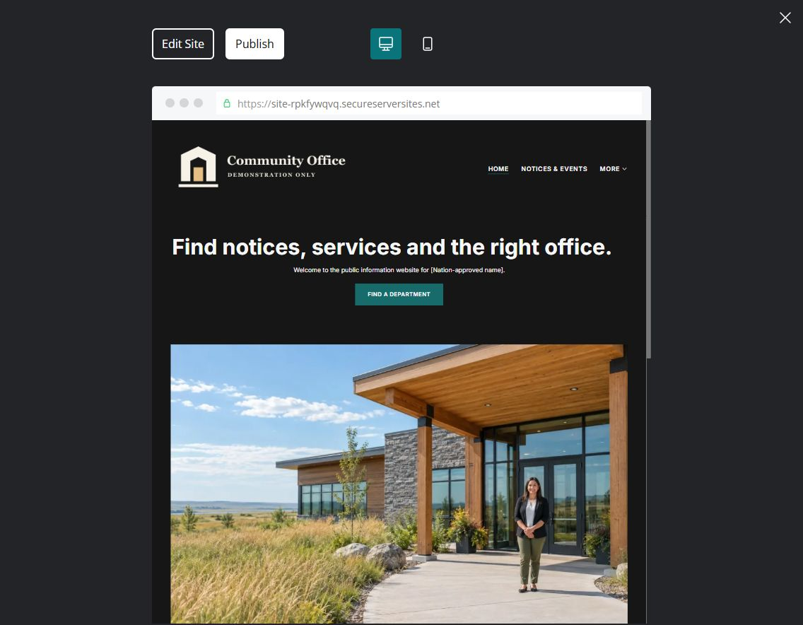
Unpublished Website Builder demo • desktop excerpt

Sample wording — adapt and verify
Find notices, services and the right office.
Welcome to the public information website for [Nation-approved name]. Find approved community notices, explore departments and programs, and see how to contact the office responsible for your question.
Start with the notices below for current dates and updates. For help with a personal matter, contact the relevant office using its published contact route; please do not include private documents in a general website message.
Suggested button: Find a department

Website advice
Make current information and service navigation easy to find on a phone.

Your draft: Home
Use the Nation-approved voice and wording. Confirm every public statement with the responsible office.

Headline and short introduction

Main content and details visitors need

Button wording and destination

Photo choice, permission and facts still to confirm
Partner check: can someone unfamiliar with the office find the appropriate contact or public information?

02 Notices & Events
Give this page one clear job in the public information journey.
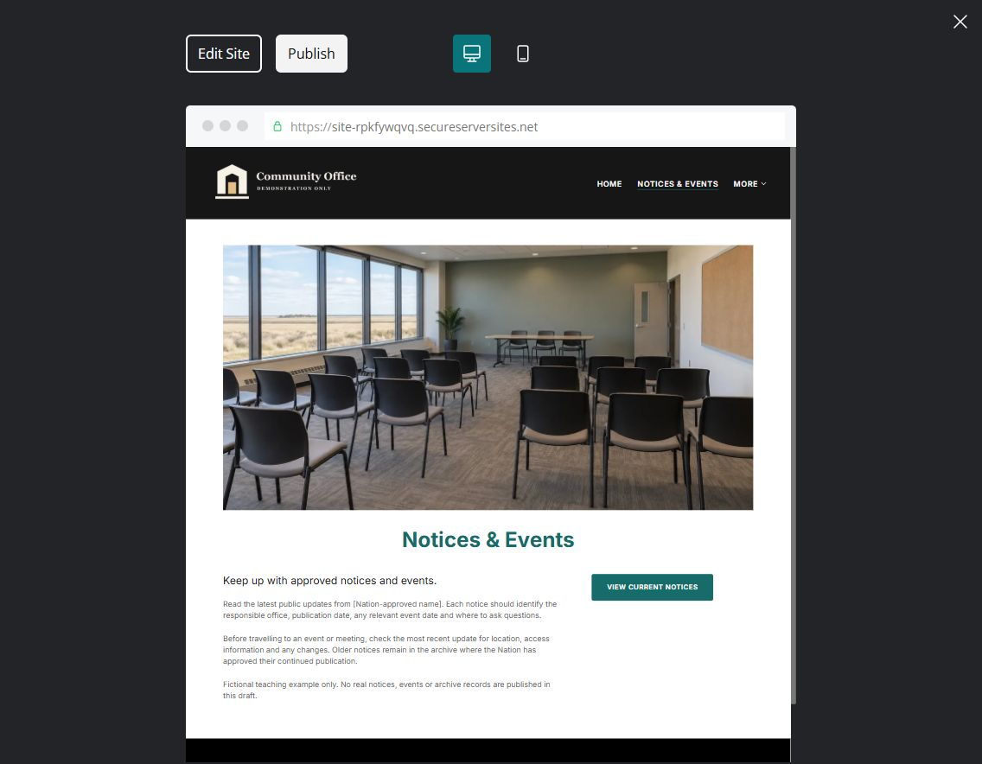
Unpublished Website Builder demo • desktop excerpt

Sample wording — adapt and verify
Keep up with approved notices and events.
Read the latest public updates from [Nation-approved name]. Each notice should identify the responsible office, publication date, any relevant event date and where to ask questions.
Before travelling to an event or meeting, check the most recent update for location, access information and any changes. Older notices remain in the archive where the Nation has approved their continued publication.
Suggested button: View current notices

Website advice
Separate current announcements from archived or cancelled items.

Your draft: Notices & Events
Use the Nation-approved voice and wording. Confirm every public statement with the responsible office.

Headline and short introduction

Main content and details visitors need

Button wording and destination

Photo choice, permission and facts still to confirm
Partner check: can someone unfamiliar with the office find the appropriate contact or public information?

03 Departments & Contacts
Give this page one clear job in the public information journey.
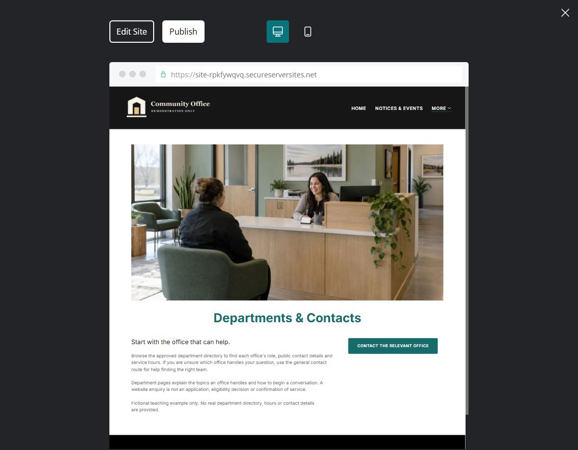
Unpublished Website Builder demo • desktop excerpt

Sample wording — adapt and verify
Start with the office that can help.
Browse the approved department directory to find each office’s role, public contact details and service hours. If you are unsure which office handles your question, use the general contact route for help finding the right team.
Department pages explain the topics an office handles and how to begin a conversation. A website enquiry is not an application, eligibility decision or confirmation of service.
Suggested button: Contact the relevant office

Website advice
Help visitors reach a responsible office without disclosing private staff information.

Your draft: Departments & Contacts
Use the Nation-approved voice and wording. Confirm every public statement with the responsible office.

Headline and short introduction

Main content and details visitors need

Button wording and destination

Photo choice, permission and facts still to confirm
Partner check: can someone unfamiliar with the office find the appropriate contact or public information?

04 Programs & Services
Give this page one clear job in the public information journey.
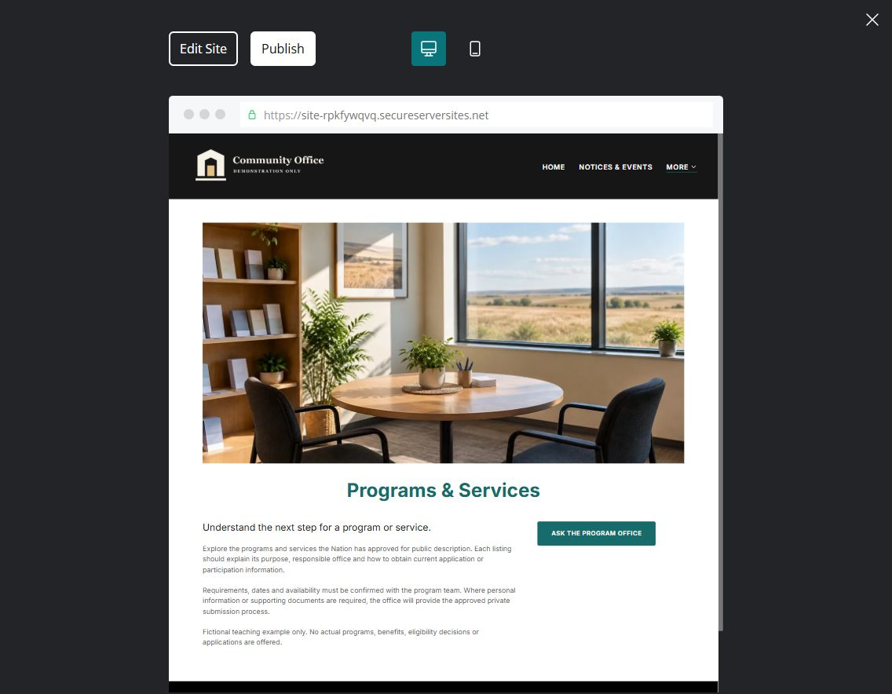
Unpublished Website Builder demo • desktop excerpt

Sample wording — adapt and verify
Understand the next step for a program or service.
Explore the programs and services the Nation has approved for public description. Each listing should explain its purpose, responsible office and how to obtain current application or participation information.
Requirements, dates and availability must be confirmed with the program team. Where personal information or supporting documents are required, the office will provide the approved private submission process.
Suggested button: Ask the program office

Website advice
Explain approved offerings without inventing entitlements, eligibility or funding.

Your draft: Programs & Services
Use the Nation-approved voice and wording. Confirm every public statement with the responsible office.

Headline and short introduction

Main content and details visitors need

Button wording and destination

Photo choice, permission and facts still to confirm
Partner check: can someone unfamiliar with the office find the appropriate contact or public information?

05 Governance & Public Documents
Give this page one clear job in the public information journey.
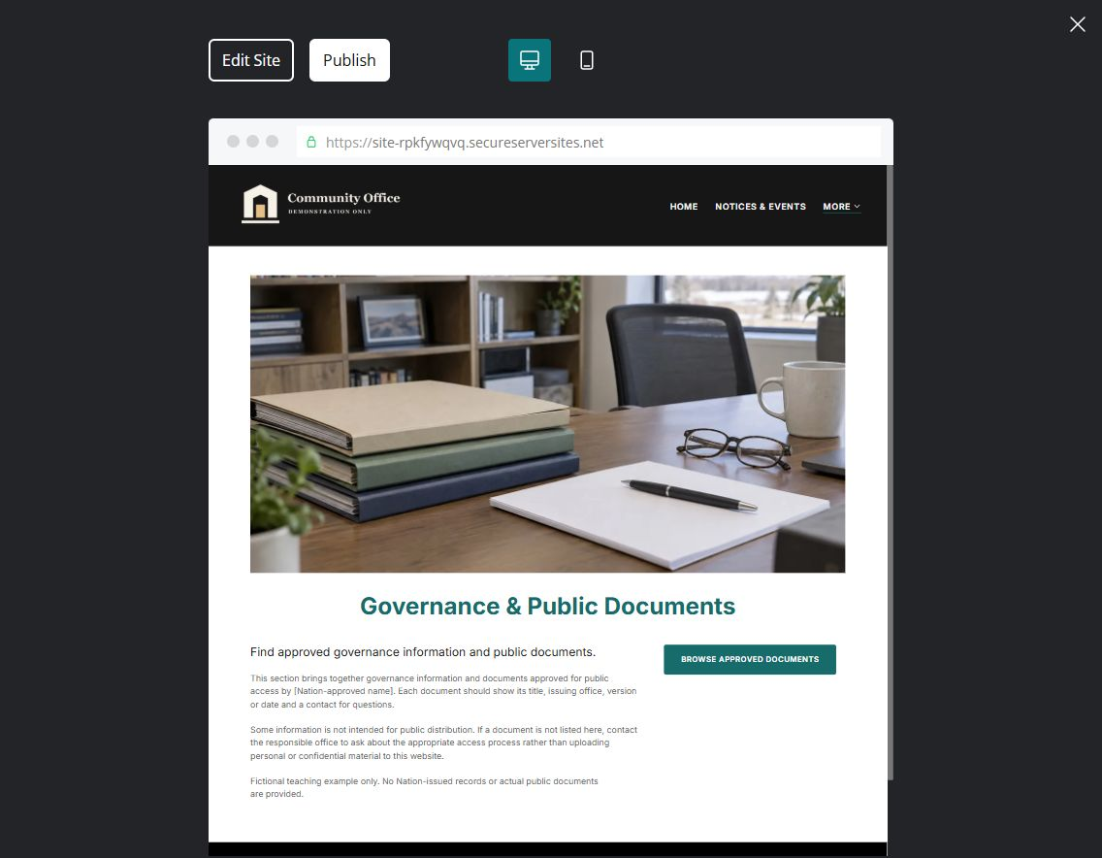
Unpublished Website Builder demo • desktop excerpt

Sample wording — adapt and verify
Find approved governance information and public documents.
This section brings together governance information and documents approved for public access by [Nation-approved name]. Each document should show its title, issuing office, version or date and a contact for questions.
Some information is not intended for public distribution. If a document is not listed here, contact the responsible office to ask about the appropriate access process rather than uploading personal or confidential material to this website.
Suggested button: Browse approved documents

Website advice
Publish only records and governance information authorized by the Nation.

Your draft: Governance & Public Documents
Use the Nation-approved voice and wording. Confirm every public statement with the responsible office.

Headline and short introduction

Main content and details visitors need

Button wording and destination

Photo choice, permission and facts still to confirm
Partner check: can someone unfamiliar with the office find the appropriate contact or public information?

06 Contact & Visiting
Give this page one clear job in the public information journey.
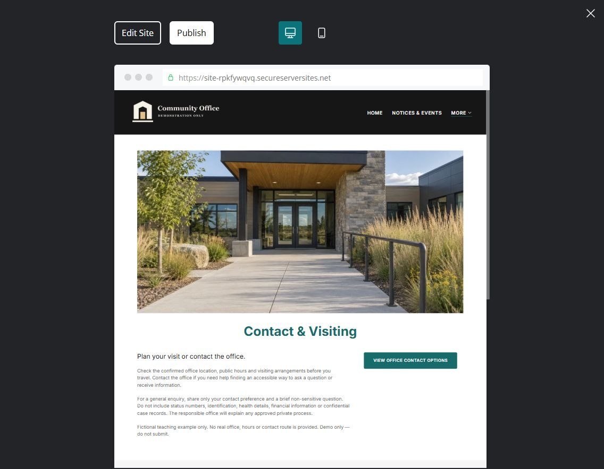
Unpublished Website Builder demo • desktop excerpt

Sample wording — adapt and verify
Plan your visit or contact the office.
Check the confirmed office location, public hours and visiting arrangements before you travel. Contact the office if you need help finding an accessible way to ask a question or receive information.
For a general enquiry, share only your contact preference and a brief non-sensitive question. Do not include status numbers, identification, health details, financial information or confidential case records. The responsible office will explain any approved private process.
Suggested button: View office contact options

Website advice
Offer practical access information and a low-data contact route.

Your draft: Contact & Visiting
Use the Nation-approved voice and wording. Confirm every public statement with the responsible office.

Headline and short introduction

Main content and details visitors need

Button wording and destination

Photo choice, permission and facts still to confirm
Partner check: can someone unfamiliar with the office find the appropriate contact or public information?

Test before publishing
Review the whole journey on a desktop and phone. Check links, image framing and demo-form privacy before launch.
□ Obtain Nation approval of name, identity, language, imagery and every public statement.
□ Confirm ownership, access, hosting, retention and publication decisions with the Nation; this draft does not certify compliance with any governance framework.
□ Do not invent leaders, members, treaty territories, benefits, policies or events.
□ Review permissions for every person, cultural image, story and location shown.
□ Test keyboard navigation, readable documents, phone links and a low-bandwidth mobile view.
□ Test enquiry delivery, access permissions and the approved retention/deletion process before enabling a form.
□ No fake member login, application acceptance or emergency-response promise.
□ Check every link, form destination, download and confirmation message.
□ Check logo contrast, hero framing, text sizes and image loading.
□ Save a named backup and assign a content-review date.

Changes to finish and person responsible

Approval and next review date
Website Builder plans and signup

