

Financial Advisors & Mortgage Brokers
Website workbook
A practical workshop for a 5-page website. Study the example, plan the content and draft your own version in Word or on paper.
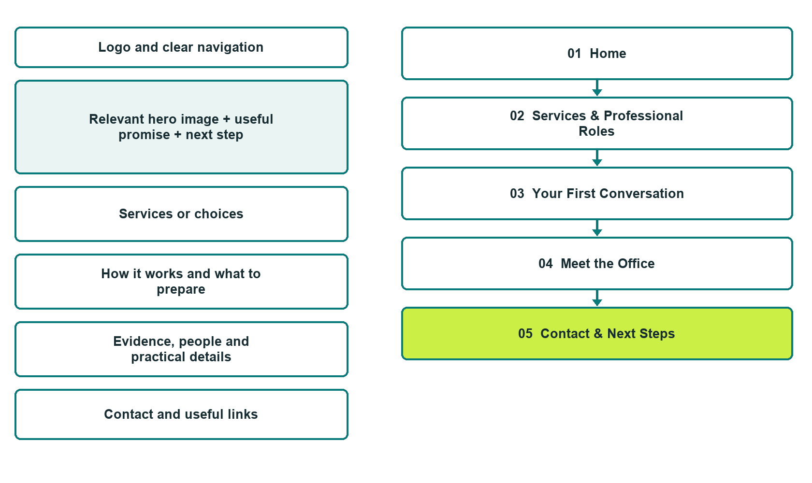

Plan → Draft → Build → Test
Capture edition: five genuine unpublished Website Builder desktop excerpts. Review mobile views on the industry page.
Explore Website Builder and compare plans

Before you build
Your business supplies the facts. Prairie Compass Advisory is a fictional teaching example, not a live service.

□ Request an introductory conversation
□ Verified business identity, services and current contact information
□ A clear enquiry, review and confirmation process
□ Choose original photographs and confirm permission to use them.
□ Keep private customer records out of public website forms.

Your audience and the action you want them to take

Facts to verify and people who must approve them
Create your SaaSTech account

01 Home
Give this page one clear job in the customer journey.
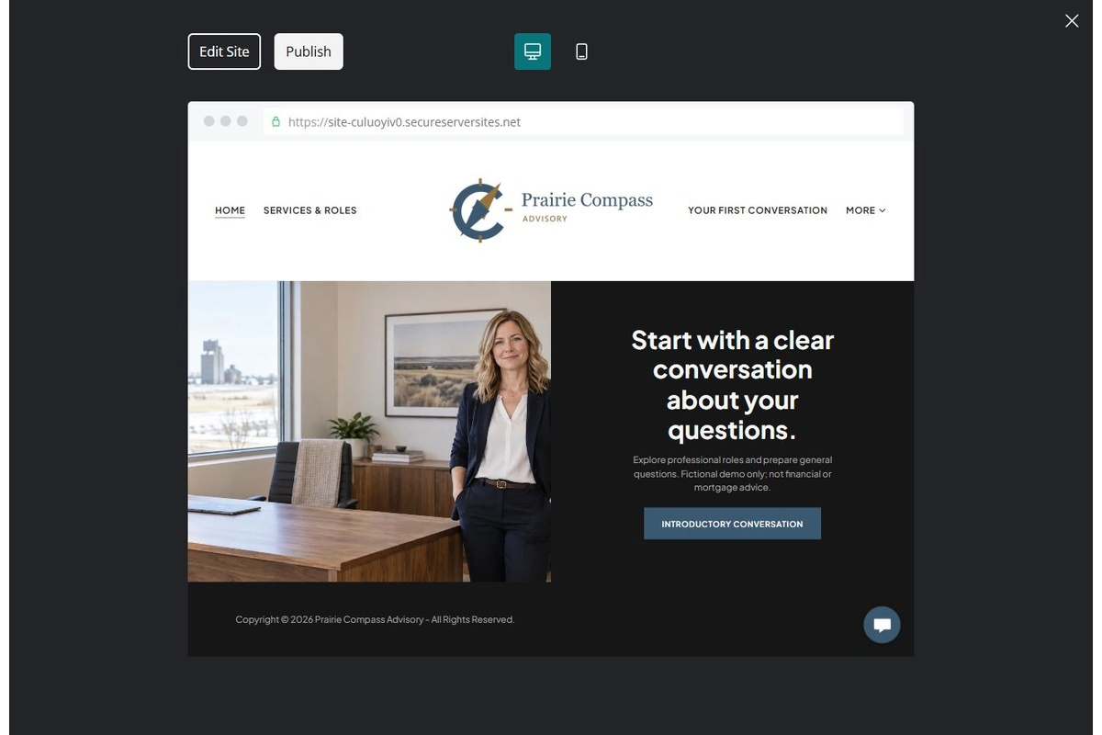
Unpublished Website Builder desktop excerpt. Page content continues below.

Sample wording — adapt and verify
Start with a clear conversation about your questions.
Explore the office, understand who handles different enquiries and prepare questions for a first conversation. The team confirms the relevant professional and next step before any service arrangement begins.
Use the relevant page to prepare a focused enquiry, then contact the team to confirm the next step.
Suggested button: Request an introductory conversation

Website advice
Separate verified financial-planning and mortgage roles, explain enquiry steps and direct private documents into approved systems.

Your draft: Home
Write in the voice of your own business. Use facts you can verify, not promises copied from the example.

Headline and short introduction

Main content and details visitors need

Button wording and destination

Photo choice, permission and facts still to confirm
Partner check: can someone unfamiliar with the business find a useful next step?

02 Services & Professional Roles
Give this page one clear job in the customer journey.
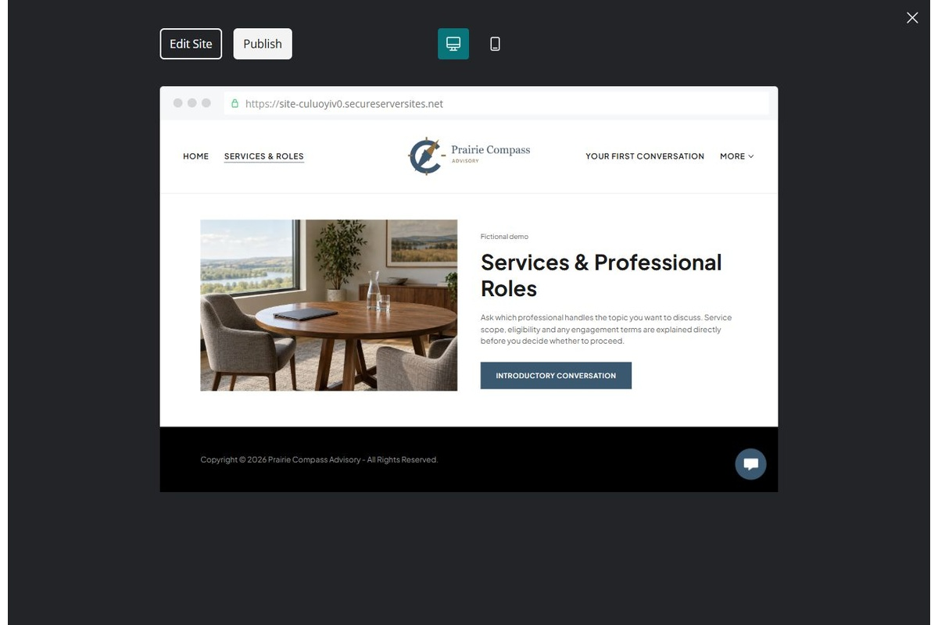
Unpublished Website Builder desktop excerpt. Page content continues below.

Sample wording — adapt and verify
Services & Professional Roles
Ask which professional handles the topic you want to discuss. Service scope, eligibility and any engagement terms are explained directly before you decide whether to proceed.
Discuss any remaining questions with the team and wait for direct confirmation before making arrangements.
Suggested button: Request an introductory conversation

Website advice
Explain only the services and regulated roles the operator has verified. Distinguish general enquiries from personalized advice.

Your draft: Services & Professional Roles
Write in the voice of your own business. Use facts you can verify, not promises copied from the example.

Headline and short introduction

Main content and details visitors need

Button wording and destination

Photo choice, permission and facts still to confirm
Partner check: can someone unfamiliar with the business find a useful next step?

03 Your First Conversation
Give this page one clear job in the customer journey.
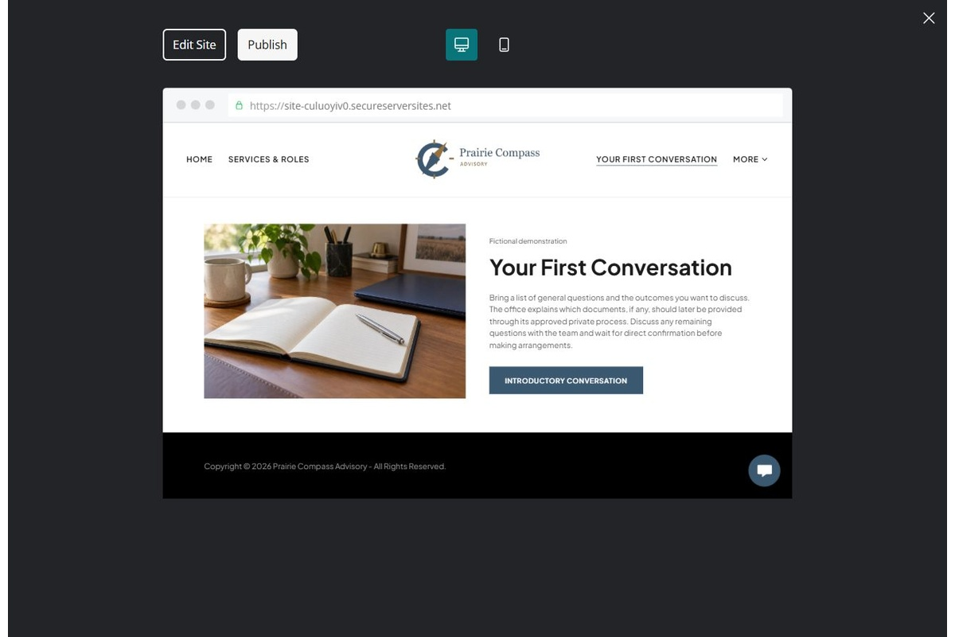
Unpublished Website Builder desktop excerpt. Page content continues below.

Sample wording — adapt and verify
Your First Conversation
Bring a list of general questions and the outcomes you want to discuss. The office explains which documents, if any, should later be provided through its approved private process.
Discuss any remaining questions with the team and wait for direct confirmation before making arrangements.
Suggested button: Request an introductory conversation

Website advice
Explain the introduction, scope discussion and secure follow-up without requesting account details.

Your draft: Your First Conversation
Write in the voice of your own business. Use facts you can verify, not promises copied from the example.

Headline and short introduction

Main content and details visitors need

Button wording and destination

Photo choice, permission and facts still to confirm
Partner check: can someone unfamiliar with the business find a useful next step?

04 Meet the Office
Give this page one clear job in the customer journey.
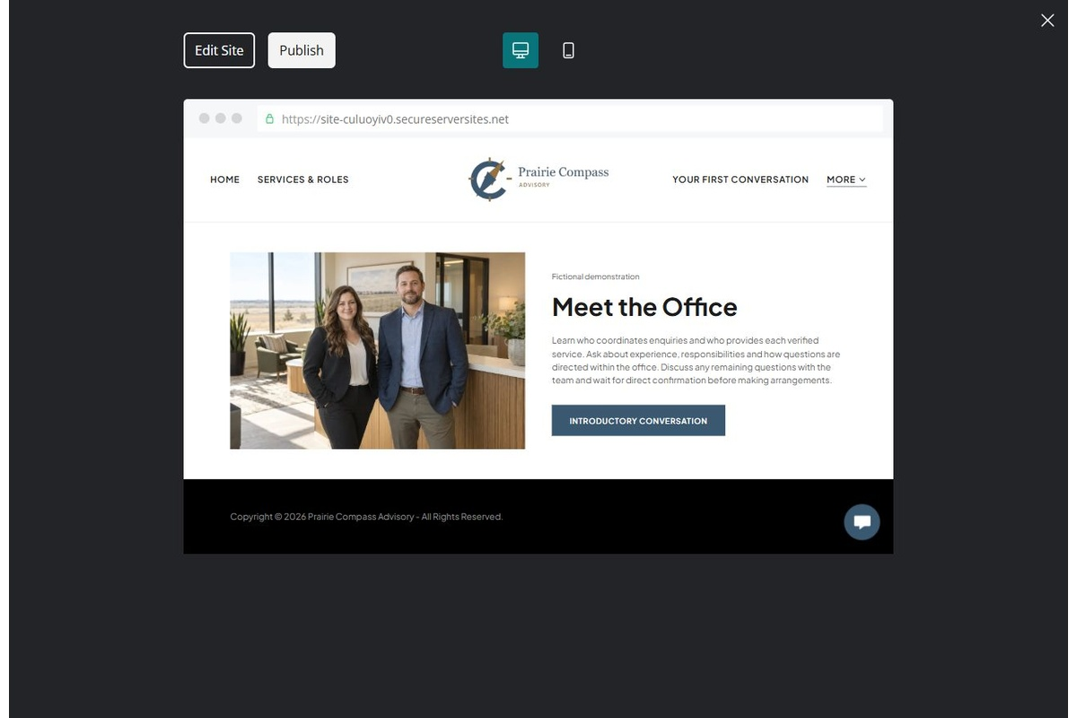
Unpublished Website Builder desktop excerpt. Page content continues below.

Sample wording — adapt and verify
Meet the Office
Learn who coordinates enquiries and who provides each verified service. Ask about experience, responsibilities and how questions are directed within the office.
Discuss any remaining questions with the team and wait for direct confirmation before making arrangements.
Suggested button: Request an introductory conversation

Website advice
Publish verified identities, credentials and responsibilities with permission. Avoid invented testimonials or affiliation badges.

Your draft: Meet the Office
Write in the voice of your own business. Use facts you can verify, not promises copied from the example.

Headline and short introduction

Main content and details visitors need

Button wording and destination

Photo choice, permission and facts still to confirm
Partner check: can someone unfamiliar with the business find a useful next step?

05 Contact & Next Steps
Give this page one clear job in the customer journey.
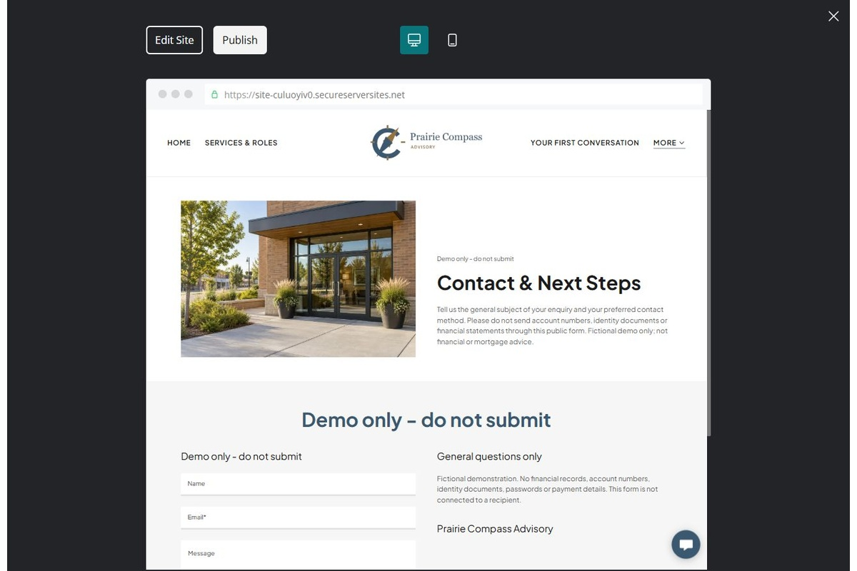
Unpublished Website Builder desktop excerpt. Page content continues below.

Sample wording — adapt and verify
Contact & Next Steps
Tell us the general subject of your enquiry and your preferred contact method. Please do not send account numbers, identity documents or financial statements through this public form.
Discuss any remaining questions with the team and wait for direct confirmation before making arrangements.
Suggested button: Request an introductory conversation

Website advice
Use a minimal general-enquiry form, a reviewed privacy notice and a clearly confirmed response route.

Your draft: Contact & Next Steps
Write in the voice of your own business. Use facts you can verify, not promises copied from the example.

Headline and short introduction

Main content and details visitors need

Button wording and destination

Photo choice, permission and facts still to confirm
Partner check: can someone unfamiliar with the business find a useful next step?

Test before publishing
Review the whole journey on a desktop and phone. Compare these desktop excerpts with the mobile captures on the industry page.
□ Fictional demonstration only, not financial, tax, investment or mortgage advice. Verify all professional roles and disclosures. Do not promise approval, returns, rates or suitability; never collect financial records through a public form.
□ Verify each offered service, contact route, location and opening arrangement.
□ Remove fictional identity, claims, availability and prices before a real launch.
□ Test every enquiry route and download on desktop and mobile.
□ Keep sensitive information in approved private systems.
□ Obtain operator approval for all public wording and image use.
□ Check every link, form destination, download and confirmation message.
□ Check logo contrast, hero framing, text sizes and image loading.
□ Save a named backup and assign a content-review date.

Changes to finish and person responsible

Approval and next review date
Website Builder plans and signup

