

Excavation, Earthworks & Aggregate Suppliers
Website workbook
A practical workshop for a 6-page website. Study the example, plan the content and draft your own version in Word or on paper.
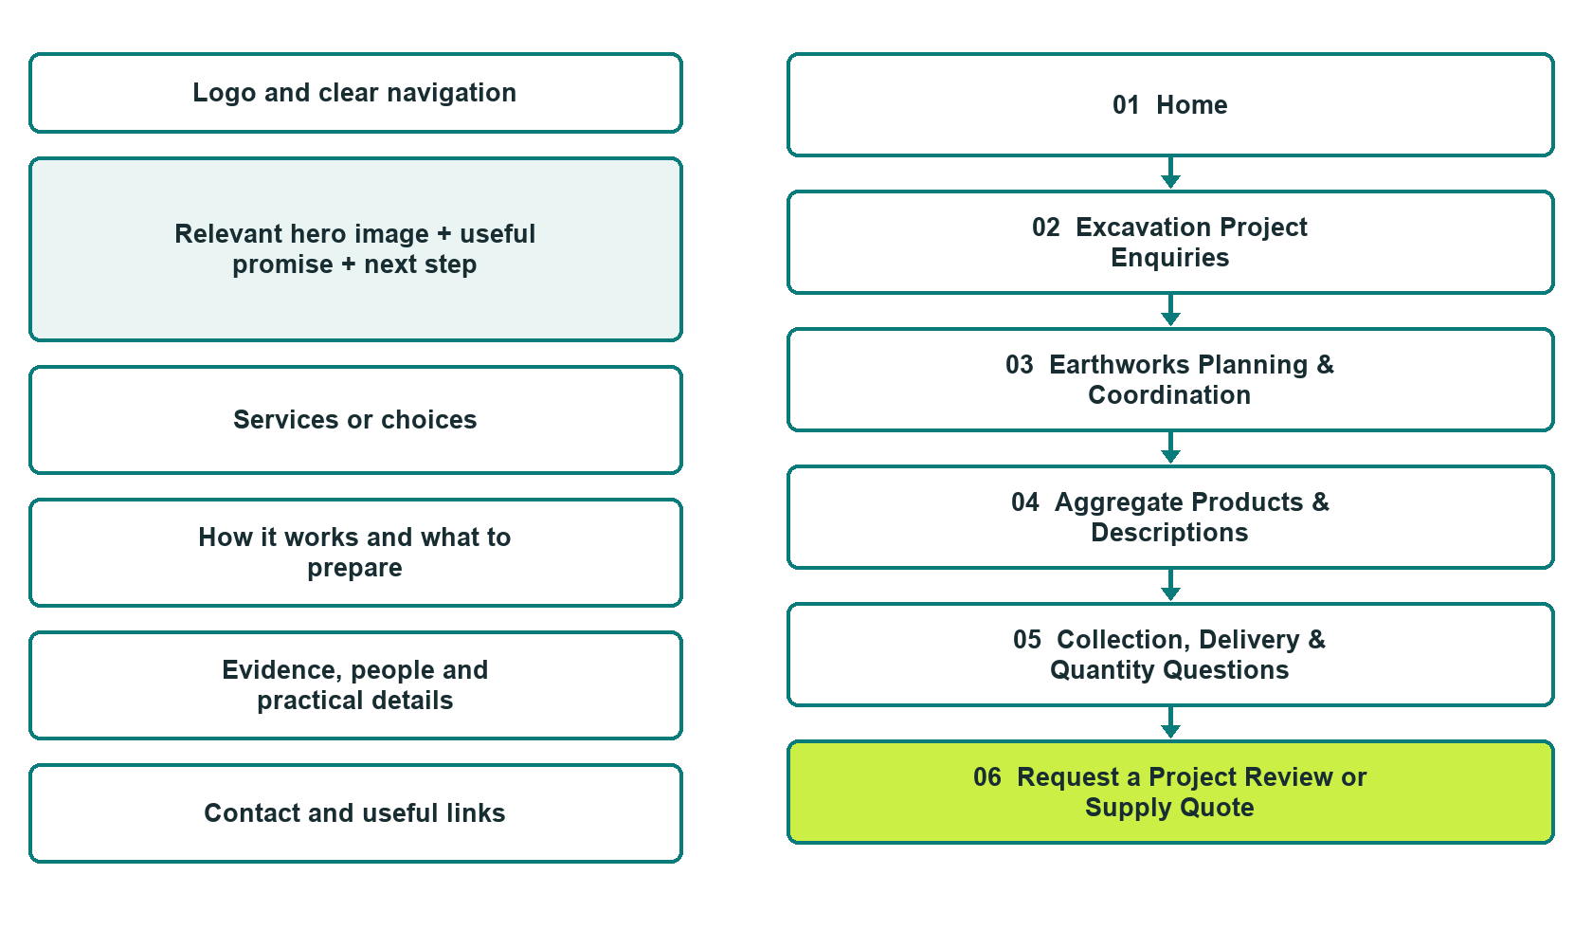

Plan → Draft → Build → Test
Website Builder capture edition: six actual desktop views from the fictional demo; the wireframe remains a planning illustration.
Explore Website Builder and compare plans

Before you build
Your business supplies the facts. Prairie Grade & Gravel is a fictional teaching example, not a live service.

□ Choose a project or material enquiry
□ Verified business identity, services and current contact information
□ A clear enquiry, review and confirmation process
□ Choose original photographs and confirm permission to use them.
□ Keep private customer records out of public website forms.

Your audience and the action you want them to take

Facts to verify and people who must approve them
Create your SaaSTech account

01 Home
Give this page one clear job in the customer journey.
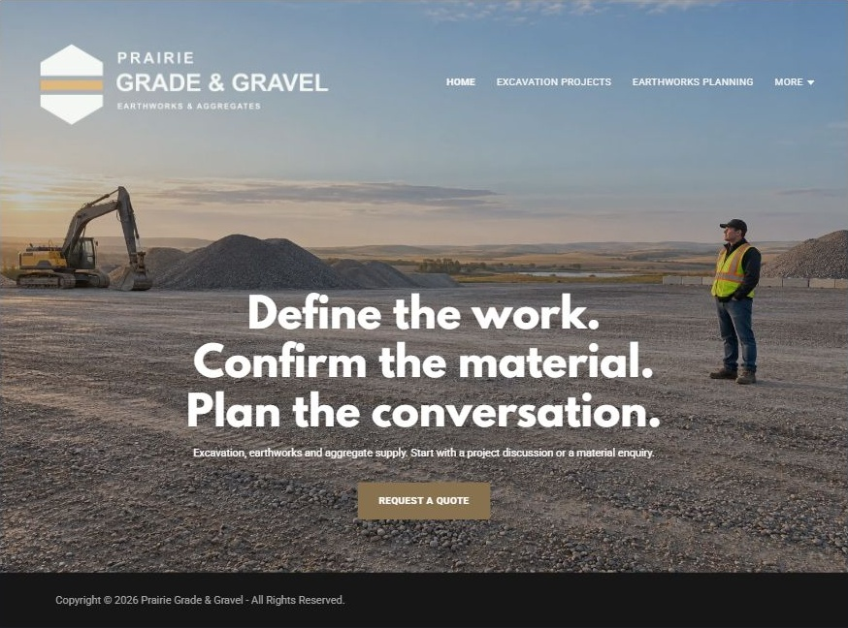
Actual Website Builder desktop capture from the fictional demo

Sample wording — adapt and verify
Define the work. Confirm the material. Plan the conversation.
Start with a project discussion if you need earth moved, or a supply enquiry if you need material.
Share the general location and the details you already know so the team can identify the right reviewer and the questions still to resolve.
Suggested button: Choose a project or material enquiry

Website advice
Keep excavation projects, broader earthworks coordination and aggregate supply distinct, with site review and exact material information confirmed by staff.

Your draft: Home
Write in the voice of your own business. Use facts you can verify, not promises copied from the example.

Headline and short introduction

Main content and details visitors need

Button wording and destination

Photo choice, permission and facts still to confirm
Partner check: can someone unfamiliar with the business find a useful next step?

02 Excavation Project Enquiries
Give this page one clear job in the customer journey.
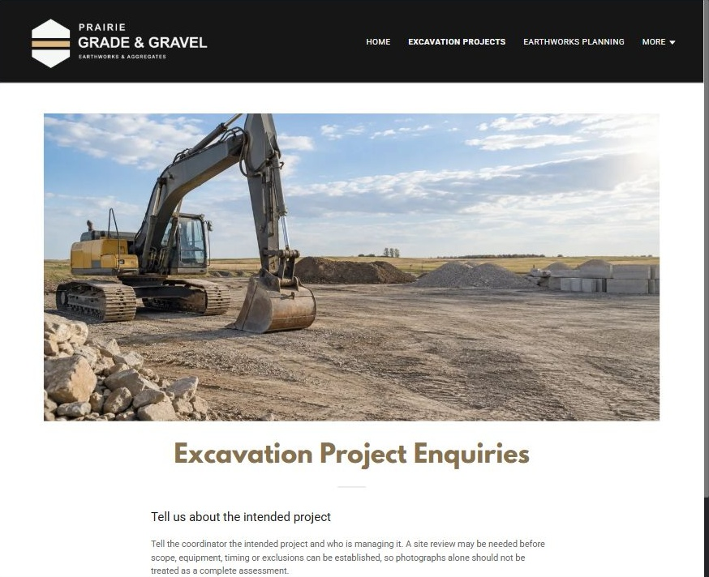
Actual Website Builder desktop capture from the fictional demo

Sample wording — adapt and verify
Excavation Project Enquiries
Tell the coordinator the intended project and who is managing it.
A site review may be needed before scope, equipment, timing or exclusions can be established, so photographs alone should not be treated as a complete assessment.
Suggested button: Choose a project or material enquiry

Website advice
Describe accepted project categories and the assessment process without providing site-work instructions.

Your draft: Excavation Project Enquiries
Write in the voice of your own business. Use facts you can verify, not promises copied from the example.

Headline and short introduction

Main content and details visitors need

Button wording and destination

Photo choice, permission and facts still to confirm
Partner check: can someone unfamiliar with the business find a useful next step?

03 Earthworks Planning & Coordination
Give this page one clear job in the customer journey.
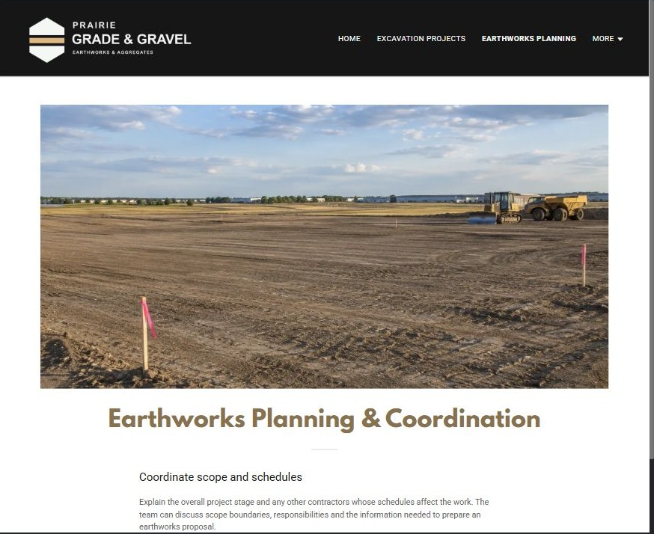
Actual Website Builder desktop capture from the fictional demo

Sample wording — adapt and verify
Earthworks Planning & Coordination
Explain the overall project stage and any other contractors whose schedules affect the work.
The team can discuss scope boundaries, responsibilities and the information needed to prepare an earthworks proposal.
Suggested button: Choose a project or material enquiry

Website advice
Differentiate grading and broader earthworks discussions from isolated excavation and aggregate-only orders.

Your draft: Earthworks Planning & Coordination
Write in the voice of your own business. Use facts you can verify, not promises copied from the example.

Headline and short introduction

Main content and details visitors need

Button wording and destination

Photo choice, permission and facts still to confirm
Partner check: can someone unfamiliar with the business find a useful next step?

04 Aggregate Products & Descriptions
Give this page one clear job in the customer journey.
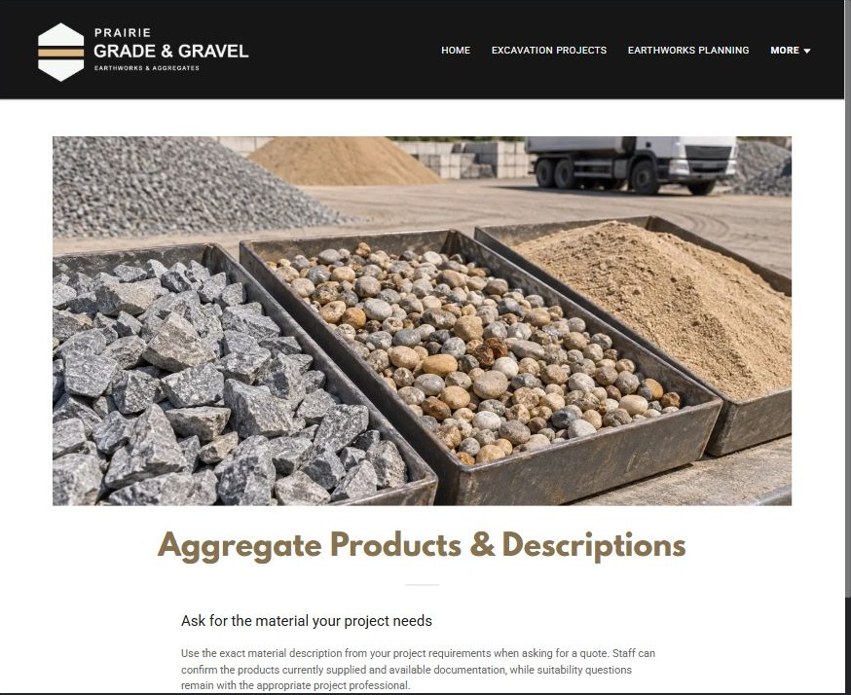
Actual Website Builder desktop capture from the fictional demo

Sample wording — adapt and verify
Aggregate Products & Descriptions
Use the exact material description from your project requirements when asking for a quote.
Staff can confirm the products currently supplied and available documentation, while suitability questions remain with the appropriate project professional.
Suggested button: Choose a project or material enquiry

Website advice
Show operator-verified material categories and supplied specifications without declaring them suitable for a particular design.

Your draft: Aggregate Products & Descriptions
Write in the voice of your own business. Use facts you can verify, not promises copied from the example.

Headline and short introduction

Main content and details visitors need

Button wording and destination

Photo choice, permission and facts still to confirm
Partner check: can someone unfamiliar with the business find a useful next step?

05 Collection, Delivery & Quantity Questions
Give this page one clear job in the customer journey.
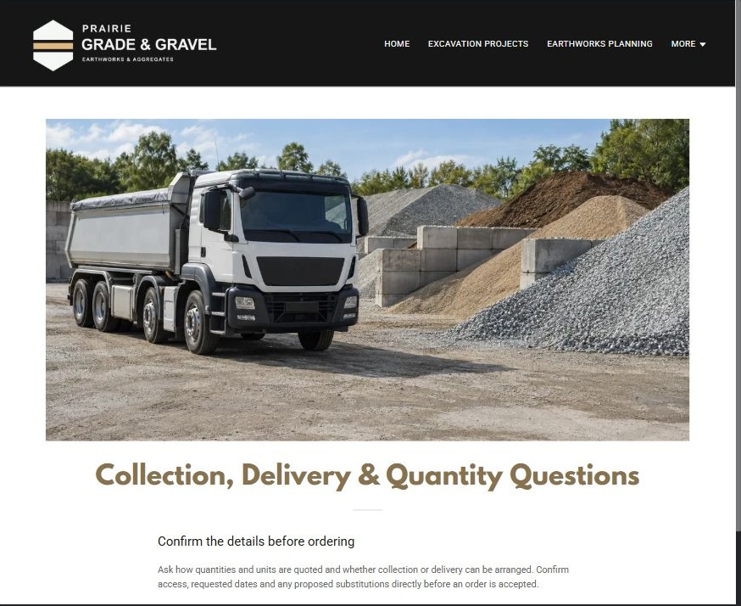
Actual Website Builder desktop capture from the fictional demo

Sample wording — adapt and verify
Collection, Delivery & Quantity Questions
Ask how quantities and units are quoted and whether collection or delivery can be arranged.
Confirm access, requested dates and any proposed substitutions directly before an order is accepted.
Suggested button: Choose a project or material enquiry

Website advice
Explain supply logistics and quantity review without presenting estimated volume as an engineered requirement.

Your draft: Collection, Delivery & Quantity Questions
Write in the voice of your own business. Use facts you can verify, not promises copied from the example.

Headline and short introduction

Main content and details visitors need

Button wording and destination

Photo choice, permission and facts still to confirm
Partner check: can someone unfamiliar with the business find a useful next step?

06 Request a Project Review or Supply Quote
Give this page one clear job in the customer journey.
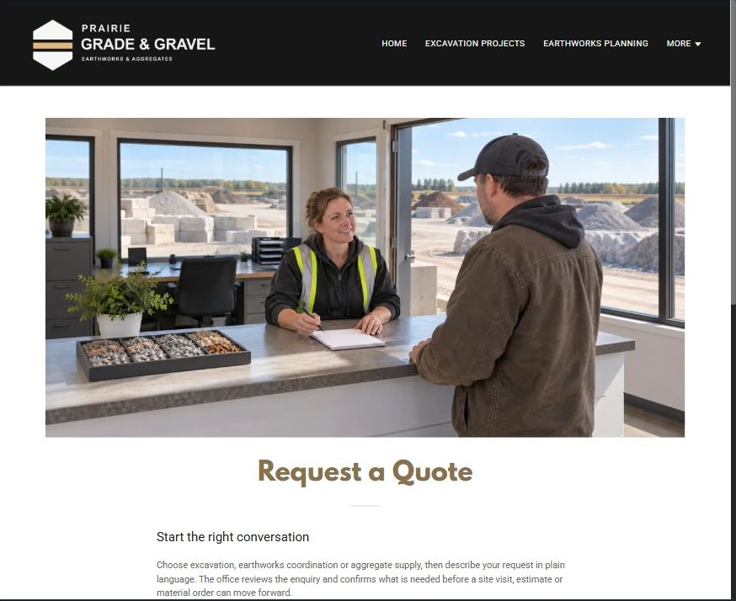
Actual Website Builder desktop capture from the fictional demo

Sample wording — adapt and verify
Request a Project Review or Supply Quote
Choose excavation, earthworks coordination or aggregate supply, then describe your request in plain language.
The office reviews the enquiry and confirms what is needed before a site visit, estimate or material order can move forward.
Suggested button: Choose a project or material enquiry

Website advice
Route earthworks and supply requests to separate staff-reviewed checklists and keep estimates unconfirmed.

Your draft: Request a Project Review or Supply Quote
Write in the voice of your own business. Use facts you can verify, not promises copied from the example.

Headline and short introduction

Main content and details visitors need

Button wording and destination

Photo choice, permission and facts still to confirm
Partner check: can someone unfamiliar with the business find a useful next step?

Test before publishing
Review the whole journey on a desktop and phone. Use the genuine example captures to plan your own pages, then verify your finished website.
□ Fictional demonstration only. No excavation procedures, structural specifications, utility-clearance advice or material suitability guarantees are provided. Verify equipment scope, material descriptions, access, quantities, delivery terms and service area with the operator.
□ Verify every service description, contact route and operating detail.
□ Replace fictional identity and example information before a live launch.
□ Test enquiries, links and downloads on desktop and mobile.
□ Keep confidential records in approved private systems.
□ Obtain operator approval for public wording and images.
□ Check every link, form destination, download and confirmation message.
□ Check logo contrast, hero framing, text sizes and image loading.
□ Save a named backup and assign a content-review date.

Changes to finish and person responsible

Approval and next review date
Website Builder plans and signup

