

E-commerce & Dropshipping
Website workbook
A practical workshop for a 5-page website. Study the example, plan the content and draft your own version in Word or on paper.
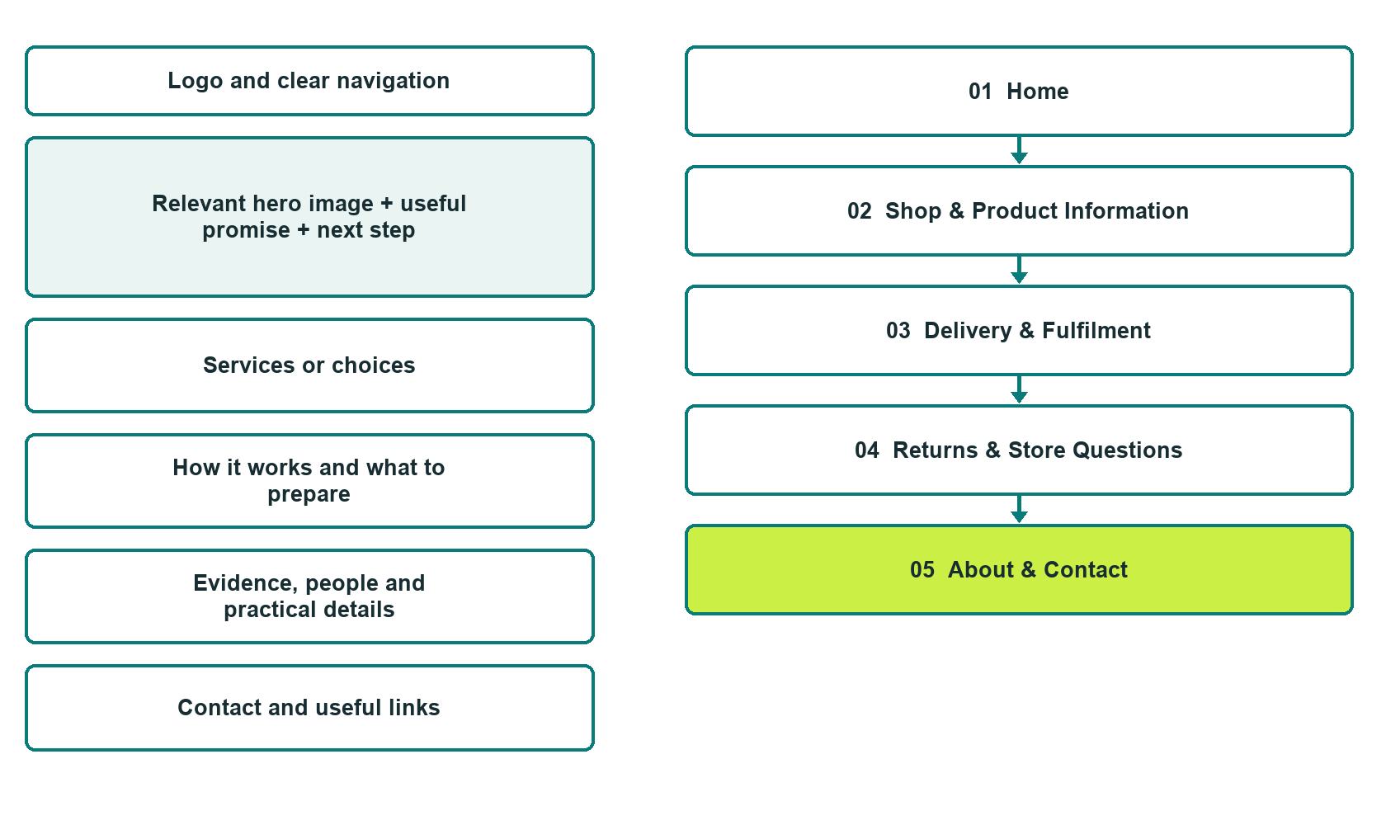

Plan → Draft → Build → Test
Capture edition: five genuine unpublished Website Builder desktop excerpts. Review mobile views on the industry page.
Explore Website Builder and compare plans

Before you build
Your business supplies the facts. Prairie Parcel Goods is a fictional teaching example, not a live service.

□ Ask a product or order question
□ Verified identity, service scope and current contacts
□ Clear enquiry and confirmation steps
□ Choose original photographs and confirm permission to use them.
□ Keep private customer records out of public website forms.

Your audience and the action you want them to take

Facts to verify and people who must approve them
Create your SaaSTech account

01 Home
Give this page one clear job in the customer journey.
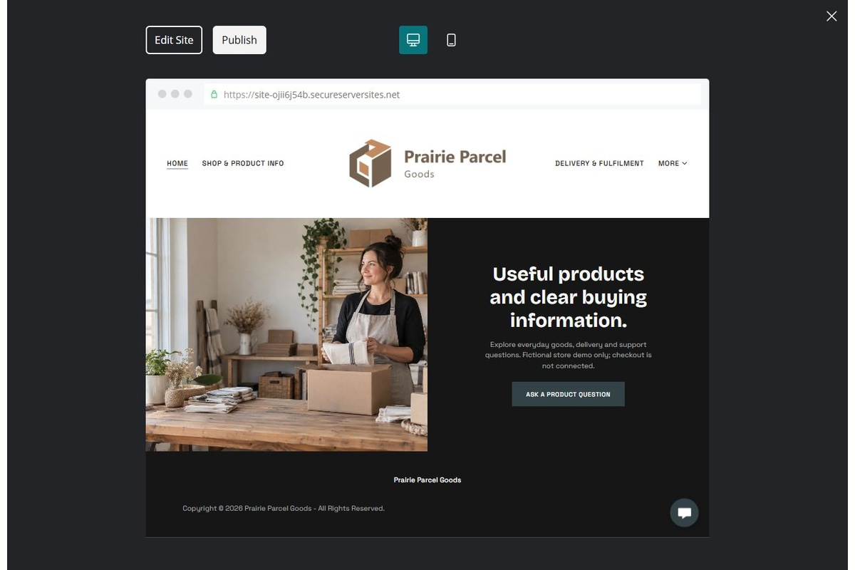
Unpublished Website Builder desktop excerpt. Page content continues below.

Sample wording — adapt and verify
Useful products and clear buying information.
Explore the kinds of everyday goods featured in the shop and learn what to confirm before ordering. Product availability, delivery arrangements and purchase terms are checked through the store’s current process.
Explore the relevant information below, then contact the team with a focused enquiry. Arrangements are confirmed only after a direct response.
Suggested button: Ask a product or order question

Website advice
Create transparent product, fulfilment, returns and contact information without pretending inventory, delivery estimates or checkout integrations are live.

Your draft: Home
Write in the voice of your own business. Use facts you can verify, not promises copied from the example.

Headline and short introduction

Main content and details visitors need

Button wording and destination

Photo choice, permission and facts still to confirm
Partner check: can someone unfamiliar with the business find a useful next step?

02 Shop & Product Information
Give this page one clear job in the customer journey.
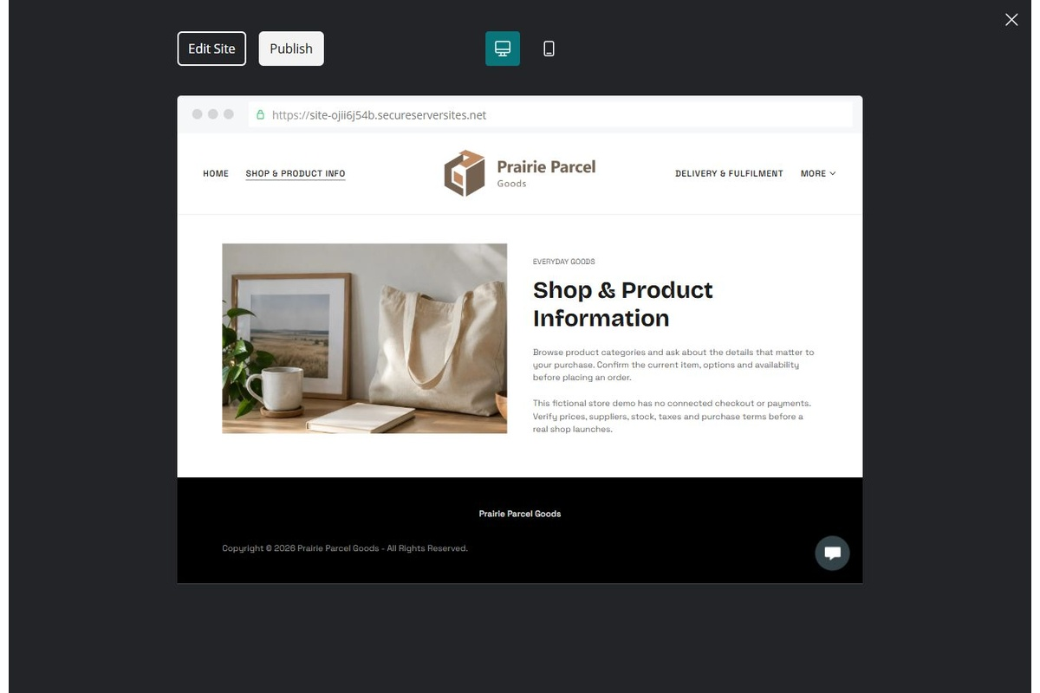
Unpublished Website Builder desktop excerpt. Page content continues below.

Sample wording — adapt and verify
Shop & Product Information
Browse product categories and ask about the details that matter to your purchase. Confirm the current item, options and availability before placing an order.
Contact the team to discuss your questions and confirm the next step.
Suggested button: Contact the team

Website advice
Provide accurate specifications and availability; do not disguise examples as live listings.

Your draft: Shop & Product Information
Write in the voice of your own business. Use facts you can verify, not promises copied from the example.

Headline and short introduction

Main content and details visitors need

Button wording and destination

Photo choice, permission and facts still to confirm
Partner check: can someone unfamiliar with the business find a useful next step?

03 Delivery & Fulfilment
Give this page one clear job in the customer journey.
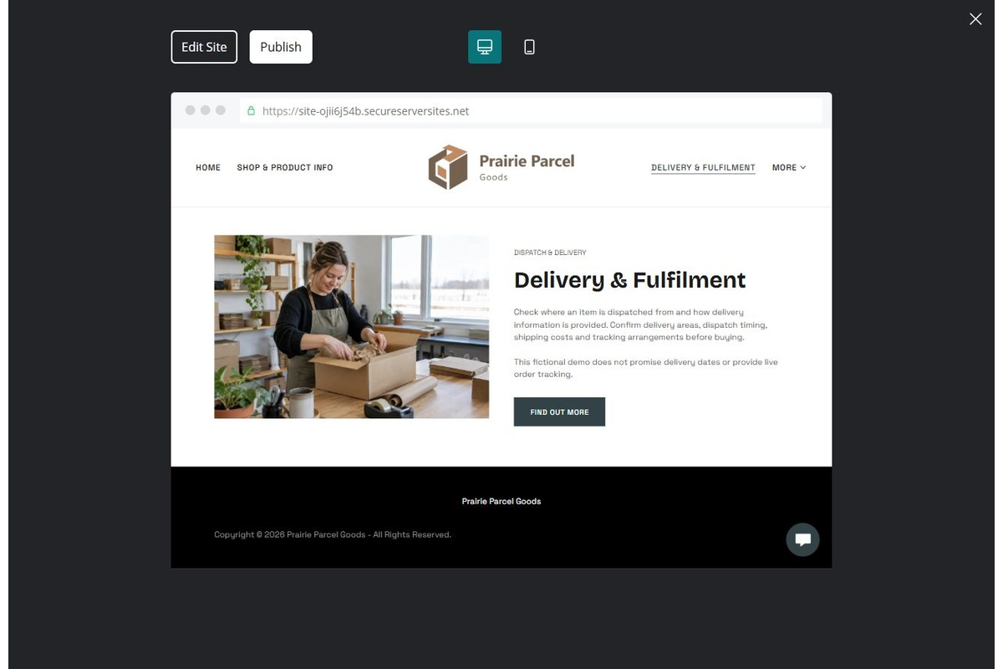
Unpublished Website Builder desktop excerpt. Page content continues below.

Sample wording — adapt and verify
Delivery & Fulfilment
Check where an item is dispatched from and how delivery information is provided. The store confirms current arrangements and explains how to follow up if you have a question.
Contact the team to discuss your questions and confirm the next step.
Suggested button: Contact the team

Website advice
Explain verified dispatch sources, tracking and delivery estimates without invented speed guarantees.

Your draft: Delivery & Fulfilment
Write in the voice of your own business. Use facts you can verify, not promises copied from the example.

Headline and short introduction

Main content and details visitors need

Button wording and destination

Photo choice, permission and facts still to confirm
Partner check: can someone unfamiliar with the business find a useful next step?

04 Returns & Store Questions
Give this page one clear job in the customer journey.
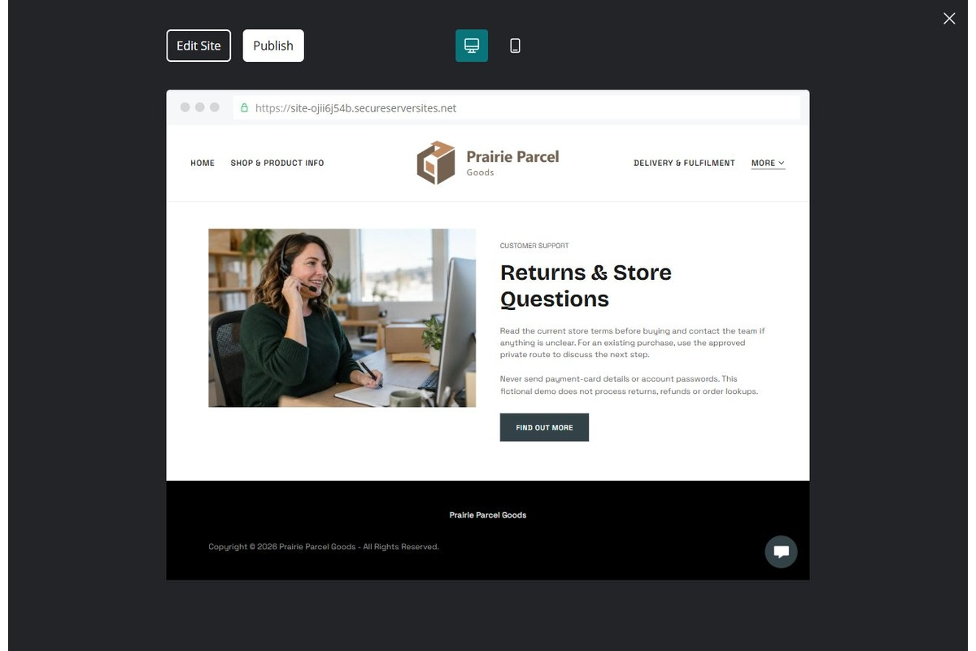
Unpublished Website Builder desktop excerpt. Page content continues below.

Sample wording — adapt and verify
Returns & Store Questions
Read the current store terms before buying and contact the team if anything is unclear. For an existing purchase, use the approved private route to discuss the next step.
Contact the team to discuss your questions and confirm the next step.
Suggested button: Contact the team

Website advice
Publish operator-approved purchase and return terms and distinguish an enquiry from authorization.

Your draft: Returns & Store Questions
Write in the voice of your own business. Use facts you can verify, not promises copied from the example.

Headline and short introduction

Main content and details visitors need

Button wording and destination

Photo choice, permission and facts still to confirm
Partner check: can someone unfamiliar with the business find a useful next step?

05 About & Contact
Give this page one clear job in the customer journey.
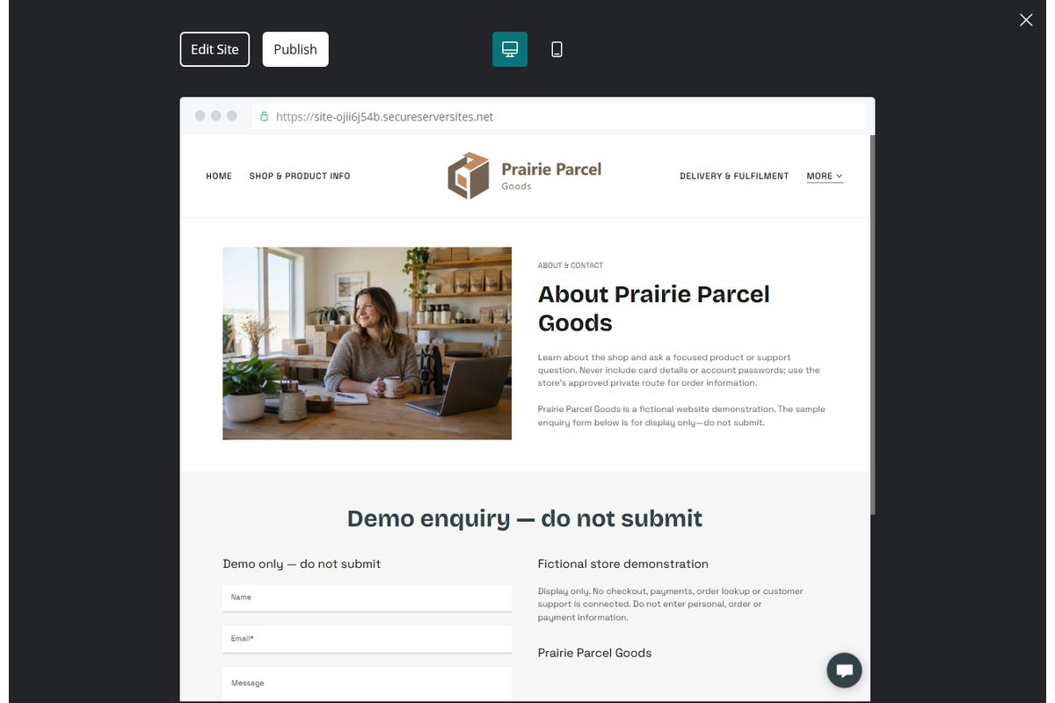
Unpublished Website Builder desktop excerpt. Page content continues below.

Sample wording — adapt and verify
About & Contact
Learn about the shop and send a focused product or support question. Never include card details or account passwords; the team will explain the approved way to share order information.
Contact the team to discuss your questions and confirm the next step.
Suggested button: Contact the team

Website advice
Explain business identity and support channels; keep payment and identity information out of public forms.

Your draft: About & Contact
Write in the voice of your own business. Use facts you can verify, not promises copied from the example.

Headline and short introduction

Main content and details visitors need

Button wording and destination

Photo choice, permission and facts still to confirm
Partner check: can someone unfamiliar with the business find a useful next step?

Test before publishing
Review the whole journey on a desktop and phone. Compare these desktop excerpts with the mobile captures on the industry page.
□ Fictional store example. Verify suppliers, stock, product claims, prices, taxes, shipping and return terms. Checkout, payments and order lookup require separate configuration and testing.
□ Verify contact routes, location, hours, service scope and all commercial terms.
□ Replace fictional identities and AI illustrations or label them accurately.
□ Remove unverified testimonials, results, credentials and availability.
□ Check every link, form and download on desktop and mobile.
□ Keep sensitive documents, access information and payment details out of public forms.
□ Check every link, form destination, download and confirmation message.
□ Check logo contrast, hero framing, text sizes and image loading.
□ Save a named backup and assign a content-review date.

Changes to finish and person responsible

Approval and next review date
Website Builder plans and signup

