

Driving Schools & Driver Training
Website workbook
A practical workshop for a 6-page website. Study the example, plan the content and draft your own version in Word or on paper.
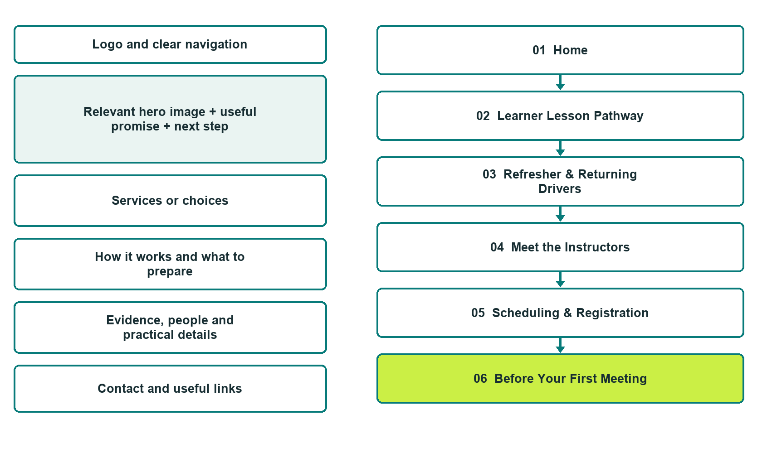

Plan → Draft → Build → Test
Website Builder capture edition: six actual desktop views from the fictional demo; the wireframe remains a planning illustration.
Explore Website Builder and compare plans

Before you build
Your business supplies the facts. Prairie Horizon Driver Learning is a fictional teaching example, not a live service.

□ Ask about a lesson pathway
□ Verified business identity, services and current contact information
□ A clear enquiry, review and confirmation process
□ Choose original photographs and confirm permission to use them.
□ Keep private customer records out of public website forms.

Your audience and the action you want them to take

Facts to verify and people who must approve them
Create your SaaSTech account

01 Home
Give this page one clear job in the customer journey.
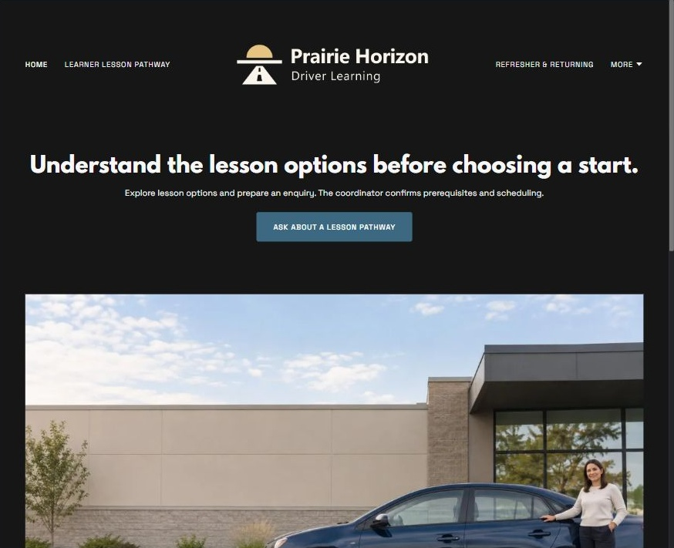
Actual Website Builder desktop capture from the fictional demo

Sample wording — adapt and verify
Understand the lesson options before choosing a start.
Explore lesson formats, ask about the school and prepare a registration enquiry.
The coordinator confirms which pathway, prerequisites and schedule are relevant before a place is accepted.
Suggested button: Ask about a lesson pathway

Website advice
Describe school-approved lesson categories, instructor roles, locally verified prerequisites and enquiry-to-registration steps without guaranteeing licensing outcomes.

Your draft: Home
Write in the voice of your own business. Use facts you can verify, not promises copied from the example.

Headline and short introduction

Main content and details visitors need

Button wording and destination

Photo choice, permission and facts still to confirm
Partner check: can someone unfamiliar with the business find a useful next step?

02 Learner Lesson Pathway
Give this page one clear job in the customer journey.
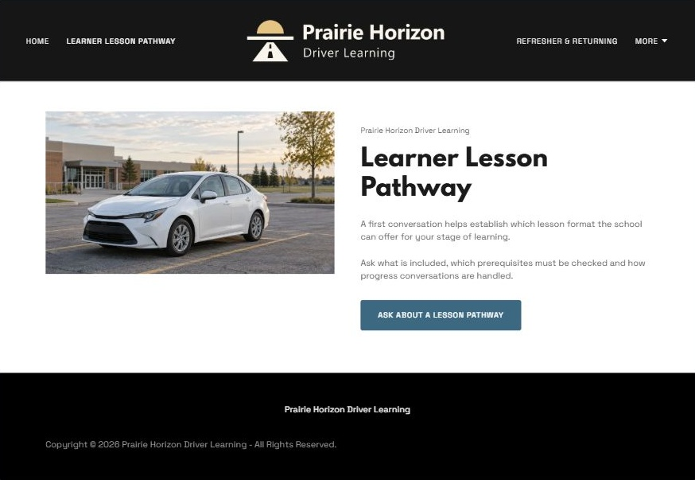
Actual Website Builder desktop capture from the fictional demo

Sample wording — adapt and verify
Learner Lesson Pathway
A first conversation helps establish which lesson format the school can offer for your stage of learning.
Ask what is included, which prerequisites must be checked and how progress conversations are handled.
Suggested button: Ask about a lesson pathway

Website advice
Describe the structure of an introductory learner enquiry without prescribing a curriculum or road techniques.

Your draft: Learner Lesson Pathway
Write in the voice of your own business. Use facts you can verify, not promises copied from the example.

Headline and short introduction

Main content and details visitors need

Button wording and destination

Photo choice, permission and facts still to confirm
Partner check: can someone unfamiliar with the business find a useful next step?

03 Refresher & Returning Drivers
Give this page one clear job in the customer journey.
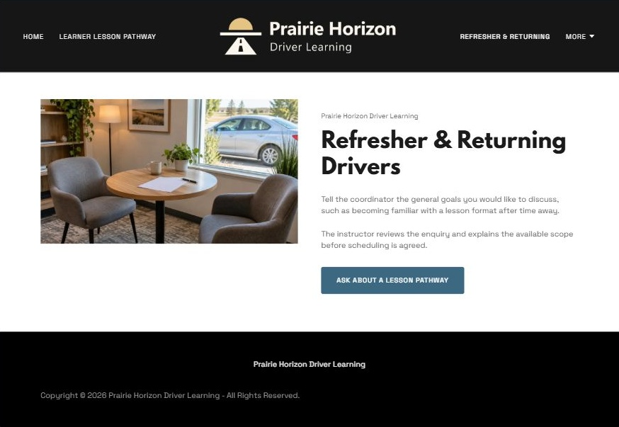
Actual Website Builder desktop capture from the fictional demo

Sample wording — adapt and verify
Refresher & Returning Drivers
Tell the coordinator the general goals you would like to discuss, such as becoming familiar with a lesson format after time away.
The instructor reviews the enquiry and explains the available scope before scheduling is agreed.
Suggested button: Ask about a lesson pathway

Website advice
Offer a distinct enquiry route for adults returning to lessons without claiming suitability for every driver.

Your draft: Refresher & Returning Drivers
Write in the voice of your own business. Use facts you can verify, not promises copied from the example.

Headline and short introduction

Main content and details visitors need

Button wording and destination

Photo choice, permission and facts still to confirm
Partner check: can someone unfamiliar with the business find a useful next step?

04 Meet the Instructors
Give this page one clear job in the customer journey.
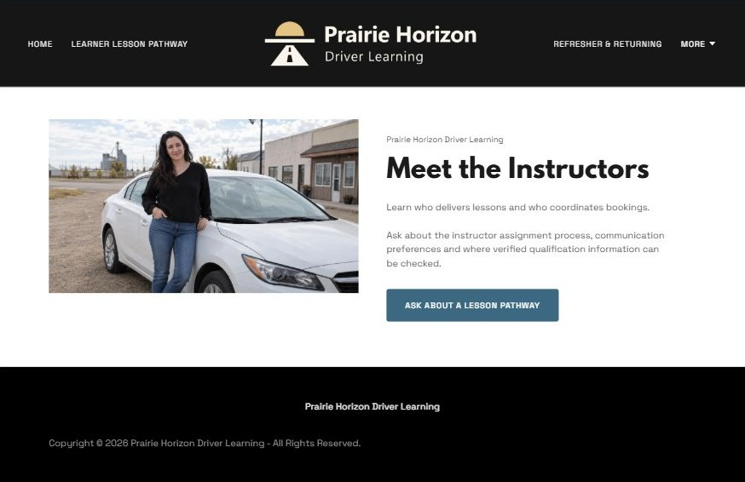
Actual Website Builder desktop capture from the fictional demo

Sample wording — adapt and verify
Meet the Instructors
Learn who delivers lessons and who coordinates bookings.
Ask about the instructor assignment process, communication preferences and where verified qualification information can be checked.
Suggested button: Ask about a lesson pathway

Website advice
Reserve biographies and qualifications for verified, permission-cleared information and identify administrative roles separately.

Your draft: Meet the Instructors
Write in the voice of your own business. Use facts you can verify, not promises copied from the example.

Headline and short introduction

Main content and details visitors need

Button wording and destination

Photo choice, permission and facts still to confirm
Partner check: can someone unfamiliar with the business find a useful next step?

05 Scheduling & Registration
Give this page one clear job in the customer journey.
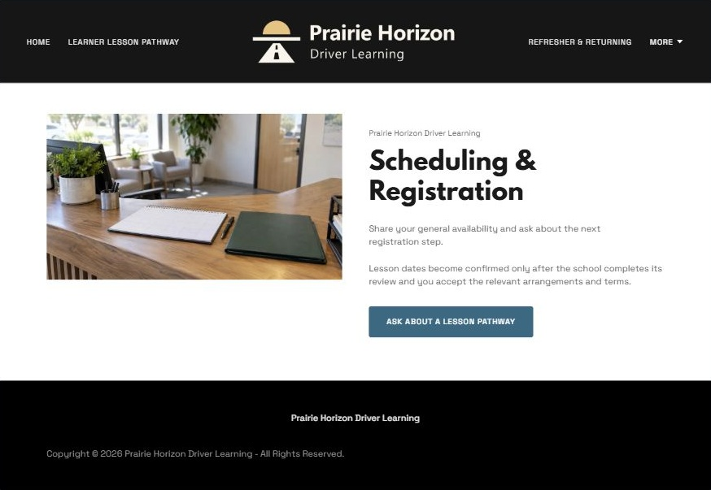
Actual Website Builder desktop capture from the fictional demo

Sample wording — adapt and verify
Scheduling & Registration
Share your general availability and ask about the next registration step.
Lesson dates become confirmed only after the school completes its review and you accept the relevant arrangements and terms.
Suggested button: Ask about a lesson pathway

Website advice
Explain requested versus confirmed sessions, reviewed terms and private prerequisite checks.

Your draft: Scheduling & Registration
Write in the voice of your own business. Use facts you can verify, not promises copied from the example.

Headline and short introduction

Main content and details visitors need

Button wording and destination

Photo choice, permission and facts still to confirm
Partner check: can someone unfamiliar with the business find a useful next step?

06 Before Your First Meeting
Give this page one clear job in the customer journey.
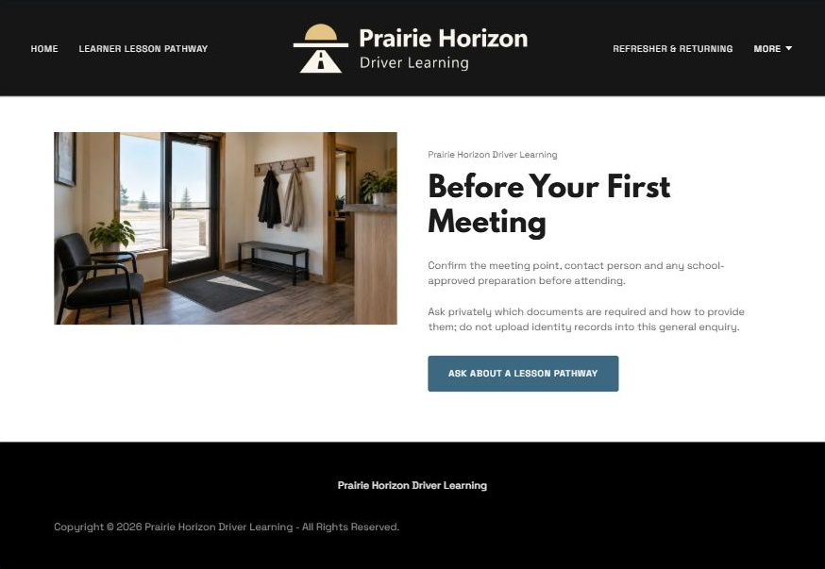
Actual Website Builder desktop capture from the fictional demo

Sample wording — adapt and verify
Before Your First Meeting
Confirm the meeting point, contact person and any school-approved preparation before attending.
Ask privately which documents are required and how to provide them; do not upload identity records into this general enquiry.
Suggested button: Ask about a lesson pathway

Website advice
Provide a question-led arrival and access page without technical driving advice or unverified document requirements.

Your draft: Before Your First Meeting
Write in the voice of your own business. Use facts you can verify, not promises copied from the example.

Headline and short introduction

Main content and details visitors need

Button wording and destination

Photo choice, permission and facts still to confirm
Partner check: can someone unfamiliar with the business find a useful next step?

Test before publishing
Review the whole journey on a desktop and phone. Use the genuine example captures to plan your own pages, then verify your finished website.
□ Fictional school demonstration, not driving instruction or a licensing guide. Verify instructor credentials, school approvals, learner prerequisites and local requirements before publication. No test pass, insurance discount or licence eligibility is promised; keep identity documents private.
□ Verify every service description, contact route and operating detail.
□ Replace fictional identity and example information before a live launch.
□ Test enquiries, links and downloads on desktop and mobile.
□ Keep confidential records in approved private systems.
□ Obtain operator approval for public wording and images.
□ Check every link, form destination, download and confirmation message.
□ Check logo contrast, hero framing, text sizes and image loading.
□ Save a named backup and assign a content-review date.

Changes to finish and person responsible

Approval and next review date
Website Builder plans and signup

