

Design, Architecture & Engineering
Website workbook
A practical workshop for a 5-page website. Study the example, plan the content and draft your own version in Word or on paper.
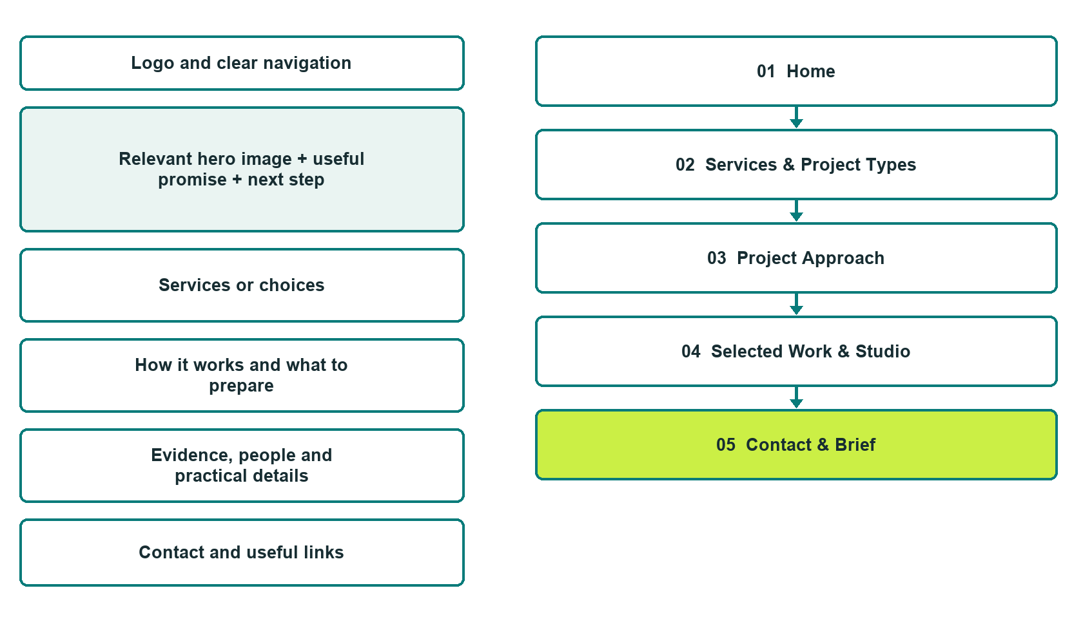

Plan → Draft → Build → Test
Capture edition: five genuine unpublished Website Builder desktop excerpts. Review mobile views on the industry page.
Explore Website Builder and compare plans

Before you build
Your business supplies the facts. Prairie Line Design Studio is a fictional teaching example, not a live service.

□ Discuss a project brief
□ Verified identity, service scope and current contacts
□ Clear enquiry and confirmation steps
□ Choose original photographs and confirm permission to use them.
□ Keep private customer records out of public website forms.

Your audience and the action you want them to take

Facts to verify and people who must approve them
Create your SaaSTech account

01 Home
Give this page one clear job in the customer journey.
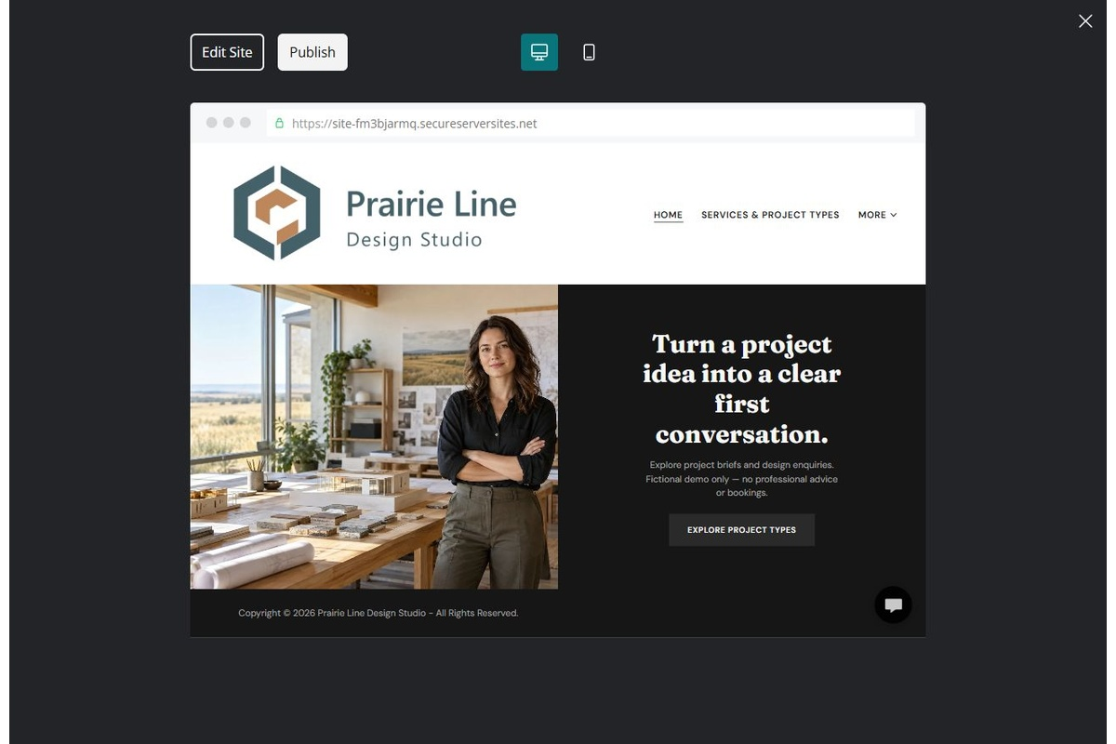
Unpublished Website Builder desktop excerpt. Page content continues below.

Sample wording — adapt and verify
Turn a project idea into a clear first conversation.
Tell us what you are planning and what matters most to the project. Our first conversation explores the brief, the people involved and the information needed before a scope is proposed.
Explore the relevant information below, then contact the team with a focused enquiry. Arrangements are confirmed only after a direct response.
Suggested button: Discuss a project brief

Website advice
Explain verified disciplines, project stages and the brief-review process. Separate inspiration from contracted professional advice.

Your draft: Home
Write in the voice of your own business. Use facts you can verify, not promises copied from the example.

Headline and short introduction

Main content and details visitors need

Button wording and destination

Photo choice, permission and facts still to confirm
Partner check: can someone unfamiliar with the business find a useful next step?

02 Services & Project Types
Give this page one clear job in the customer journey.
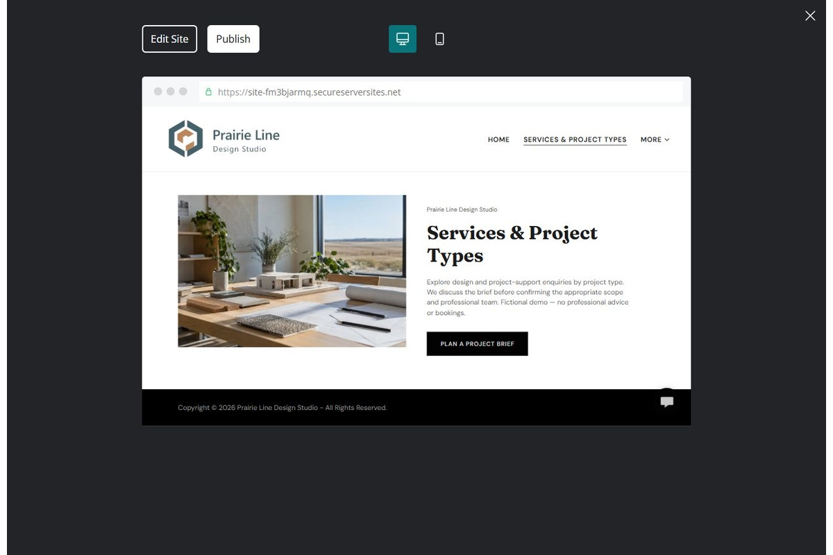
Unpublished Website Builder desktop excerpt. Page content continues below.

Sample wording — adapt and verify
Services & Project Types
Explore design and project-support enquiries by project type. We discuss the brief before confirming the appropriate scope and professional team.
Contact the team to discuss your questions and confirm the next step.
Suggested button: Contact the team

Website advice
Describe the disciplines actually provided and when other professionals are needed.

Your draft: Services & Project Types
Write in the voice of your own business. Use facts you can verify, not promises copied from the example.

Headline and short introduction

Main content and details visitors need

Button wording and destination

Photo choice, permission and facts still to confirm
Partner check: can someone unfamiliar with the business find a useful next step?

03 Project Approach
Give this page one clear job in the customer journey.
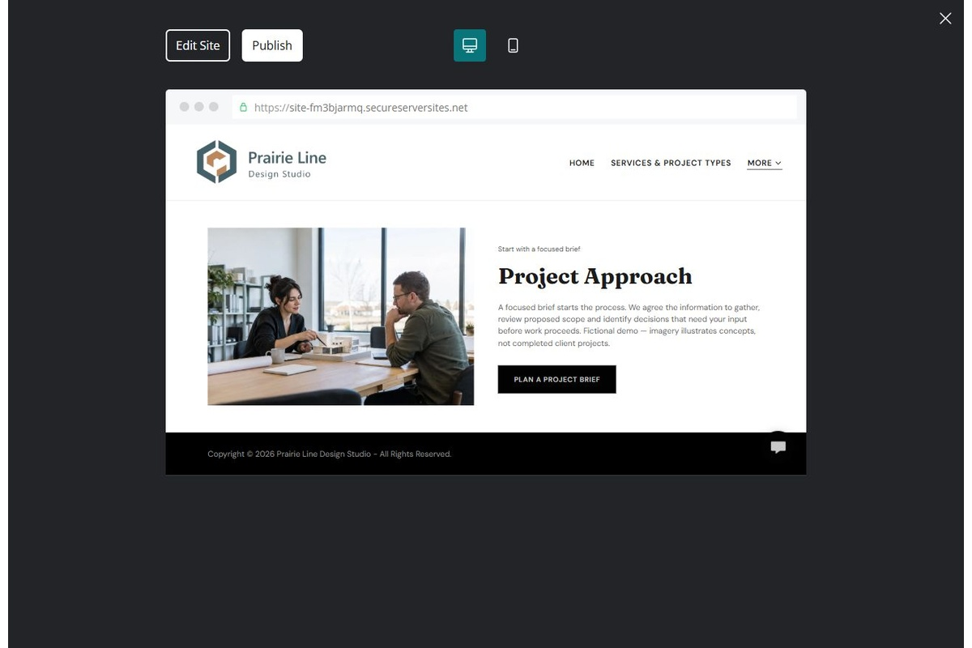
Unpublished Website Builder desktop excerpt. Page content continues below.

Sample wording — adapt and verify
Project Approach
A focused brief starts the process. We agree the information to gather, review proposed scope and identify decisions that need your input before work proceeds.
Contact the team to discuss your questions and confirm the next step.
Suggested button: Contact the team

Website advice
Explain briefing, scope agreement, review stages and decisions without promising permits or outcomes.

Your draft: Project Approach
Write in the voice of your own business. Use facts you can verify, not promises copied from the example.

Headline and short introduction

Main content and details visitors need

Button wording and destination

Photo choice, permission and facts still to confirm
Partner check: can someone unfamiliar with the business find a useful next step?

04 Selected Work & Studio
Give this page one clear job in the customer journey.
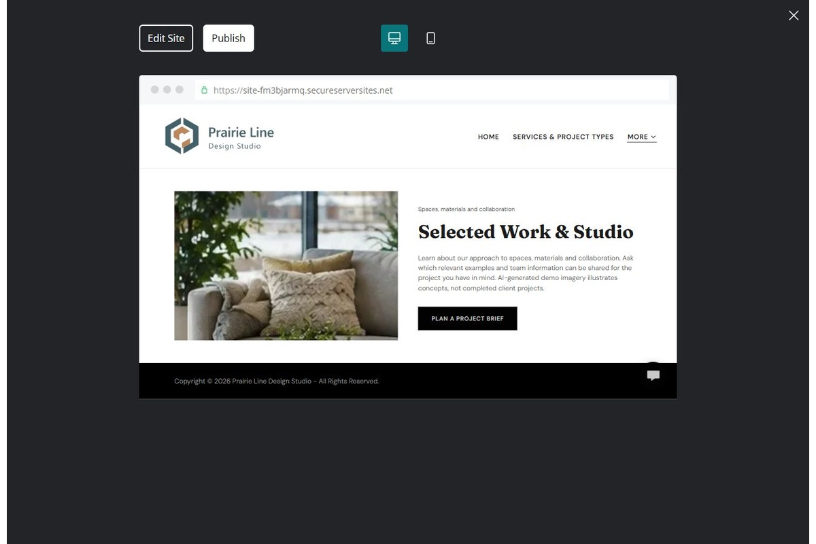
Unpublished Website Builder desktop excerpt. Page content continues below.

Sample wording — adapt and verify
Selected Work & Studio
Learn about our approach to spaces, materials and collaboration. Ask which relevant examples and team information can be shared for the project you have in mind.
Contact the team to discuss your questions and confirm the next step.
Suggested button: Contact the team

Website advice
Use permission-cleared examples with accurate roles, dates and scope. Never imply the fictional images are completed projects.

Your draft: Selected Work & Studio
Write in the voice of your own business. Use facts you can verify, not promises copied from the example.

Headline and short introduction

Main content and details visitors need

Button wording and destination

Photo choice, permission and facts still to confirm
Partner check: can someone unfamiliar with the business find a useful next step?

05 Contact & Brief
Give this page one clear job in the customer journey.
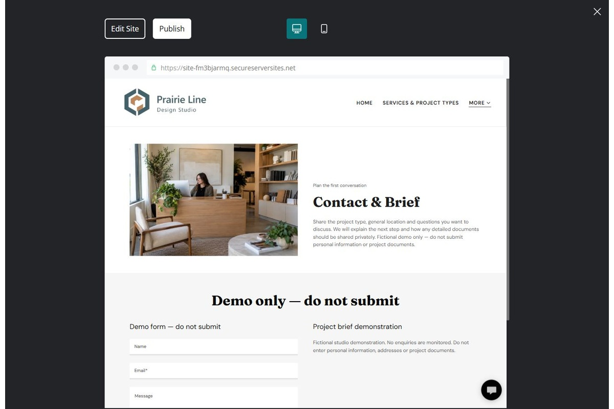
Unpublished Website Builder desktop excerpt. Page content continues below.

Sample wording — adapt and verify
Contact & Brief
Share the project type, general location and questions you want to discuss. We will explain the next step and how any detailed documents should be shared privately.
Contact the team to discuss your questions and confirm the next step.
Suggested button: Contact the team

Website advice
Collect a general brief and contact preference; share drawings through an approved private channel.

Your draft: Contact & Brief
Write in the voice of your own business. Use facts you can verify, not promises copied from the example.

Headline and short introduction

Main content and details visitors need

Button wording and destination

Photo choice, permission and facts still to confirm
Partner check: can someone unfamiliar with the business find a useful next step?

Test before publishing
Review the whole journey on a desktop and phone. Compare these desktop excerpts with the mobile captures on the industry page.
□ Fictional studio example. Verify professional titles, licensing, practice scope, project permissions and local requirements. This guide supplies no engineering or architectural advice.
□ Verify contact routes, location, hours, service scope and all commercial terms.
□ Replace fictional identities and AI illustrations or label them accurately.
□ Remove unverified testimonials, results, credentials and availability.
□ Check every link, form and download on desktop and mobile.
□ Keep sensitive documents, access information and payment details out of public forms.
□ Check every link, form destination, download and confirmation message.
□ Check logo contrast, hero framing, text sizes and image loading.
□ Save a named backup and assign a content-review date.

Changes to finish and person responsible

Approval and next review date
Website Builder plans and signup

