

Dance, Music & Art Schools
Website workbook
A practical workshop for a 6-page website. Study the example, plan the content and draft your own version in Word or on paper.
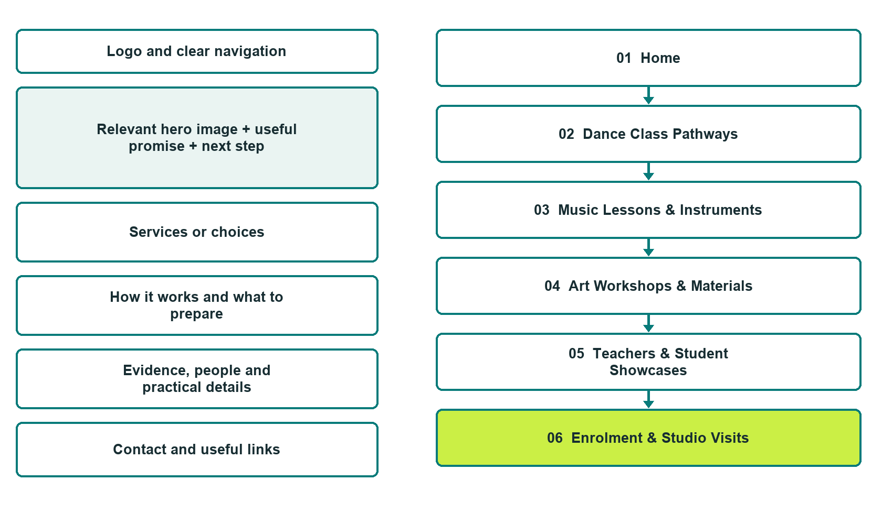

Plan → Draft → Build → Test
Website Builder capture edition: six desktop excerpts from the fictional demo; the wireframe remains a planning illustration.
Explore Website Builder and compare plans

Before you build
Your business supplies the facts. Prairie Lantern Arts School is a fictional teaching example, not a live service.

□ Ask about a class pathway
□ Verified business identity, services and current contact information
□ A clear enquiry, review and confirmation process
□ Choose original photographs and confirm permission to use them.
□ Keep private customer records out of public website forms.

Your audience and the action you want them to take

Facts to verify and people who must approve them
Create your SaaSTech account

01 Home
Give this page one clear job in the customer journey.
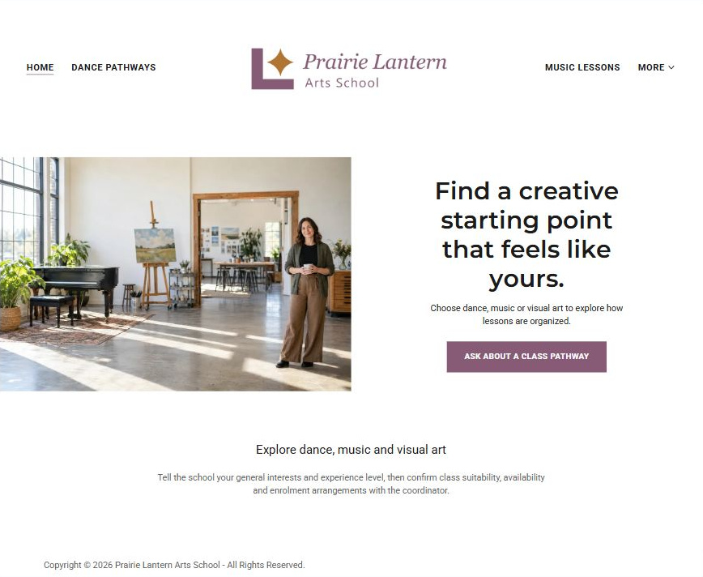
Actual Website Builder desktop excerpt from the fictional demo

Sample wording — adapt and verify
Find a creative starting point that feels like yours.
Choose dance, music or visual art to explore how lessons are organized.
Tell the school your general interests and experience level, then confirm class suitability, availability and enrolment arrangements with the coordinator.
Suggested button: Ask about a class pathway

Website advice
Separate dance classes, music tuition and visual-art workshops with discipline-specific pathways, enrolment questions and permission-cleared showcases.

Your draft: Home
Write in the voice of your own business. Use facts you can verify, not promises copied from the example.

Headline and short introduction

Main content and details visitors need

Button wording and destination

Photo choice, permission and facts still to confirm
Partner check: can someone unfamiliar with the business find a useful next step?

02 Dance Class Pathways
Give this page one clear job in the customer journey.
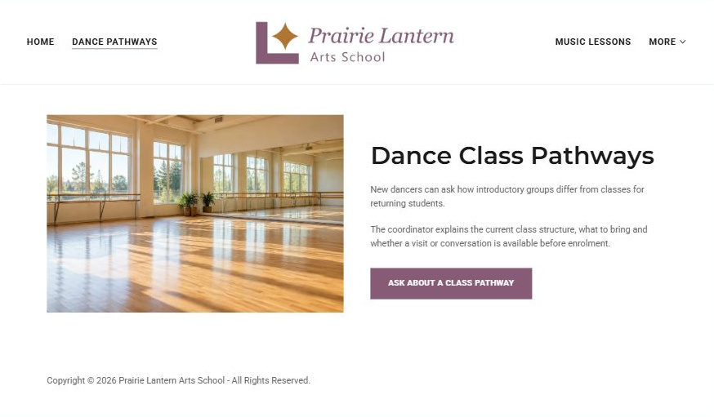
Actual Website Builder desktop excerpt from the fictional demo

Sample wording — adapt and verify
Dance Class Pathways
New dancers can ask how introductory groups differ from classes for returning students.
The coordinator explains the current class structure, what to bring and whether a visit or conversation is available before enrolment.
Suggested button: Ask about a class pathway

Website advice
Organize dance enquiries by style, experience and class format without inventing timetables or competition results.

Your draft: Dance Class Pathways
Write in the voice of your own business. Use facts you can verify, not promises copied from the example.

Headline and short introduction

Main content and details visitors need

Button wording and destination

Photo choice, permission and facts still to confirm
Partner check: can someone unfamiliar with the business find a useful next step?

03 Music Lessons & Instruments
Give this page one clear job in the customer journey.
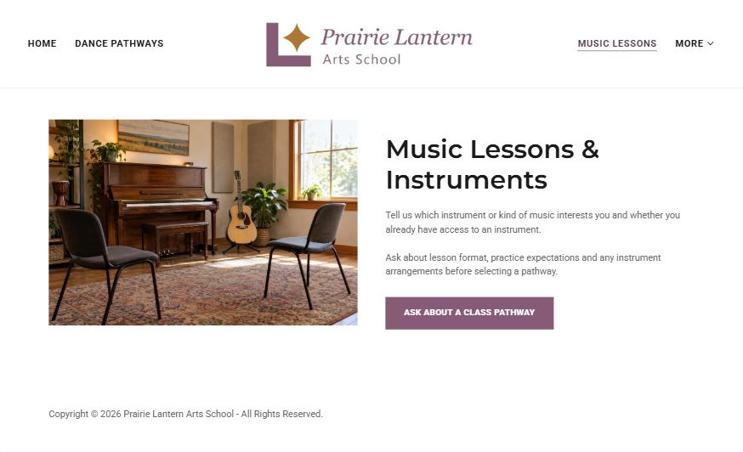
Actual Website Builder desktop excerpt from the fictional demo

Sample wording — adapt and verify
Music Lessons & Instruments
Tell us which instrument or kind of music interests you and whether you already have access to an instrument.
Ask about lesson format, practice expectations and any instrument arrangements before selecting a pathway.
Suggested button: Ask about a class pathway

Website advice
Distinguish individual tuition, group learning and instrument enquiries; confirm what the school actually offers.

Your draft: Music Lessons & Instruments
Write in the voice of your own business. Use facts you can verify, not promises copied from the example.

Headline and short introduction

Main content and details visitors need

Button wording and destination

Photo choice, permission and facts still to confirm
Partner check: can someone unfamiliar with the business find a useful next step?

04 Art Workshops & Materials
Give this page one clear job in the customer journey.
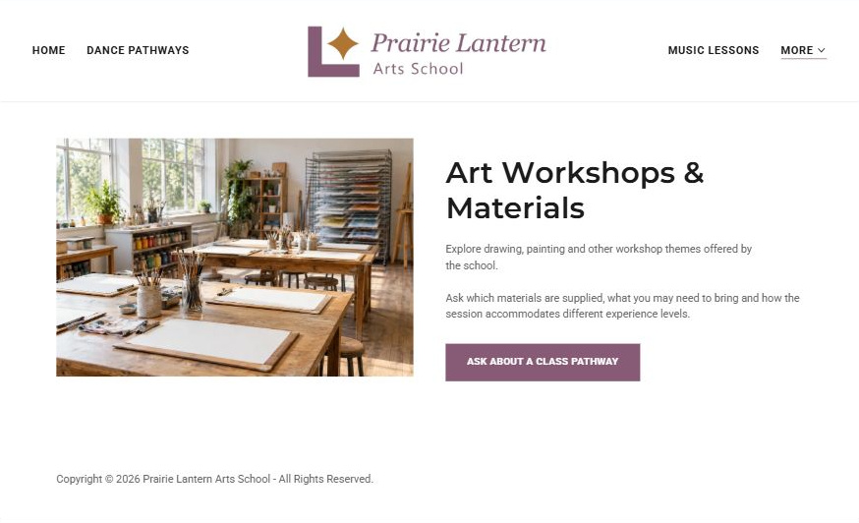
Actual Website Builder desktop excerpt from the fictional demo

Sample wording — adapt and verify
Art Workshops & Materials
Explore drawing, painting and other workshop themes offered by the school.
Ask which materials are supplied, what you may need to bring and how the session accommodates different experience levels.
Suggested button: Ask about a class pathway

Website advice
Explain visual-art workshop themes and materials arrangements without assuming all supplies are included.

Your draft: Art Workshops & Materials
Write in the voice of your own business. Use facts you can verify, not promises copied from the example.

Headline and short introduction

Main content and details visitors need

Button wording and destination

Photo choice, permission and facts still to confirm
Partner check: can someone unfamiliar with the business find a useful next step?

05 Teachers & Student Showcases
Give this page one clear job in the customer journey.
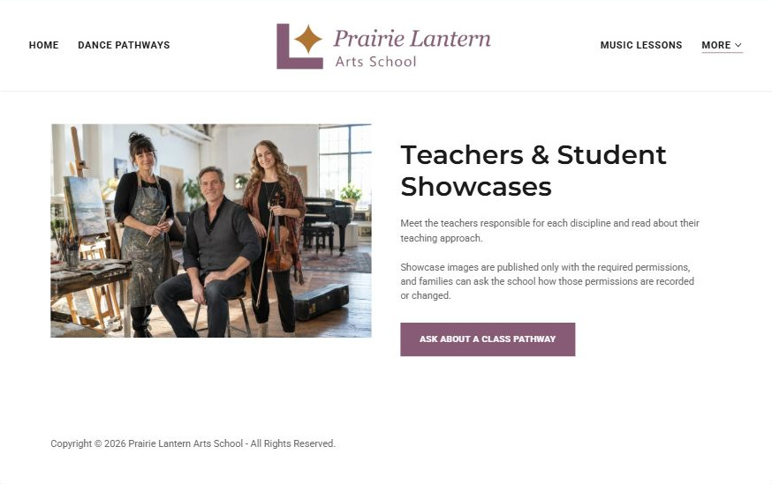
Actual Website Builder desktop excerpt from the fictional demo

Sample wording — adapt and verify
Teachers & Student Showcases
Meet the teachers responsible for each discipline and read about their teaching approach.
Showcase images are published only with the required permissions, and families can ask the school how those permissions are recorded or changed.
Suggested button: Ask about a class pathway

Website advice
Provide a verified teacher profile structure and a consent-controlled showcase process.

Your draft: Teachers & Student Showcases
Write in the voice of your own business. Use facts you can verify, not promises copied from the example.

Headline and short introduction

Main content and details visitors need

Button wording and destination

Photo choice, permission and facts still to confirm
Partner check: can someone unfamiliar with the business find a useful next step?

06 Enrolment & Studio Visits
Give this page one clear job in the customer journey.
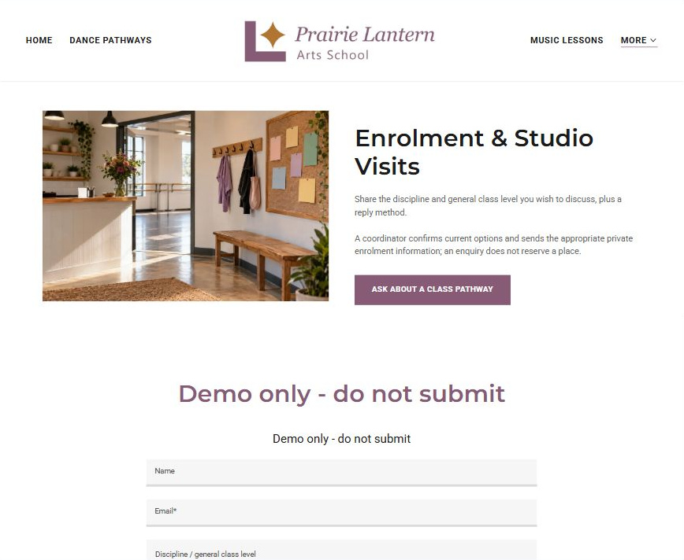
Actual Website Builder desktop excerpt from the fictional demo

Sample wording — adapt and verify
Enrolment & Studio Visits
Share the discipline and general class level you wish to discuss, plus a reply method.
A coordinator confirms current options and sends the appropriate private enrolment information; an enquiry does not reserve a place.
Suggested button: Ask about a class pathway

Website advice
Explain enquiry, class discussion, private enrolment and confirmation as separate steps.

Your draft: Enrolment & Studio Visits
Write in the voice of your own business. Use facts you can verify, not promises copied from the example.

Headline and short introduction

Main content and details visitors need

Button wording and destination

Photo choice, permission and facts still to confirm
Partner check: can someone unfamiliar with the business find a useful next step?

Test before publishing
Review the whole journey on a desktop and phone. Use these first-screen examples to plan your own pages, then verify your complete website.
□ Fictional demonstration only. Verify instructors, age bands, class requirements and enrolment terms. Do not collect children’s names, schedules, photographs or personal information through public forms; use a guardian-led private enrolment process.
□ Verify every service description, contact route and operating detail.
□ Replace fictional identity and example information before a live launch.
□ Test enquiries, links and downloads on desktop and mobile.
□ Keep confidential records in approved private systems.
□ Obtain operator approval for public wording and images.
□ Check every link, form destination, download and confirmation message.
□ Check logo contrast, hero framing, text sizes and image loading.
□ Save a named backup and assign a content-review date.

Changes to finish and person responsible

Approval and next review date
Website Builder plans and signup

