

Courier, Delivery, Logistics & Warehousing
Website workbook
A practical workshop for a 5-page website. Study the example, plan the content and draft your own version in Word or on paper.
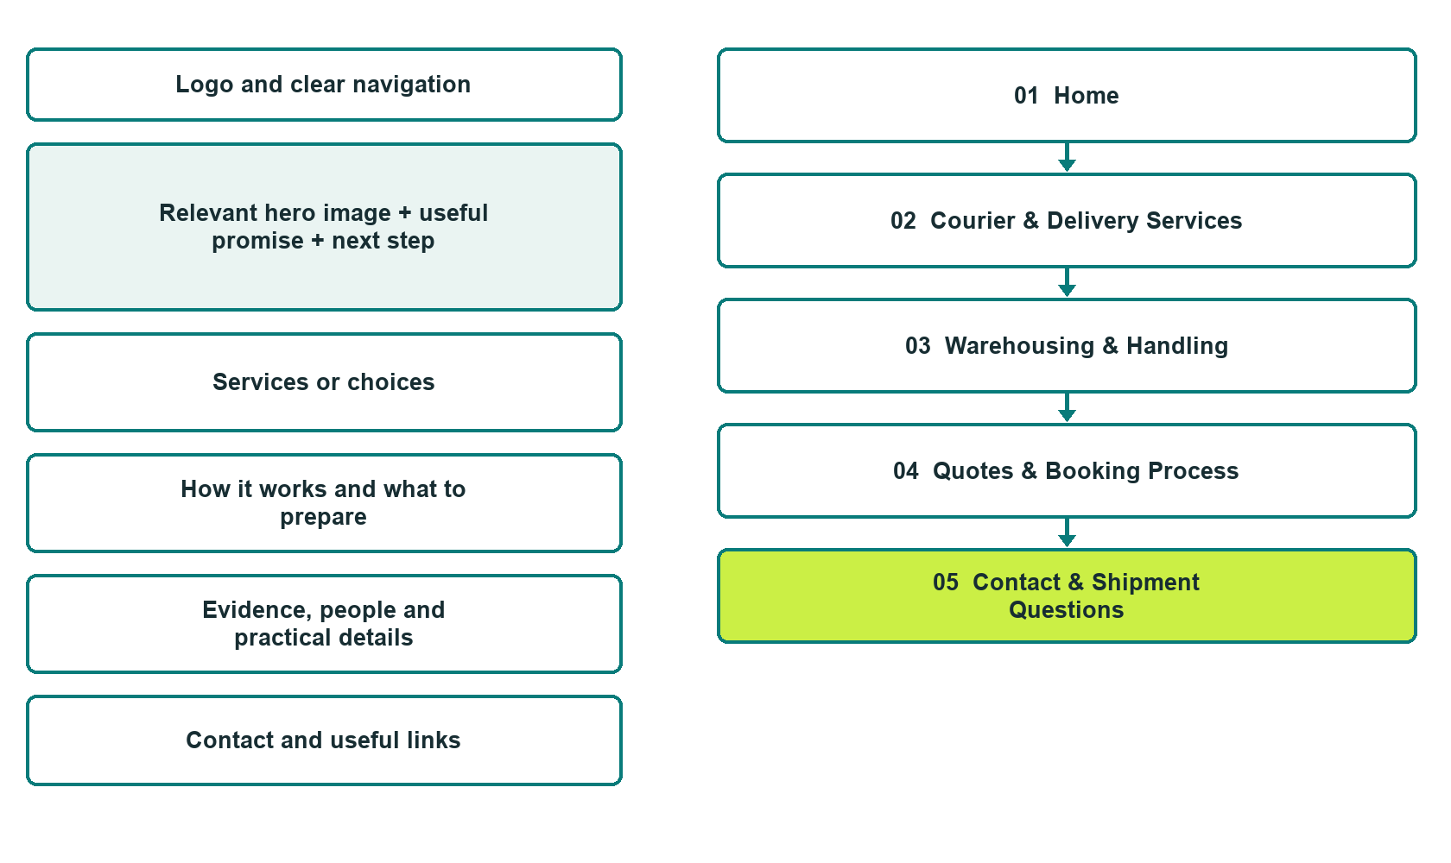

Plan → Draft → Build → Test
Capture edition: five genuine unpublished Website Builder desktop excerpts. Review mobile views on the industry page.
Explore Website Builder and compare plans

Before you build
Your business supplies the facts. Prairie Waypoint Logistics is a fictional teaching example, not a live service.

□ Request a delivery or storage discussion
□ Verified business identity, services and current contact information
□ A clear enquiry, review and confirmation process
□ Choose original photographs and confirm permission to use them.
□ Keep private customer records out of public website forms.

Your audience and the action you want them to take

Facts to verify and people who must approve them
Create your SaaSTech account

01 Home
Give this page one clear job in the customer journey.
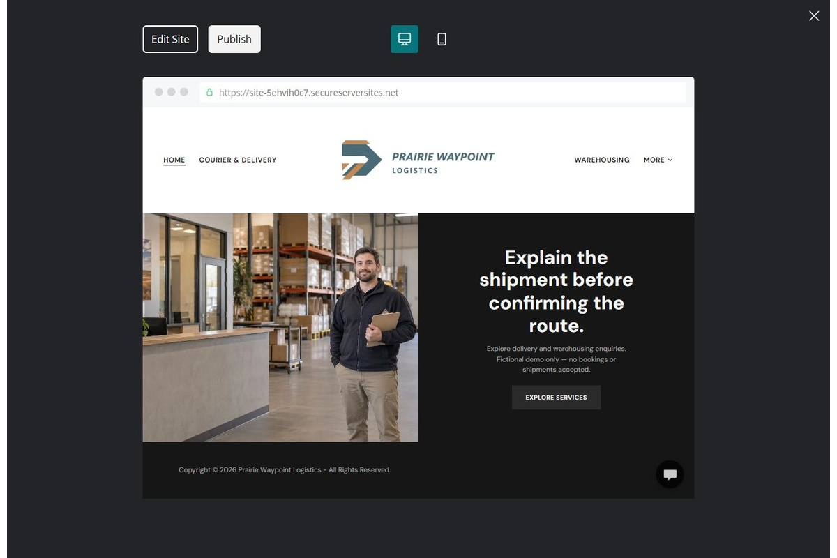
Unpublished Website Builder desktop excerpt. Page content continues below.

Sample wording — adapt and verify
Explain the shipment before confirming the route.
Explore delivery and warehousing categories and prepare the details needed for an initial discussion. The coordinator confirms whether the request can be accepted and explains the next step.
Use the relevant page to prepare a focused enquiry, then contact the team to confirm the next step.
Suggested button: Request a delivery or storage discussion

Website advice
Separate delivery and warehousing enquiries, explain suitability and capacity review, and keep enquiries distinct from confirmed bookings or live tracking.

Your draft: Home
Write in the voice of your own business. Use facts you can verify, not promises copied from the example.

Headline and short introduction

Main content and details visitors need

Button wording and destination

Photo choice, permission and facts still to confirm
Partner check: can someone unfamiliar with the business find a useful next step?

02 Courier & Delivery Services
Give this page one clear job in the customer journey.
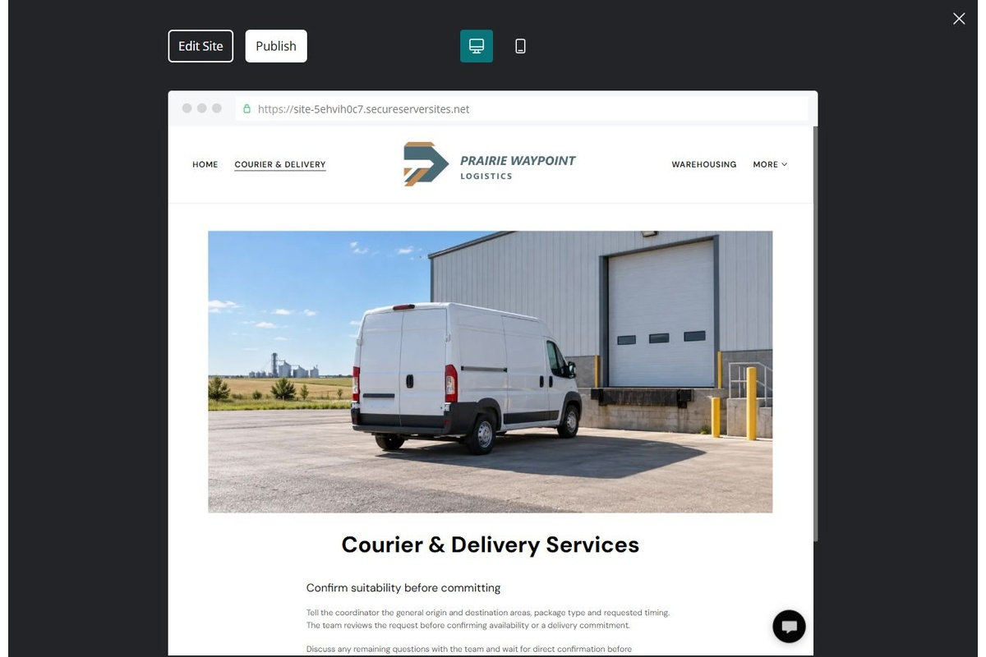
Unpublished Website Builder desktop excerpt. Page content continues below.

Sample wording — adapt and verify
Courier & Delivery Services
Tell the coordinator the general origin and destination areas, package type and requested timing. The team reviews the request before confirming availability or a delivery commitment.
Discuss any remaining questions with the team and wait for direct confirmation before making arrangements.
Suggested button: Request a delivery or storage discussion

Website advice
Describe verified route and shipment categories; make timing and acceptance subject to review.

Your draft: Courier & Delivery Services
Write in the voice of your own business. Use facts you can verify, not promises copied from the example.

Headline and short introduction

Main content and details visitors need

Button wording and destination

Photo choice, permission and facts still to confirm
Partner check: can someone unfamiliar with the business find a useful next step?

03 Warehousing & Handling
Give this page one clear job in the customer journey.
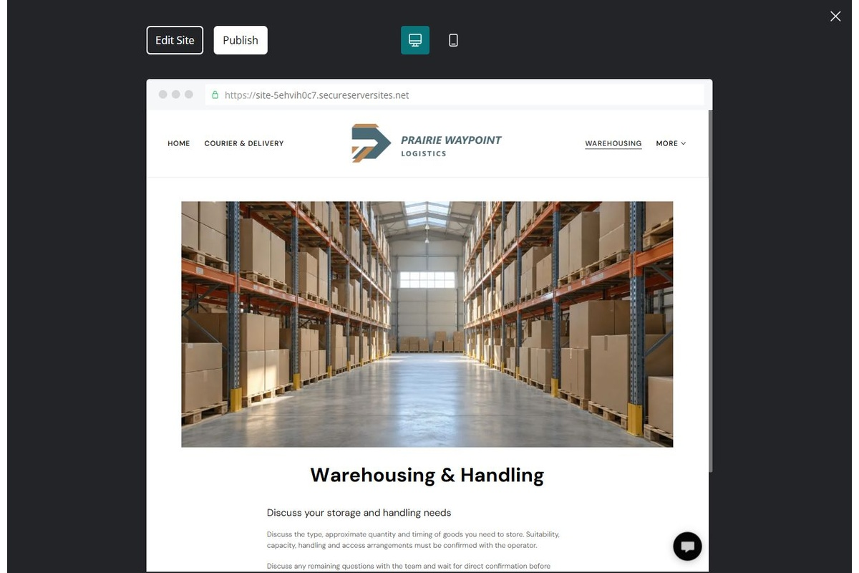
Unpublished Website Builder desktop excerpt. Page content continues below.

Sample wording — adapt and verify
Warehousing & Handling
Discuss the type, approximate quantity and timing of goods you need to store. Suitability, capacity, handling and access arrangements must be confirmed with the operator.
Discuss any remaining questions with the team and wait for direct confirmation before making arrangements.
Suggested button: Request a delivery or storage discussion

Website advice
Explain offered storage and handling categories without inventing capacity, security ratings or special-goods capability.

Your draft: Warehousing & Handling
Write in the voice of your own business. Use facts you can verify, not promises copied from the example.

Headline and short introduction

Main content and details visitors need

Button wording and destination

Photo choice, permission and facts still to confirm
Partner check: can someone unfamiliar with the business find a useful next step?

04 Quotes & Booking Process
Give this page one clear job in the customer journey.
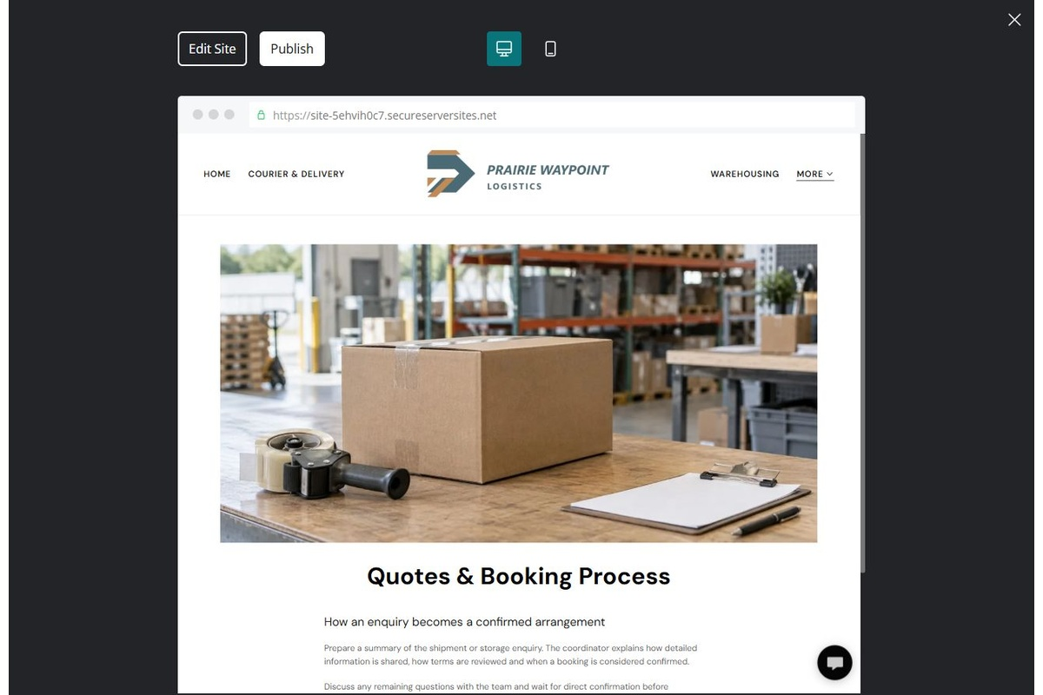
Unpublished Website Builder desktop excerpt. Page content continues below.

Sample wording — adapt and verify
Quotes & Booking Process
Prepare a summary of the shipment or storage enquiry. The coordinator explains how detailed information is shared, how terms are reviewed and when a booking is considered confirmed.
Discuss any remaining questions with the team and wait for direct confirmation before making arrangements.
Suggested button: Request a delivery or storage discussion

Website advice
Explain non-sensitive enquiry, private details, quote review and explicit acceptance. Do not mimic live tracking.

Your draft: Quotes & Booking Process
Write in the voice of your own business. Use facts you can verify, not promises copied from the example.

Headline and short introduction

Main content and details visitors need

Button wording and destination

Photo choice, permission and facts still to confirm
Partner check: can someone unfamiliar with the business find a useful next step?

05 Contact & Shipment Questions
Give this page one clear job in the customer journey.
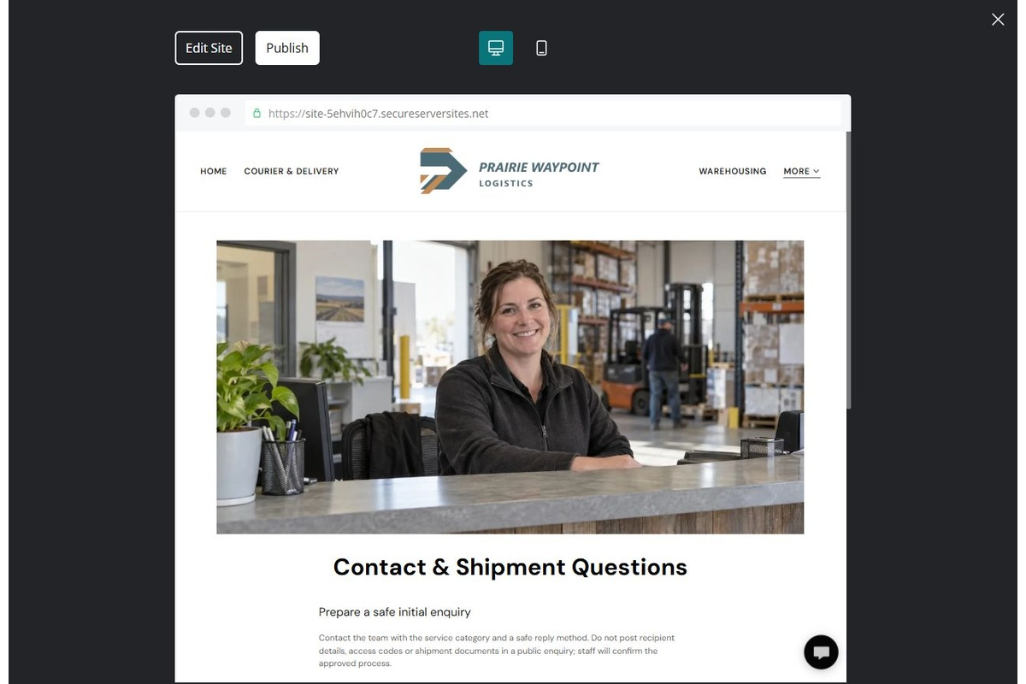
Unpublished Website Builder desktop excerpt. Page content continues below.

Sample wording — adapt and verify
Contact & Shipment Questions
Contact the team with the service category and a safe reply method. Do not post recipient details, access codes or shipment documents in a public enquiry; staff will confirm the approved process.
Discuss any remaining questions with the team and wait for direct confirmation before making arrangements.
Suggested button: Request a delivery or storage discussion

Website advice
Provide reviewed contacts and clear limits; use private routes for recipient information or shipment documents.

Your draft: Contact & Shipment Questions
Write in the voice of your own business. Use facts you can verify, not promises copied from the example.

Headline and short introduction

Main content and details visitors need

Button wording and destination

Photo choice, permission and facts still to confirm
Partner check: can someone unfamiliar with the business find a useful next step?

Test before publishing
Review the whole journey on a desktop and phone. Compare these desktop excerpts with the mobile captures on the industry page.
□ Fictional demonstration only. Verify service coverage, goods acceptance, capacity and terms. Do not imply live tracking, customs expertise, hazardous-goods capability or guaranteed delivery; keep recipient data and access details private.
□ Verify each offered service, contact route, location and opening arrangement.
□ Remove fictional identity, claims, availability and prices before a real launch.
□ Test every enquiry route and download on desktop and mobile.
□ Keep sensitive information in approved private systems.
□ Obtain operator approval for all public wording and image use.
□ Check every link, form destination, download and confirmation message.
□ Check logo contrast, hero framing, text sizes and image loading.
□ Save a named backup and assign a content-review date.

Changes to finish and person responsible

Approval and next review date
Website Builder plans and signup

