

Coffee Shops, Tea Houses & Ice Cream Shops
Website workbook
A practical workshop for a 6-page website. Study the example, plan the content and draft your own version in Word or on paper.
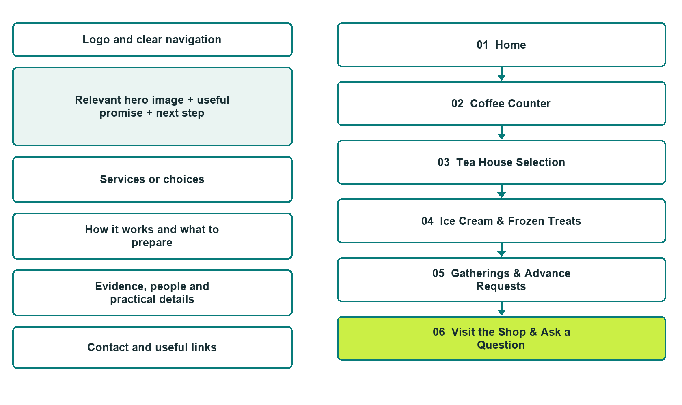

Plan → Draft → Build → Test
Captured demo edition. Study the unpublished six-page example, then draft your own verified content. Open the industry gallery for desktop and mobile previews.
Explore Website Builder and compare plans

Before you build
Your business supplies the facts. Prairie Willow Cup & Scoop is a fictional teaching example, not a live service.

□ Ask about today’s menu or a gathering
□ Verified business identity, services and current contact information
□ A clear enquiry, review and confirmation process
□ Choose original photographs and confirm permission to use them.
□ Keep private customer records out of public website forms.

Your audience and the action you want them to take

Facts to verify and people who must approve them
Create your SaaSTech account

01 Home
Give this page one clear job in the customer journey.
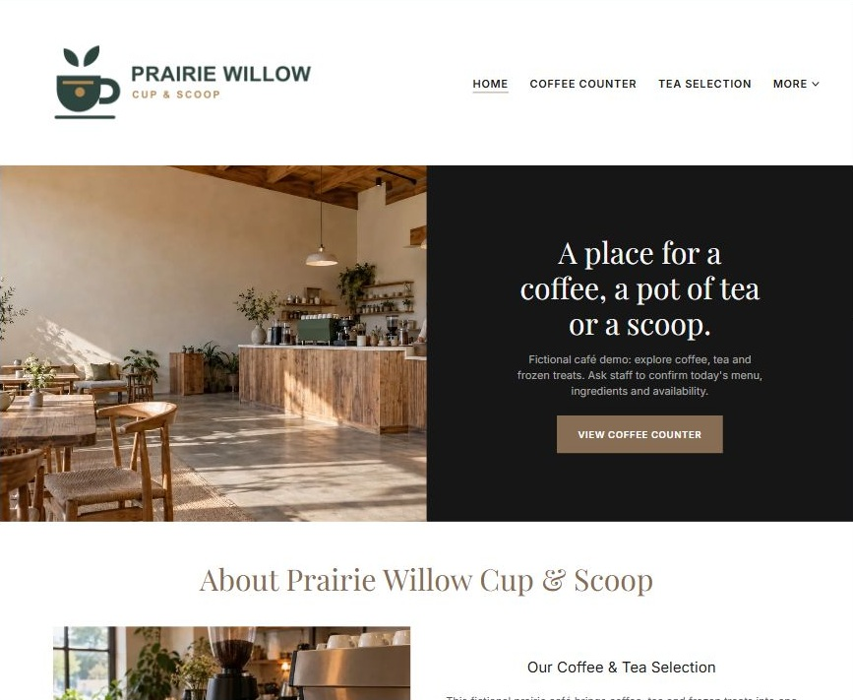
Actual desktop Website Builder preview. Open the industry gallery for its paired mobile view.

Sample wording — adapt and verify
A place for a coffee, a pot of tea or a scoop.
Explore three counter menus and the space around them, then confirm what is being served before you visit.
The team can discuss a product question or a small gathering request through the appropriate enquiry route.
Suggested button: Ask about today’s menu or a gathering

Website advice
Give coffee, tea and frozen treats distinct menu sections, separate current stock from examples, and explain visits and small gathering enquiries without implying full-service restaurant offerings.

Your draft: Home
Write in the voice of your own business. Use facts you can verify, not promises copied from the example.

Headline and short introduction

Main content and details visitors need

Button wording and destination

Photo choice, permission and facts still to confirm
Partner check: can someone unfamiliar with the business find a useful next step?

02 Coffee Counter
Give this page one clear job in the customer journey.
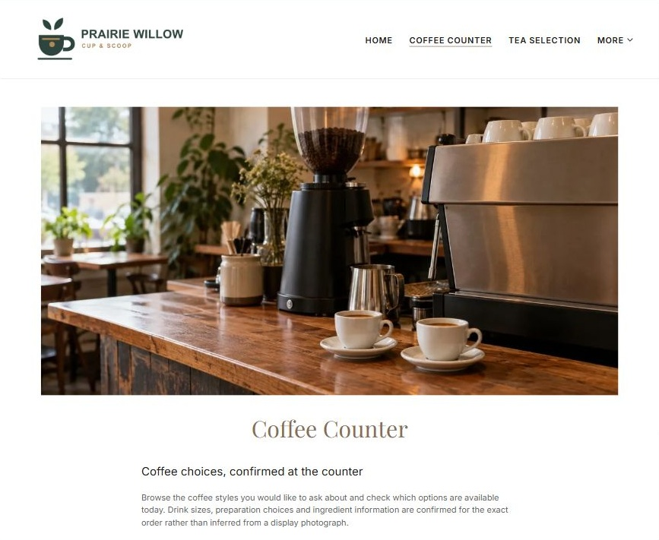
Actual desktop Website Builder preview. Open the industry gallery for its paired mobile view.

Sample wording — adapt and verify
Coffee Counter
Browse the coffee styles you would like to ask about and check which options are available today.
Drink sizes, preparation choices and ingredient information are confirmed for the exact order rather than inferred from a display photograph.
Suggested button: Ask about today’s menu or a gathering

Website advice
Give brewed and espresso-style drink enquiries their own menu context with current sizes and options operator-verified.

Your draft: Coffee Counter
Write in the voice of your own business. Use facts you can verify, not promises copied from the example.

Headline and short introduction

Main content and details visitors need

Button wording and destination

Photo choice, permission and facts still to confirm
Partner check: can someone unfamiliar with the business find a useful next step?

03 Tea House Selection
Give this page one clear job in the customer journey.
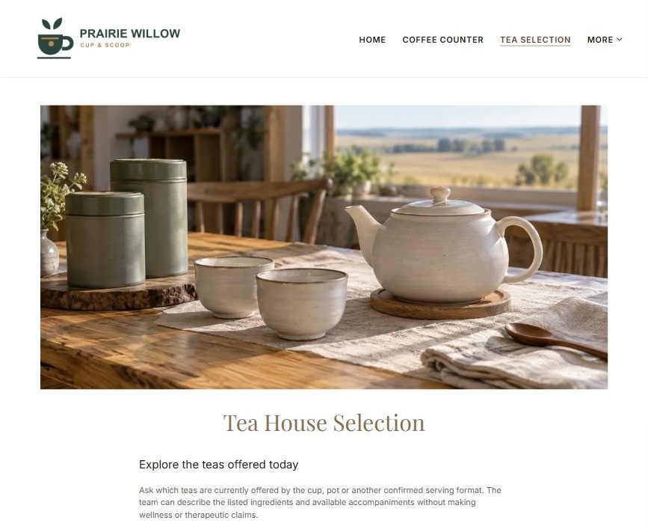
Actual desktop Website Builder preview. Open the industry gallery for its paired mobile view.

Sample wording — adapt and verify
Tea House Selection
Ask which teas are currently offered by the cup, pot or another confirmed serving format.
The team can describe the listed ingredients and available accompaniments without making wellness or therapeutic claims.
Suggested button: Ask about today’s menu or a gathering

Website advice
Treat tea as a separate service with verified varieties and formats, not coffee copy with changed nouns.

Your draft: Tea House Selection
Write in the voice of your own business. Use facts you can verify, not promises copied from the example.

Headline and short introduction

Main content and details visitors need

Button wording and destination

Photo choice, permission and facts still to confirm
Partner check: can someone unfamiliar with the business find a useful next step?

04 Ice Cream & Frozen Treats
Give this page one clear job in the customer journey.
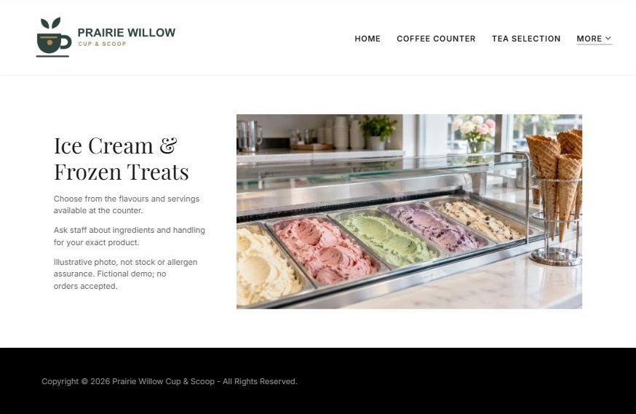
Actual desktop Website Builder preview. Open the industry gallery for its paired mobile view.

Sample wording — adapt and verify
Ice Cream & Frozen Treats
Check the flavours and serving options available at the counter before choosing.
Ingredients and handling questions must be answered for the exact product; a pictured scoop is neither a stock update nor an allergen assurance.
Suggested button: Ask about today’s menu or a gathering

Website advice
Create a distinct seasonal counter journey with product-specific flavour and ingredient checks.

Your draft: Ice Cream & Frozen Treats
Write in the voice of your own business. Use facts you can verify, not promises copied from the example.

Headline and short introduction

Main content and details visitors need

Button wording and destination

Photo choice, permission and facts still to confirm
Partner check: can someone unfamiliar with the business find a useful next step?

05 Gatherings & Advance Requests
Give this page one clear job in the customer journey.
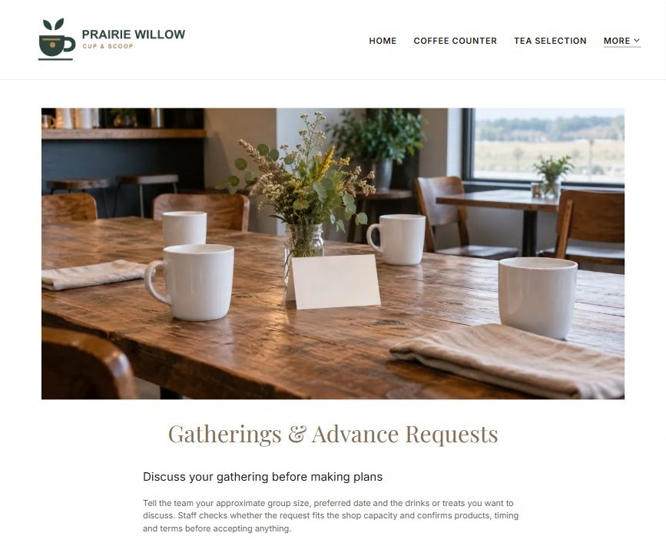
Actual desktop Website Builder preview. Open the industry gallery for its paired mobile view.

Sample wording — adapt and verify
Gatherings & Advance Requests
Tell the team your approximate group size, preferred date and the drinks or treats you want to discuss.
Staff checks whether the request fits the shop capacity and confirms products, timing and terms before accepting anything.
Suggested button: Ask about today’s menu or a gathering

Website advice
Explain modest group refreshment enquiries separately from full-service catering or confirmed event bookings.

Your draft: Gatherings & Advance Requests
Write in the voice of your own business. Use facts you can verify, not promises copied from the example.

Headline and short introduction

Main content and details visitors need

Button wording and destination

Photo choice, permission and facts still to confirm
Partner check: can someone unfamiliar with the business find a useful next step?

06 Visit the Shop & Ask a Question
Give this page one clear job in the customer journey.
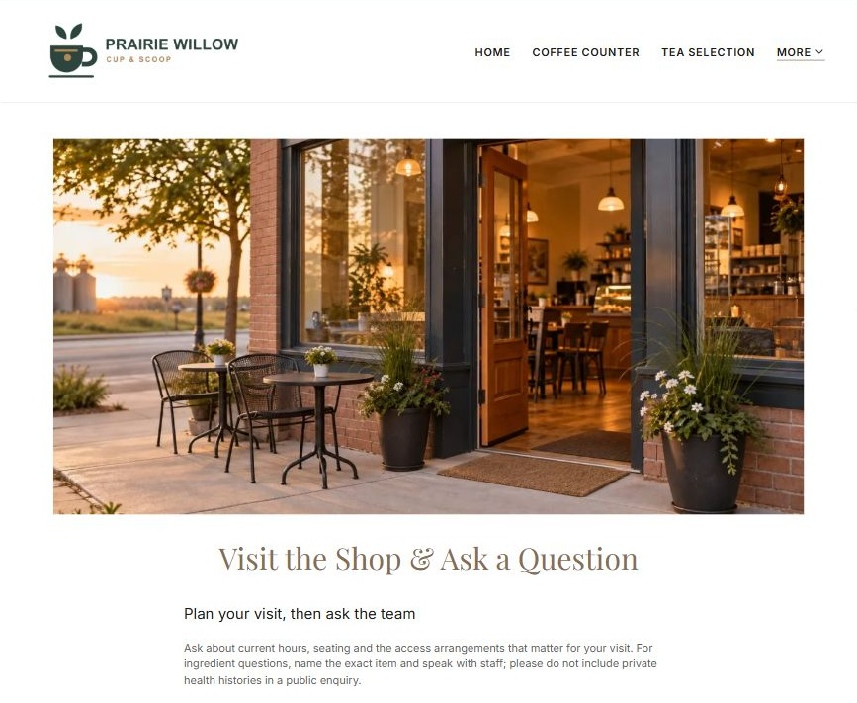
Actual desktop Website Builder preview. Open the industry gallery for its paired mobile view.

Sample wording — adapt and verify
Visit the Shop & Ask a Question
Ask about current hours, seating and the access arrangements that matter for your visit.
For ingredient questions, name the exact item and speak with staff; please do not include private health histories in a public enquiry.
Suggested button: Ask about today’s menu or a gathering

Website advice
Provide verified hours, seating and access details with product questions kept separate from sensitive health histories.

Your draft: Visit the Shop & Ask a Question
Write in the voice of your own business. Use facts you can verify, not promises copied from the example.

Headline and short introduction

Main content and details visitors need

Button wording and destination

Photo choice, permission and facts still to confirm
Partner check: can someone unfamiliar with the business find a useful next step?

Test before publishing
Review the desktop and phone journey. The demo enquiry form has no live shop recipient and was not submitted. Verify approved delivery before a real launch.
□ Fictional shop demonstration. Verify menu, opening hours, ingredient information, allergen handling, prices and group-order capability before publication. No allergen-free assurance, nutrition claim or guaranteed seasonal availability is made; a general enquiry is not an accepted order.
□ Verify every service description, contact route and operating detail.
□ Replace fictional identity and example information before a live launch.
□ Test enquiries, links and downloads on desktop and mobile.
□ Keep confidential records in approved private systems.
□ Obtain operator approval for public wording and images.
□ Check every link, form destination, download and confirmation message.
□ Check logo contrast, hero framing, text sizes and image loading.
□ Save a named backup and assign a content-review date.

Changes to finish and person responsible

Approval and next review date
Website Builder plans and signup

