

Car Washes & Auto Detailing
Website workbook
A practical workshop for a 6-page website. Study the example, plan the content and draft your own version in Word or on paper.
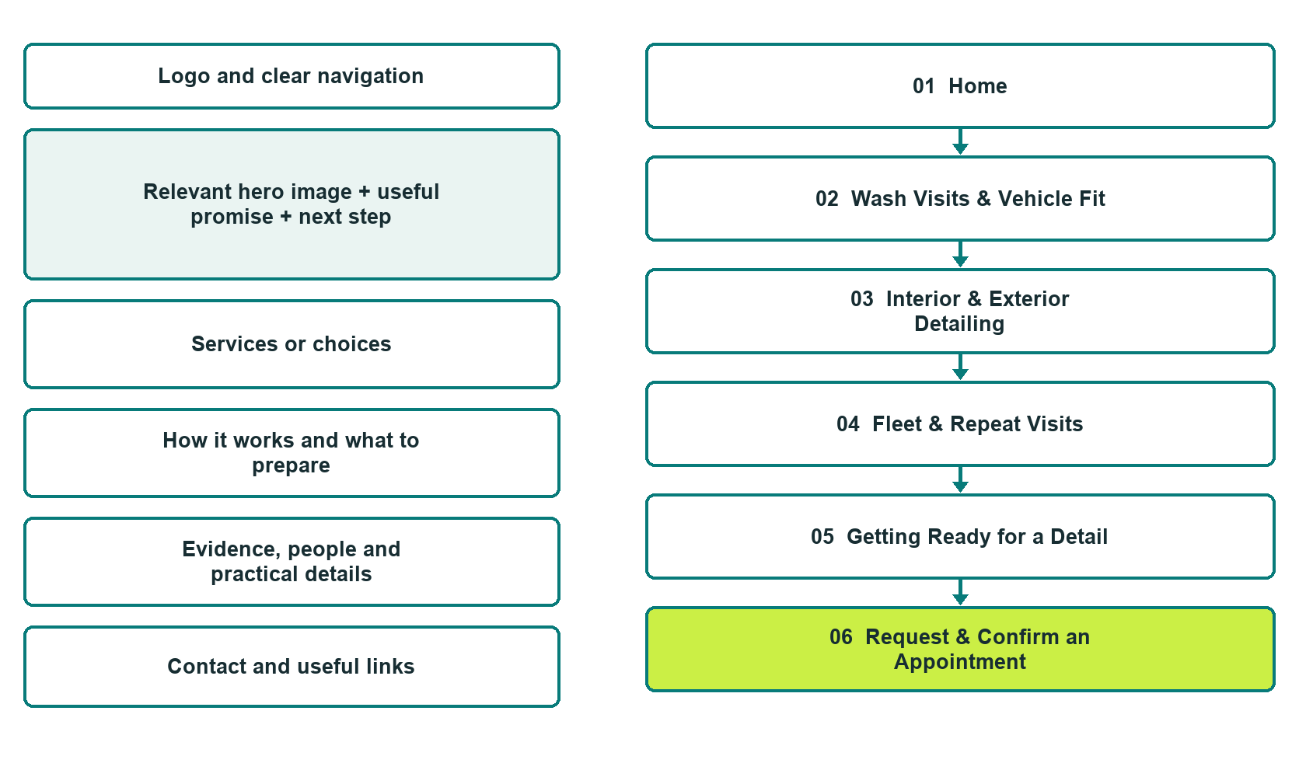

Plan → Draft → Build → Test
Actual Website Builder edition: six unpublished demonstration pages with distinct photographs. The example enquiry form is disconnected and was not submitted.
Explore Website Builder and compare plans

Before you build
Your business supplies the facts. Prairie Shine Wash & Detail is a fictional teaching example, not a live service.

□ Ask about a wash or detail visit
□ Verified business identity, services and current contact information
□ A clear enquiry, review and confirmation process
□ Choose original photographs and confirm permission to use them.
□ Keep private customer records out of public website forms.

Your audience and the action you want them to take

Facts to verify and people who must approve them
Create your SaaSTech account

01 Home
Give this page one clear job in the customer journey.
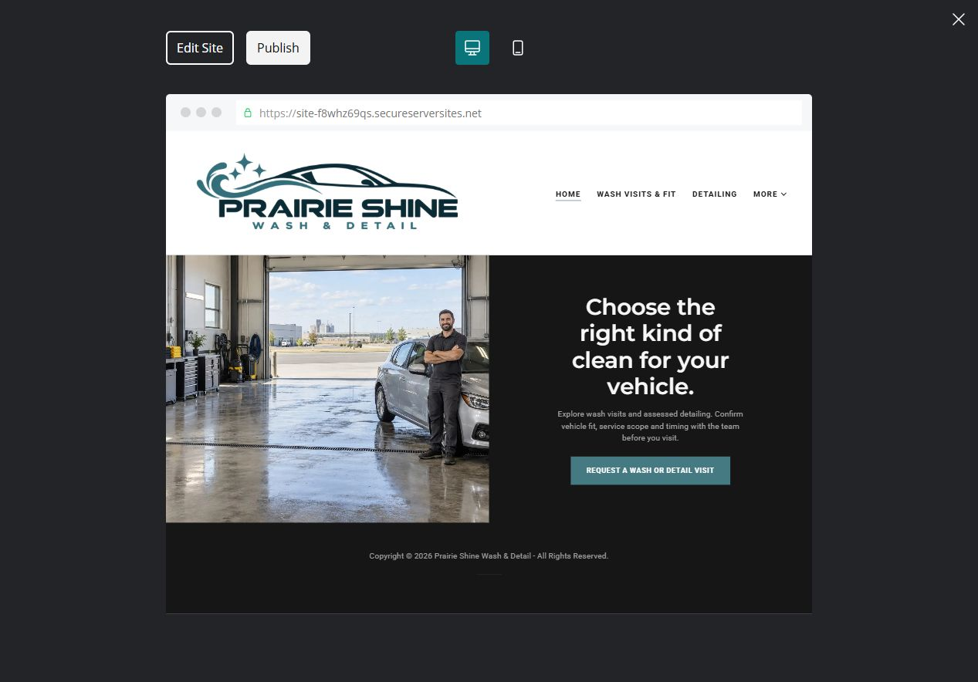
Actual desktop preview of the unpublished demonstration

Sample wording — adapt and verify
Choose the right kind of clean for your vehicle.
Explore wash visits and assessed detailing.
Confirm vehicle fit, service scope and timing with the team before you visit.
Suggested button: Request a wash or detail visit

Website advice
Keep everyday wash visits separate from assessed detailing appointments, with vehicle questions, preparation and finish expectations reviewed by staff.

Your draft: Home
Write in the voice of your own business. Use facts you can verify, not promises copied from the example.

Headline and short introduction

Main content and details visitors need

Button wording and destination

Photo choice, permission and facts still to confirm
Partner check: can someone unfamiliar with the business find a useful next step?

02 Wash Visits & Vehicle Fit
Give this page one clear job in the customer journey.
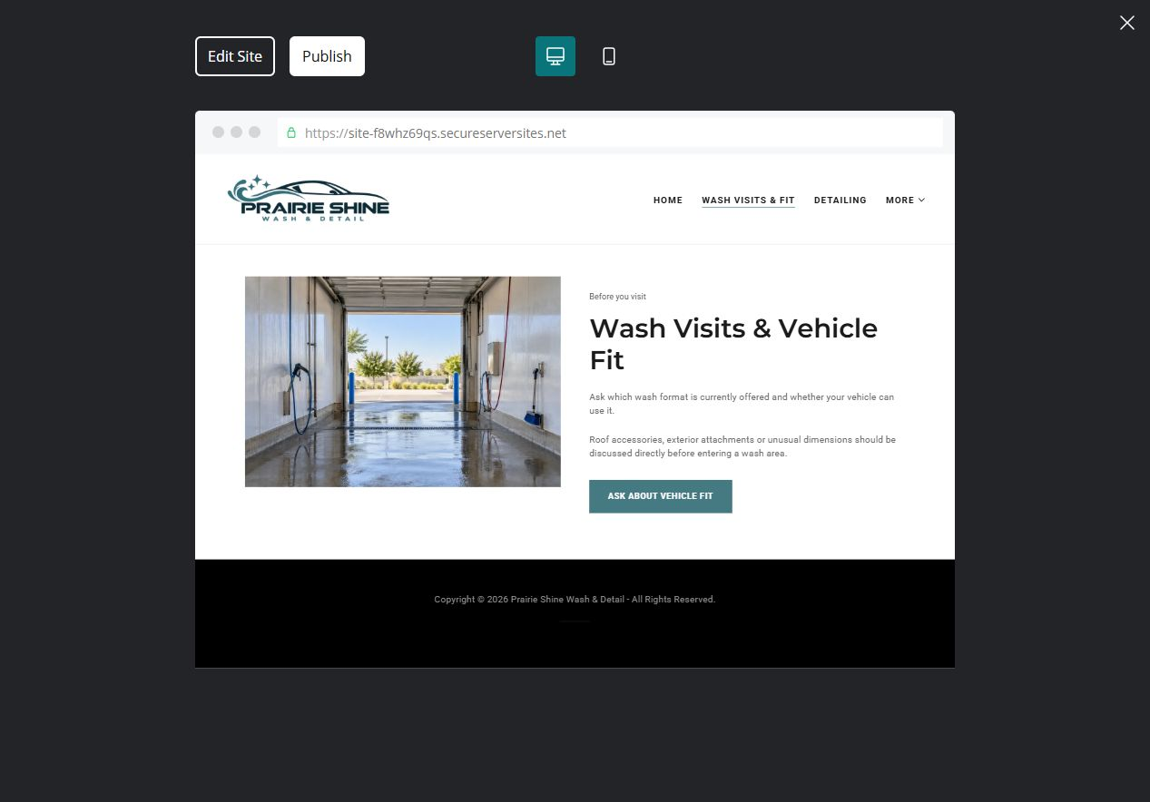
Actual desktop preview of the unpublished demonstration

Sample wording — adapt and verify
Wash Visits & Vehicle Fit
Ask which wash format is currently offered and whether your vehicle can use it.
Roof accessories, exterior attachments or unusual dimensions should be discussed directly before entering a wash area.
Suggested button: Ask about vehicle fit

Website advice
Explain available wash formats, entry arrangements and operator-confirmed restrictions without inventing dimensions.

Your draft: Wash Visits & Vehicle Fit
Write in the voice of your own business. Use facts you can verify, not promises copied from the example.

Headline and short introduction

Main content and details visitors need

Button wording and destination

Photo choice, permission and facts still to confirm
Partner check: can someone unfamiliar with the business find a useful next step?

03 Interior & Exterior Detailing
Give this page one clear job in the customer journey.
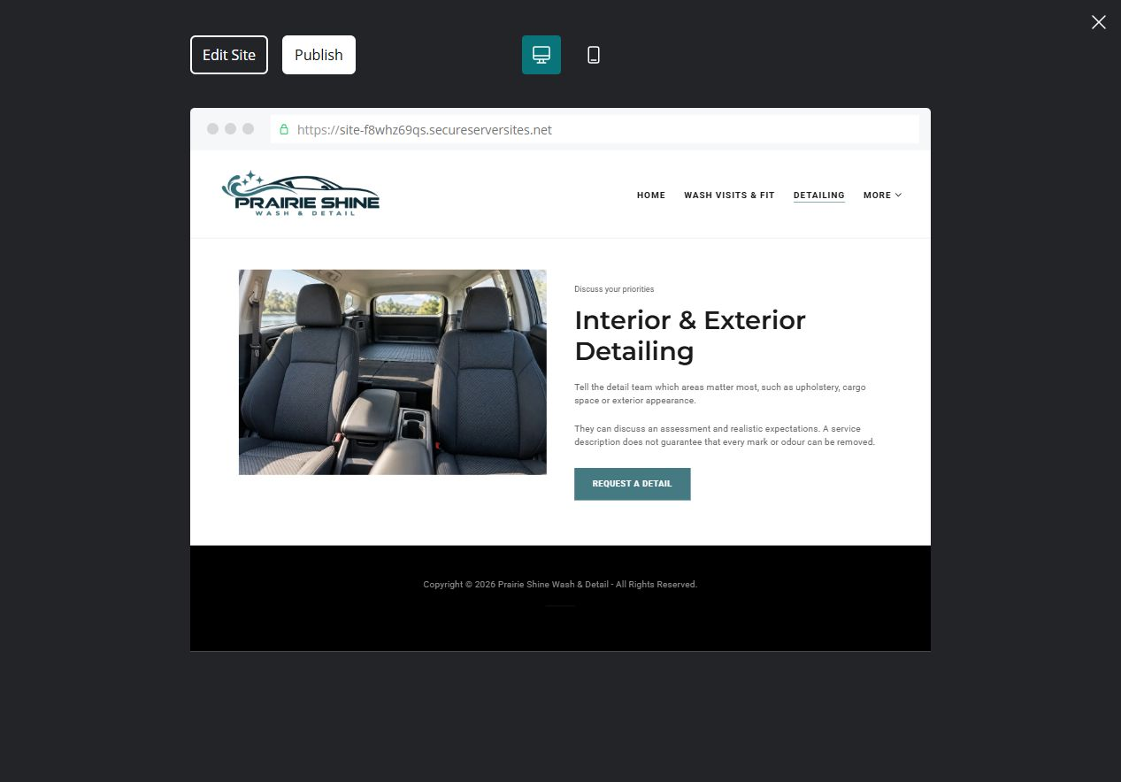
Actual desktop preview of the unpublished demonstration

Sample wording — adapt and verify
Interior & Exterior Detailing
Tell the detail team which areas matter most, such as upholstery, cargo space or exterior appearance.
They can discuss an assessment and realistic expectations. A service description does not guarantee that every mark or odour can be removed.
Suggested button: Request a detail

Website advice
Separate interior cleaning, exterior detailing and any specialist finish services into staff-reviewed categories.

Your draft: Interior & Exterior Detailing
Write in the voice of your own business. Use facts you can verify, not promises copied from the example.

Headline and short introduction

Main content and details visitors need

Button wording and destination

Photo choice, permission and facts still to confirm
Partner check: can someone unfamiliar with the business find a useful next step?

04 Fleet & Repeat Visits
Give this page one clear job in the customer journey.
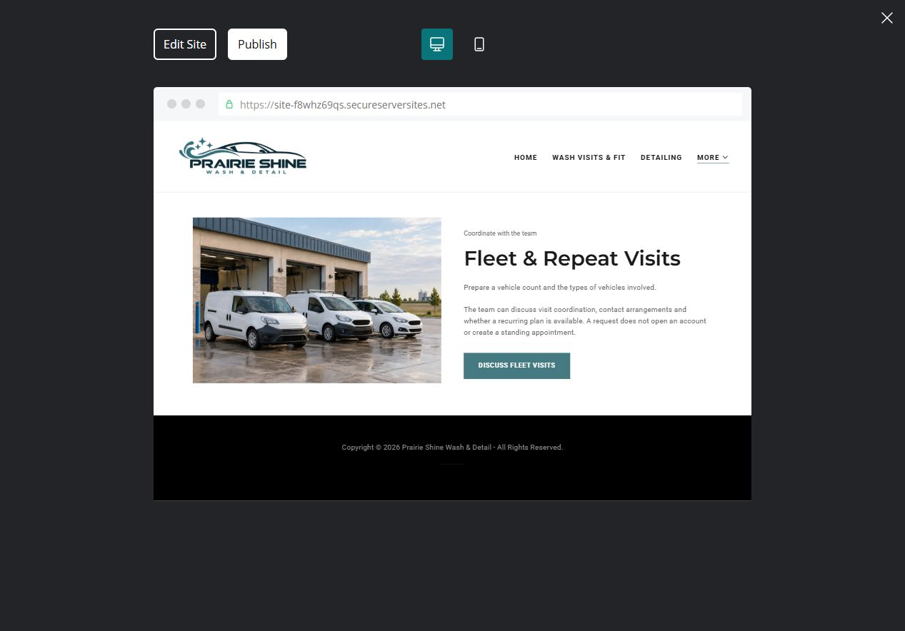
Actual desktop preview of the unpublished demonstration

Sample wording — adapt and verify
Fleet & Repeat Visits
Prepare a vehicle count and the types of vehicles involved.
The team can discuss visit coordination, contact arrangements and whether a recurring plan is available. A request does not open an account or create a standing appointment.
Suggested button: Discuss fleet visits

Website advice
Provide a distinct route for small business fleets, regular visits and coordination questions.

Your draft: Fleet & Repeat Visits
Write in the voice of your own business. Use facts you can verify, not promises copied from the example.

Headline and short introduction

Main content and details visitors need

Button wording and destination

Photo choice, permission and facts still to confirm
Partner check: can someone unfamiliar with the business find a useful next step?

05 Getting Ready for a Detail
Give this page one clear job in the customer journey.
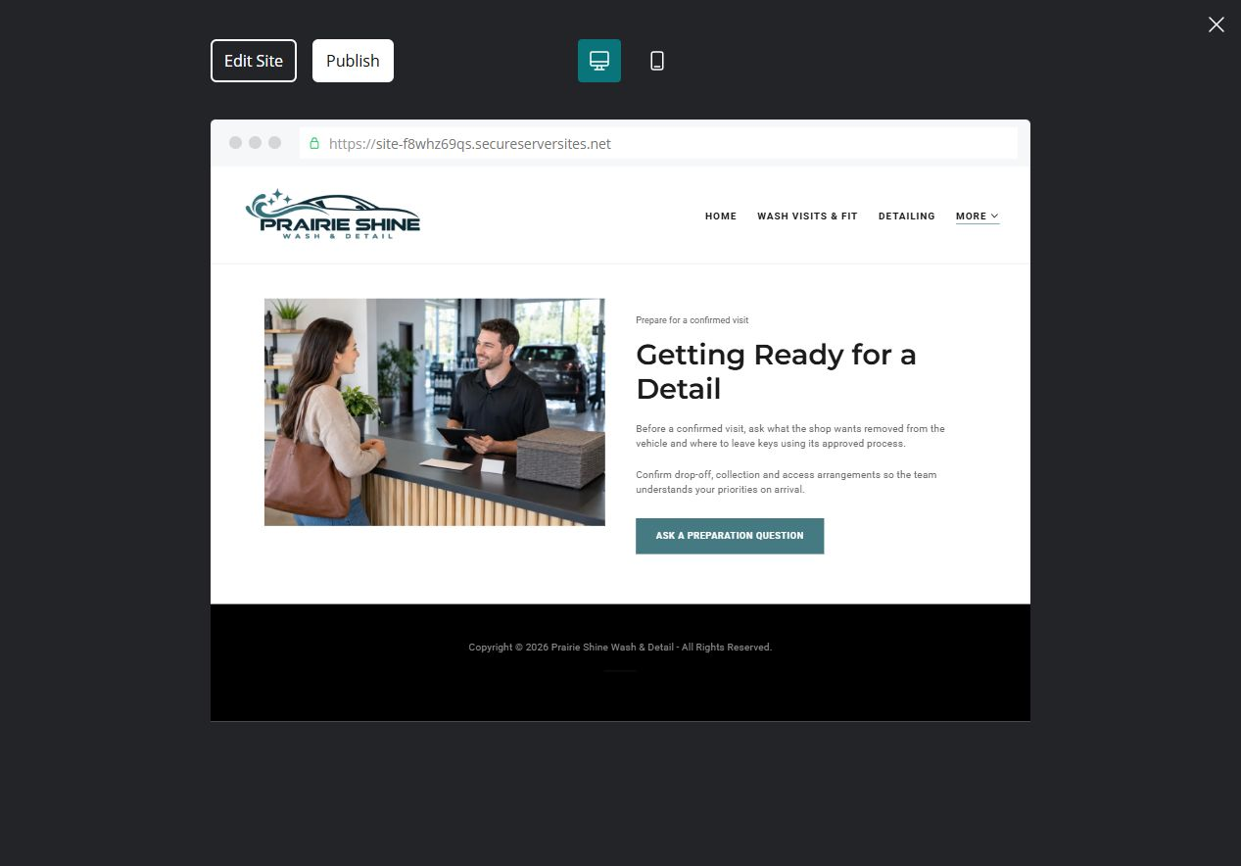
Actual desktop preview of the unpublished demonstration

Sample wording — adapt and verify
Getting Ready for a Detail
Before a confirmed visit, ask what the shop wants removed from the vehicle and where to leave keys using its approved process.
Confirm drop-off, collection and access arrangements so the team understands your priorities on arrival.
Suggested button: Ask a preparation question

Website advice
Publish only staff-approved arrival and personal-item guidance, keeping preparation separate from technical vehicle care.

Your draft: Getting Ready for a Detail
Write in the voice of your own business. Use facts you can verify, not promises copied from the example.

Headline and short introduction

Main content and details visitors need

Button wording and destination

Photo choice, permission and facts still to confirm
Partner check: can someone unfamiliar with the business find a useful next step?

06 Request & Confirm an Appointment
Give this page one clear job in the customer journey.
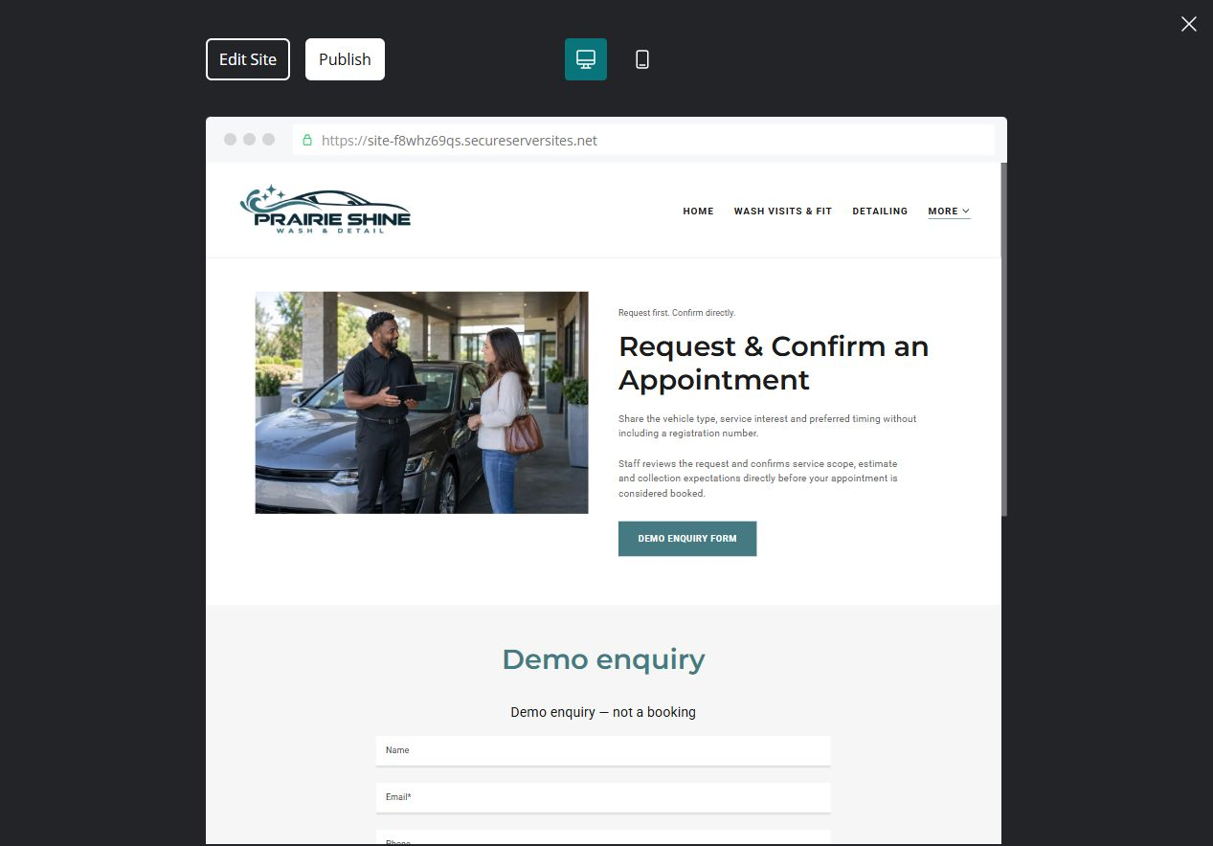
Actual desktop preview of the unpublished demonstration

Sample wording — adapt and verify
Request & Confirm an Appointment
Share the vehicle type, service interest and preferred timing without including a registration number.
Staff reviews the request and confirms the service scope, estimate and collection expectations directly before your appointment is considered booked.
Suggested button: Demo enquiry form

Website advice
Distinguish a general request from a confirmed booking and provide specific questions about vehicle condition and timing.

Your draft: Request & Confirm an Appointment
Write in the voice of your own business. Use facts you can verify, not promises copied from the example.

Headline and short introduction

Main content and details visitors need

Button wording and destination

Photo choice, permission and facts still to confirm
Partner check: can someone unfamiliar with the business find a useful next step?

Test before publishing
Review the whole journey on a desktop and phone. Confirm the form destination and delivery process before using it for real enquiries.
□ Fictional demonstration only. Verify packages, vehicle restrictions, finish suitability, prices and operating hours. Do not promise stain removal, paint correction results, protection duration or suitability for every vehicle.
□ Verify every service description, contact route and operating detail.
□ Replace fictional identity and example information before a live launch.
□ Test enquiries, links and downloads on desktop and mobile.
□ Keep confidential records in approved private systems.
□ Obtain operator approval for public wording and images.
□ Check every link, form destination, download and confirmation message.
□ Check logo contrast, hero framing, text sizes and image loading.
□ Save a named backup and assign a content-review date.

Changes to finish and person responsible

Approval and next review date
Website Builder plans and signup

