

Cabinetmakers & Custom Furniture Shops
Website workbook
A practical workshop for a 6-page website. Study the example, plan the content and draft your own version in Word or on paper.
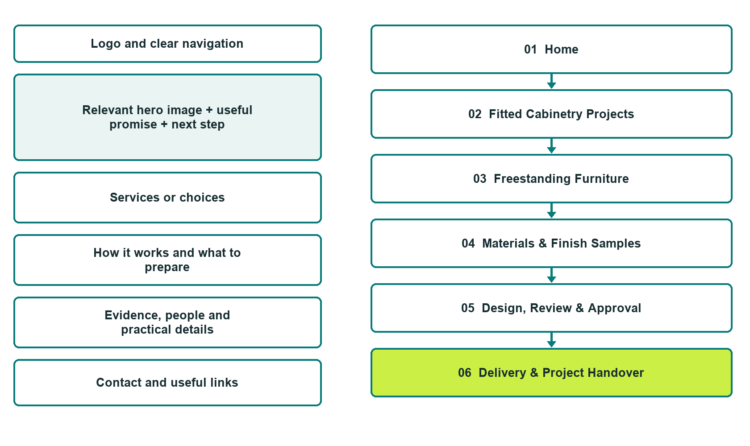

Plan → Draft → Build → Test
Website Builder capture edition: six actual desktop views from the fictional demo; the wireframe remains a planning illustration.
Explore Website Builder and compare plans

Before you build
Your business supplies the facts. Prairie Grain Cabinet & Furniture is a fictional teaching example, not a live service.

□ Start a project conversation
□ Verified business identity, services and current contact information
□ A clear enquiry, review and confirmation process
□ Choose original photographs and confirm permission to use them.
□ Keep private customer records out of public website forms.

Your audience and the action you want them to take

Facts to verify and people who must approve them
Create your SaaSTech account

01 Home
Give this page one clear job in the customer journey.
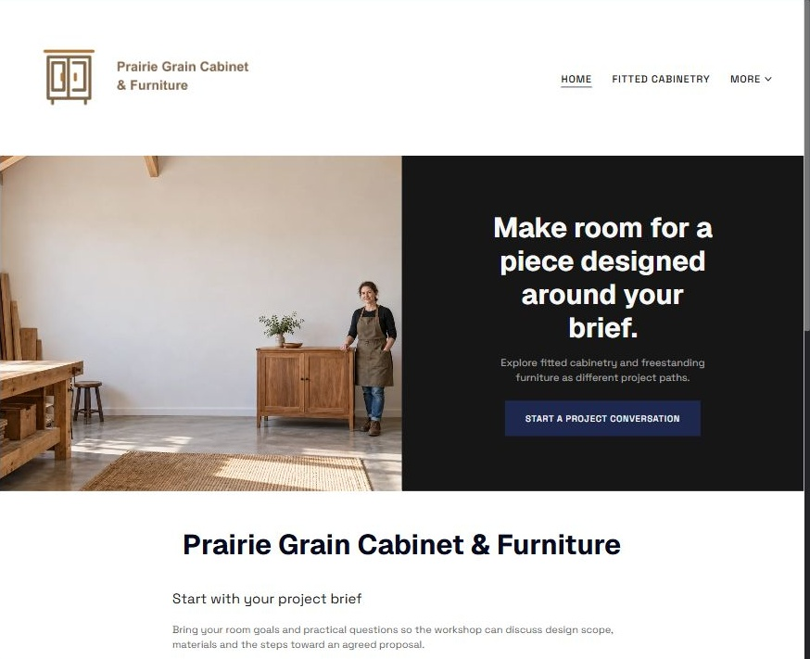
Actual Website Builder desktop capture from the fictional demo

Sample wording — adapt and verify
Make room for a piece designed around your brief.
Explore fitted cabinetry and freestanding furniture as different project paths.
Bring your room goals and practical questions so the workshop can discuss design scope, materials and the steps toward an agreed proposal.
Suggested button: Start a project conversation

Website advice
Separate fitted cabinetry from freestanding furniture, explain design review, materials, approval and installation or collection boundaries using permission-cleared examples.

Your draft: Home
Write in the voice of your own business. Use facts you can verify, not promises copied from the example.

Headline and short introduction

Main content and details visitors need

Button wording and destination

Photo choice, permission and facts still to confirm
Partner check: can someone unfamiliar with the business find a useful next step?

02 Fitted Cabinetry Projects
Give this page one clear job in the customer journey.
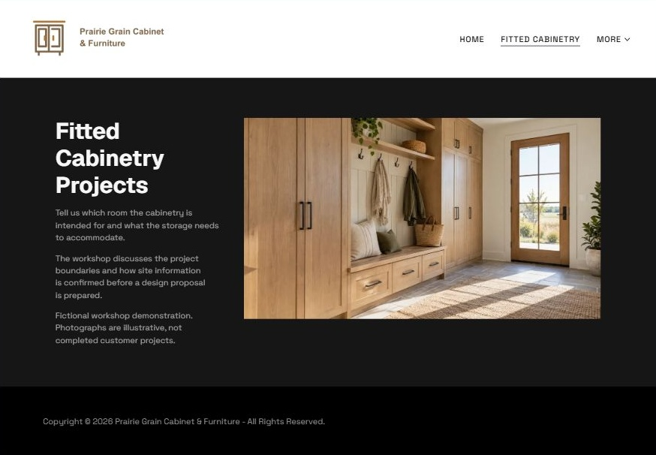
Actual Website Builder desktop capture from the fictional demo

Sample wording — adapt and verify
Fitted Cabinetry Projects
Tell us which room the cabinetry is intended for and what the storage needs to accommodate.
The workshop discusses the project boundaries and how site information is confirmed before a design proposal is prepared.
Suggested button: Start a project conversation

Website advice
Describe built-in storage and room projects without implying standard packages or structural capability.

Your draft: Fitted Cabinetry Projects
Write in the voice of your own business. Use facts you can verify, not promises copied from the example.

Headline and short introduction

Main content and details visitors need

Button wording and destination

Photo choice, permission and facts still to confirm
Partner check: can someone unfamiliar with the business find a useful next step?

03 Freestanding Furniture
Give this page one clear job in the customer journey.
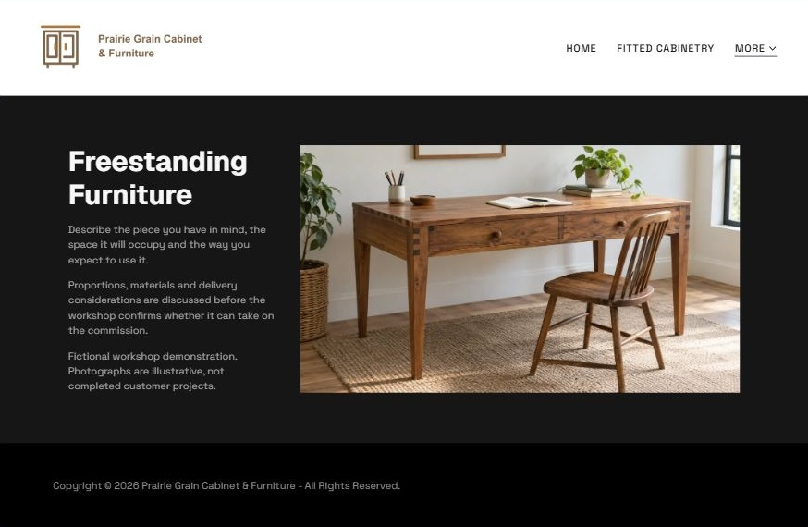
Actual Website Builder desktop capture from the fictional demo

Sample wording — adapt and verify
Freestanding Furniture
Describe the piece you have in mind, the space it will occupy and the way you expect to use it.
Proportions, materials and delivery considerations are discussed before the workshop confirms whether it can take on the commission.
Suggested button: Start a project conversation

Website advice
Give tables, desks and other movable pieces a separate commissioning journey from fitted work.

Your draft: Freestanding Furniture
Write in the voice of your own business. Use facts you can verify, not promises copied from the example.

Headline and short introduction

Main content and details visitors need

Button wording and destination

Photo choice, permission and facts still to confirm
Partner check: can someone unfamiliar with the business find a useful next step?

04 Materials & Finish Samples
Give this page one clear job in the customer journey.
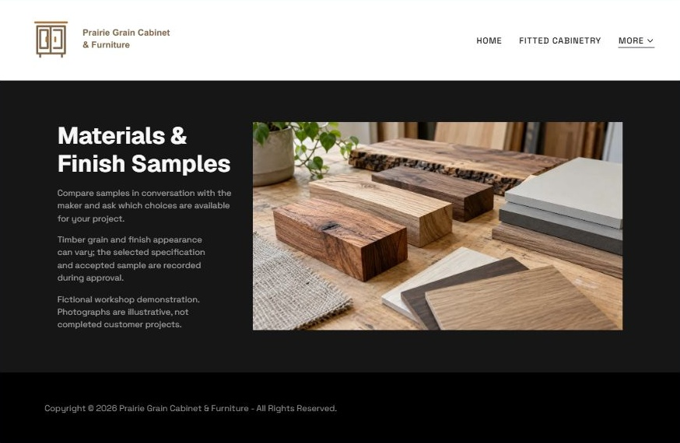
Actual Website Builder desktop capture from the fictional demo

Sample wording — adapt and verify
Materials & Finish Samples
Compare samples in conversation with the maker and ask which choices are available for your project.
Timber grain and finish appearance can vary; the selected specification and accepted sample are recorded during approval.
Suggested button: Start a project conversation

Website advice
Present reviewed samples and natural variation without promising identical outcomes or durability claims.

Your draft: Materials & Finish Samples
Write in the voice of your own business. Use facts you can verify, not promises copied from the example.

Headline and short introduction

Main content and details visitors need

Button wording and destination

Photo choice, permission and facts still to confirm
Partner check: can someone unfamiliar with the business find a useful next step?

05 Design, Review & Approval
Give this page one clear job in the customer journey.
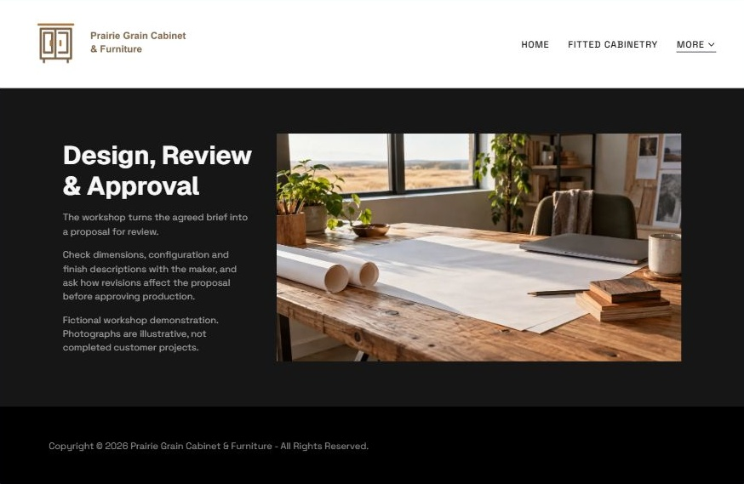
Actual Website Builder desktop capture from the fictional demo

Sample wording — adapt and verify
Design, Review & Approval
The workshop turns the agreed brief into a proposal for review.
Check dimensions, configuration and finish descriptions with the maker, and ask how revisions affect the proposal before approving production.
Suggested button: Start a project conversation

Website advice
Explain brief, drawing review, revisions and explicit approval without treating a web enquiry as a production order.

Your draft: Design, Review & Approval
Write in the voice of your own business. Use facts you can verify, not promises copied from the example.

Headline and short introduction

Main content and details visitors need

Button wording and destination

Photo choice, permission and facts still to confirm
Partner check: can someone unfamiliar with the business find a useful next step?

06 Delivery & Project Handover
Give this page one clear job in the customer journey.
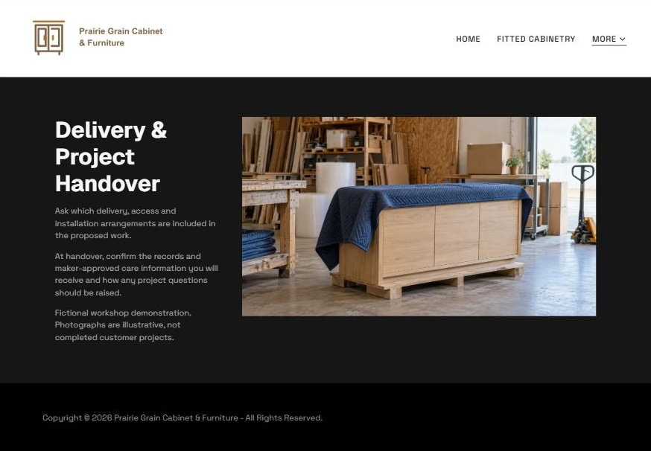
Actual Website Builder desktop capture from the fictional demo

Sample wording — adapt and verify
Delivery & Project Handover
Ask which delivery, access and installation arrangements are included in the proposed work.
At handover, confirm the records and maker-approved care information you will receive and how any project questions should be raised.
Suggested button: Start a project conversation

Website advice
Separate installation, delivery and collection responsibilities and include a clear snag or question route.

Your draft: Delivery & Project Handover
Write in the voice of your own business. Use facts you can verify, not promises copied from the example.

Headline and short introduction

Main content and details visitors need

Button wording and destination

Photo choice, permission and facts still to confirm
Partner check: can someone unfamiliar with the business find a useful next step?

Test before publishing
Review the whole journey on a desktop and phone. Use the genuine example captures to plan your own pages, then verify your finished website.
□ Fictional workshop demonstration. Portfolio images are illustrative, not completed customer projects. Verify material descriptions, design ownership, installation scope, lead times and terms; no engineering, structural or installation instructions are provided.
□ Verify every service description, contact route and operating detail.
□ Replace fictional identity and example information before a live launch.
□ Test enquiries, links and downloads on desktop and mobile.
□ Keep confidential records in approved private systems.
□ Obtain operator approval for public wording and images.
□ Check every link, form destination, download and confirmation message.
□ Check logo contrast, hero framing, text sizes and image loading.
□ Save a named backup and assign a content-review date.

Changes to finish and person responsible

Approval and next review date
Website Builder plans and signup

