

Butchers, Delis & Specialty Food Shops
Website workbook
A practical workshop for a 5-page website. Study the example, plan the content and draft your own version in Word or on paper.
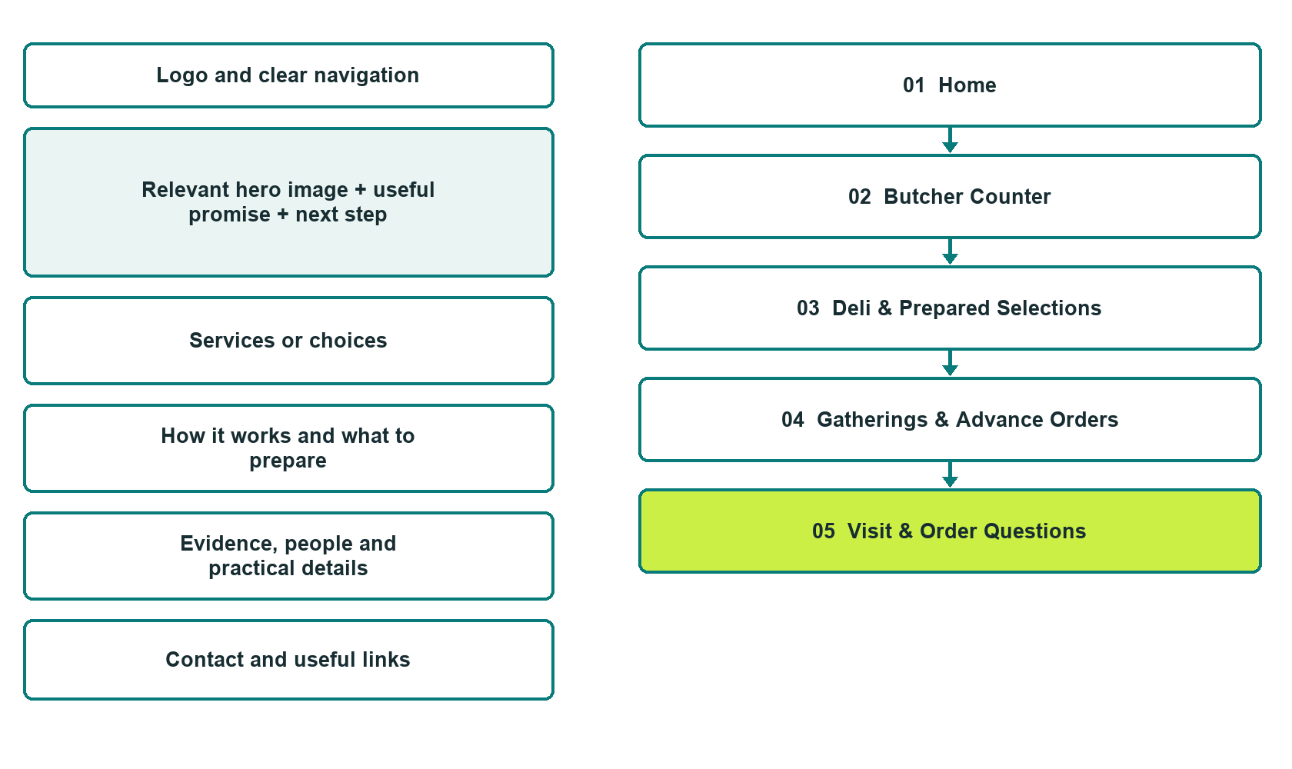

Plan → Draft → Build → Test
Captured demo edition. Study the unpublished five-page example, then draft your own verified content. Open the industry gallery for desktop and mobile previews.
Explore Website Builder and compare plans

Before you build
Your business supplies the facts. Prairie Board & Butcher is a fictional teaching example, not a live service.

□ Ask about counter selections or an order
□ Verified business identity, services and current contact information
□ A clear enquiry, review and confirmation process
□ Choose original photographs and confirm permission to use them.
□ Keep private customer records out of public website forms.

Your audience and the action you want them to take

Facts to verify and people who must approve them
Create your SaaSTech account

01 Home
Give this page one clear job in the customer journey.
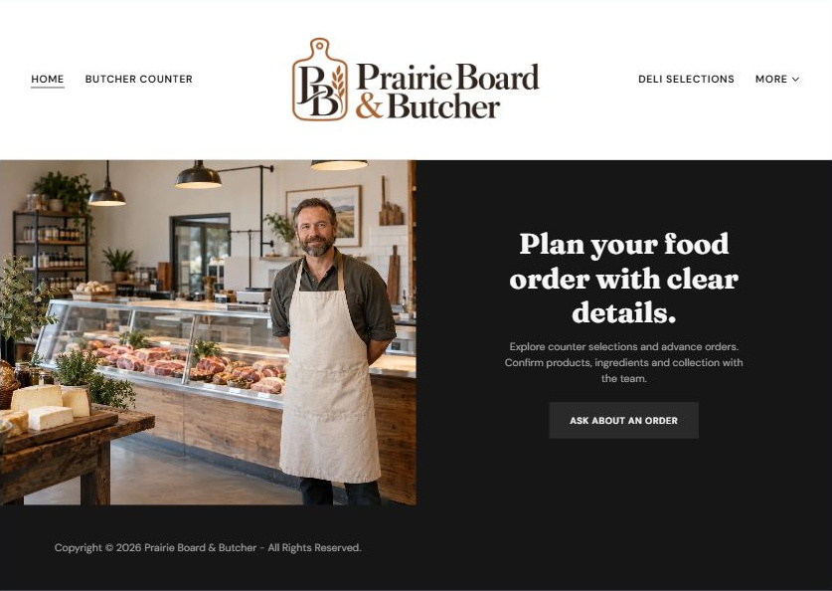
Actual desktop Website Builder preview. Open the industry gallery for its paired mobile view.

Sample wording — adapt and verify
Plan your food order with clear details.
Explore counter selections and advance orders. Confirm products, ingredients and collection with the team.
Choose the relevant page and use its enquiry link to discuss your next step.
Suggested button: Ask about an order

Website advice
Show product categories and explain order enquiries, lead-time review and collection confirmation without food-safety or allergen assumptions.

Your draft: Home
Write in the voice of your own business. Use facts you can verify, not promises copied from the example.

Headline and short introduction

Main content and details visitors need

Button wording and destination

Photo choice, permission and facts still to confirm
Partner check: can someone unfamiliar with the business find a useful next step?

02 Butcher Counter
Give this page one clear job in the customer journey.
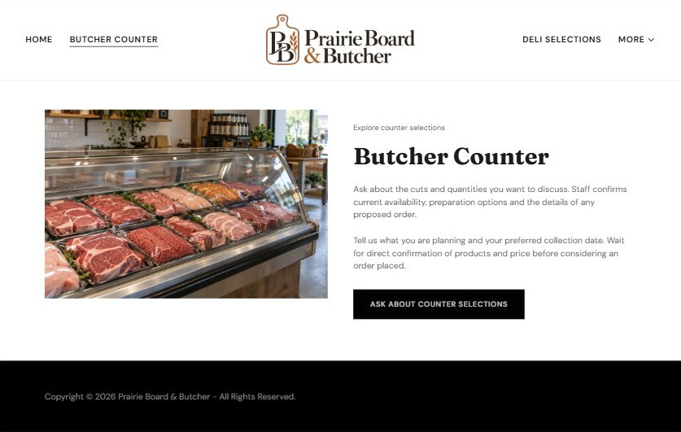
Actual desktop Website Builder preview. Open the industry gallery for its paired mobile view.

Sample wording — adapt and verify
Butcher Counter
Ask about the cuts and quantities you want to discuss. Staff confirms current availability, preparation options and the details of any proposed order.
Tell us what you are planning and your preferred collection date. Wait for direct confirmation of products and price before considering an order placed.
Suggested button: Ask about counter selections

Website advice
Show accurate product categories and operator-approved descriptions, not invented live inventory or sourcing claims.

Your draft: Butcher Counter
Write in the voice of your own business. Use facts you can verify, not promises copied from the example.

Headline and short introduction

Main content and details visitors need

Button wording and destination

Photo choice, permission and facts still to confirm
Partner check: can someone unfamiliar with the business find a useful next step?

03 Deli & Prepared Selections
Give this page one clear job in the customer journey.
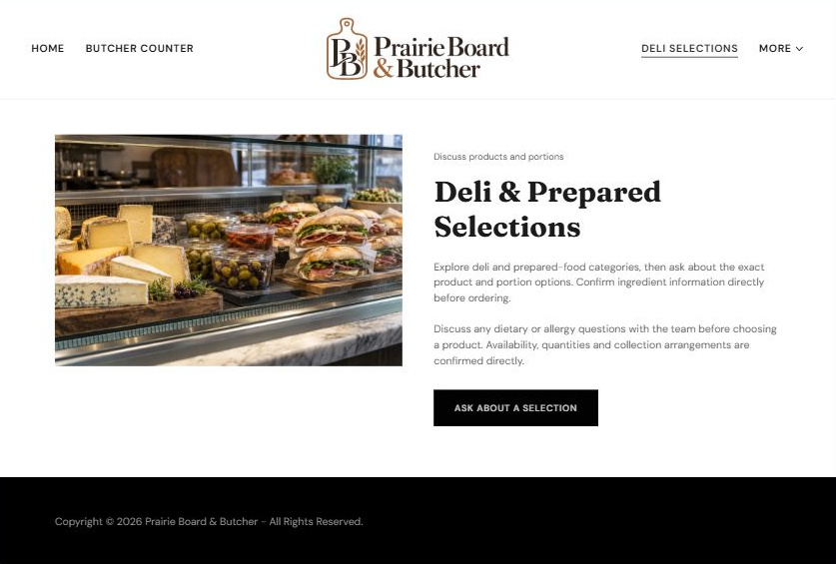
Actual desktop Website Builder preview. Open the industry gallery for its paired mobile view.

Sample wording — adapt and verify
Deli & Prepared Selections
Explore deli and prepared-food categories, then ask about the exact product and portion options. Confirm ingredient information directly before ordering.
Discuss any dietary or allergy questions with the team before choosing a product. Availability, quantities and collection arrangements are confirmed directly.
Suggested button: Ask about a selection

Website advice
Use distinct food imagery and make ingredient information product-specific and current.

Your draft: Deli & Prepared Selections
Write in the voice of your own business. Use facts you can verify, not promises copied from the example.

Headline and short introduction

Main content and details visitors need

Button wording and destination

Photo choice, permission and facts still to confirm
Partner check: can someone unfamiliar with the business find a useful next step?

04 Gatherings & Advance Orders
Give this page one clear job in the customer journey.
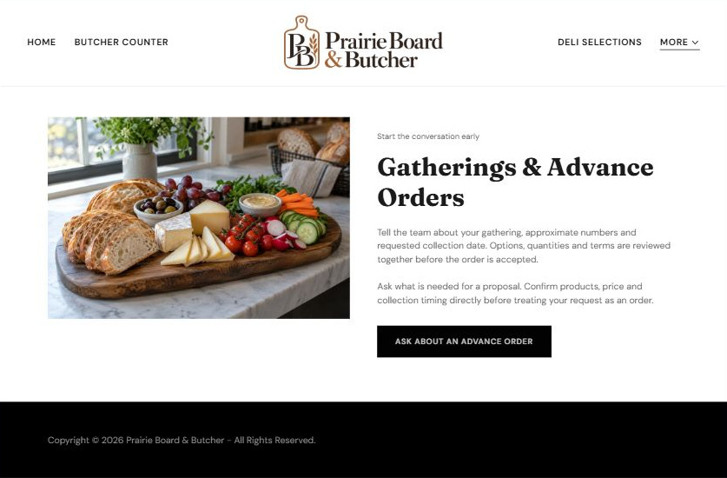
Actual desktop Website Builder preview. Open the industry gallery for its paired mobile view.

Sample wording — adapt and verify
Gatherings & Advance Orders
Tell the team about your gathering, approximate numbers and requested collection date. Options, quantities and terms are reviewed together before the order is accepted.
Ask what is needed for a proposal. Confirm products, price and collection timing directly before treating your request as an order.
Suggested button: Ask about an advance order

Website advice
Explain quantity discussion, requested date, quote and final confirmation without invented lead times.

Your draft: Gatherings & Advance Orders
Write in the voice of your own business. Use facts you can verify, not promises copied from the example.

Headline and short introduction

Main content and details visitors need

Button wording and destination

Photo choice, permission and facts still to confirm
Partner check: can someone unfamiliar with the business find a useful next step?

05 Visit & Order Questions
Give this page one clear job in the customer journey.
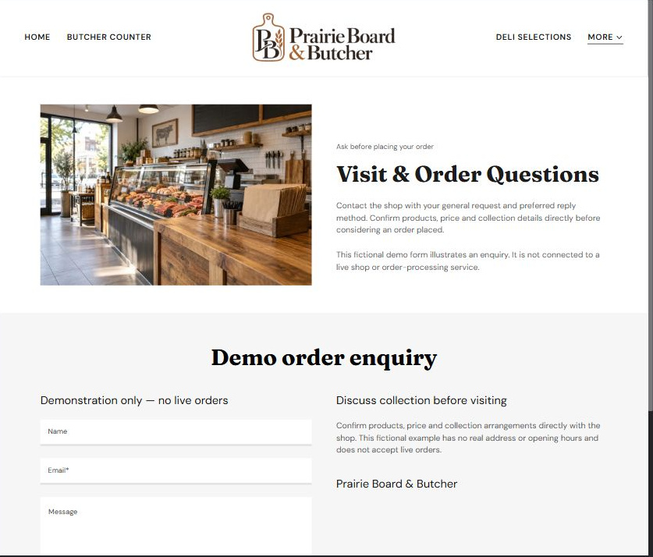
Actual desktop Website Builder preview. Open the industry gallery for its paired mobile view.

Sample wording — adapt and verify
Visit & Order Questions
Contact the shop with your general request and preferred reply method. Confirm products, price and collection details directly before considering an order placed.
This fictional demo form illustrates an enquiry. It is not connected to a live shop or order-processing service.
Suggested button: Demo enquiry form

Website advice
Separate an enquiry from an accepted order and explain how to obtain verified product guidance.

Your draft: Visit & Order Questions
Write in the voice of your own business. Use facts you can verify, not promises copied from the example.

Headline and short introduction

Main content and details visitors need

Button wording and destination

Photo choice, permission and facts still to confirm
Partner check: can someone unfamiliar with the business find a useful next step?

Test before publishing
Review the captured desktop and phone journey. The demo enquiry form has no live shop recipient and was not submitted. Verify and test approved delivery before a real launch.
□ Fictional demonstration only. Verify current products, ingredient information, handling guidance and fulfilment terms with the operator. No food-safety instructions or allergen-free guarantees are provided.
□ Verify each offered service, contact route, location and opening arrangement.
□ Remove fictional identity, claims, availability and prices before a real launch.
□ Test every enquiry route and download on desktop and mobile.
□ Keep sensitive information in approved private systems.
□ Obtain operator approval for all public wording and image use.
□ Check every link, form destination, download and confirmation message.
□ Check logo contrast, hero framing, text sizes and image loading.
□ Save a named backup and assign a content-review date.

Changes to finish and person responsible

Approval and next review date
Website Builder plans and signup

