

Breweries, Wineries & Distilleries
Website workbook
A practical workshop for a 6-page website. Study the example, plan the content and draft your own version in Word or on paper.
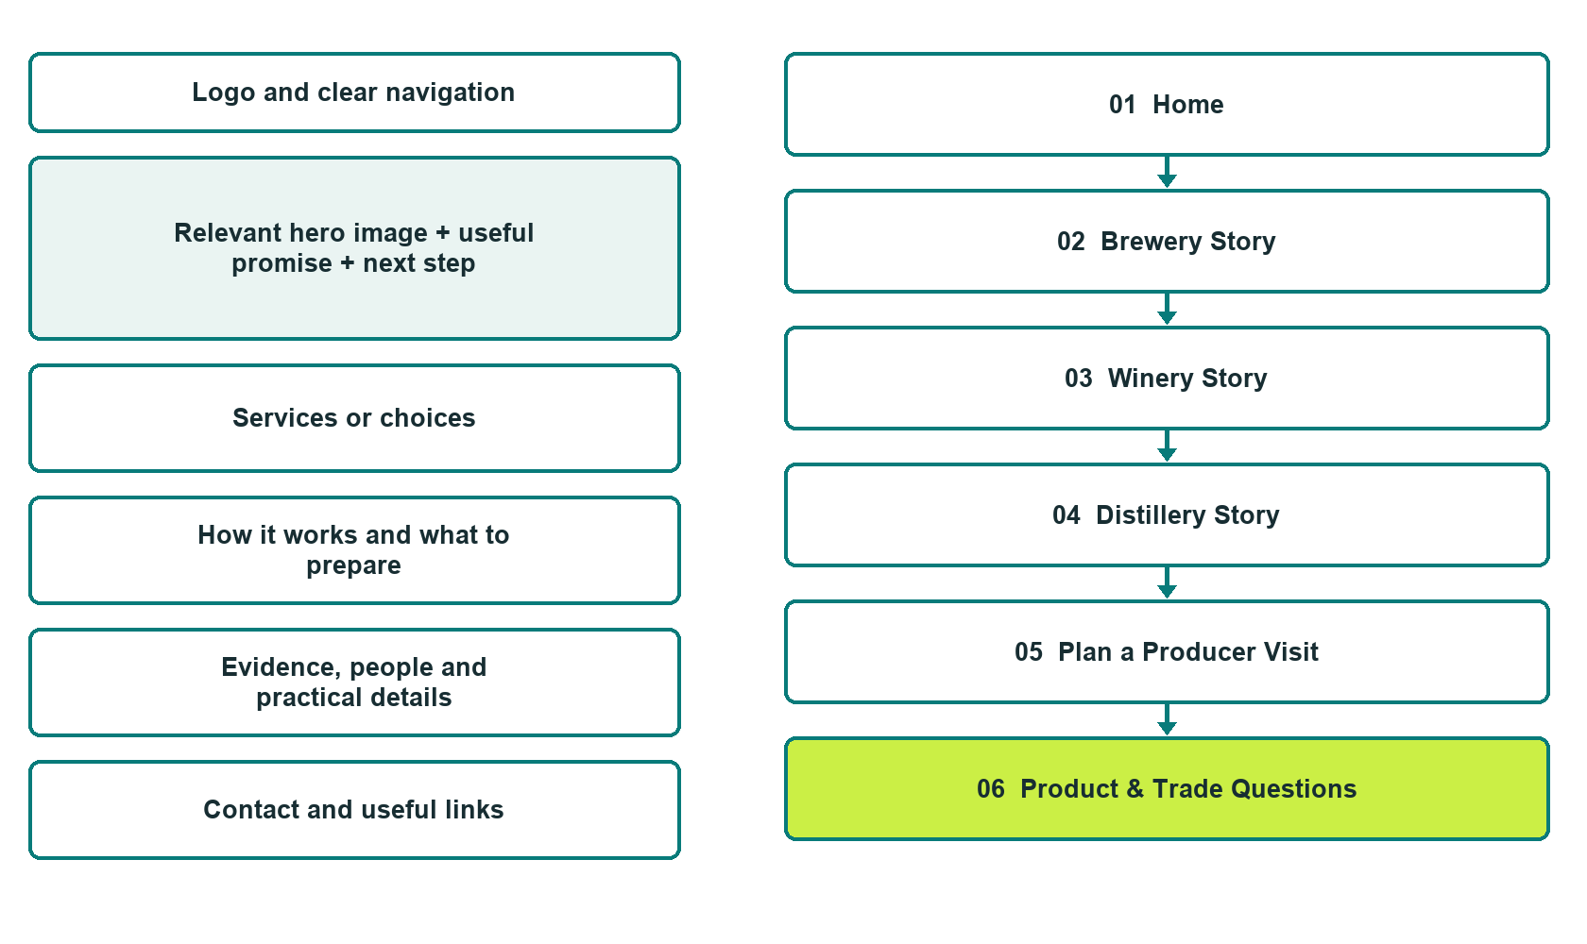

Plan → Draft → Build → Test
Captured demo edition. Study the unpublished six-page example, then draft your own verified content. Open the industry gallery for desktop and mobile previews.
Explore Website Builder and compare plans

Before you build
Your business supplies the facts. Prairie Field & Cask is a fictional teaching example, not a live service.
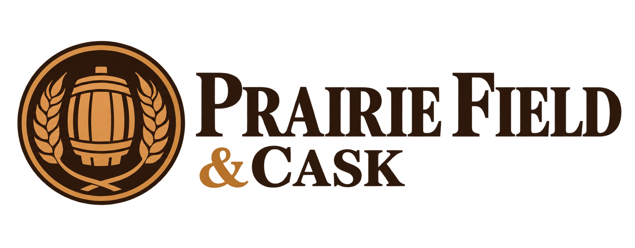
□ Ask about the producer or a visit
□ Verified business identity, services and current contact information
□ A clear enquiry, review and confirmation process
□ Choose original photographs and confirm permission to use them.
□ Keep private customer records out of public website forms.

Your audience and the action you want them to take

Facts to verify and people who must approve them
Create your SaaSTech account

01 Home
Give this page one clear job in the customer journey.
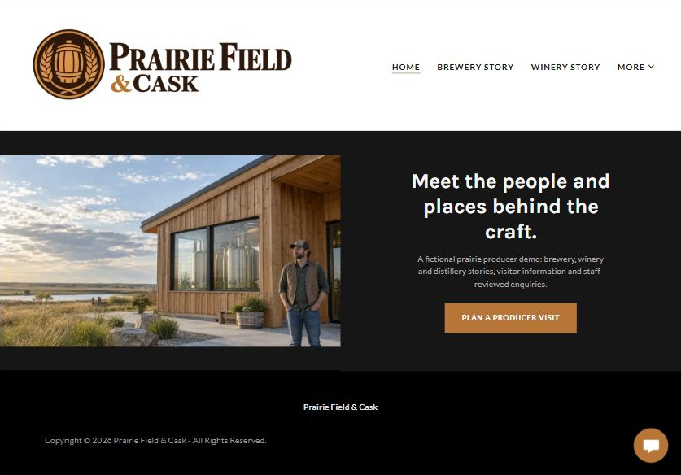
Actual desktop Website Builder preview. Open the industry gallery for its paired mobile view.

Sample wording — adapt and verify
Meet the people and places behind the craft.
Explore three distinct production stories and the questions to ask before planning a visit.
Visitor access and any product enquiry are confirmed directly by the producer, not by this demonstration.
Suggested button: Plan a Producer Visit

Website advice
Keep brewery, winery and distillery stories distinct, with operator-reviewed visitor information and product enquiries rather than implied online alcohol sales.

Your draft: Home
Write in the voice of your own business. Use facts you can verify, not promises copied from the example.

Headline and short introduction

Main content and details visitors need

Button wording and destination

Photo choice, permission and facts still to confirm
Partner check: can someone unfamiliar with the business find a useful next step?

02 Brewery Story
Give this page one clear job in the customer journey.
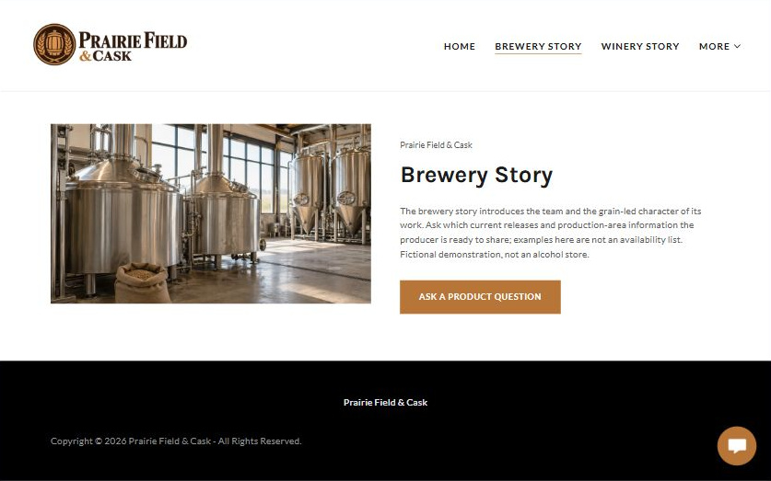
Actual desktop Website Builder preview. Open the industry gallery for its paired mobile view.

Sample wording — adapt and verify
Brewery Story
The brewery story introduces the team and the grain-led character of its work.
Ask which current releases and production-area information the producer is ready to share; examples here are not an availability list.
Suggested button: Ask a Product Question

Website advice
Explain the brewing business through verified people, ingredients and facility photographs, without instructional production content.

Your draft: Brewery Story
Write in the voice of your own business. Use facts you can verify, not promises copied from the example.

Headline and short introduction

Main content and details visitors need

Button wording and destination

Photo choice, permission and facts still to confirm
Partner check: can someone unfamiliar with the business find a useful next step?

03 Winery Story
Give this page one clear job in the customer journey.
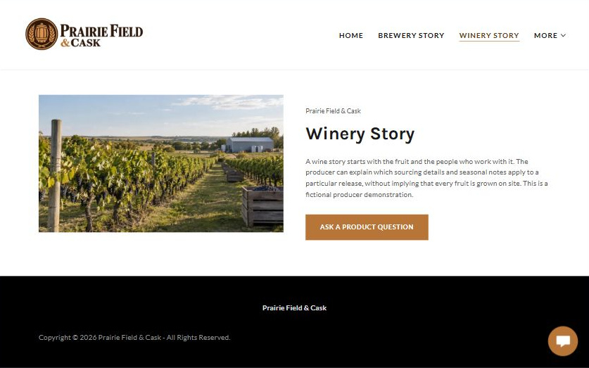
Actual desktop Website Builder preview. Open the industry gallery for its paired mobile view.

Sample wording — adapt and verify
Winery Story
A wine story starts with the fruit and the people who work with it.
The producer can explain which sourcing details and seasonal notes apply to a particular release, without implying that every fruit is grown on site.
Suggested button: Ask a Product Question

Website advice
Give the winery its own origin and growing-region narrative rather than reusing brewery terminology.

Your draft: Winery Story
Write in the voice of your own business. Use facts you can verify, not promises copied from the example.

Headline and short introduction

Main content and details visitors need

Button wording and destination

Photo choice, permission and facts still to confirm
Partner check: can someone unfamiliar with the business find a useful next step?

04 Distillery Story
Give this page one clear job in the customer journey.
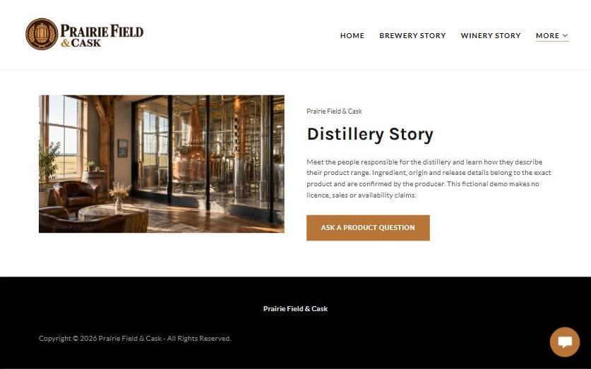
Actual desktop Website Builder preview. Open the industry gallery for its paired mobile view.

Sample wording — adapt and verify
Distillery Story
Meet the people responsible for the distillery and learn how they describe their product range.
Ingredient, origin and release details belong to the exact product and are confirmed by the producer.
Suggested button: Ask a Product Question

Website advice
Separate distilled-product information from brewing and wine content; keep descriptions factual and reviewed.

Your draft: Distillery Story
Write in the voice of your own business. Use facts you can verify, not promises copied from the example.

Headline and short introduction

Main content and details visitors need

Button wording and destination

Photo choice, permission and facts still to confirm
Partner check: can someone unfamiliar with the business find a useful next step?

05 Plan a Producer Visit
Give this page one clear job in the customer journey.
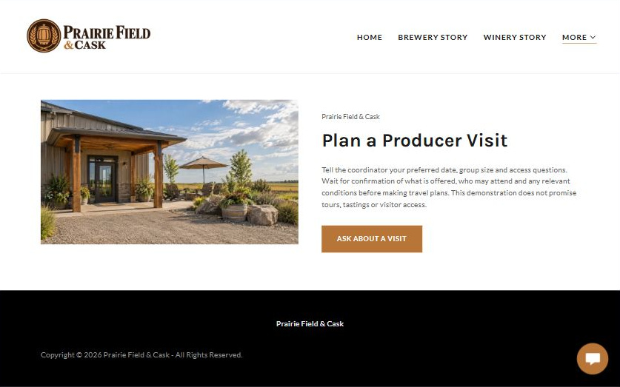
Actual desktop Website Builder preview. Open the industry gallery for its paired mobile view.

Sample wording — adapt and verify
Plan a Producer Visit
Tell the coordinator your preferred date, group size and access questions.
Wait for confirmation of what is offered, who may attend and any relevant conditions before making travel plans.
Suggested button: Ask About a Visit

Website advice
Explain enquiries about visitor access, group size, accessibility and confirmed activities without promising tours or tastings.

Your draft: Plan a Producer Visit
Write in the voice of your own business. Use facts you can verify, not promises copied from the example.

Headline and short introduction

Main content and details visitors need

Button wording and destination

Photo choice, permission and facts still to confirm
Partner check: can someone unfamiliar with the business find a useful next step?

06 Product & Trade Questions
Give this page one clear job in the customer journey.
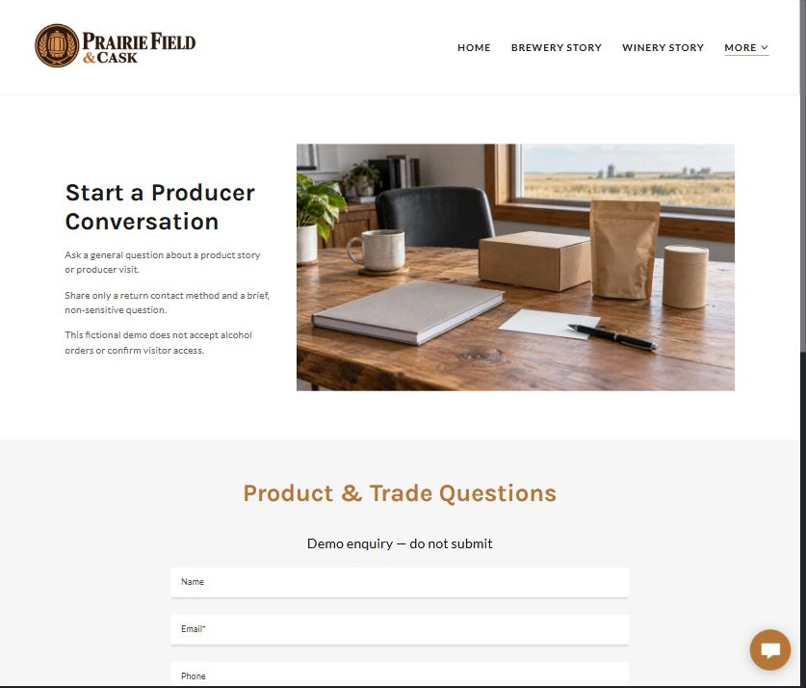
Actual desktop Website Builder preview. Open the industry gallery for its paired mobile view.

Sample wording — adapt and verify
Product & Trade Questions
Identify the product or business topic you wish to discuss and provide a reply method.
Staff confirms whether the enquiry can proceed and which verified information applies; this form does not place an order.
Suggested button: Demo enquiry form

Website advice
Route general consumer and business questions separately without checkout, order acceptance or wholesale eligibility claims.

Your draft: Product & Trade Questions
Write in the voice of your own business. Use facts you can verify, not promises copied from the example.

Headline and short introduction

Main content and details visitors need

Button wording and destination

Photo choice, permission and facts still to confirm
Partner check: can someone unfamiliar with the business find a useful next step?

Test before publishing
Review the captured desktop and phone journey. Confirm every enquiry destination and test approved delivery before a live launch. The demonstration is unpublished.
□ Fictional producer demonstration. No alcohol sales, shipment, tasting availability or licence claims are made. Verify applicable age requirements, permissions, visitor arrangements and every product description before launch; do not present alcohol as a health benefit.
□ Verify every service description, contact route and operating detail.
□ Replace fictional identity and example information before a live launch.
□ Test enquiries, links and downloads on desktop and mobile.
□ Keep confidential records in approved private systems.
□ Obtain operator approval for public wording and images.
□ Check every link, form destination, download and confirmation message.
□ Check logo contrast, hero framing, text sizes and image loading.
□ Save a named backup and assign a content-review date.

Changes to finish and person responsible

Approval and next review date
Website Builder plans and signup

