

Bicycle, Motorcycle & Powersports Shops
Website workbook
A practical workshop for a 6-page website. Study the example, plan the content and draft your own version in Word or on paper.
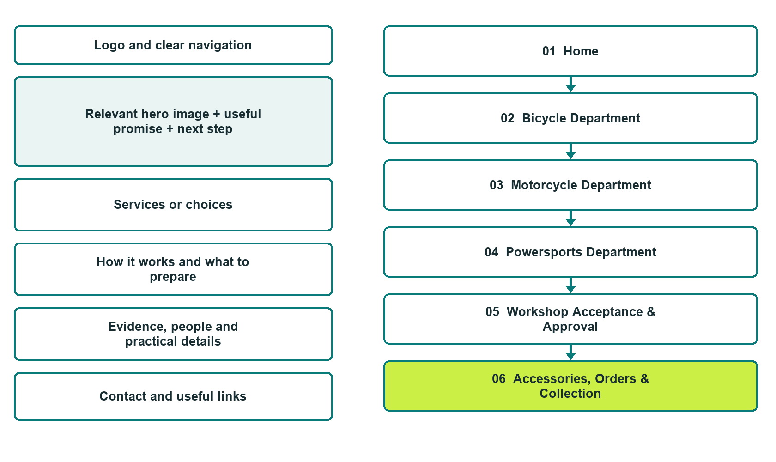

Plan → Draft → Build → Test
Captured demo edition. Study the unpublished six-page example, then draft your own verified content. Open the industry gallery for desktop and mobile previews.
Explore Website Builder and compare plans

Before you build
Your business supplies the facts. Prairie Crossroads Cycle & Recreation is a fictional teaching example, not a live service.

□ Choose a vehicle or service enquiry
□ Verified business identity, services and current contact information
□ A clear enquiry, review and confirmation process
□ Choose original photographs and confirm permission to use them.
□ Keep private customer records out of public website forms.

Your audience and the action you want them to take

Facts to verify and people who must approve them
Create your SaaSTech account

01 Home
Give this page one clear job in the customer journey.
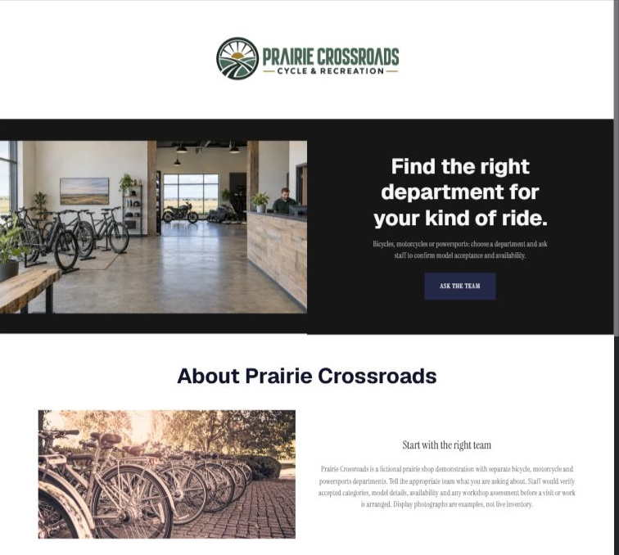
Actual desktop Website Builder preview. Open the industry gallery for its paired mobile view.

Sample wording — adapt and verify
Find the right department for your kind of ride.
Select bicycles, motorcycles or powersports to start with the appropriate team.
Describe your product or service question so staff can confirm whether the category and model fall within the shop scope.
Suggested button: Choose a vehicle or service enquiry

Website advice
Separate bicycles, motorcycles and powersports categories, identify verified sales and service capabilities and make model acceptance and appointment arrangements subject to staff review.

Your draft: Home
Write in the voice of your own business. Use facts you can verify, not promises copied from the example.

Headline and short introduction

Main content and details visitors need

Button wording and destination

Photo choice, permission and facts still to confirm
Partner check: can someone unfamiliar with the business find a useful next step?

02 Bicycle Department
Give this page one clear job in the customer journey.
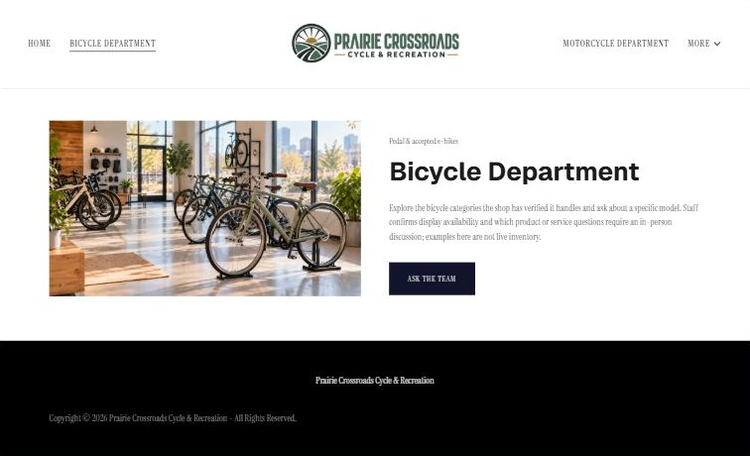
Actual desktop Website Builder preview. Open the industry gallery for its paired mobile view.

Sample wording — adapt and verify
Bicycle Department
Explore the bicycle categories the shop has verified it handles and ask about a specific model.
Staff confirms display availability and which product or service questions require an in-person discussion; examples here are not live inventory.
Suggested button: Choose a vehicle or service enquiry

Website advice
Keep pedal and accepted electric-bicycle product enquiries distinct from motor-vehicle sales and service.

Your draft: Bicycle Department
Write in the voice of your own business. Use facts you can verify, not promises copied from the example.

Headline and short introduction

Main content and details visitors need

Button wording and destination

Photo choice, permission and facts still to confirm
Partner check: can someone unfamiliar with the business find a useful next step?

03 Motorcycle Department
Give this page one clear job in the customer journey.
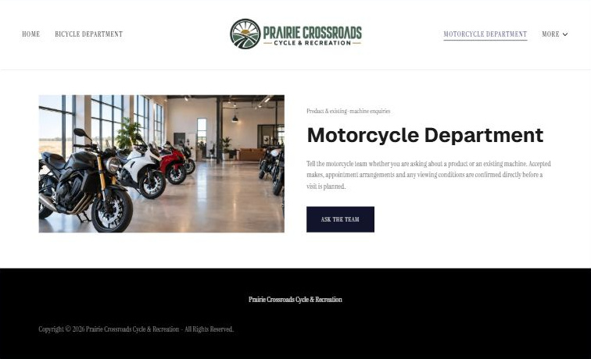
Actual desktop Website Builder preview. Open the industry gallery for its paired mobile view.

Sample wording — adapt and verify
Motorcycle Department
Tell the motorcycle team whether you are asking about a product or an existing machine.
Accepted makes, appointment arrangements and any viewing conditions are confirmed directly before a visit is planned.
Suggested button: Choose a vehicle or service enquiry

Website advice
Provide a separate motorcycle route without assumptions about brand authorization, licence requirements or test rides.

Your draft: Motorcycle Department
Write in the voice of your own business. Use facts you can verify, not promises copied from the example.

Headline and short introduction

Main content and details visitors need

Button wording and destination

Photo choice, permission and facts still to confirm
Partner check: can someone unfamiliar with the business find a useful next step?

04 Powersports Department
Give this page one clear job in the customer journey.
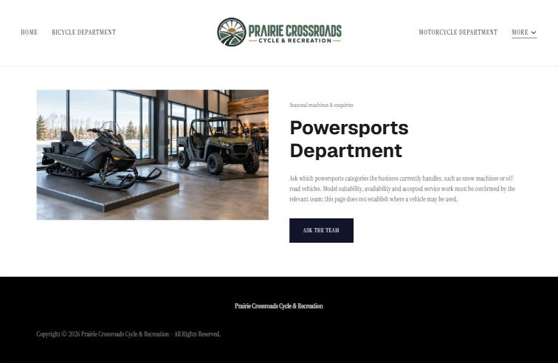
Actual desktop Website Builder preview. Open the industry gallery for its paired mobile view.

Sample wording — adapt and verify
Powersports Department
Ask which powersports categories the business currently handles, such as snow machines or off-road vehicles.
Model suitability, availability and accepted service work must be confirmed by the relevant team; the page does not establish where a vehicle may be used.
Suggested button: Choose a vehicle or service enquiry

Website advice
Distinguish recreational machine categories and seasonal enquiries from bicycles and road motorcycles.

Your draft: Powersports Department
Write in the voice of your own business. Use facts you can verify, not promises copied from the example.

Headline and short introduction

Main content and details visitors need

Button wording and destination

Photo choice, permission and facts still to confirm
Partner check: can someone unfamiliar with the business find a useful next step?

05 Workshop Acceptance & Approval
Give this page one clear job in the customer journey.
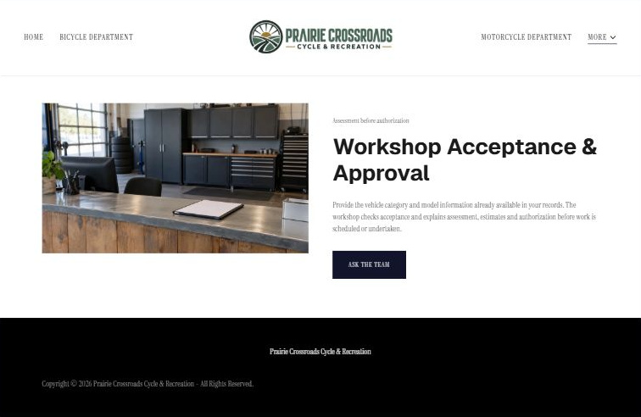
Actual desktop Website Builder preview. Open the industry gallery for its paired mobile view.

Sample wording — adapt and verify
Workshop Acceptance & Approval
Provide the vehicle category and model information already available in your records.
The workshop checks acceptance and explains assessment, estimates and authorization before work is scheduled or undertaken.
Suggested button: Choose a vehicle or service enquiry

Website advice
Explain model checks, service intake and explicit authorization without technical repair or seasonal-preparation instructions.

Your draft: Workshop Acceptance & Approval
Write in the voice of your own business. Use facts you can verify, not promises copied from the example.

Headline and short introduction

Main content and details visitors need

Button wording and destination

Photo choice, permission and facts still to confirm
Partner check: can someone unfamiliar with the business find a useful next step?

06 Accessories, Orders & Collection
Give this page one clear job in the customer journey.
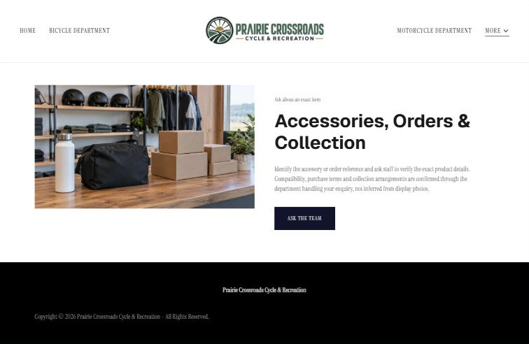
Actual desktop Website Builder preview. Open the industry gallery for its paired mobile view.

Sample wording — adapt and verify
Accessories, Orders & Collection
Identify the accessory or order reference and ask staff to verify the exact product details.
Compatibility, purchase terms and collection arrangements are confirmed through the department handling your enquiry, not inferred from display photos.
Suggested button: Choose a vehicle or service enquiry

Website advice
Make accessory compatibility and order status item-specific and avoid product-fit or protective-performance advice.

Your draft: Accessories, Orders & Collection
Write in the voice of your own business. Use facts you can verify, not promises copied from the example.

Headline and short introduction

Main content and details visitors need

Button wording and destination

Photo choice, permission and facts still to confirm
Partner check: can someone unfamiliar with the business find a useful next step?

Test before publishing
Review the captured desktop and phone journey. Confirm every enquiry destination and test approved delivery before a live launch. The demonstration is unpublished.
□ Fictional retailer demonstration. Do not imply every shop serves all three categories. Verify vehicle specifications, service qualifications, inventory and purchase terms; no riding, repair, road-use, licensing, safety or equipment-fit advice is provided. No finance approval or trail access is promised.
□ Verify every service description, contact route and operating detail.
□ Replace fictional identity and example information before a live launch.
□ Test enquiries, links and downloads on desktop and mobile.
□ Keep confidential records in approved private systems.
□ Obtain operator approval for public wording and images.
□ Check every link, form destination, download and confirmation message.
□ Check logo contrast, hero framing, text sizes and image loading.
□ Save a named backup and assign a content-review date.

Changes to finish and person responsible

Approval and next review date
Website Builder plans and signup

