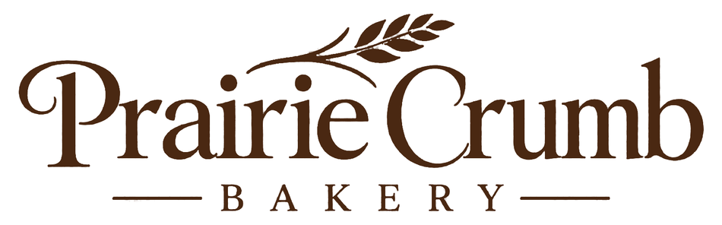

Custom cake enquiry checklist
Prairie Crumb Bakery
Complete the response areas in Word, or print and write in the spaces provided.

Order details
Customer reference

Occasion, date and pickup window

Servings, flavour and filling

Design and dietary discussion
[ ] Record design references and permission to use them.
[ ] Discuss allergens and cross-contact using the bakery’s approved wording.
[ ] Confirm storage, transport and serving instructions.

Confirmation
[ ] Confirm feasibility and final price before accepting the order.
[ ] Share the approved deposit and cancellation terms.
Next action and owner

