

Auto Body & Collision Repair
Website workbook
A practical workshop for a 5-page website. Study the example, plan the content and draft your own version in Word or on paper.
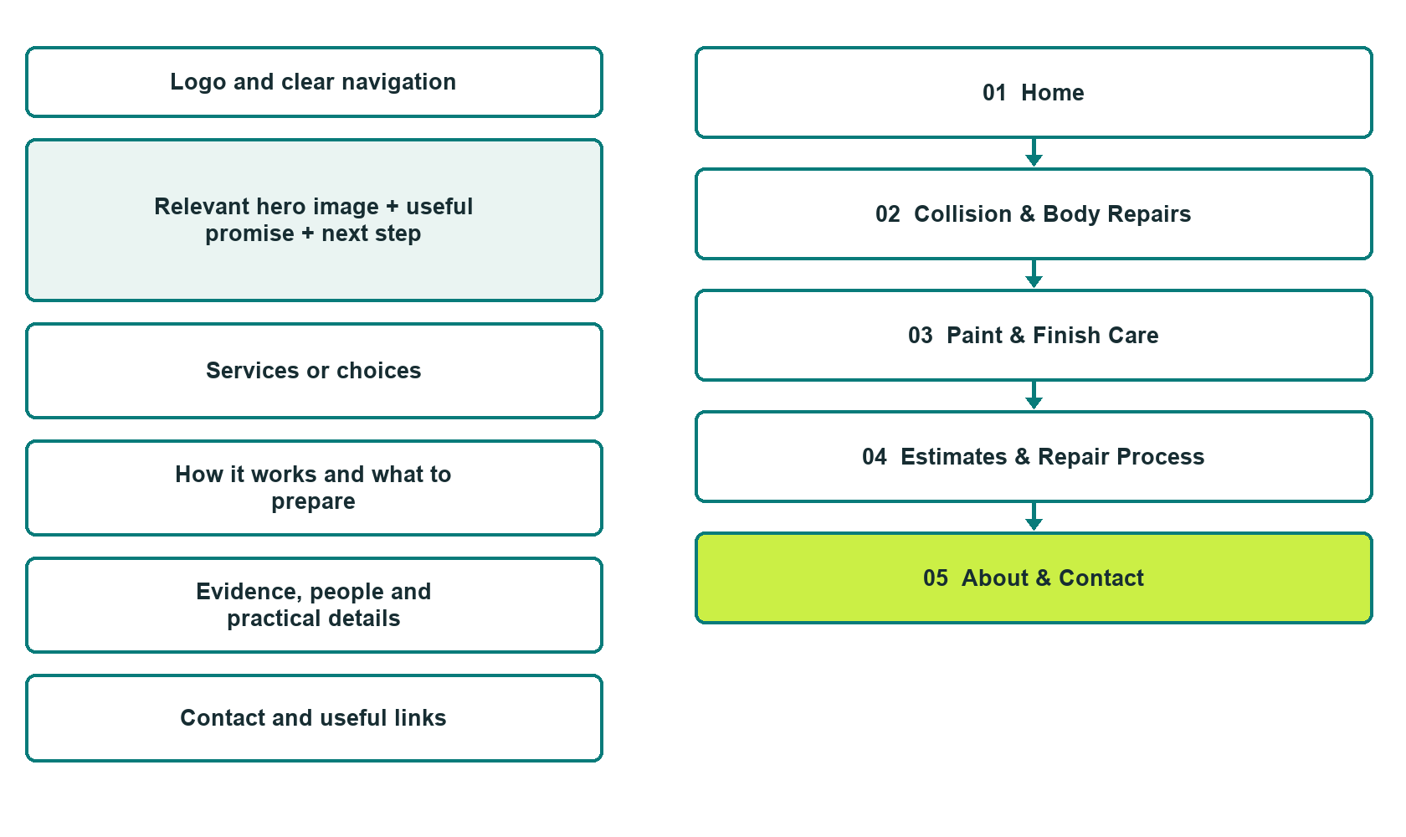

Plan → Draft → Build → Test
Captured demo edition. Study the unpublished five-page example, then draft your own verified content. Paired desktop and mobile previews, Editor Highlights, Themes and Paint appear in the industry gallery.
Explore Website Builder and compare plans

Before you build
Your business supplies the facts. Prairie Restore Auto Body is a fictional teaching example, not a live service.

□ Request a repair assessment discussion
□ Verified shop identity, contact details and current service scope
□ Clear assessment, estimate and customer-authorization process
□ Choose original photographs and confirm permission to use them.
□ Keep private customer records out of public website forms.

Your audience and the action you want them to take

Facts to verify and people who must approve them
Create your SaaSTech account

01 Home
Give this page one clear job in the customer journey.
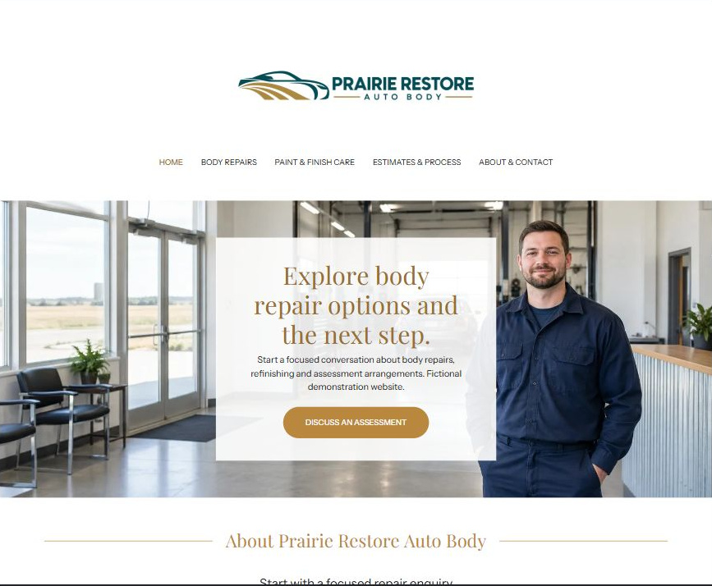
Actual desktop Website Builder preview. The paired mobile view appears in the industry gallery.

Sample wording — adapt and verify
Explore body repair options and the next step.
Explore the types of body-repair and finish enquiries our team can discuss. Tell us the general concern and how to contact you so we can explain how a repair assessment is arranged.
The team confirms the next step directly. Sending an enquiry does not produce a price, approve an insurance claim or authorize a repair.
Home button: Discuss an assessment opens the general enquiry form

Website advice
Explain verified collision and body-repair services, finish-related enquiries and the assessment process. Separate an enquiry from an estimate, insurer decision, repair authorization or confirmed appointment.

Your draft: Home
Write in the voice of your own business. Use facts you can verify, not promises copied from the example.

Headline and short introduction

Main content and details visitors need

Button wording and destination

Photo choice, permission and facts still to confirm
Partner check: can someone unfamiliar with the business find a useful next step?

02 Collision & Body Repairs
Give this page one clear job in the customer journey.
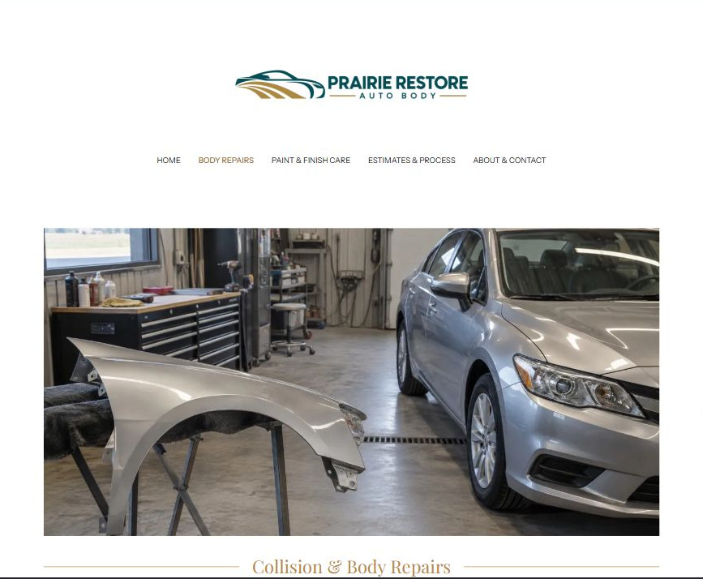
Actual desktop Website Builder preview. The paired mobile view appears in the industry gallery.

Sample wording — adapt and verify
Discuss the bodywork your vehicle may need.
Ask about the types of collision and body-repair work the shop accepts. A direct assessment helps the team explain the proposed scope and any questions that need further review.
Confirm how the vehicle should be presented for assessment with the shop. Website images and a general enquiry cannot establish repairability or roadworthiness.
Suggested button: Ask about a body-repair assessment

Website advice
Describe only operator-verified repair categories and vehicle acceptance criteria. Explain that assessment determines the proposed scope; do not promise repairability, safety certification or a particular result.

Your draft: Collision & Body Repairs
Write in the voice of your own business. Use facts you can verify, not promises copied from the example.

Headline and short introduction

Main content and details visitors need

Button wording and destination

Photo choice, permission and facts still to confirm
Partner check: can someone unfamiliar with the business find a useful next step?

03 Paint & Finish Care
Give this page one clear job in the customer journey.
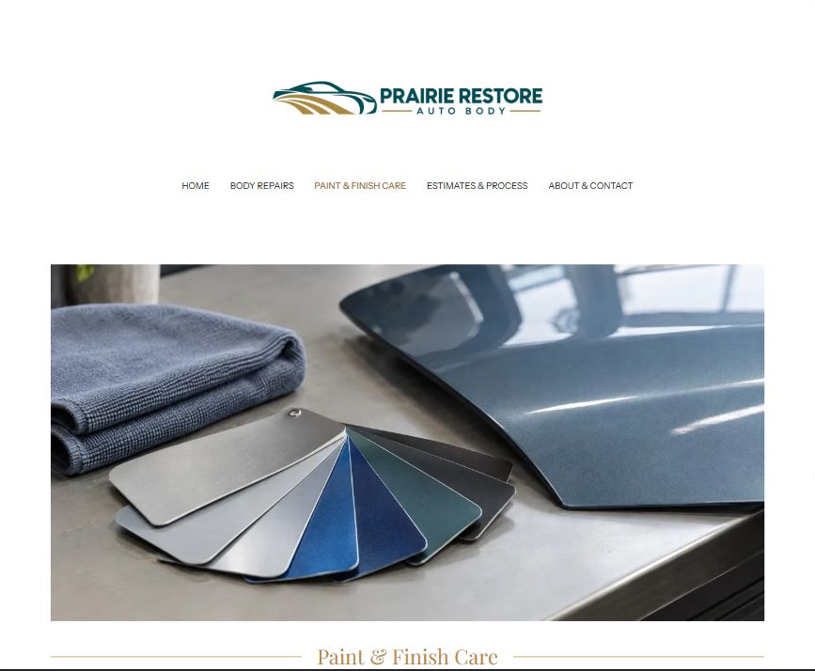
Actual desktop Website Builder preview. The paired mobile view appears in the industry gallery.

Sample wording — adapt and verify
Ask about refinishing and finish-care options.
Describe the finish concern you would like the team to review. The shop explains which services it offers and what must be assessed before a proposal is prepared.
Ask the team which care information applies to your completed work. Finish options, colour expectations and any warranty terms are discussed and confirmed separately.
Suggested button: Discuss a finish enquiry

Website advice
Explain verified refinishing or finish-care services in plain language. Use original example imagery without before-and-after claims. Publish only operator-approved care instructions, warranty wording and limitations.

Your draft: Paint & Finish Care
Write in the voice of your own business. Use facts you can verify, not promises copied from the example.

Headline and short introduction

Main content and details visitors need

Button wording and destination

Photo choice, permission and facts still to confirm
Partner check: can someone unfamiliar with the business find a useful next step?

04 Estimates & Repair Process
Give this page one clear job in the customer journey.
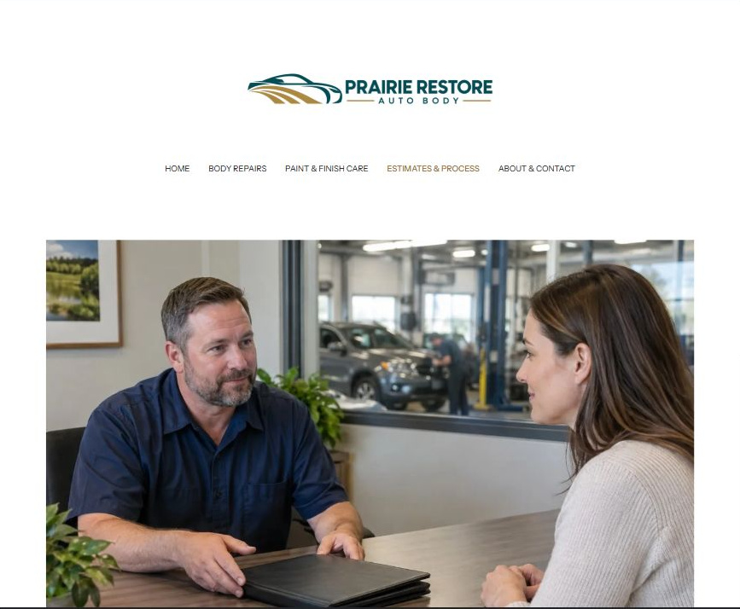
Actual desktop Website Builder preview. The paired mobile view appears in the industry gallery.

Sample wording — adapt and verify
Know what happens before repairs are agreed.
Start with a general enquiry, then confirm the assessment arrangements with the team. Review the proposed scope, estimate and timing questions before deciding whether to authorize work.
Any insurer decision, additional work or schedule change needs the appropriate separate confirmation. Ask how updates will be communicated and where private documents should be supplied.
Suggested button: Ask about the assessment process

Website advice
Set out enquiry, assessment, written scope, customer questions and authorization steps. Distinguish shop estimates from insurer decisions; use private approved routes for claim documents.

Your draft: Estimates & Repair Process
Write in the voice of your own business. Use facts you can verify, not promises copied from the example.

Headline and short introduction

Main content and details visitors need

Button wording and destination

Photo choice, permission and facts still to confirm
Partner check: can someone unfamiliar with the business find a useful next step?

05 About & Contact
Give this page one clear job in the customer journey.
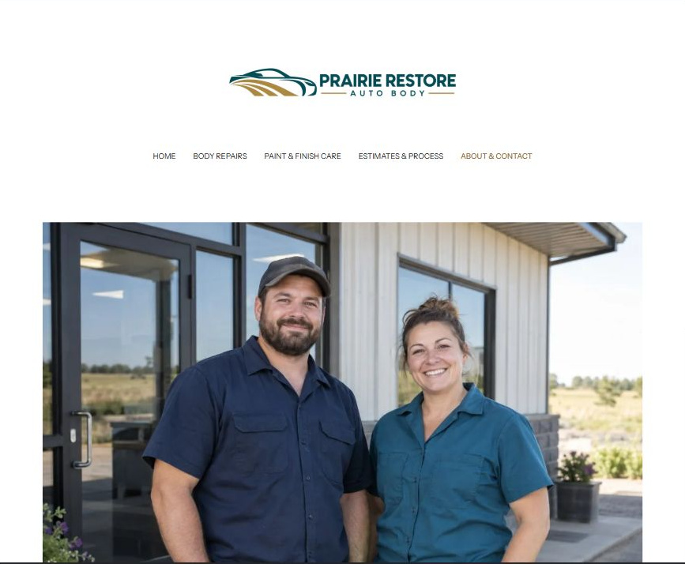
Actual desktop Website Builder preview. The paired mobile view appears in the industry gallery.

Sample wording — adapt and verify
Meet the team and start a focused conversation.
Meet the people who coordinate repair enquiries and customer updates. Contact the shop to confirm current hours, access arrangements and the right person for your question.
Use a short non-sensitive description for an initial enquiry. The team will explain the approved private process if claim information, identification or other documents are needed.
Suggested button: Contact the repair team

Website advice
Introduce verified team roles and approved contact details. Show an honest route for enquiries, confirmed hours and access information. Do not invent certifications, insurer approvals, reviews or emergency services.

Your draft: About & Contact
Write in the voice of your own business. Use facts you can verify, not promises copied from the example.

Headline and short introduction

Main content and details visitors need

Button wording and destination

Photo choice, permission and facts still to confirm
Partner check: can someone unfamiliar with the business find a useful next step?

Test before publishing
Review the captured desktop and phone journey. The demo form has Name, required Email and Message. Recipient blank; attachments and messaging off. It was not submitted or delivery-tested. Configure approved delivery before launch.
□ Fictional teaching example only, not an operating repair shop. The operator must verify repair scope, qualifications, any insurer relationships and all service terms. This example provides no repair, insurance or roadworthiness advice.
□ Verify every offered repair category, qualification, term and contact route with the operator.
□ Do not promise an instant price, insurer approval, guaranteed repair result or roadworthiness from a website enquiry.
□ Keep VINs, claim and policy numbers, identity documents and payment details out of public forms.
□ Replace fictional example imagery with permission-cleared business photos before making real premises, people or project claims.
□ Check every enquiry route, download and link on a phone; do not publish before operator approval.
□ Check every link, form destination, download and confirmation message.
□ Check logo contrast, hero framing, text sizes and image loading.
□ Save a named backup and assign a content-review date.

Changes to finish and person responsible

Approval and next review date
Website Builder plans and signup

