

Book Authors & Independent Publishers
Website workbook
A practical workshop for a 6-page website. Study the example, plan the content and draft your own version in Word or on paper.
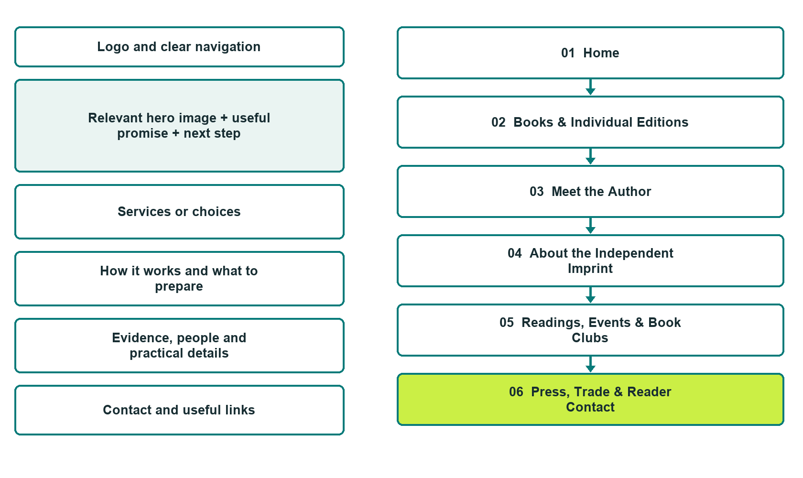

Plan → Draft → Build → Test
Captured demo edition. Study the unpublished six-page example, then draft your own verified content. Paired desktop and mobile previews, Editor Highlights, Themes and Paint appear in the industry gallery.
Explore Website Builder and compare plans

Before you build
Your business supplies the facts. Prairie Margin Books is a fictional teaching example, not a live service.

□ Explore the books or send a publishing enquiry
□ Verified business identity, services and current contact information
□ A clear enquiry, review and confirmation process
□ Choose original photographs and confirm permission to use them.
□ Keep private customer records out of public website forms.

Your audience and the action you want them to take

Facts to verify and people who must approve them
Create your SaaSTech account

01 Home
Give this page one clear job in the customer journey.
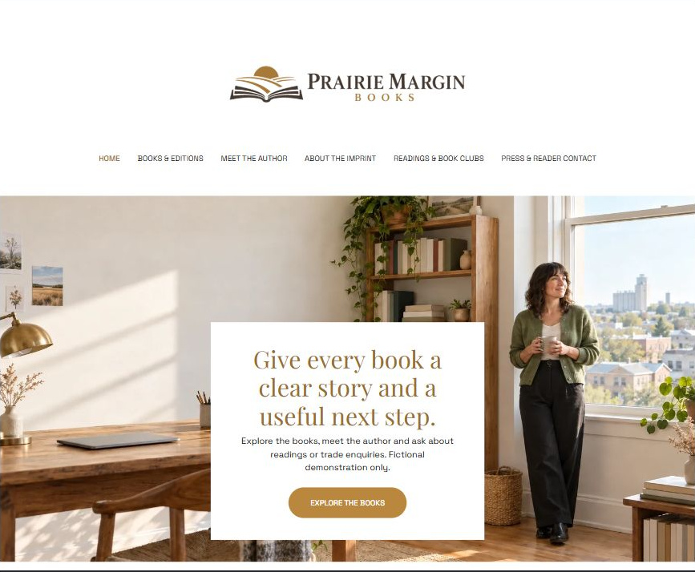
Actual desktop Website Builder preview. Open the industry gallery for its paired mobile view.

Sample wording — adapt and verify
Give every book a clear story and a useful next step.
Discover the author’s work, understand the imprint’s role and find the right route for a reader, bookseller or event enquiry.
This demonstration shows how each book can have an informative page without pretending that an unpublished example is available to buy.
Suggested next step: explore the books or use the general enquiry form on Home.

Website advice
Separate author identity, individual book information, publisher activity, readings and press enquiries; link to purchasing only after a real destination is verified.

Your draft: Home
Write in the voice of your own business. Use facts you can verify, not promises copied from the example.

Headline and short introduction

Main content and details visitors need

Button wording and destination

Photo choice, permission and facts still to confirm
Partner check: can someone unfamiliar with the business find a useful next step?

02 Books & Individual Editions
Give this page one clear job in the customer journey.
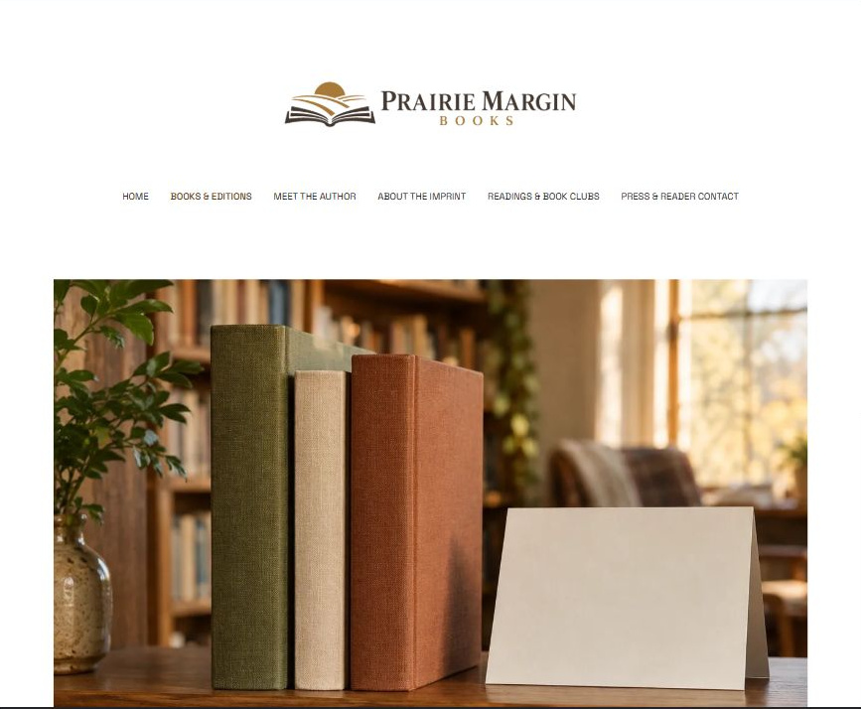
Actual desktop Website Builder preview. Open the industry gallery for its paired mobile view.

Sample wording — adapt and verify
Books & Individual Editions
A useful book page explains the subject, intended audience and available edition without borrowing unverified praise.
Confirm format, publication details and the actual bookseller destination before inviting readers to purchase.
Suggested next step: explore the books or use the general enquiry form on Home.

Website advice
Give each verified title its own description, format and edition details; reserve purchase buttons for tested destinations.

Your draft: Books & Individual Editions
Write in the voice of your own business. Use facts you can verify, not promises copied from the example.

Headline and short introduction

Main content and details visitors need

Button wording and destination

Photo choice, permission and facts still to confirm
Partner check: can someone unfamiliar with the business find a useful next step?

03 Meet the Author
Give this page one clear job in the customer journey.
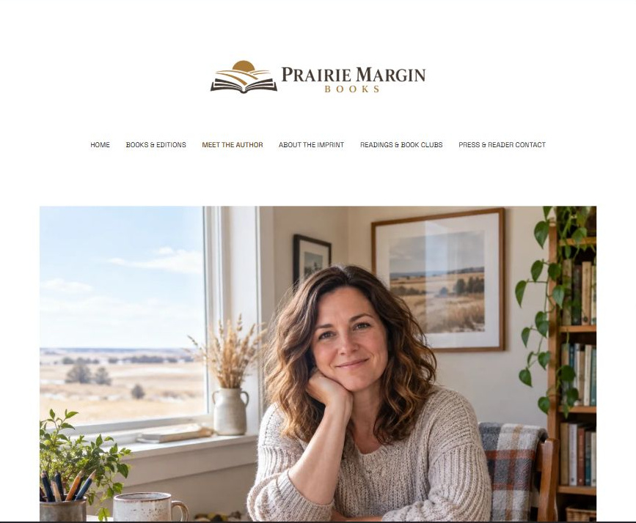
Actual desktop Website Builder preview. Open the industry gallery for its paired mobile view.

Sample wording — adapt and verify
Meet the Author
An author biography can explain the themes behind the work and the places or experiences the author chooses to share.
Keep personal details deliberate, distinguish the author from the publisher and provide an appropriate public enquiry route.
Suggested next step: explore the books or use the general enquiry form on Home.

Website advice
Use an approved biography, permission-cleared portrait and genuine writing interests without fabricated achievements.

Your draft: Meet the Author
Write in the voice of your own business. Use facts you can verify, not promises copied from the example.

Headline and short introduction

Main content and details visitors need

Button wording and destination

Photo choice, permission and facts still to confirm
Partner check: can someone unfamiliar with the business find a useful next step?

04 About the Independent Imprint
Give this page one clear job in the customer journey.
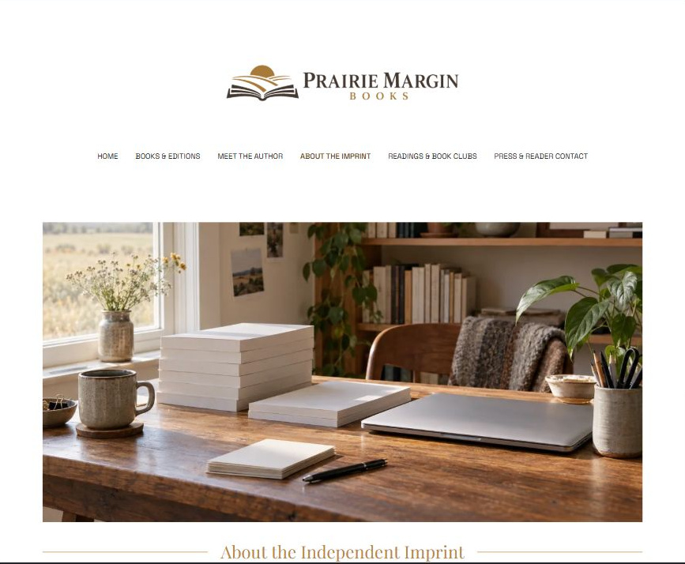
Actual desktop Website Builder preview. Open the industry gallery for its paired mobile view.

Sample wording — adapt and verify
About the Independent Imprint
Explain whether the imprint publishes one author or a wider catalogue and who handles trade questions.
State clearly whether submissions are accepted; do not invite manuscripts unless a real reviewed submission process exists.
Suggested next step: explore the books or use the general enquiry form on Home.

Website advice
Describe the publisher’s verified role, catalogue focus and enquiry boundaries separately from the author profile.

Your draft: About the Independent Imprint
Write in the voice of your own business. Use facts you can verify, not promises copied from the example.

Headline and short introduction

Main content and details visitors need

Button wording and destination

Photo choice, permission and facts still to confirm
Partner check: can someone unfamiliar with the business find a useful next step?

05 Readings, Events & Book Clubs
Give this page one clear job in the customer journey.
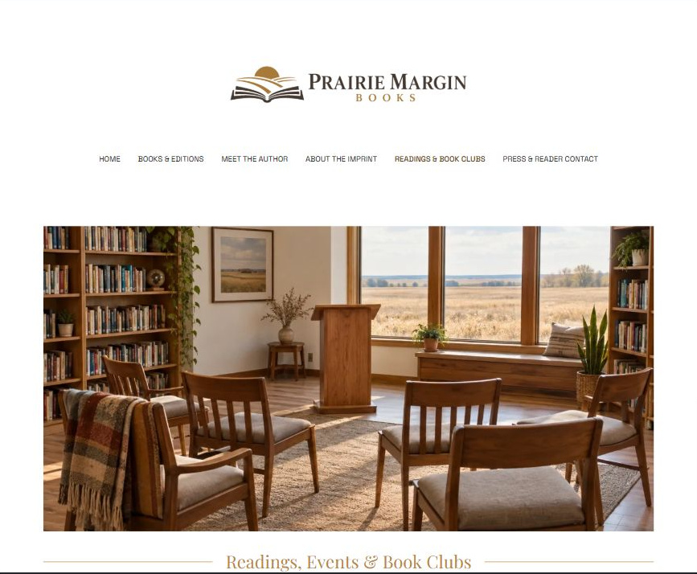
Actual desktop Website Builder preview. Open the industry gallery for its paired mobile view.

Sample wording — adapt and verify
Readings, Events & Book Clubs
Tell the organizer the event format, location or online setting and the audience you expect.
Availability, access arrangements, fees if applicable and permission to record are discussed directly before an appearance is confirmed.
Suggested next step: explore the books or use the general enquiry form on Home.

Website advice
Provide an event enquiry path covering format, audience and permissions, not an invented event calendar.

Your draft: Readings, Events & Book Clubs
Write in the voice of your own business. Use facts you can verify, not promises copied from the example.

Headline and short introduction

Main content and details visitors need

Button wording and destination

Photo choice, permission and facts still to confirm
Partner check: can someone unfamiliar with the business find a useful next step?

06 Press, Trade & Reader Contact
Give this page one clear job in the customer journey.
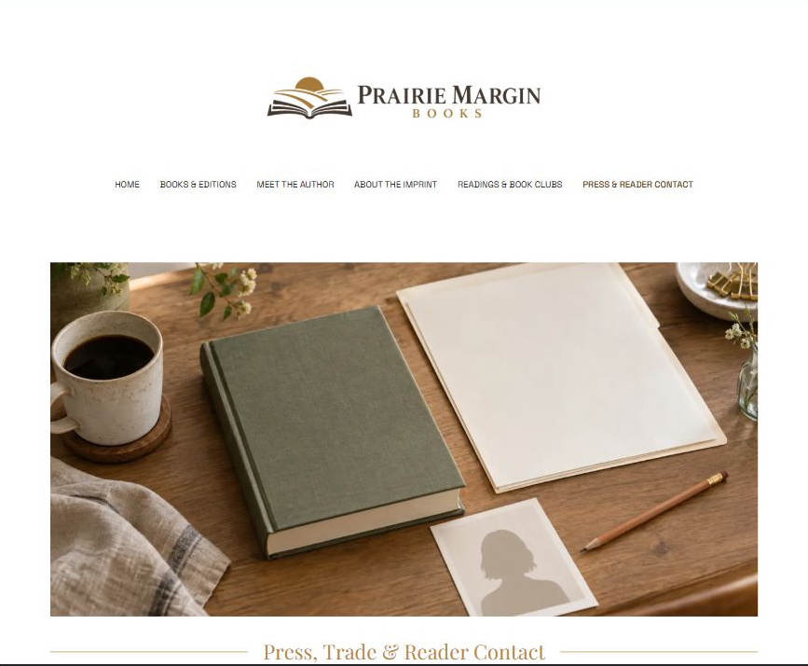
Actual desktop Website Builder preview. Open the industry gallery for its paired mobile view.

Sample wording — adapt and verify
Press, Trade & Reader Contact
Choose the purpose of your message so it reaches the appropriate contact.
Press assets should carry clear permitted-use information, while rights and trade requests require direct review rather than being treated as permission to reproduce the work.
Suggested next step: explore the books or use the general enquiry form on Home.

Website advice
Organize rights-cleared media materials and separate general reader messages, trade questions and rights enquiries.

Your draft: Press, Trade & Reader Contact
Write in the voice of your own business. Use facts you can verify, not promises copied from the example.

Headline and short introduction

Main content and details visitors need

Button wording and destination

Photo choice, permission and facts still to confirm
Partner check: can someone unfamiliar with the business find a useful next step?

Test before publishing
Review the captured desktop and phone journey. The Home enquiry form has Name, required Email and Message. Recipient blank; attachments and messaging off. It was not submitted or delivery-tested. Configure approved delivery before launch.
□ Fictional demonstration only. All author, book and imprint examples require replacement or explicit demo labels. Do not invent awards, reviews, sales rankings, publication contracts or availability. Publish excerpts, biographies and images only with rights and consent confirmed.
□ Verify every service description, contact route and operating detail.
□ Replace fictional identity and example information before a live launch.
□ Test enquiries, links and downloads on desktop and mobile.
□ Keep confidential records in approved private systems.
□ Obtain operator approval for public wording and images.
□ Check every link, form destination, download and confirmation message.
□ Check logo contrast, hero framing, text sizes and image loading.
□ Save a named backup and assign a content-review date.

Changes to finish and person responsible

Approval and next review date
Website Builder plans and signup

