SaaSTech Servers
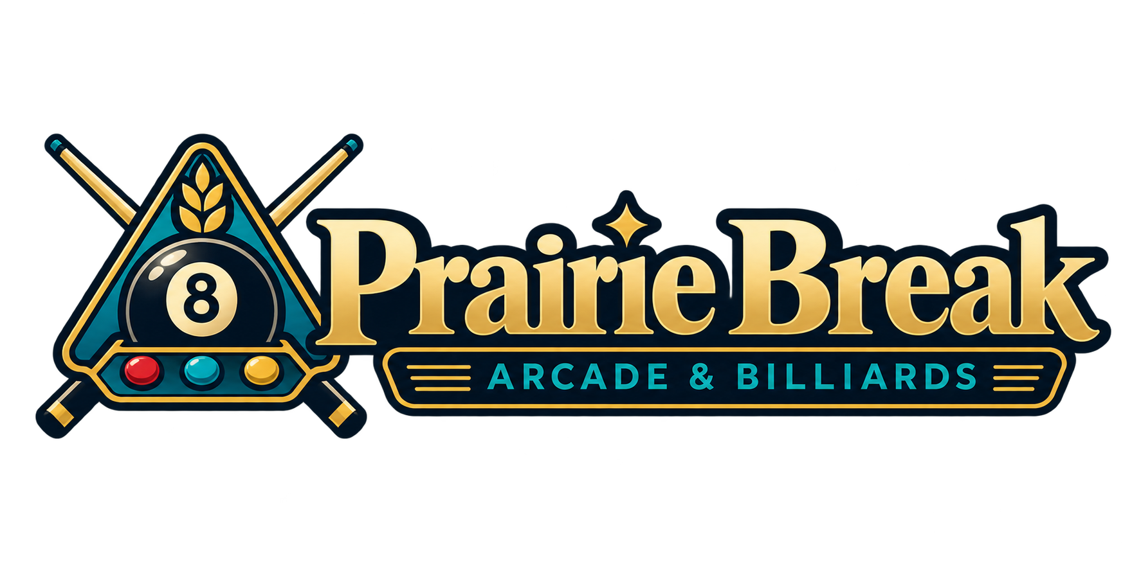

Group event planning worksheet
Organise an initial group enquiry and the details the venue must confirm. This worksheet is a planning aid, not a reservation, quote, contract or payment form.
Type in the response lines in Word or print and write by hand. Prairie Break is a fictional learning example; replace its details with your approved business information.
Occasion and approximate group size

Preferred date time and alternatives

Pool arcade activities and food requests to discuss

Access or supervision arrangements to confirm without recording private medical details

Confirm the arrangements
Complete this page with the operator before sending a final confirmation. Keep payment details and private guest records in approved systems.
Availability capacity and assigned spaces

Agreed inclusions total price and payment process

Cancellation changes and confirmation conditions

Person responsible next action and follow up date

